edgar6_check

22 Juli, 2021

Table of Contents

Global trends and totals 9

CO2, CH4, N2O emissions 9

Fgas emissions 9

All gases (GWPs applied) 10

IPCC 1996 sector trends 11

AFOLU sectors 11

Buildings sectors 23

Energy systems sectors 25

Industry sectors 43

Transport sectors 71

Country trends 77

Afghanistan 78

Albania 79

Algeria 80

American Samoa 81

Angola 82

Anguilla 83

Antigua and Barbuda 84

Argentina 85

Armenia 86

Aruba 87

Australia 88

Austria 89

Azerbaijan 90

Bahamas, The 91

Bahrain 92

Bangladesh 93

Barbados 94

Belarus 95

Belgium 96

Belize 97

Benin 98

Bermuda 99

Bhutan 100

Bolivia 101

Bosnia and Herzegovina 102

Botswana 103

Bouvet Island 104

Brazil 105

British Virgin Islands 106

Brunei Darussalam 107

Bulgaria 108

Burkina Faso 109

Burundi 110

Cabo Verde 111

Cambodia 112

Cameroon 113

Canada 114

Cayman Islands 115

Central African Republic 116

Chad 117

Chile 118

China 119

Christmas Island 120

Cocos (Keeling) Islands 121

Colombia 122

Comoros 123

Congo, Dem. Rep. 124

Congo, Rep. 125

Cook Islands 126

Costa Rica 127

Côte d’Ivoire 128

Croatia 129

Cuba 130

Curaçao 131

Cyprus 132

Czech Republic 133

Denmark 134

Djibouti 135

Dominica 136

Dominican Republic 137

Ecuador 138

Egypt, Arab Rep. 139

El Salvador 140

Equatorial Guinea 141

Eritrea 142

Estonia 143

Ethiopia 144

Falkland Islands (Malvinas) 145

Faroe Islands 146

Fiji 147

Finland 148

France 149

French Guiana 150

French Polynesia 151

French Southern Territories 152

Gabon 153

Gambia, The 154

Georgia 155

Germany 156

Ghana 157

Gibraltar 158

Greece 159

Greenland 160

Grenada 161

Guadeloupe 162

Guam 163

Guatemala 164

Guinea 165

Guinea-Bissau 166

Guyana 167

Haiti 168

Heard Island and McDonald Islands 169

Honduras 170

Hong Kong SAR, China 171

Hungary 172

Iceland 173

India 174

Indonesia 175

Int. Aviation 176

Int. Shipping 177

Iran, Islamic Rep. 178

Iraq 179

Ireland 180

Israel 181

Italy 182

Jamaica 183

Japan 184

Jordan 185

Kazakhstan 186

Kenya 187

Kiribati 188

Korea, Dem. People’s Rep. 189

Korea, Rep. 190

Kuwait 191

Kyrgyz Republic 192

Lao PDR 193

Latvia 194

Lebanon 195

Lesotho 196

Liberia 197

Libya 198

Lithuania 199

Luxembourg 200

Macao SAR, China 201

Macedonia, FYR 202

Madagascar 203

Malawi 204

Malaysia 205

Maldives 206

Mali 207

Malta 208

Marshall Islands 209

Martinique 210

Mauritania 211

Mauritius 212

Mayotte 213

Mexico 214

Micronesia, Fed. Sts. 215

Moldova 216

Mongolia 217

Montserrat 218

Morocco 219

Mozambique 220

Myanmar 221

Namibia 222

Nauru 223

Nepal 224

Netherlands 225

Netherlands Antilles 226

New Caledonia 227

New Zealand 228

Nicaragua 229

Niger 230

Nigeria 231

Niue 232

Norfolk Island 233

Northern Mariana Islands 234

Norway 235

Oman 236

Pakistan 237

Palau 238

Panama 239

Papua New Guinea 240

Paraguay 241

Peru 242

Philippines 243

Pitcairn 244

Poland 245

Portugal 246

Puerto Rico 247

Qatar 248

Réunion 249

Romania 250

Russian Federation 251

Rwanda 252

Saint Helena, Ascension and Tristan da Cunha 253

Saint Pierre and Miquelon 254

Samoa 255

São Tomé and Principe 256

Saudi Arabia 257

Senegal 258

Serbia and Montenegro 259

Seychelles 260

Sierra Leone 261

Singapore 262

Slovak Republic 263

Slovenia 264

Solomon Islands 265

Somalia 266

South Africa 267

South Georgia and the South Sandwich Islands 268

Spain 269

Sri Lanka 270

St. Kitts and Nevis 271

St. Lucia 272

St. Vincent and the Grenadines 273

Sudan 274

Suriname 275

Swaziland 276

Sweden 277

Switzerland 278

Syrian Arab Republic 279

Taiwan, China 280

Tajikistan 281

Tanzania 282

Thailand 283

Timor-Leste 284

Togo 285

Tokelau 286

Tonga 287

Trinidad and Tobago 288

Tunisia 289

Turkey 290

Turkmenistan 291

Turks and Caicos Islands 292

Tuvalu 293

Uganda 294

Ukraine 295

United Arab Emirates 296

United Kingdom 297

United States 298

United States Minor Outlying Islands 299

Uruguay 300

Uzbekistan 301

Vanuatu 302

Venezuela, RB 303

Vietnam 304

Virgin Islands (U.S.) 305

Wallis and Futuna 306

Western Sahara 307

Yemen, Rep. 308

Zambia 309

Zimbabwe 310

# Global trends and totals

### CO2, CH4, N2O emissions

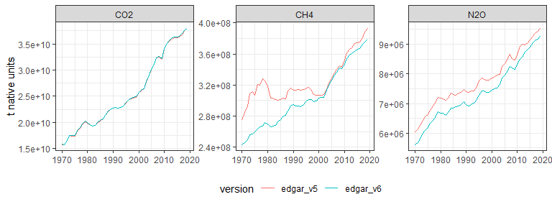

### Fgas emissions

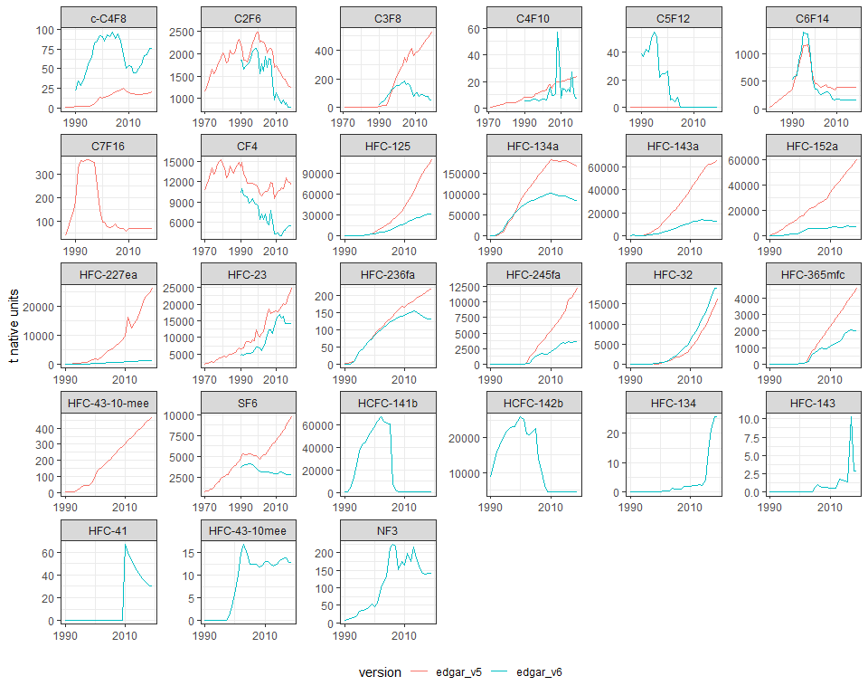

### All gases (GWPs applied)

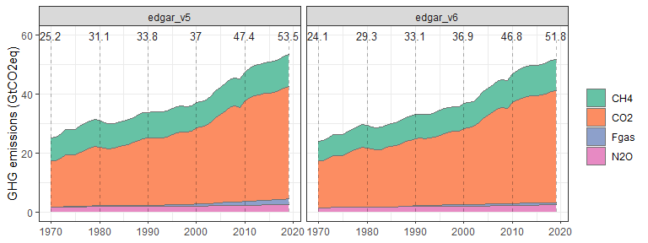

# IPCC 1996 sector trends

### AFOLU sectors

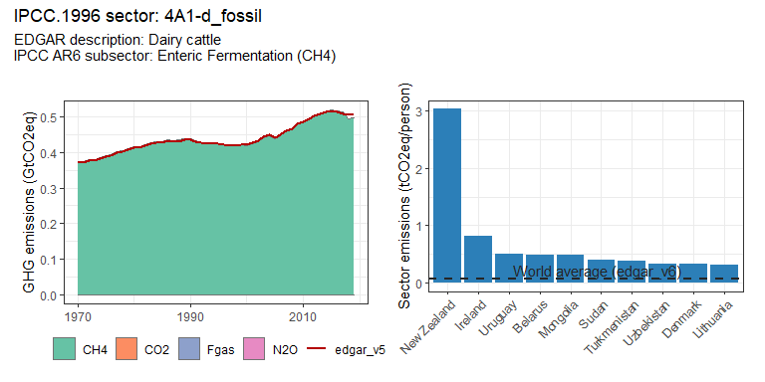 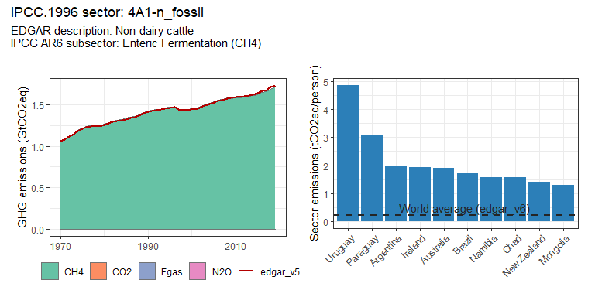 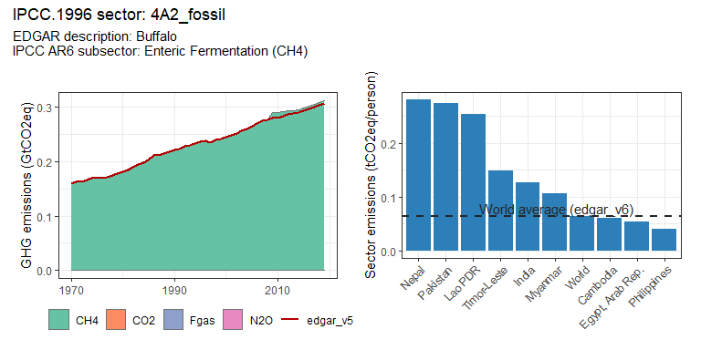 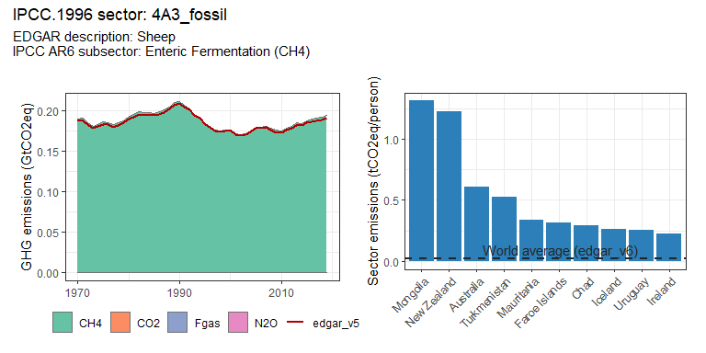 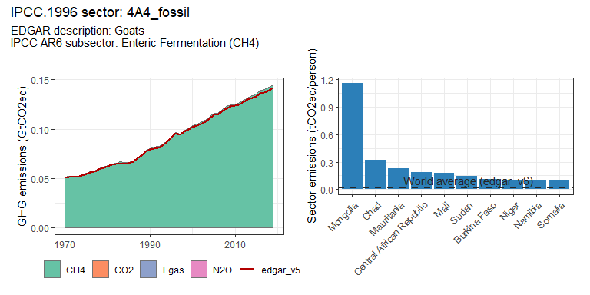 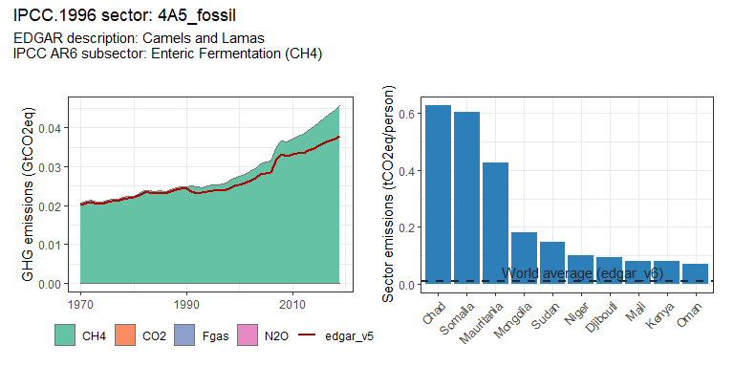 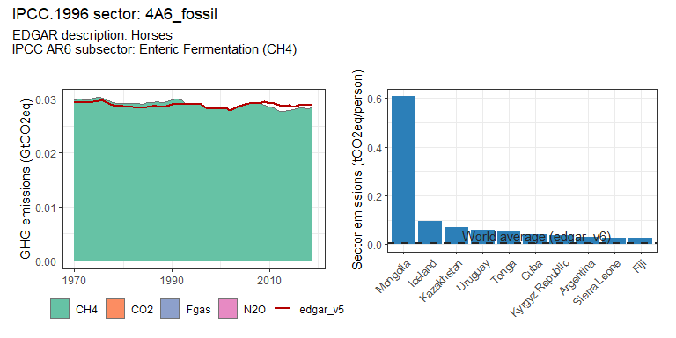 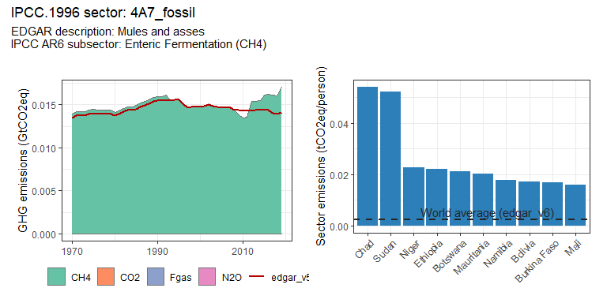 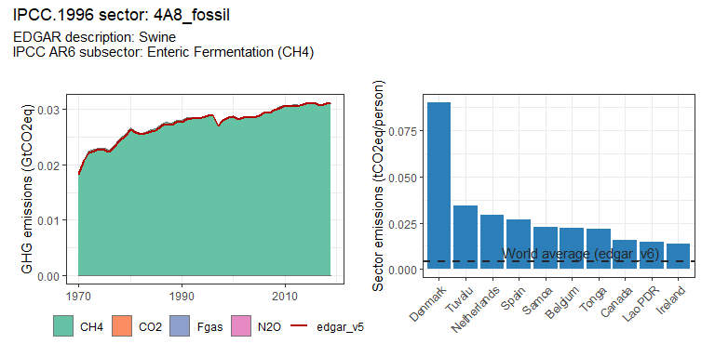 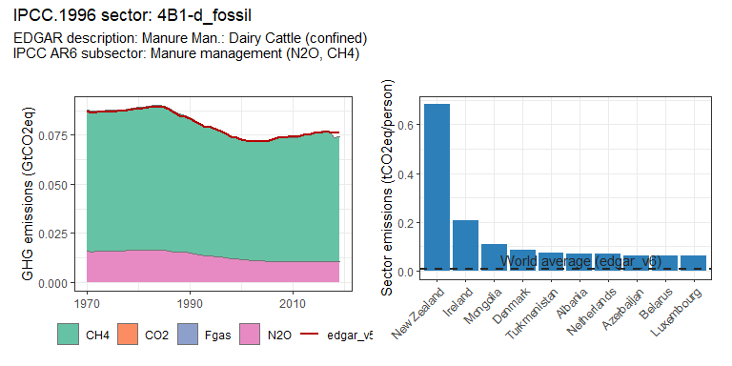 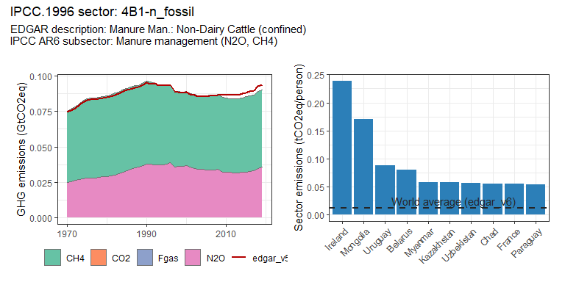 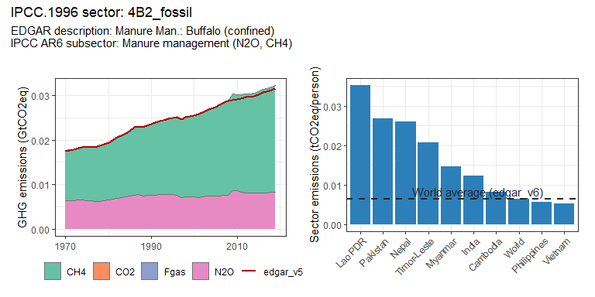 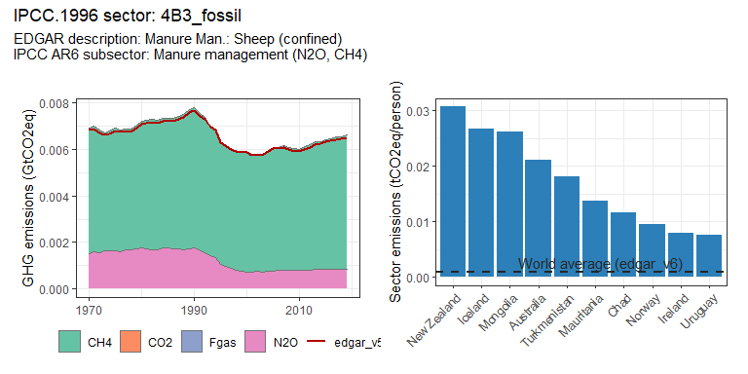 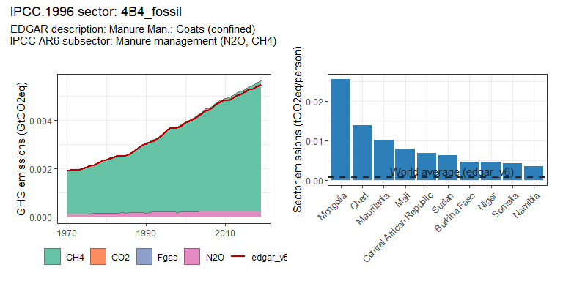 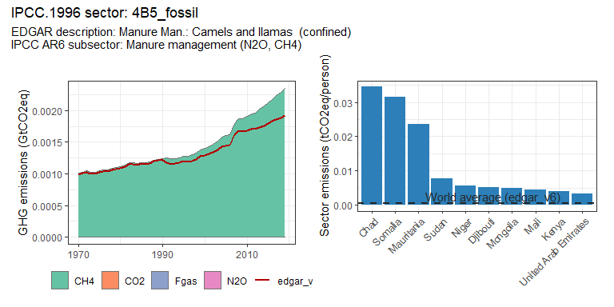 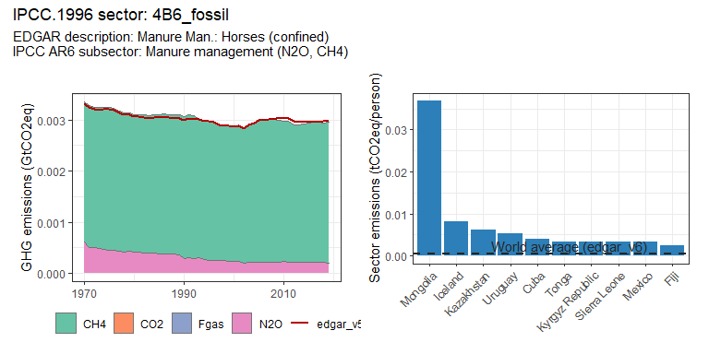 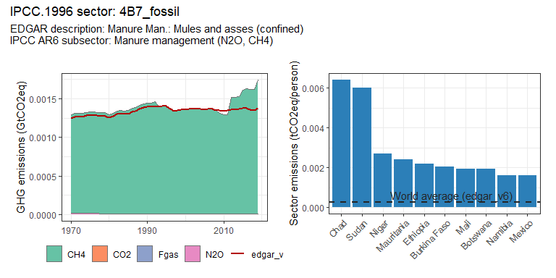 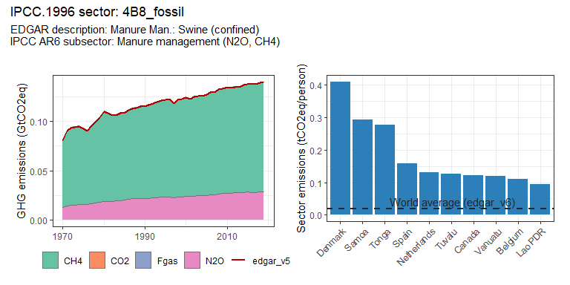 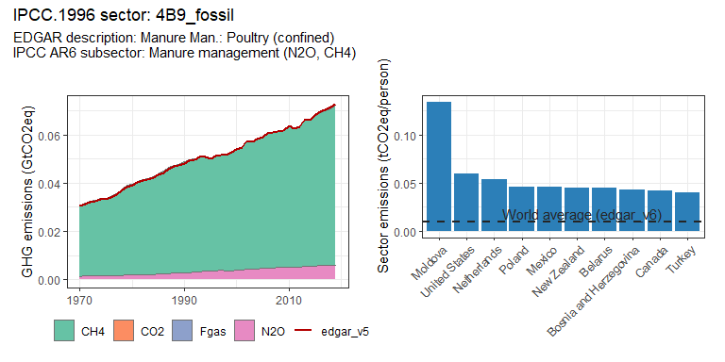 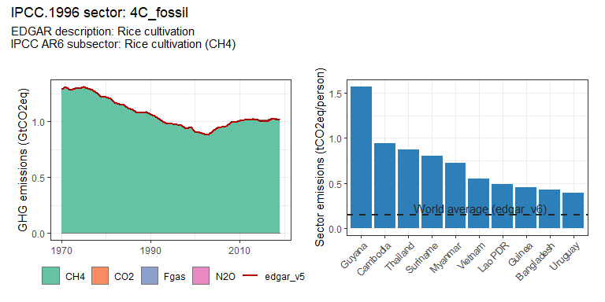 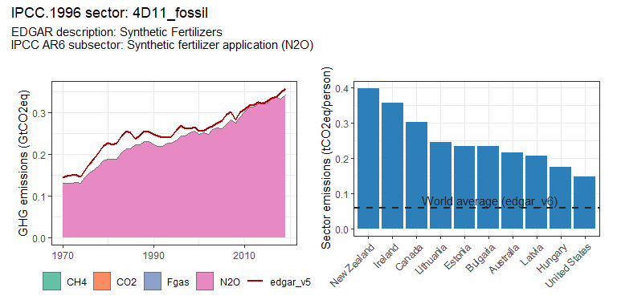 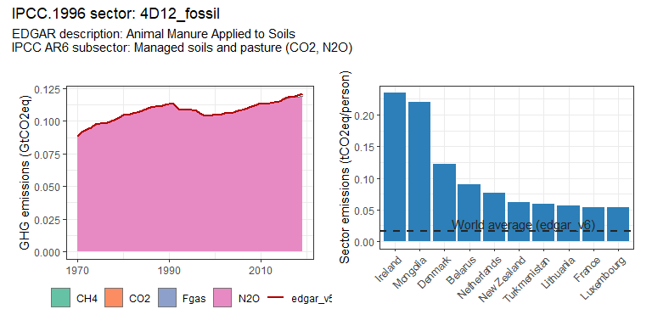 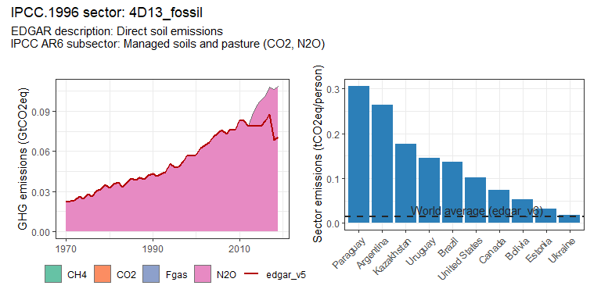 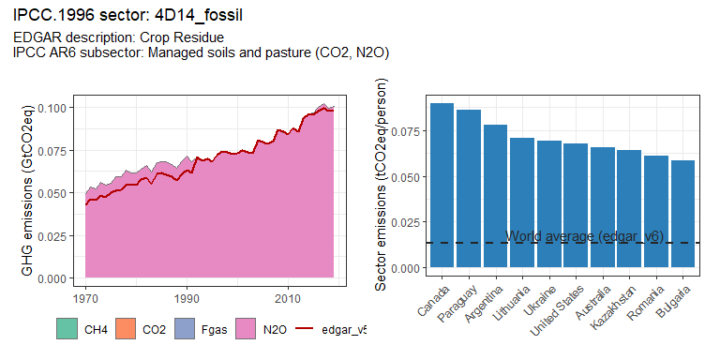 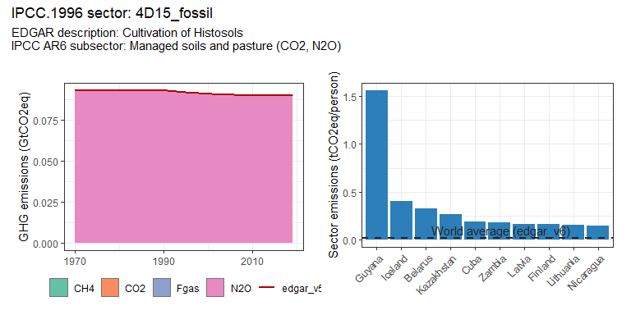 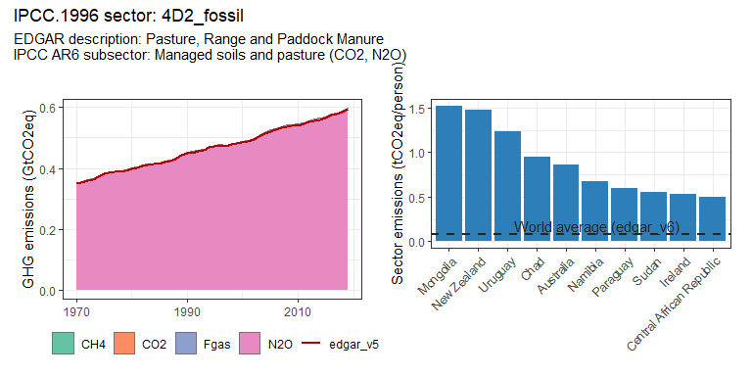 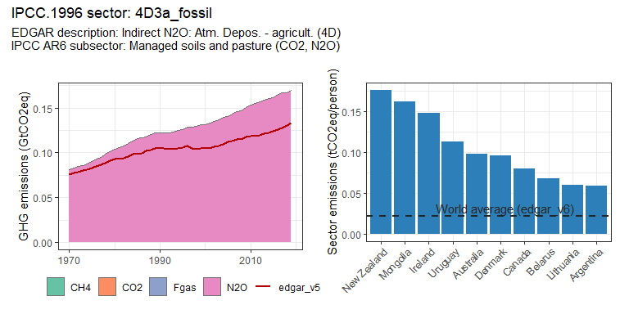 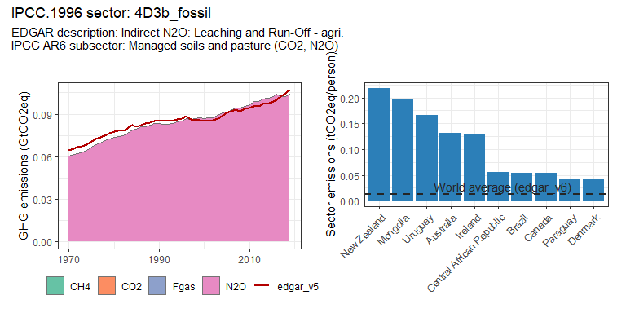 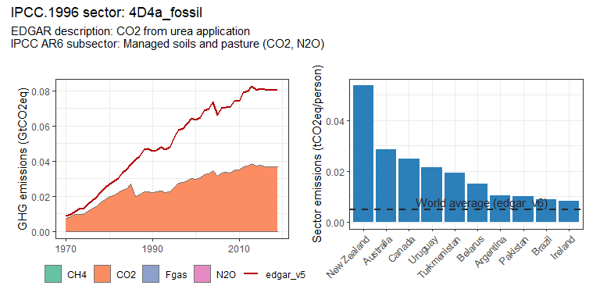 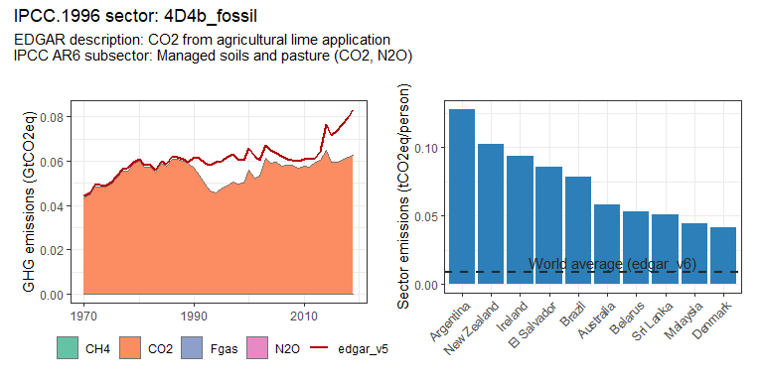 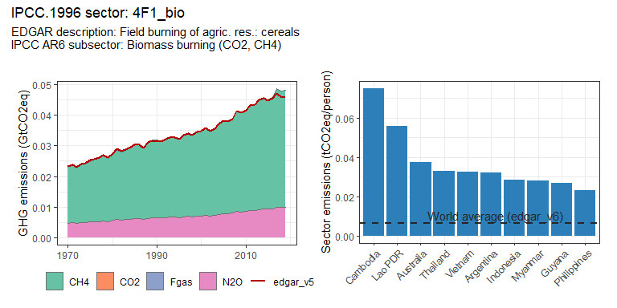 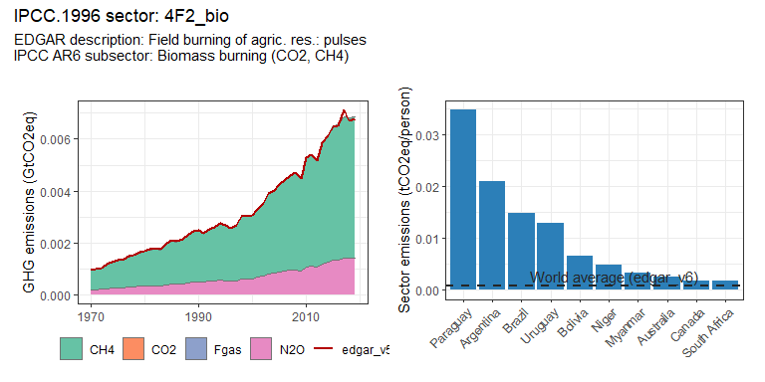 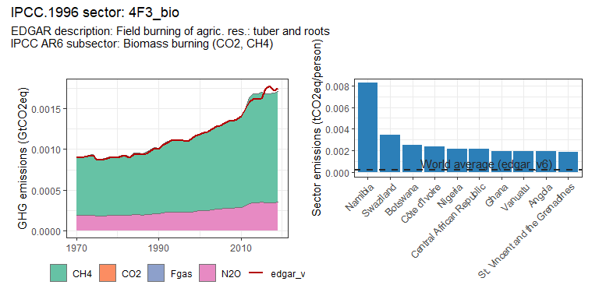 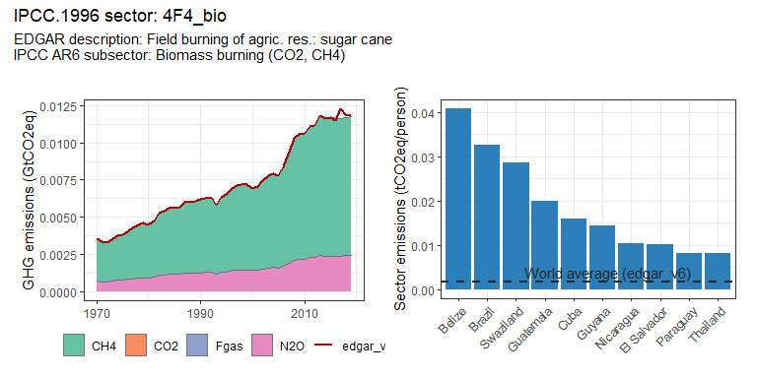 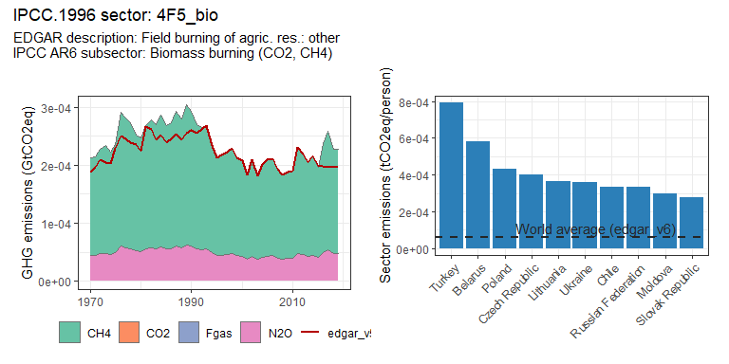

### Buildings sectors

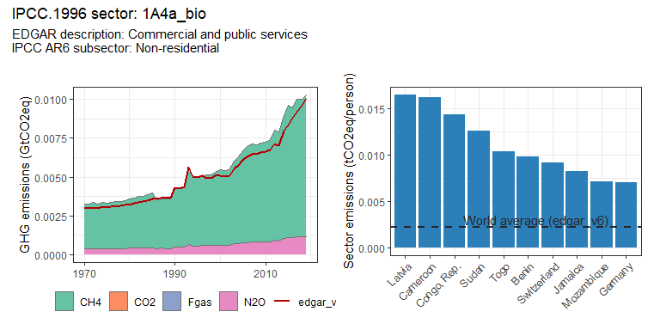 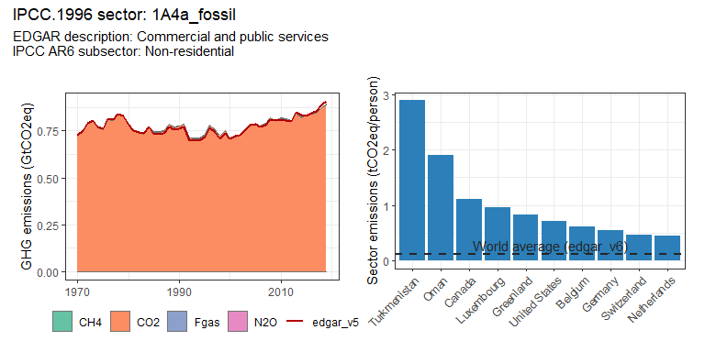 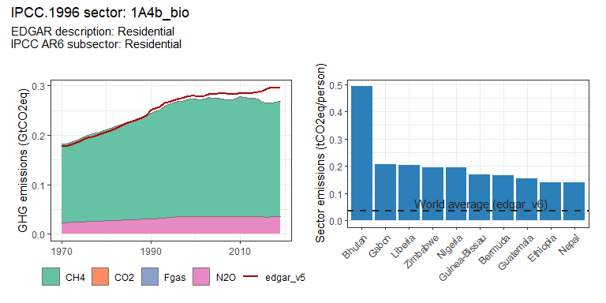 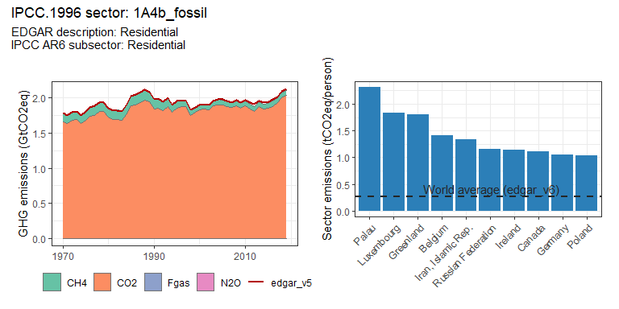 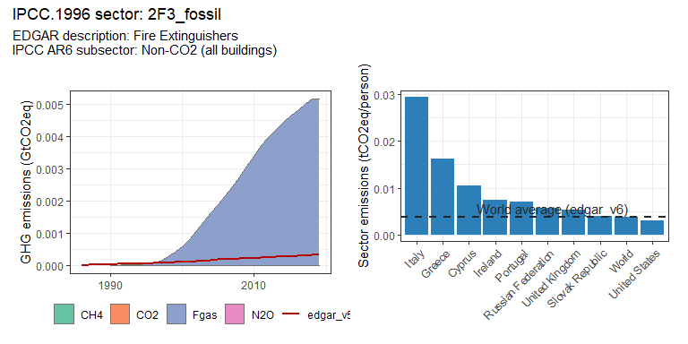 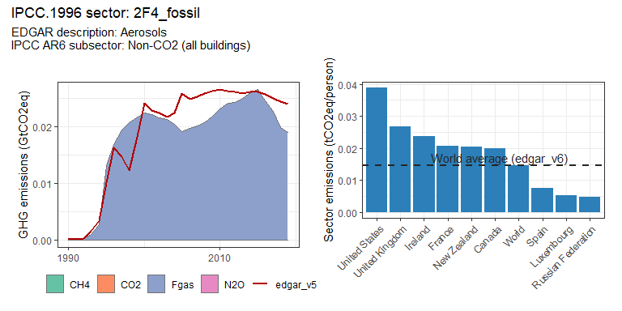

### Energy systems sectors

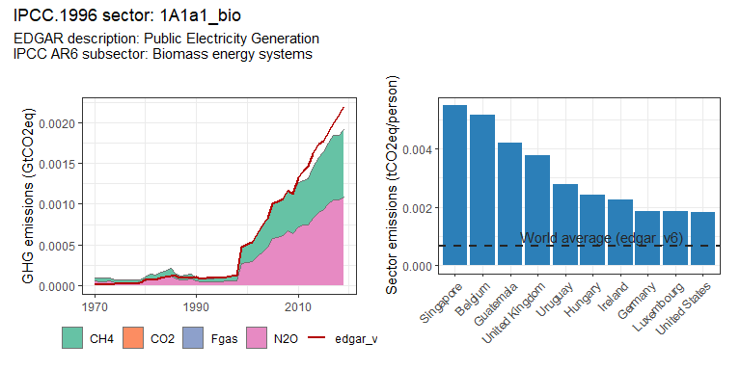 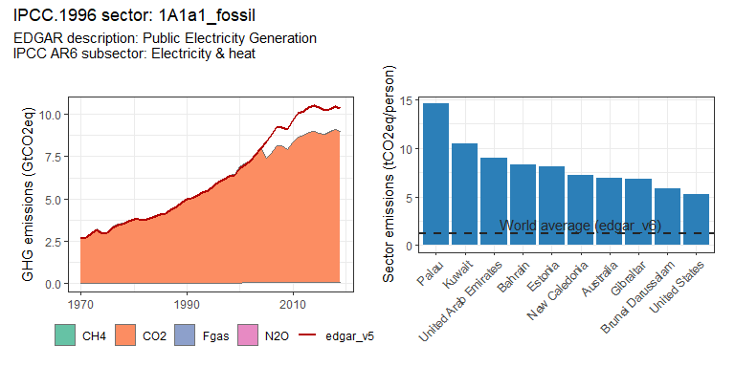 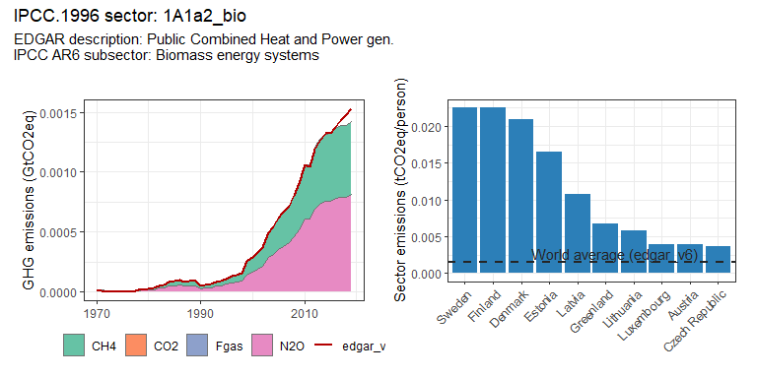 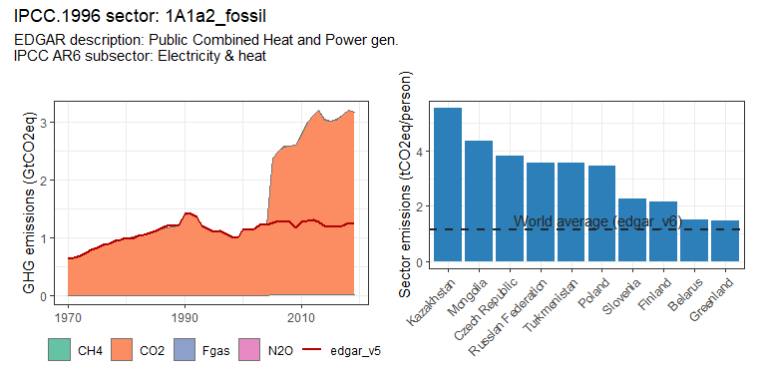 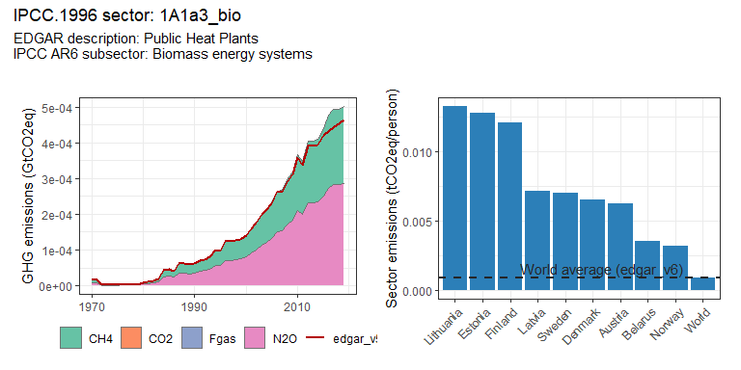 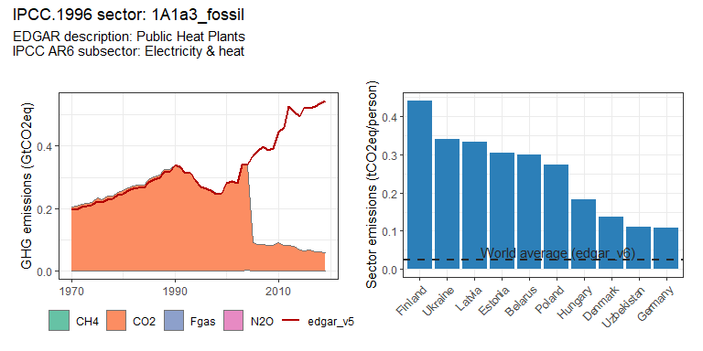 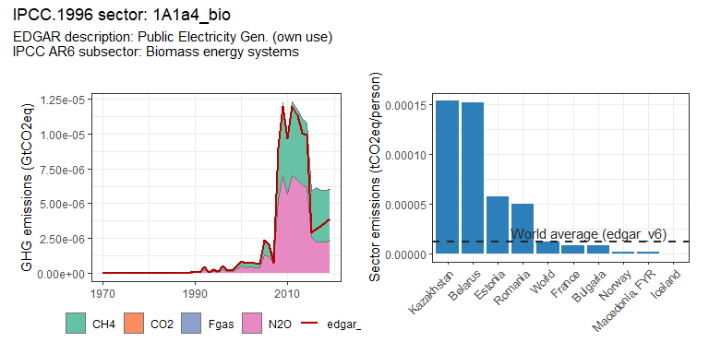 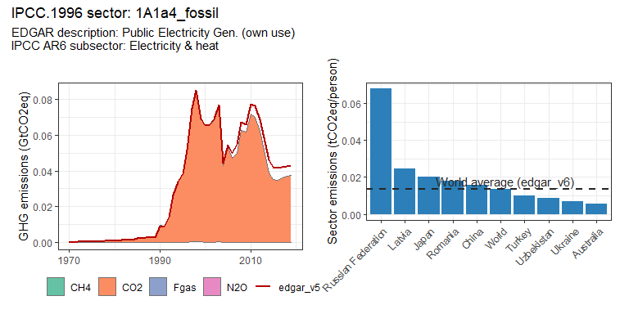 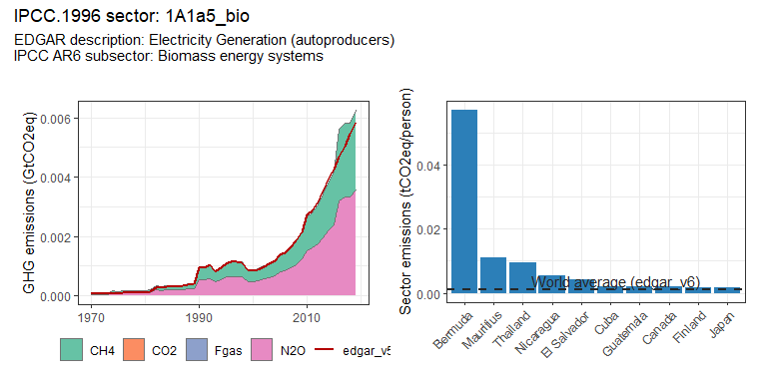 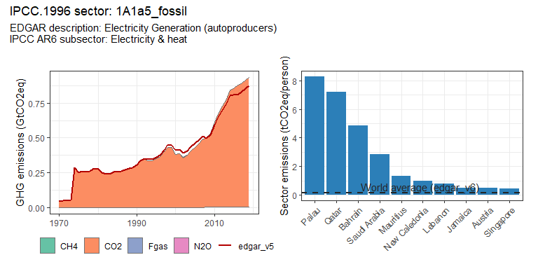 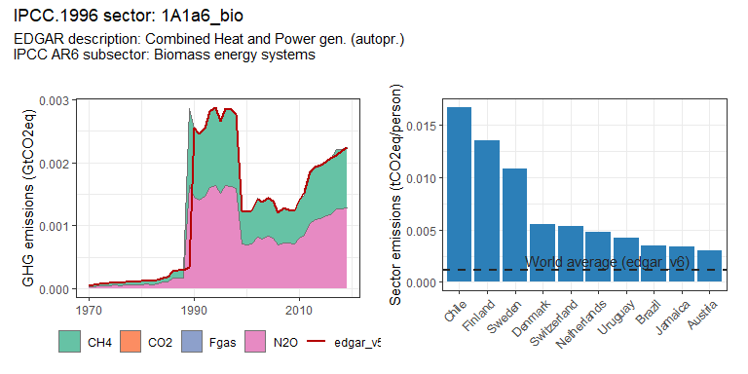 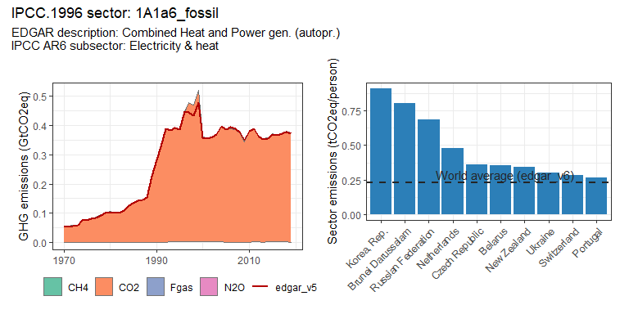 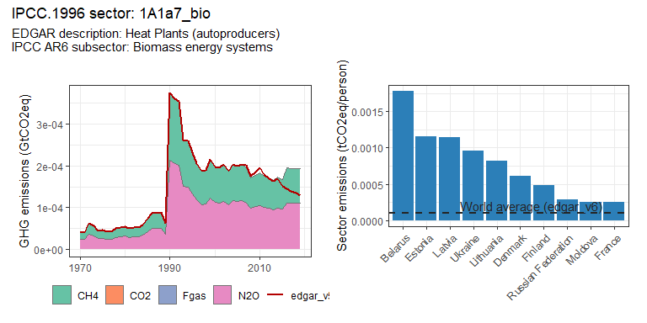 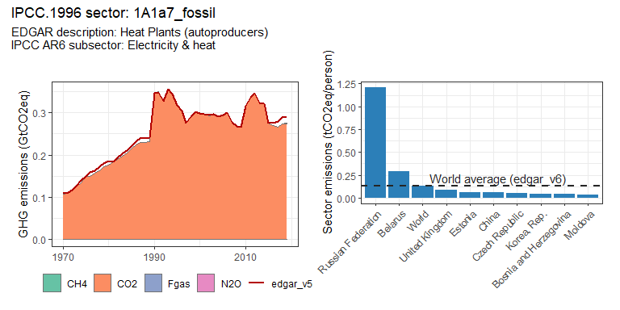 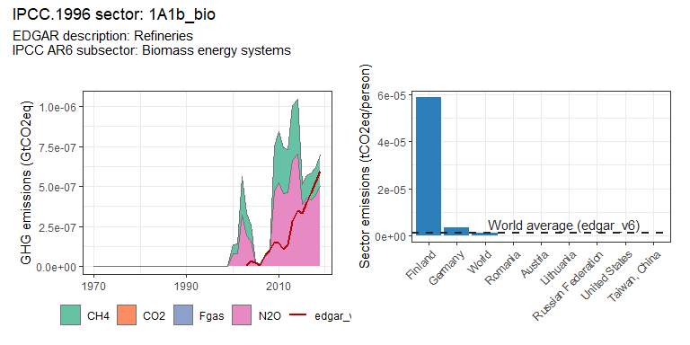 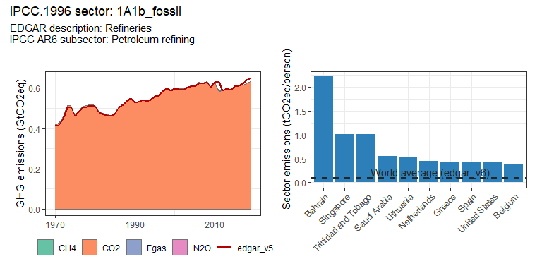 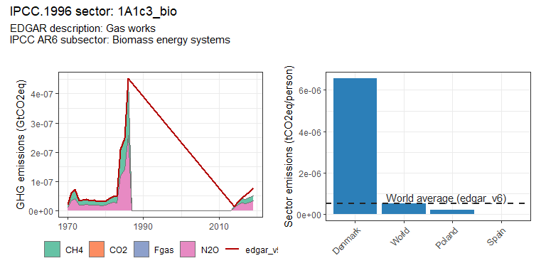 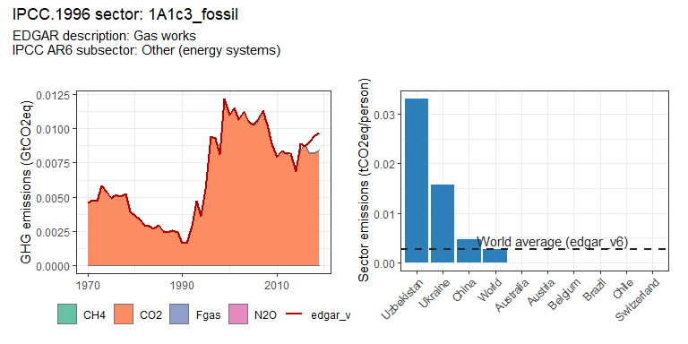 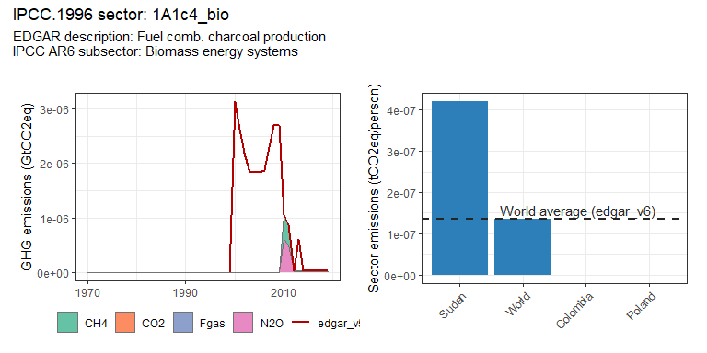 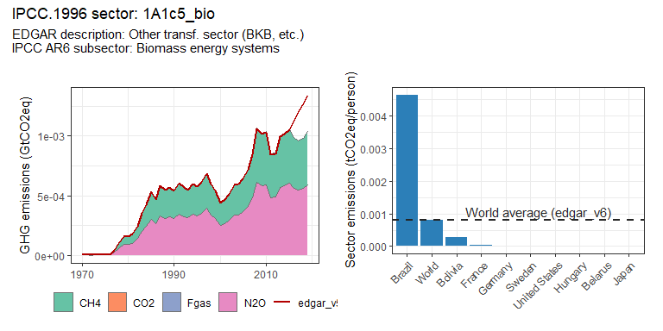 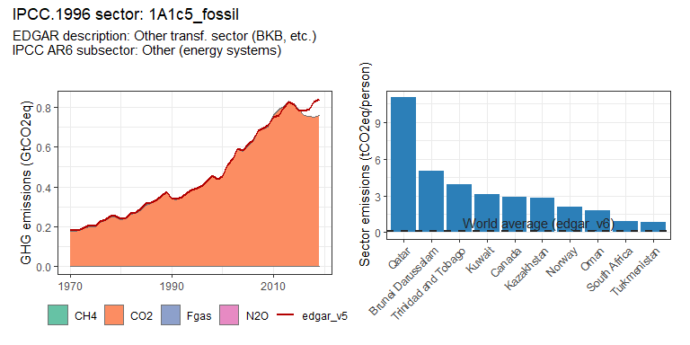 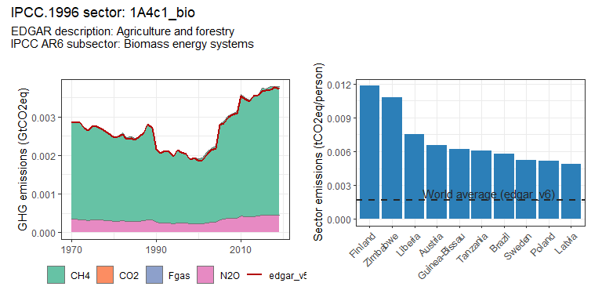 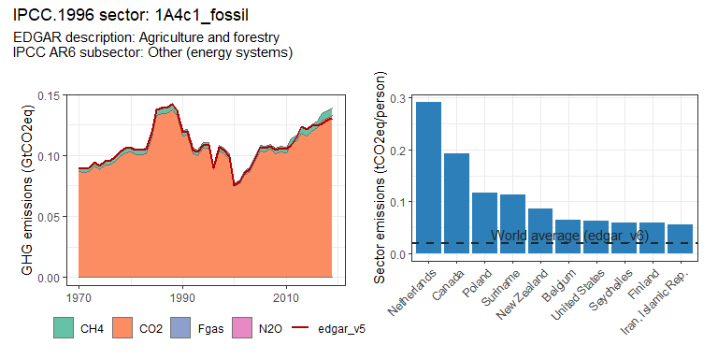 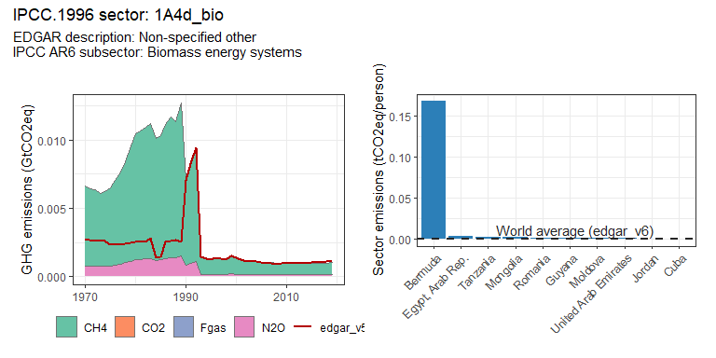 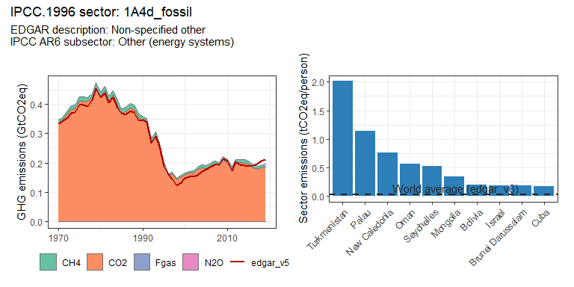 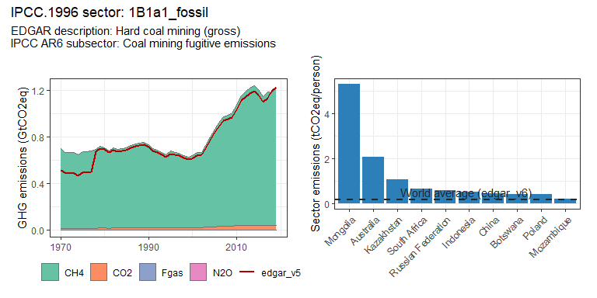 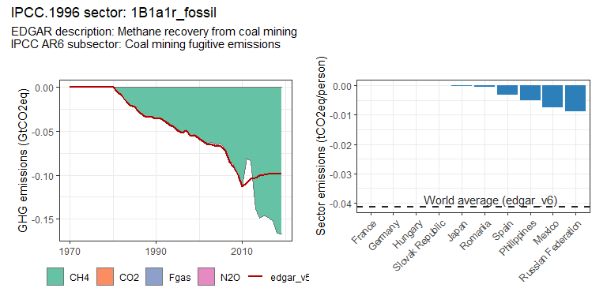 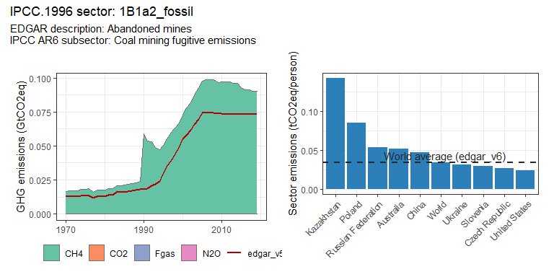 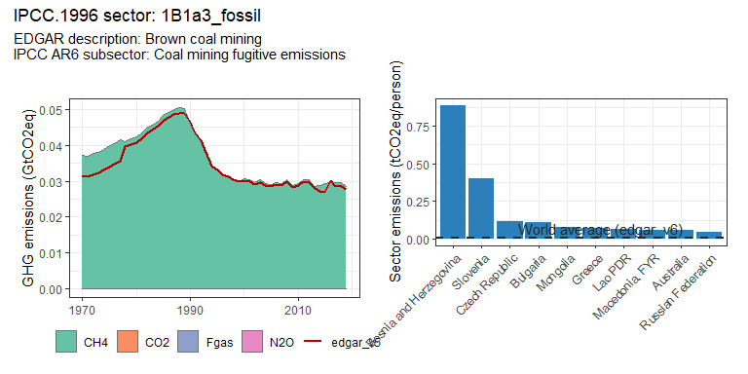 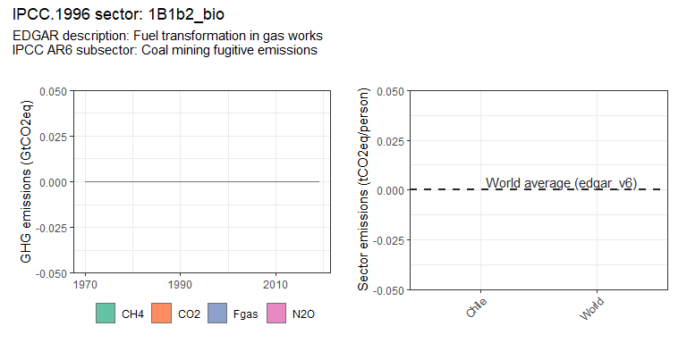 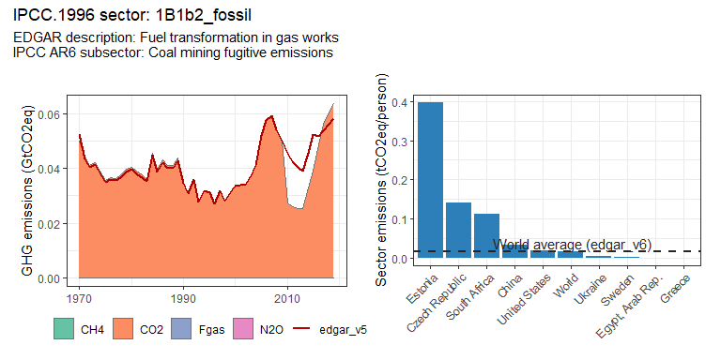 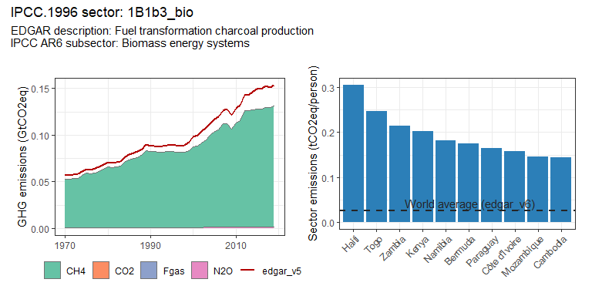 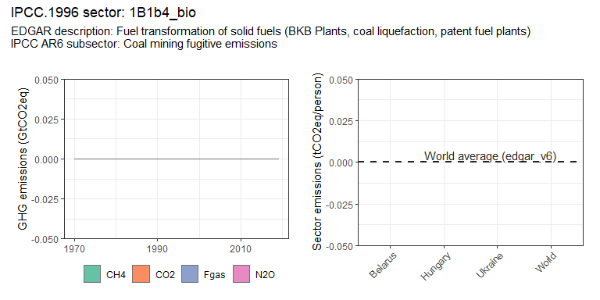 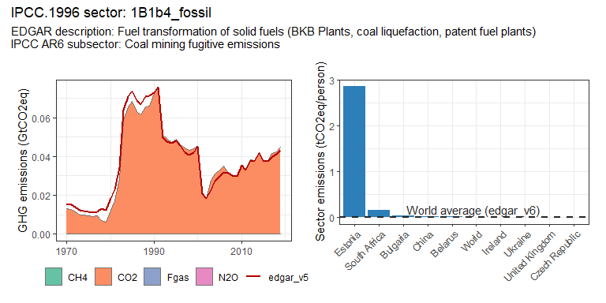 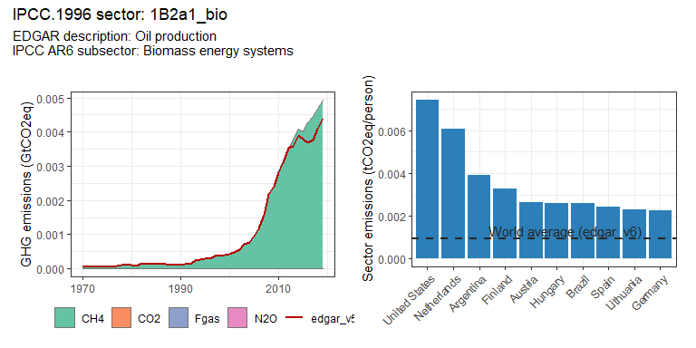 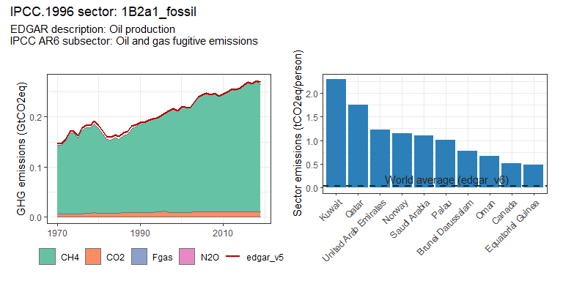 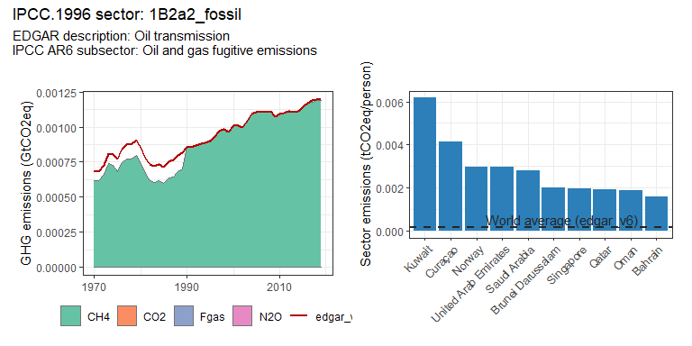 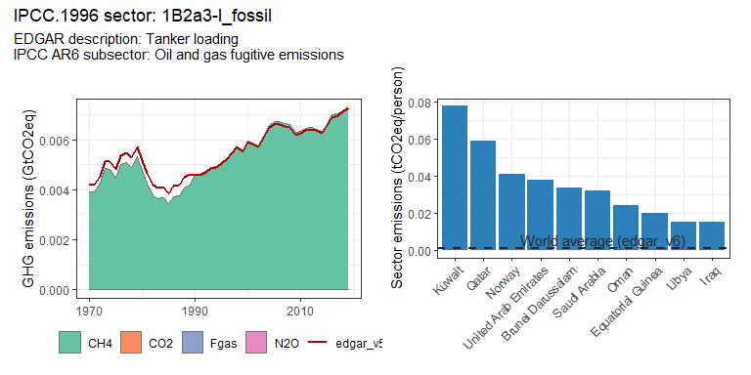 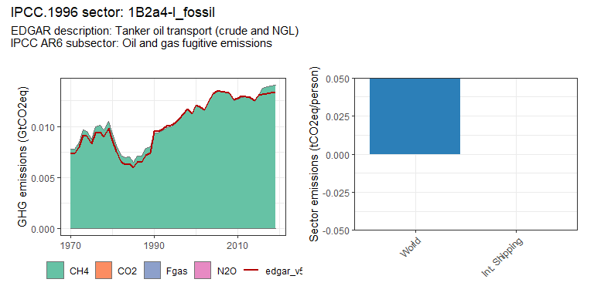 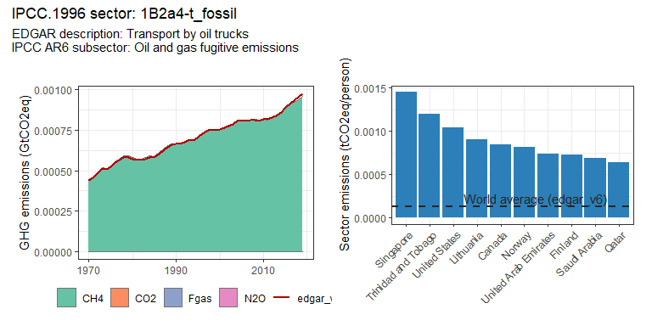 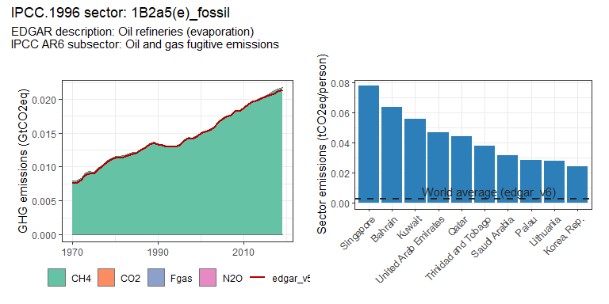 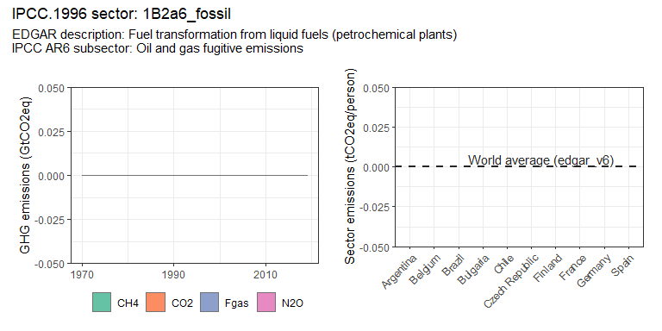 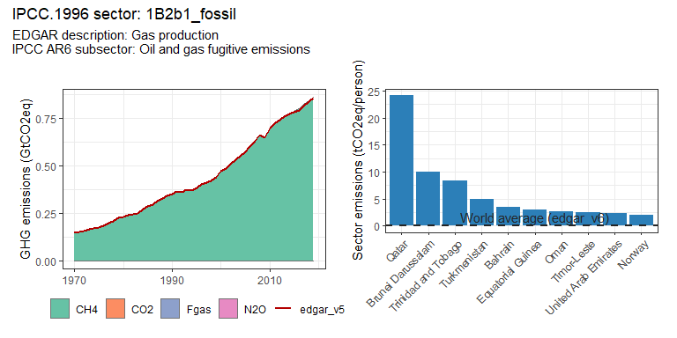 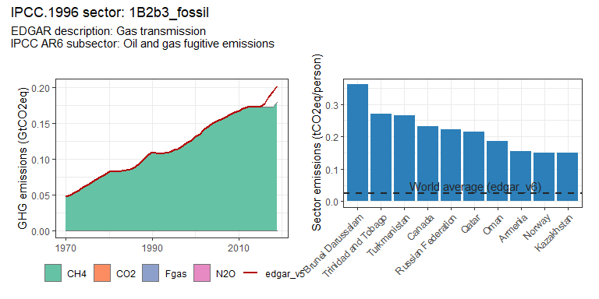 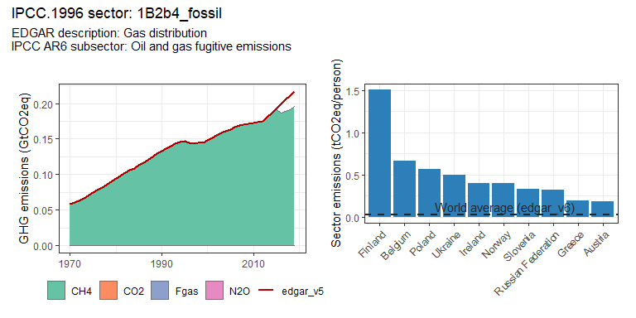 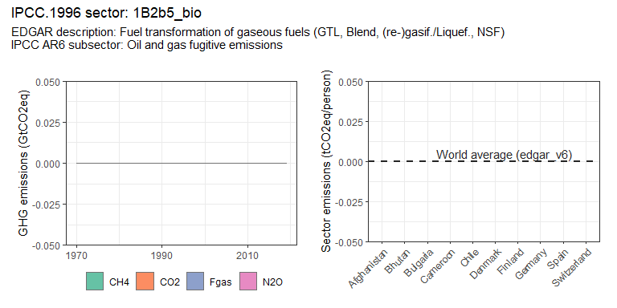 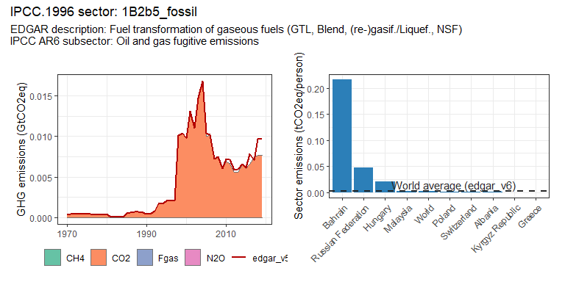 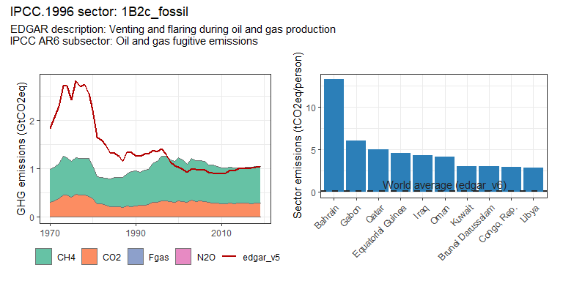 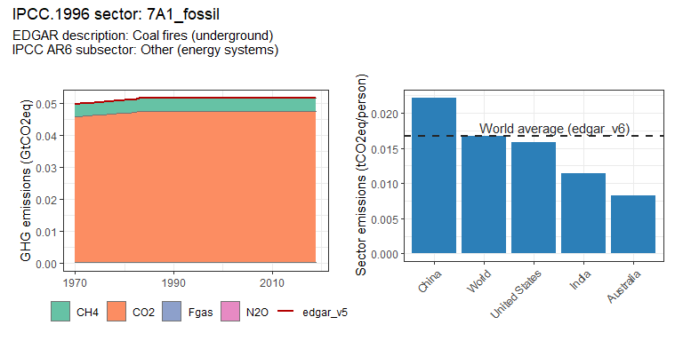

## geom_path: Each group consists of only one observation. Do you need to adjust  
## the group aesthetic?

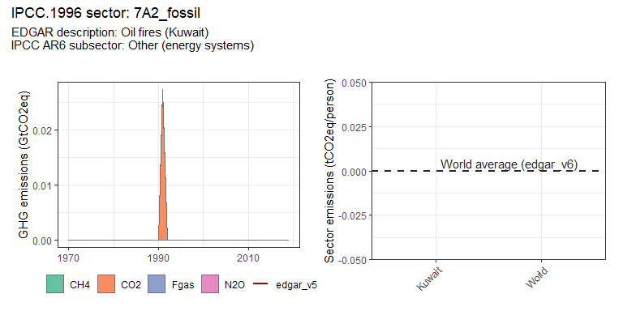 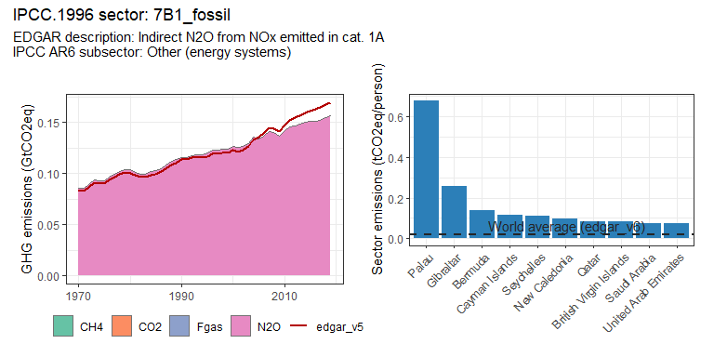 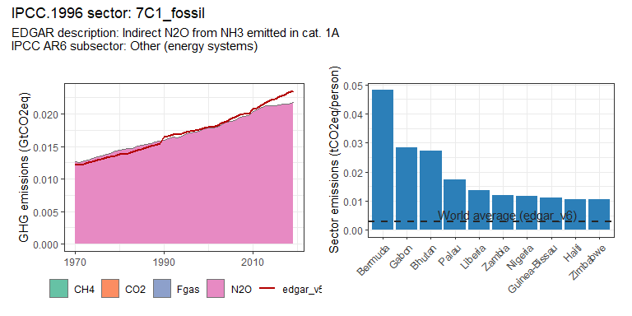

### Industry sectors

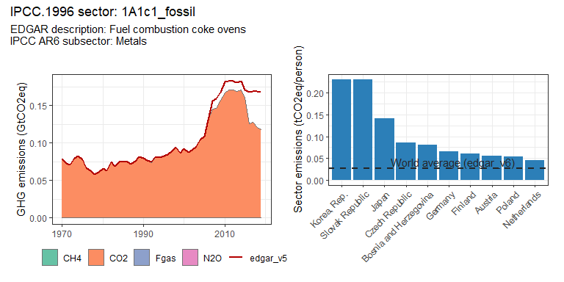 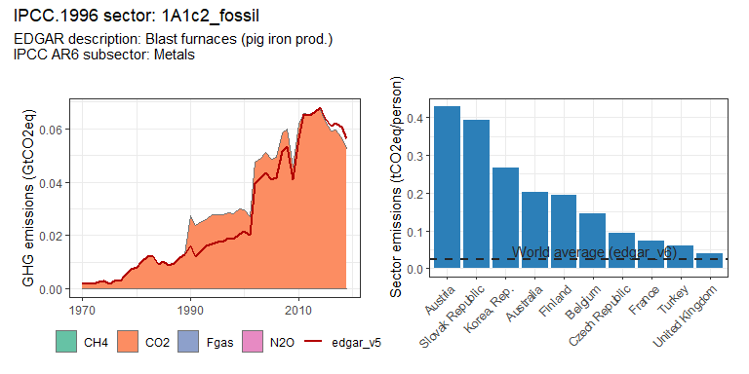 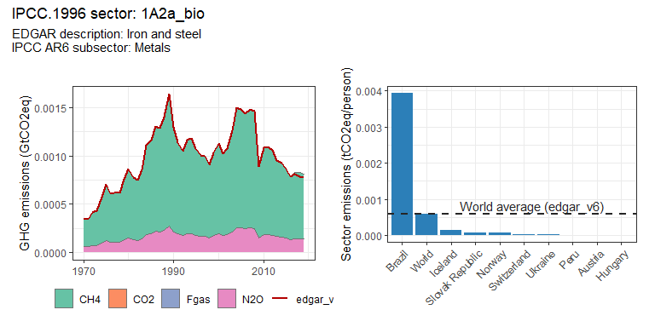 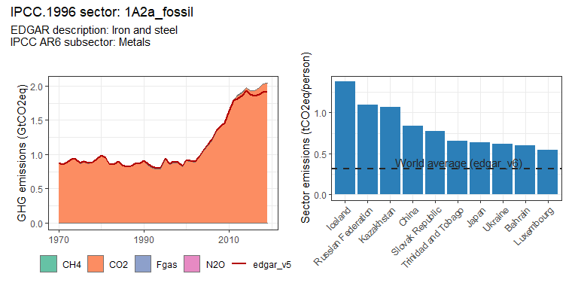 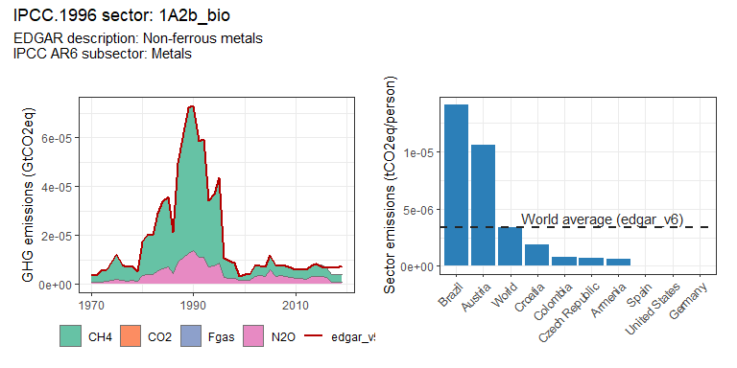 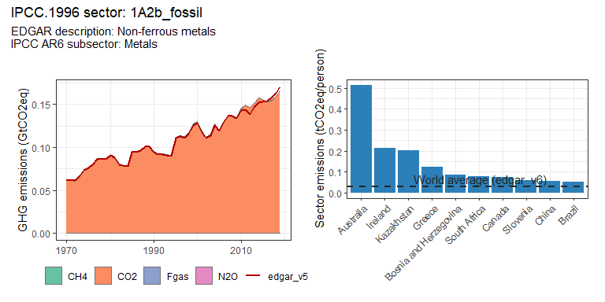 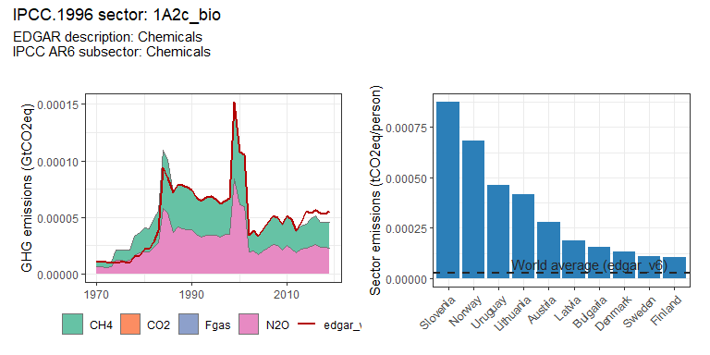 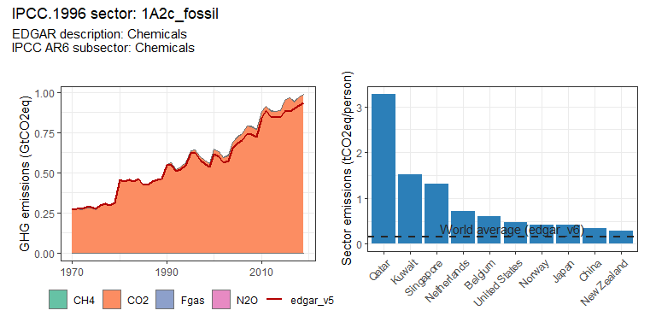 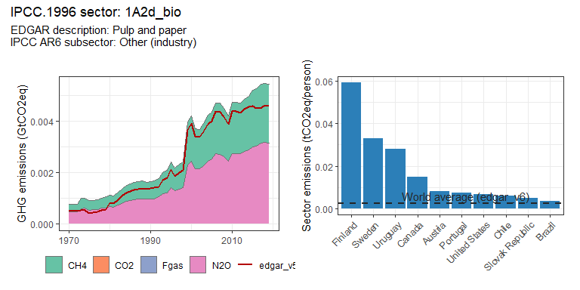 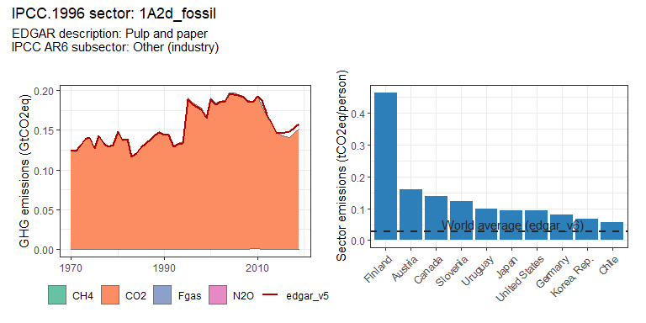 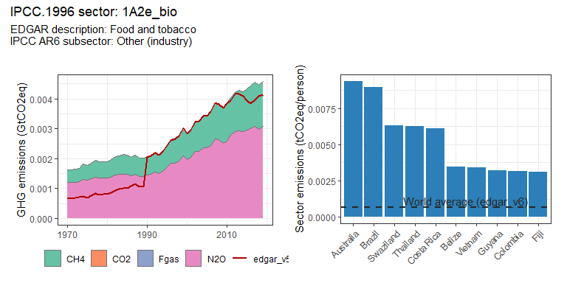 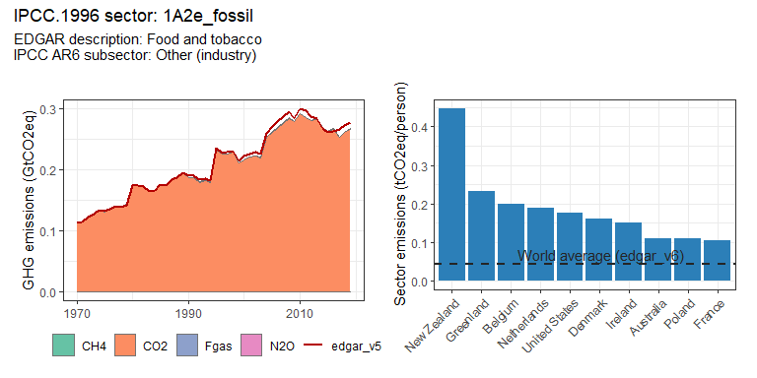 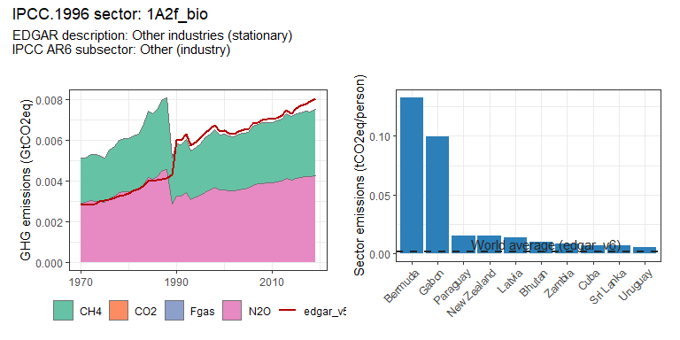 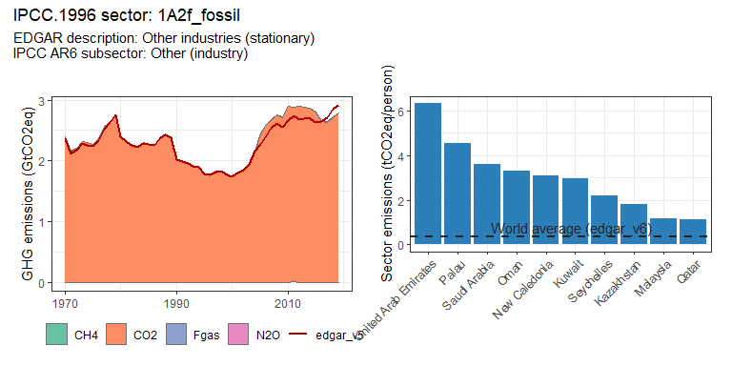 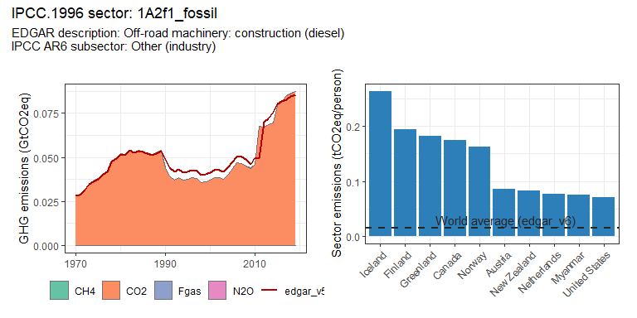 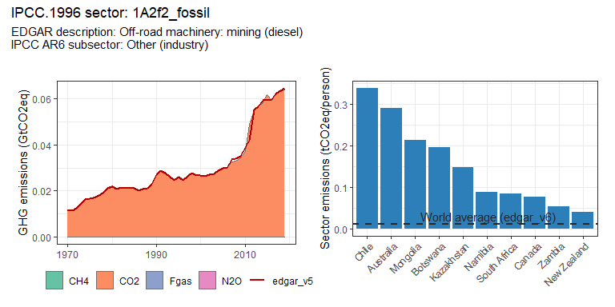 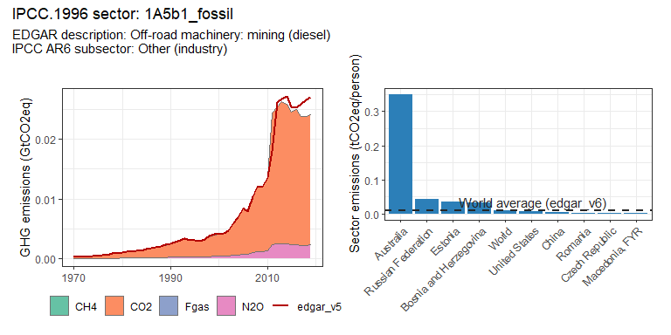 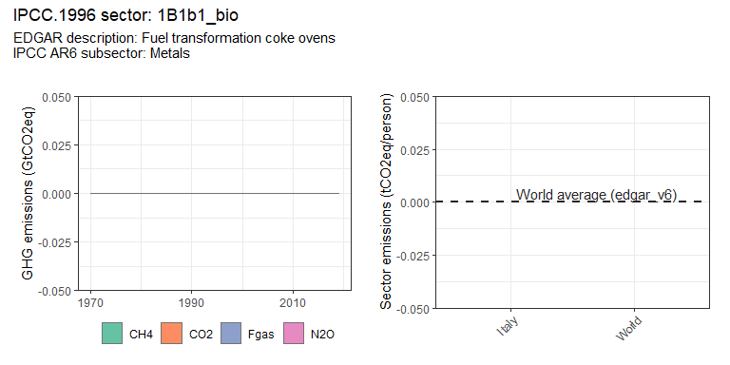 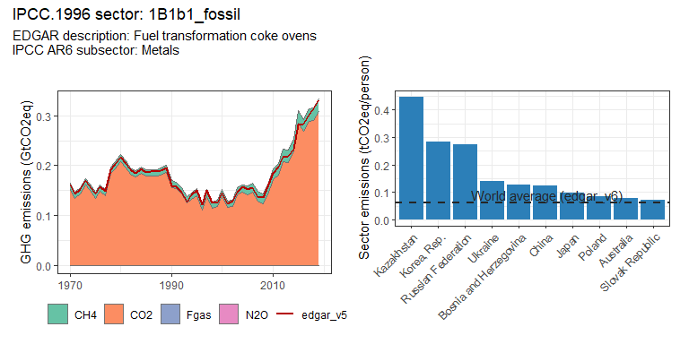 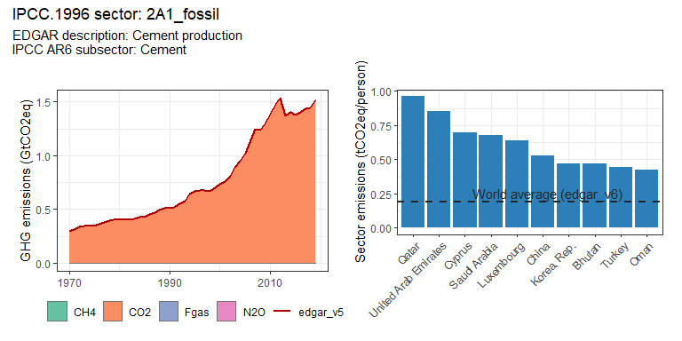 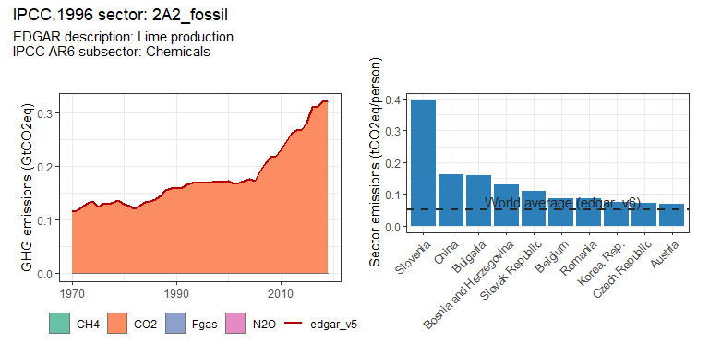 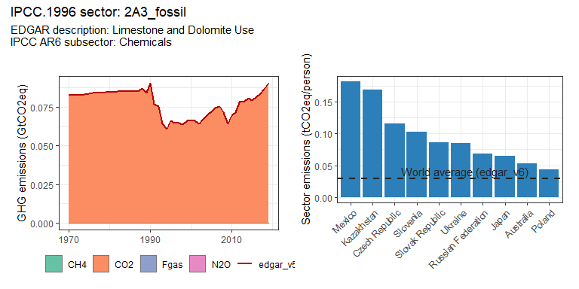 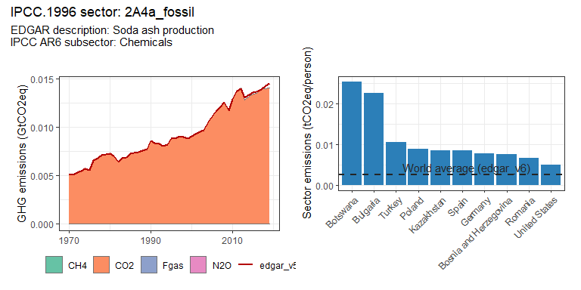 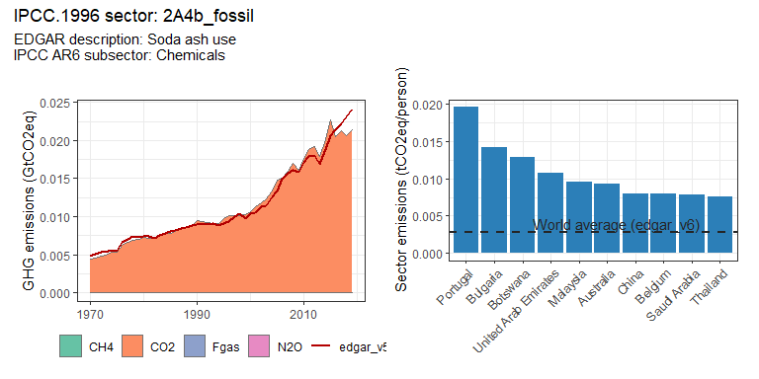 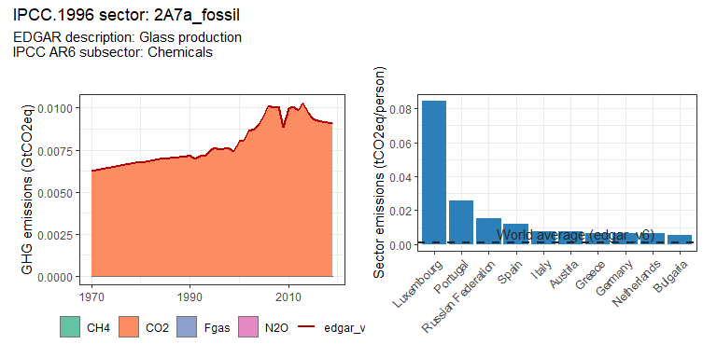 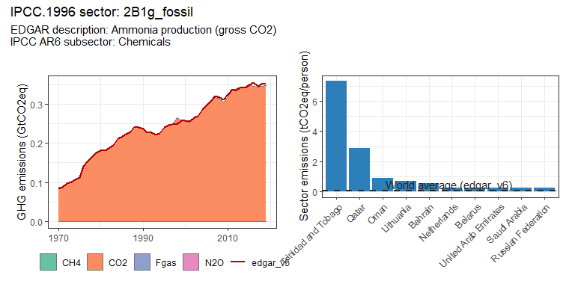 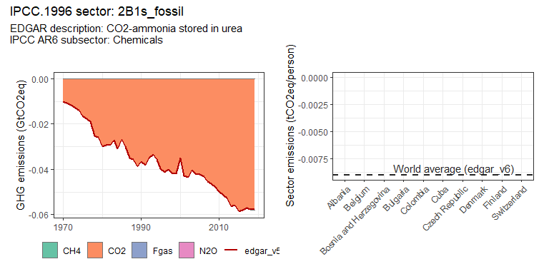 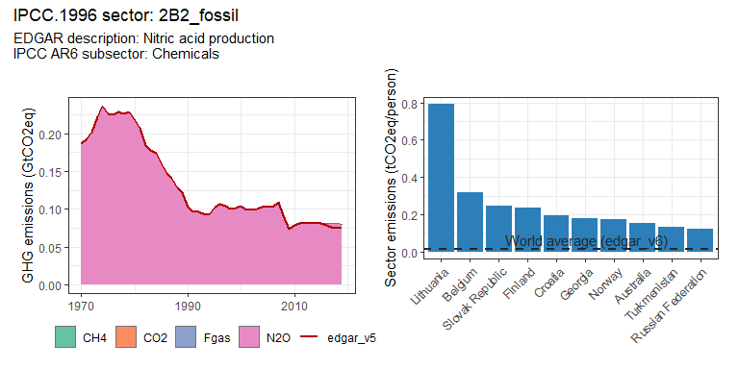 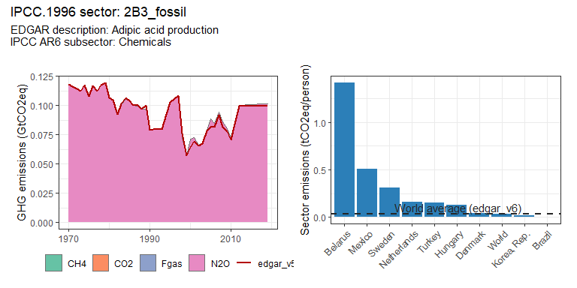 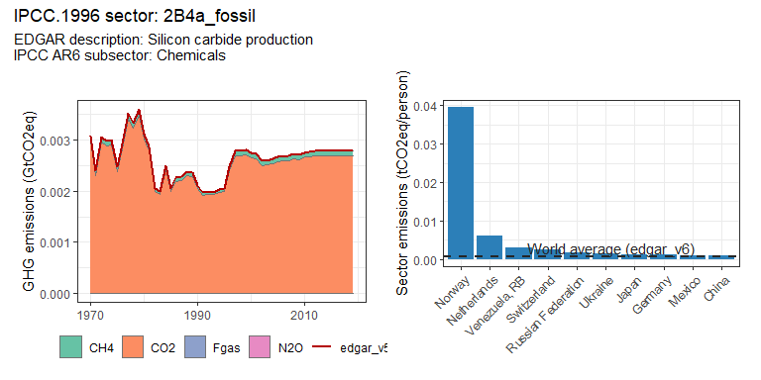 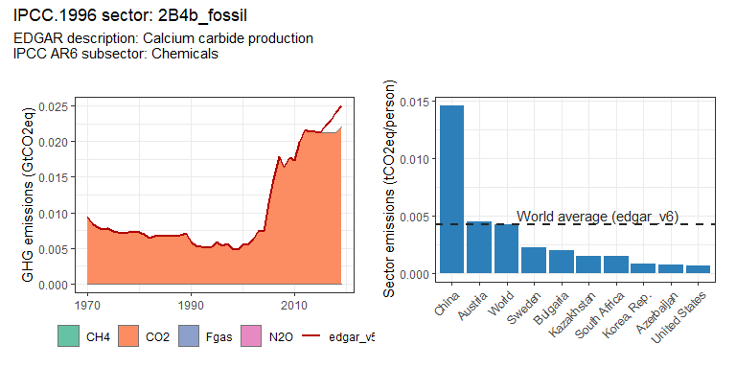 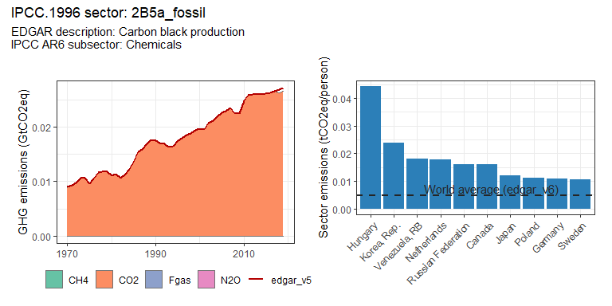 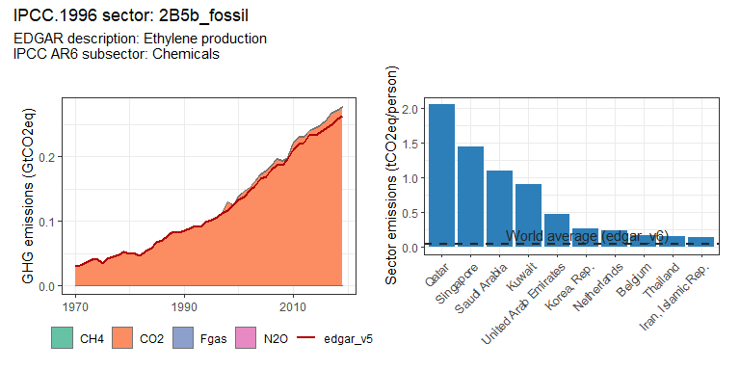 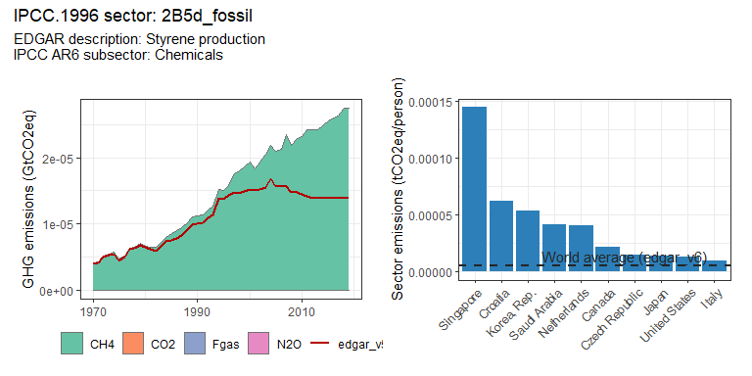 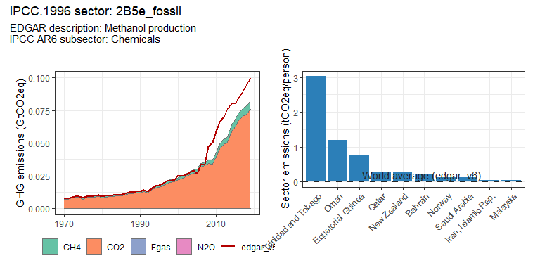 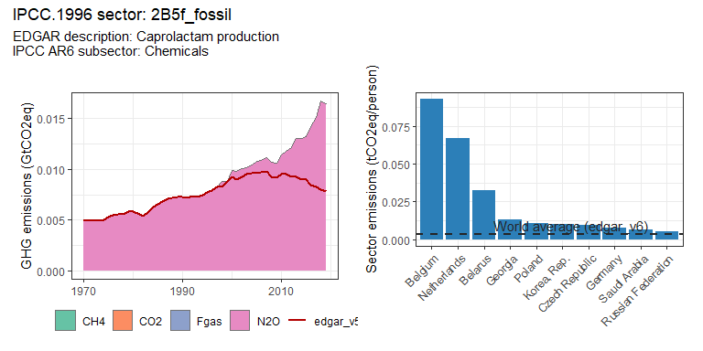 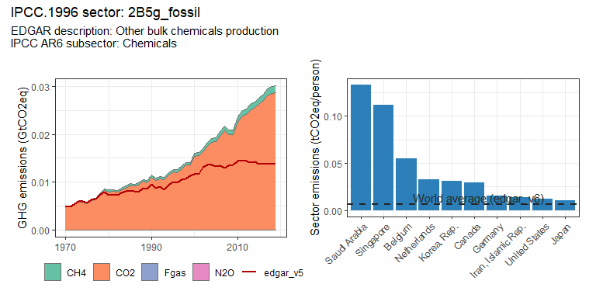 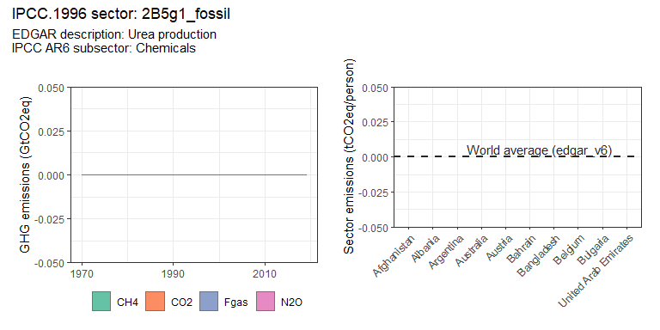 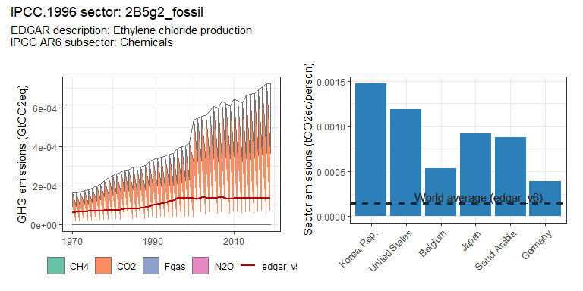 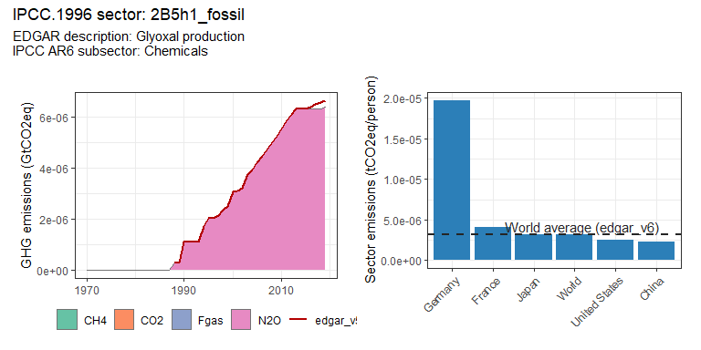 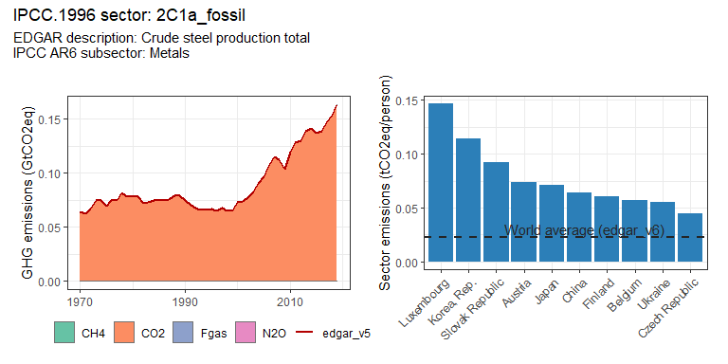 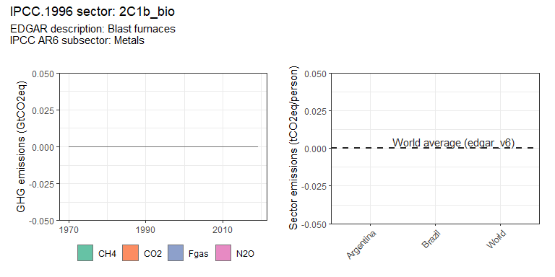 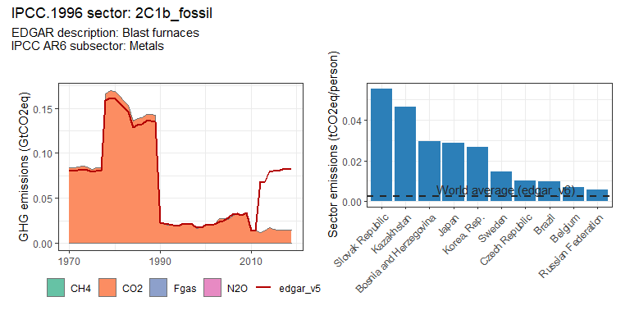 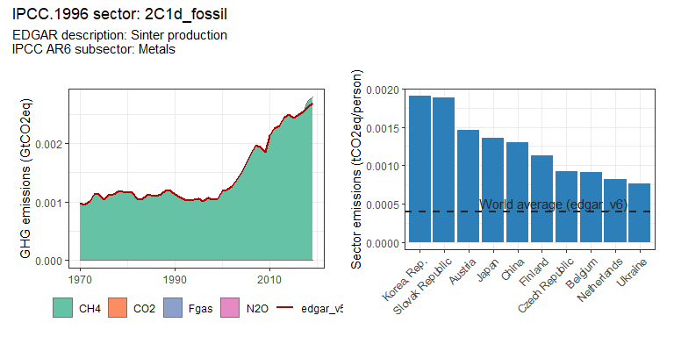 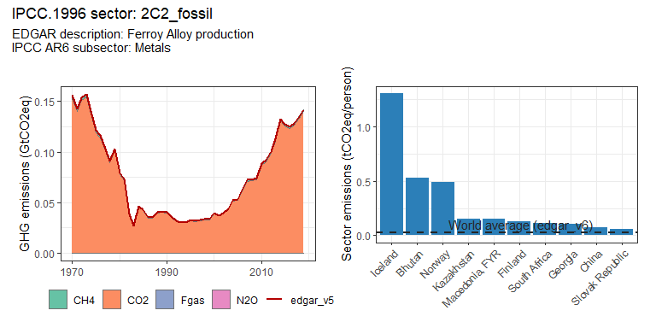 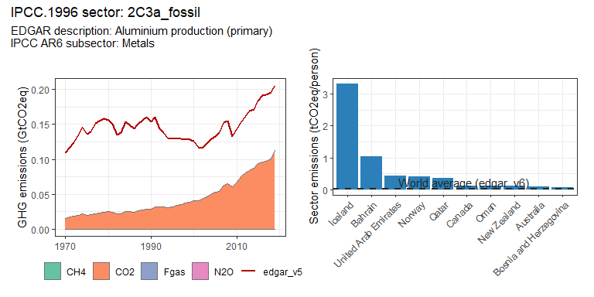 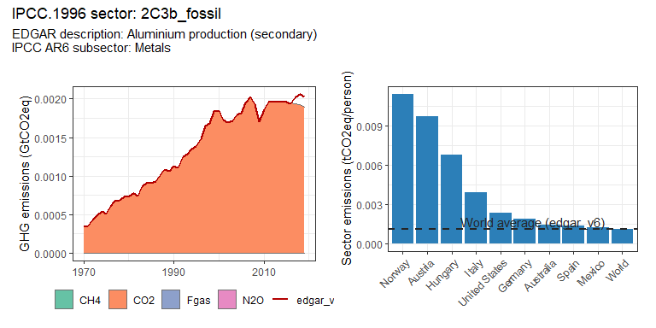 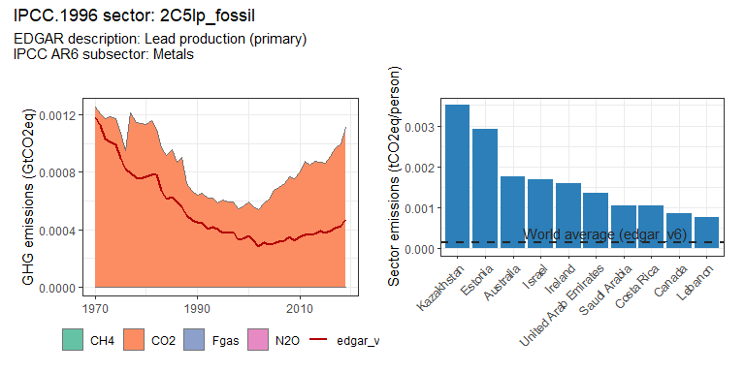 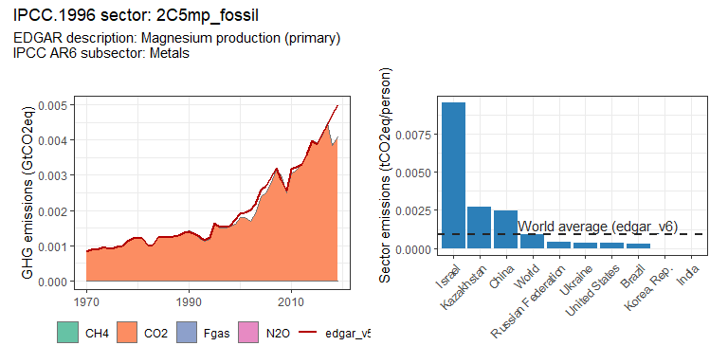 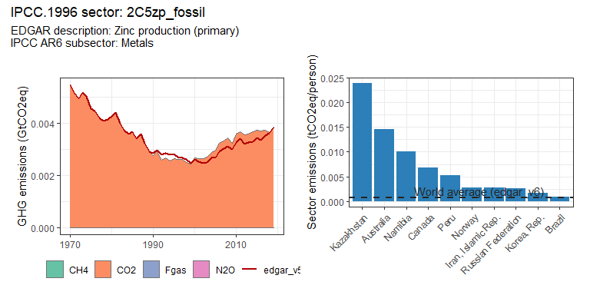 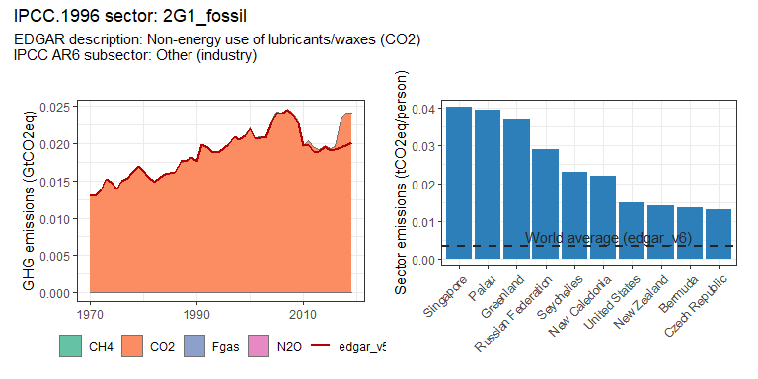 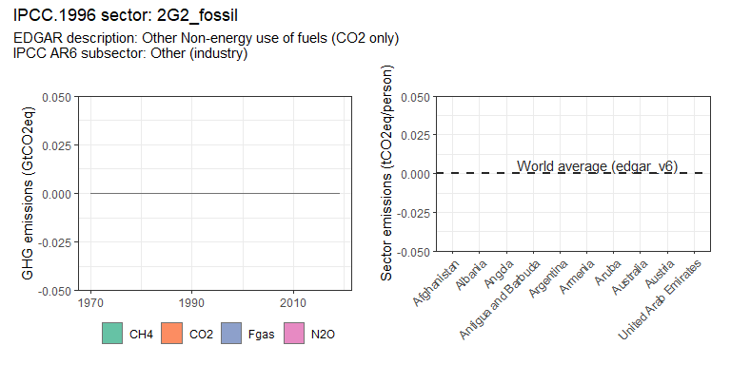 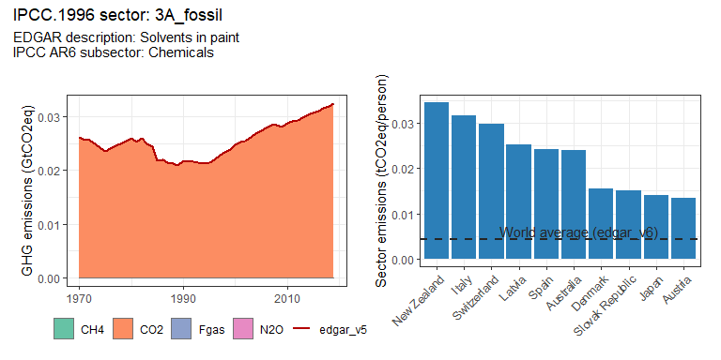 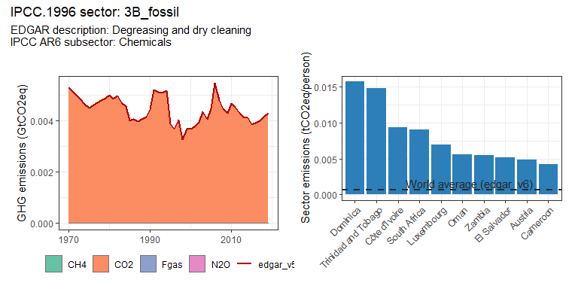 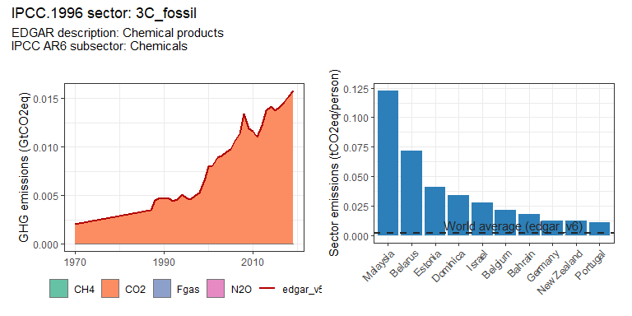 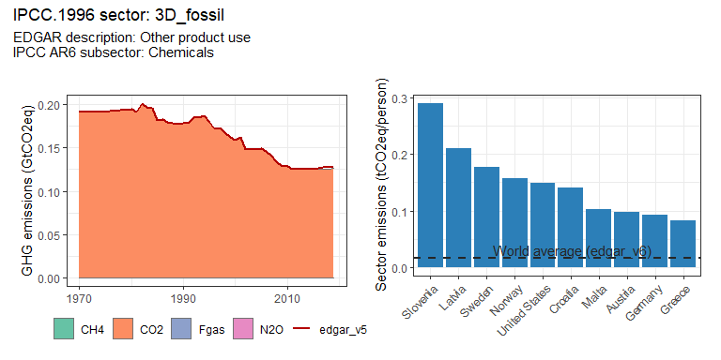 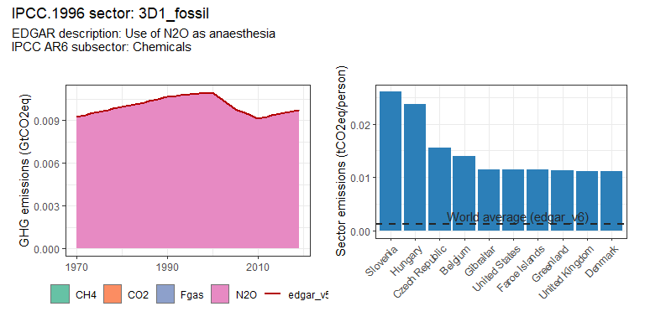 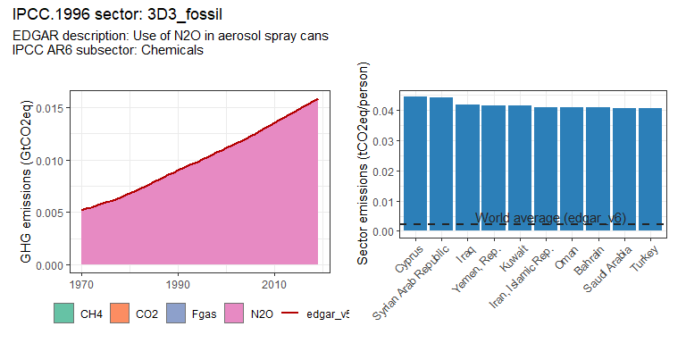 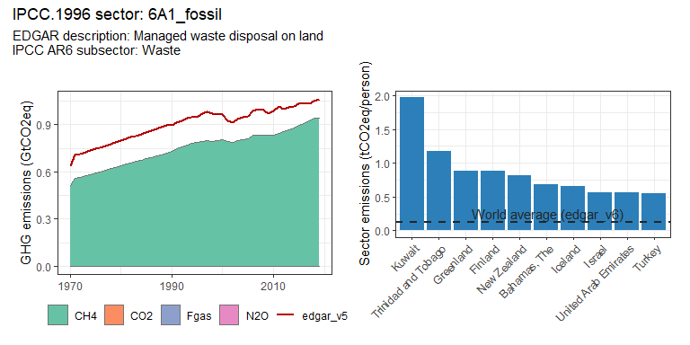 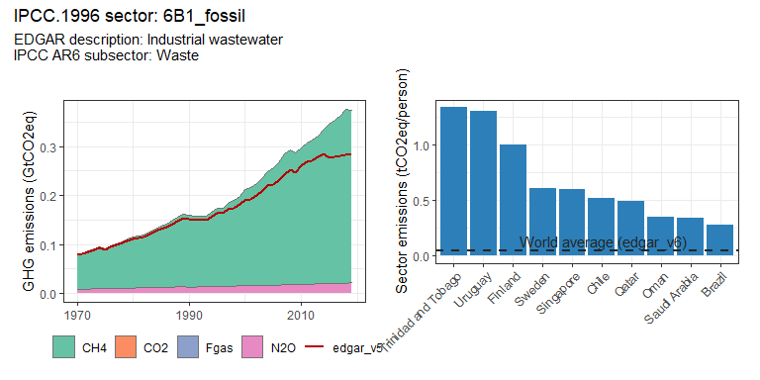 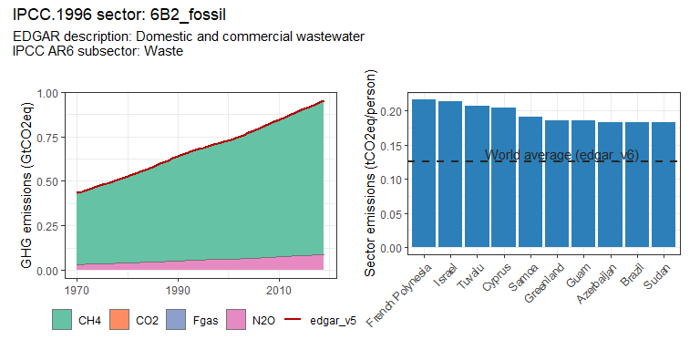 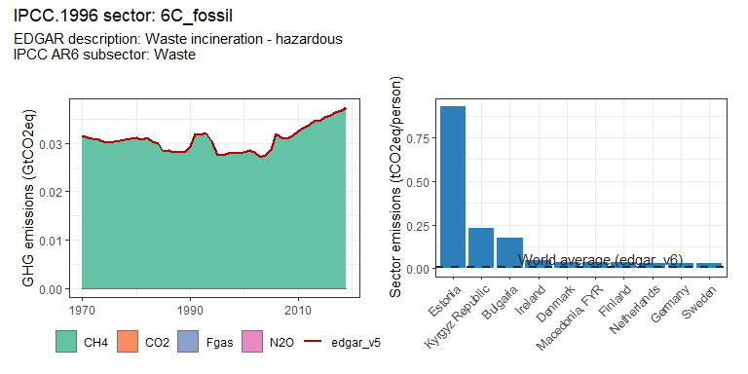 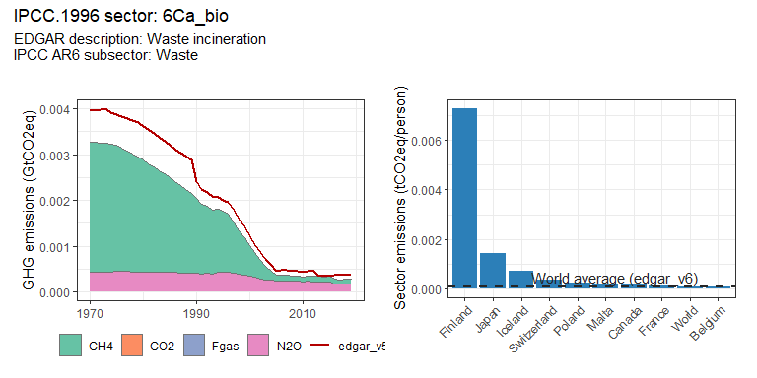 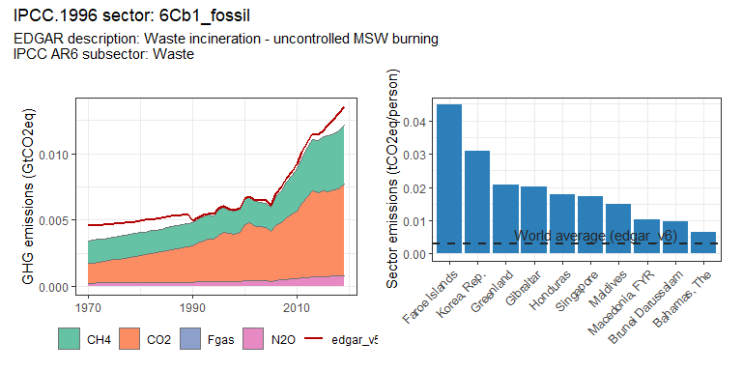 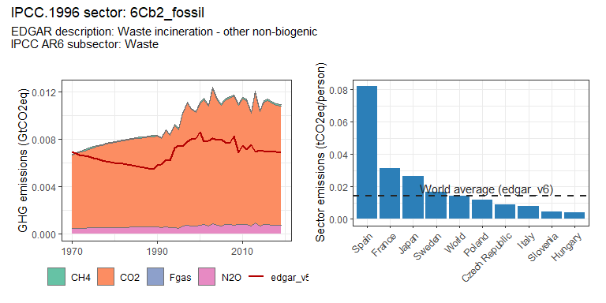 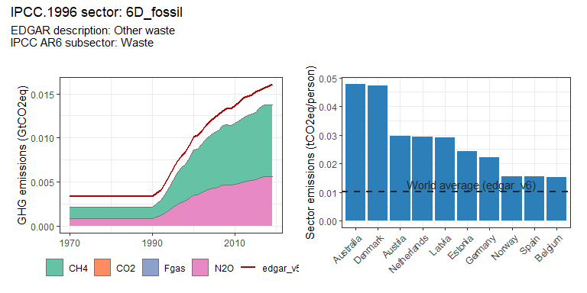 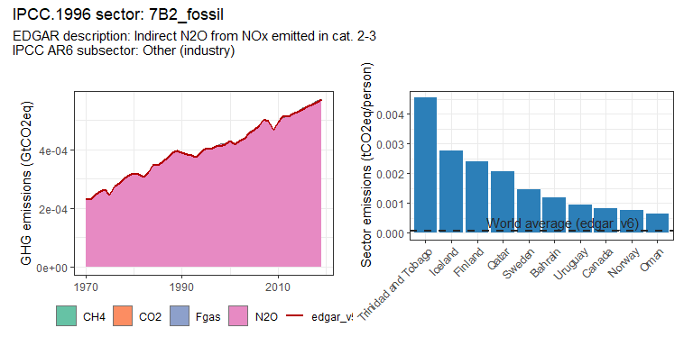 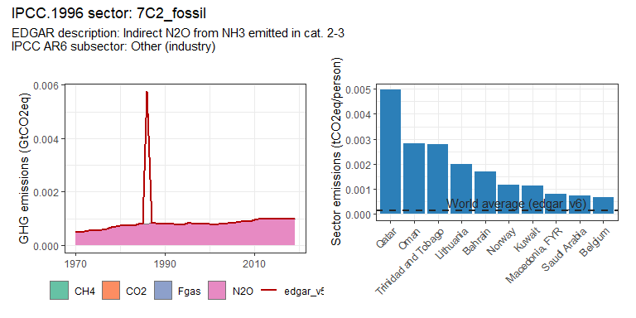 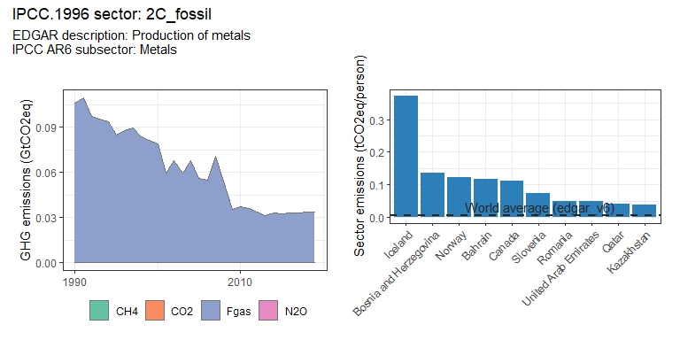 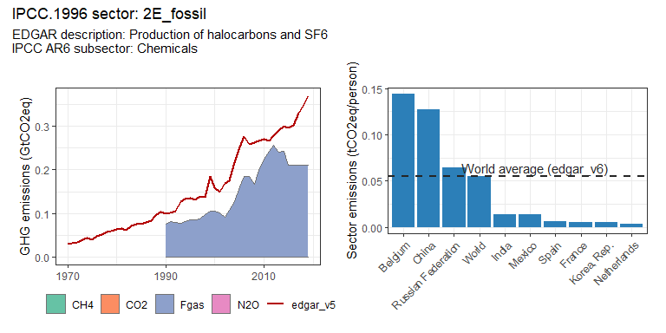 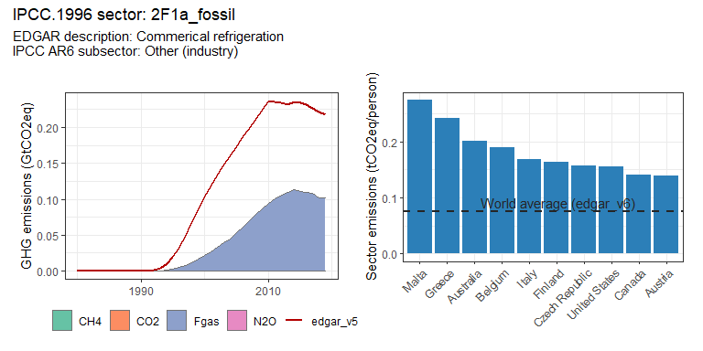 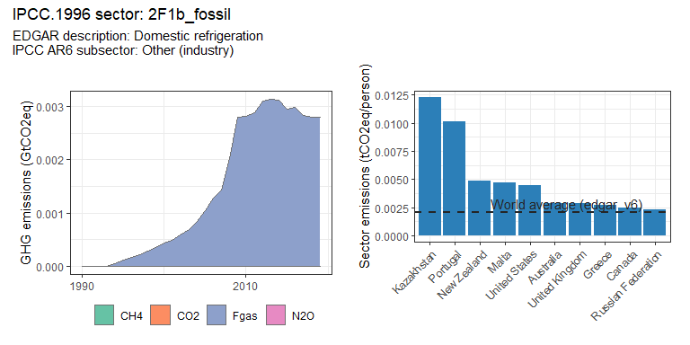 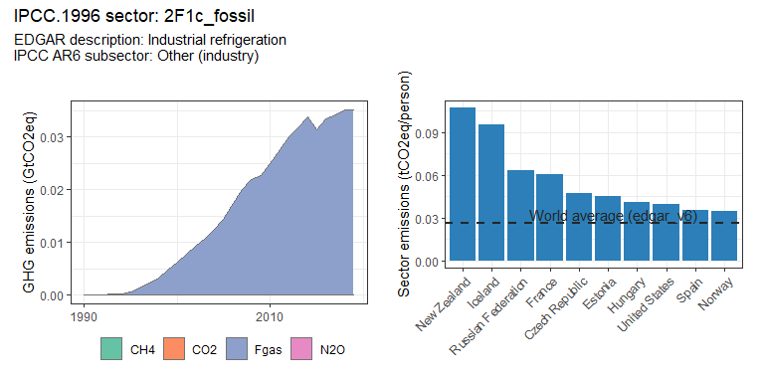 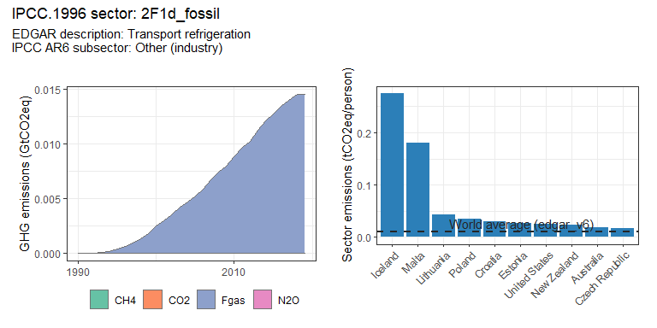 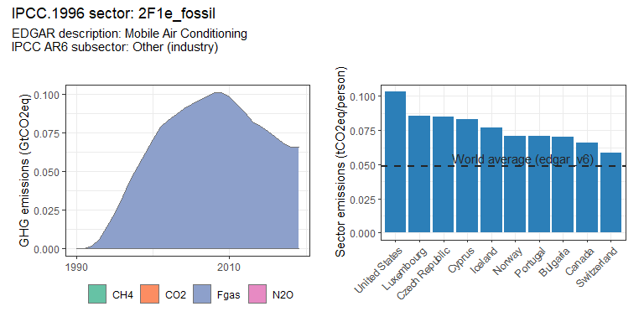 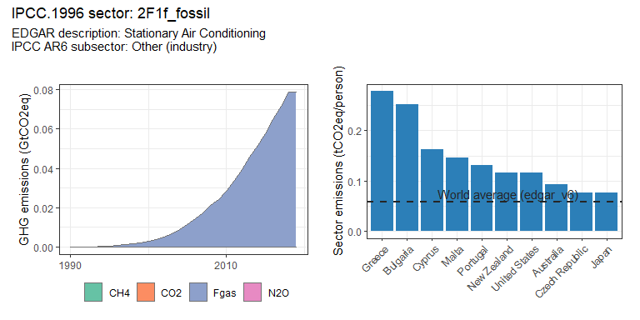 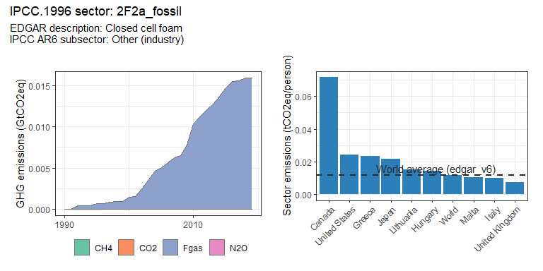 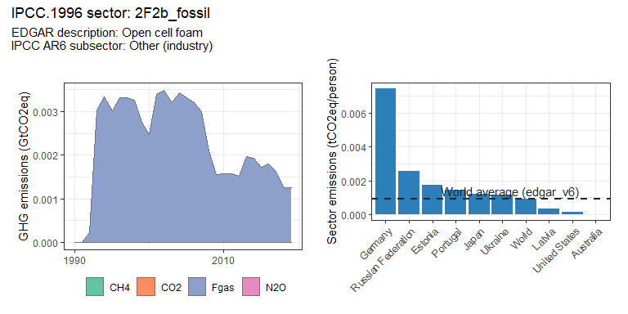 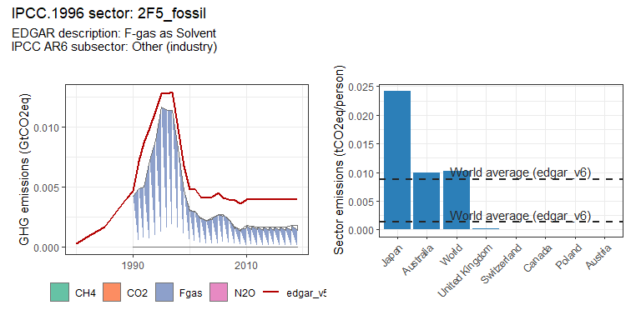 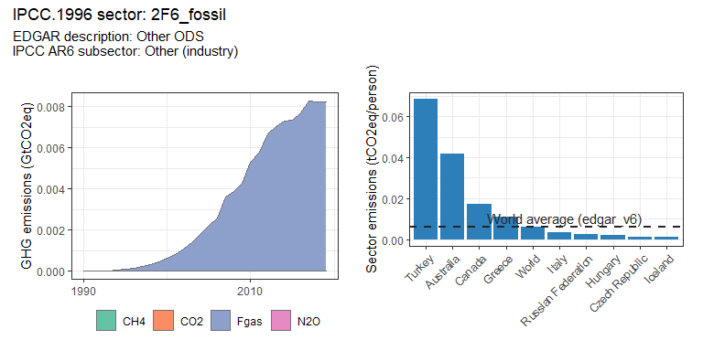 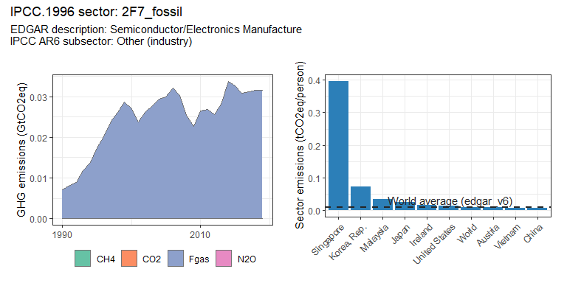 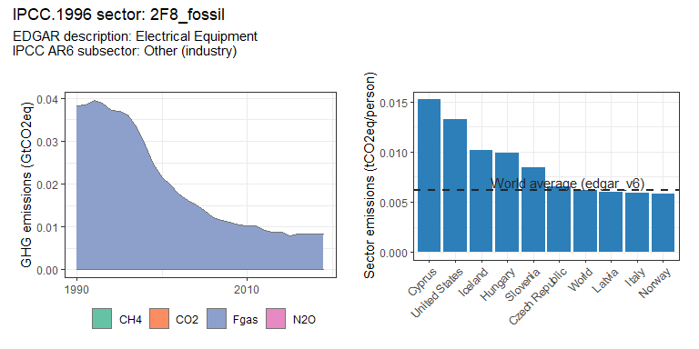 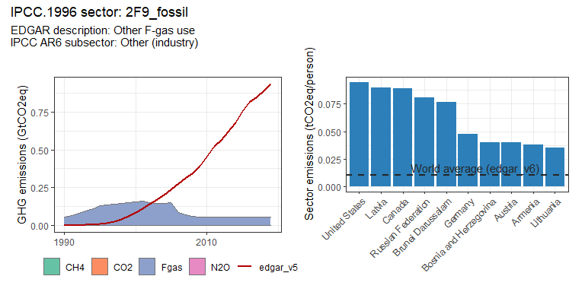

### Transport sectors

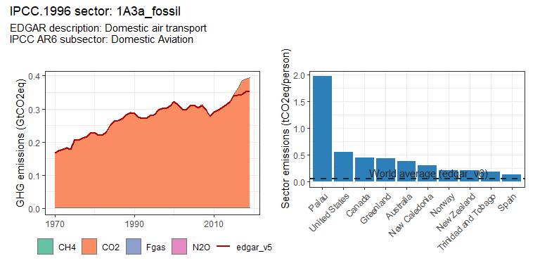 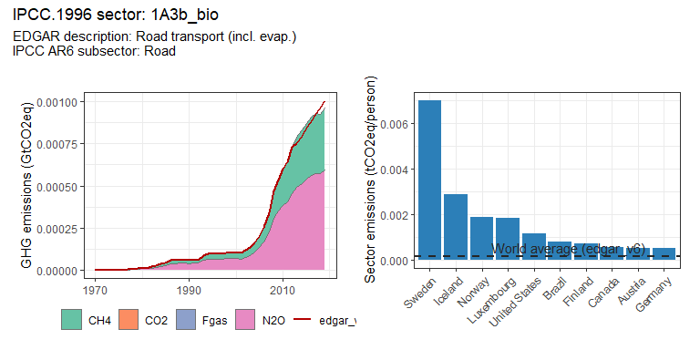 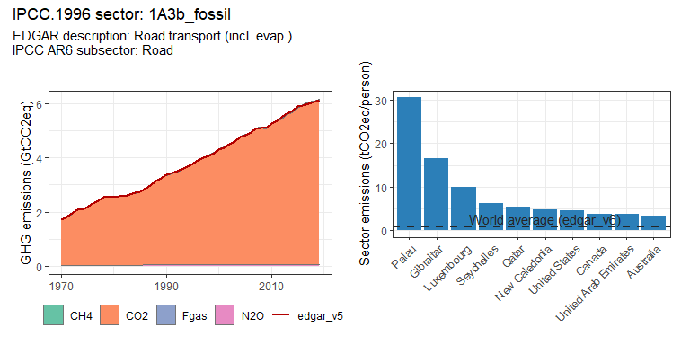 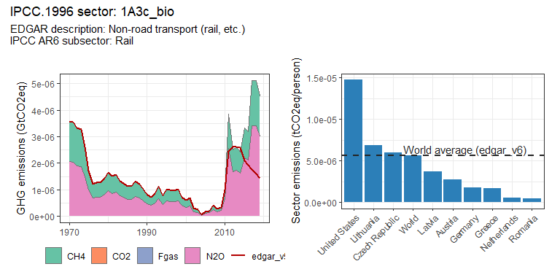 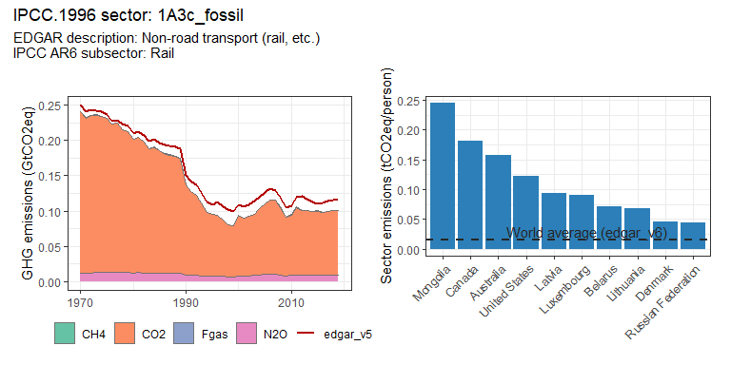 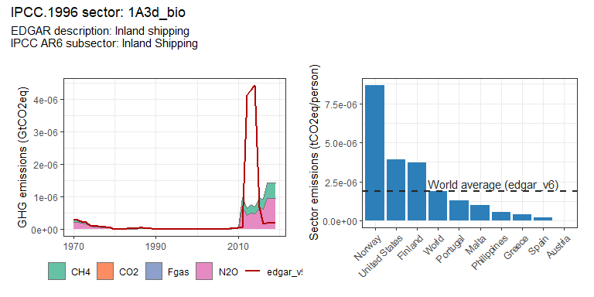 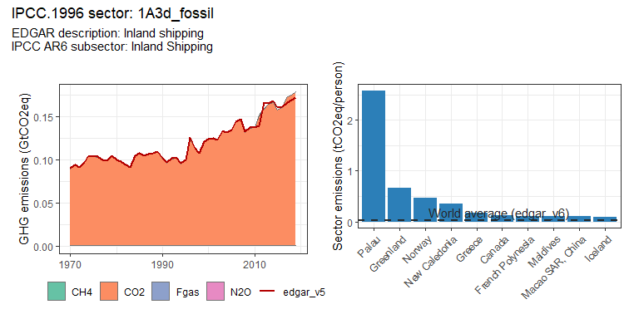 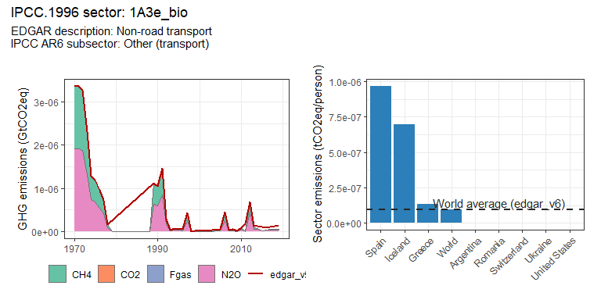 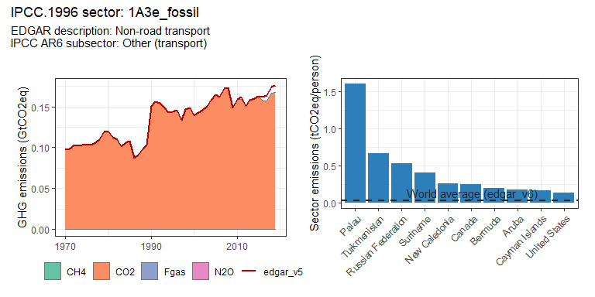 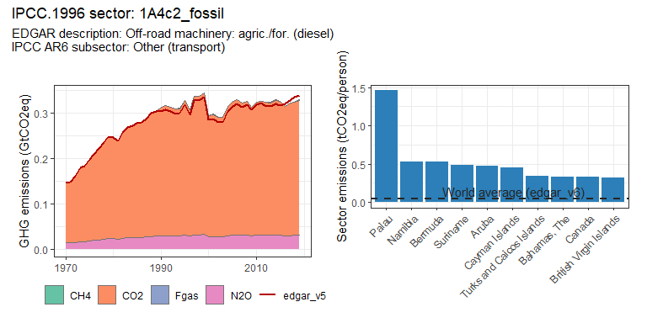 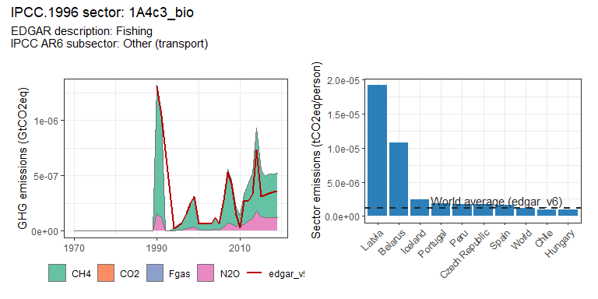 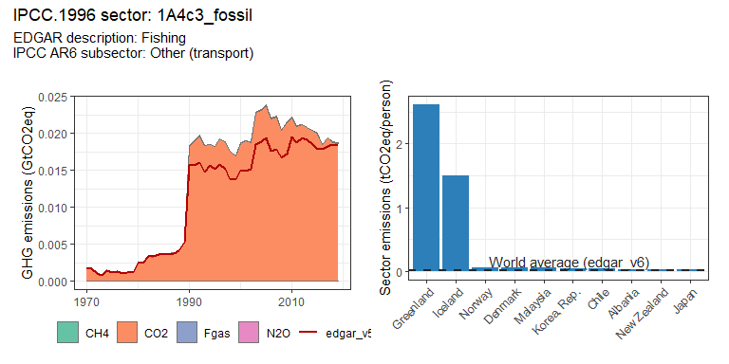 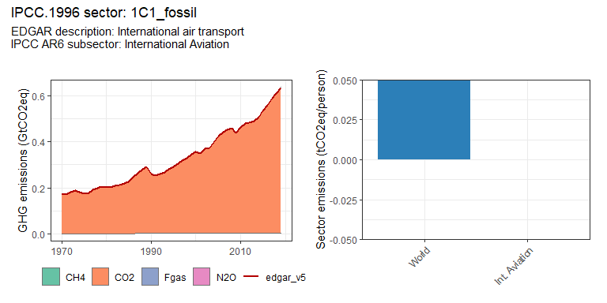 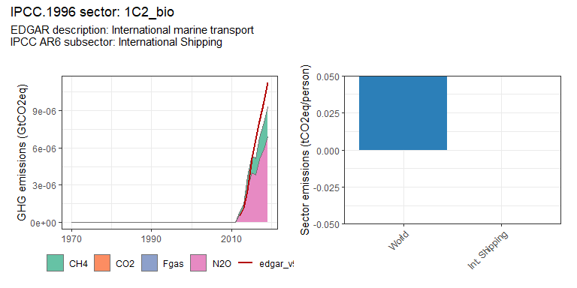 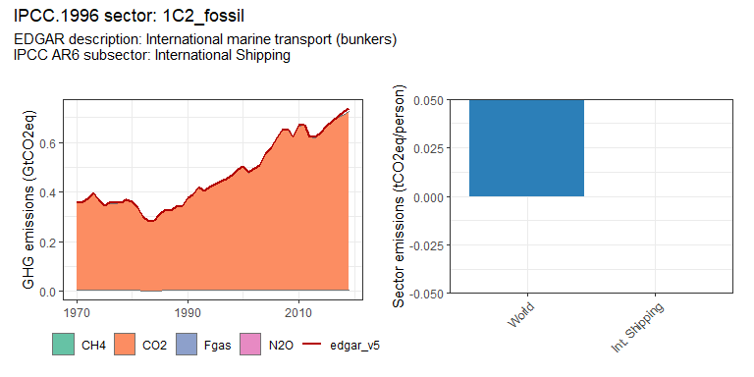 # Region trends

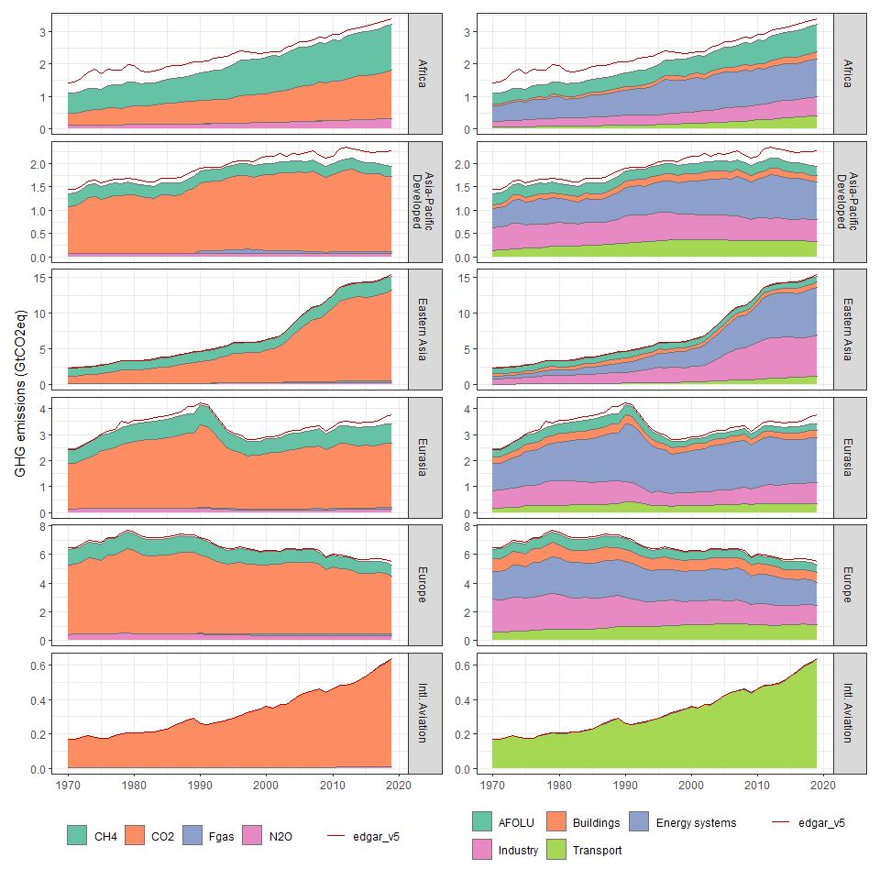 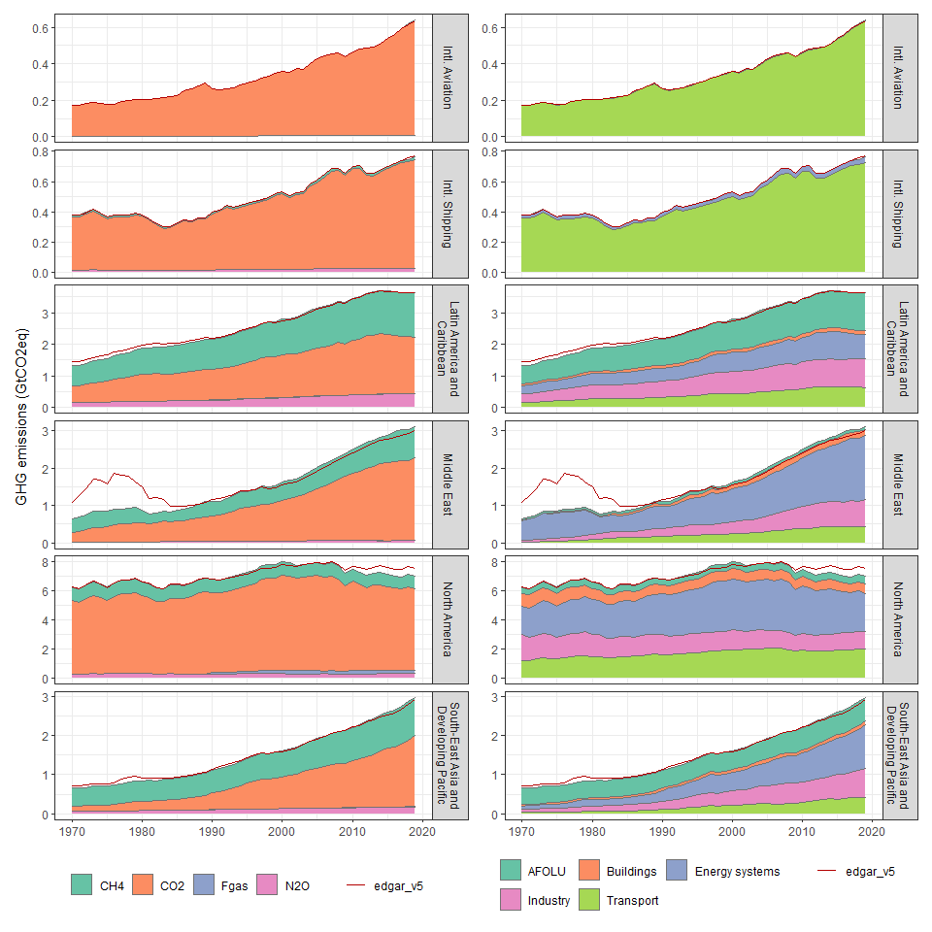

# Country trends

### Afghanistan

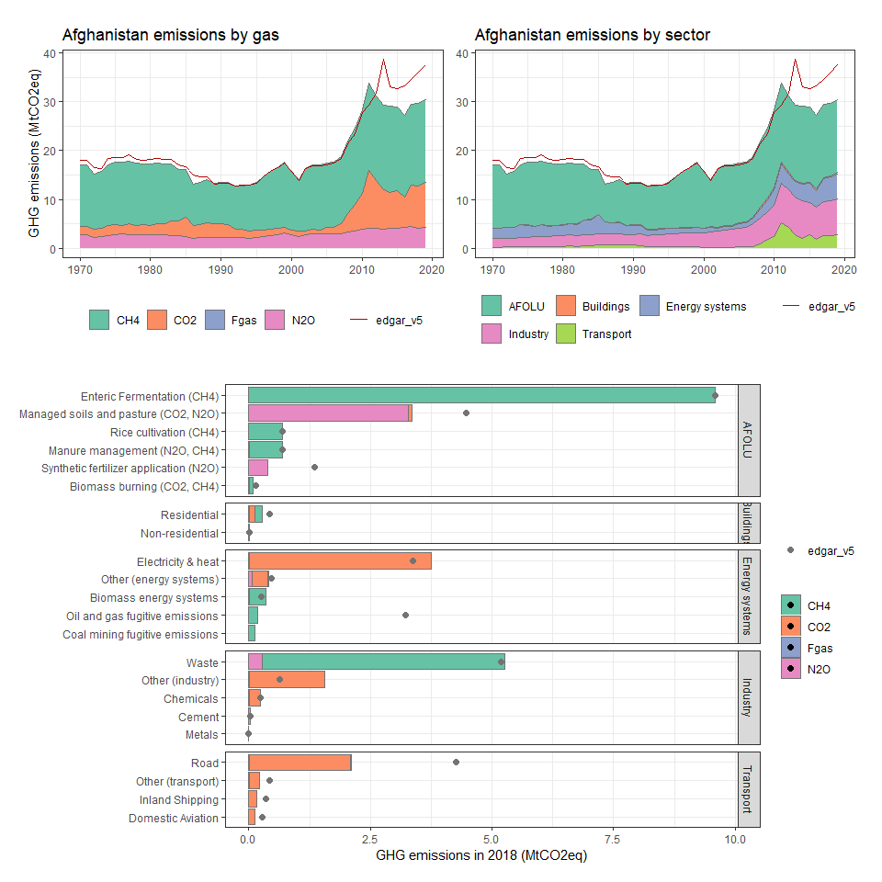

### Albania

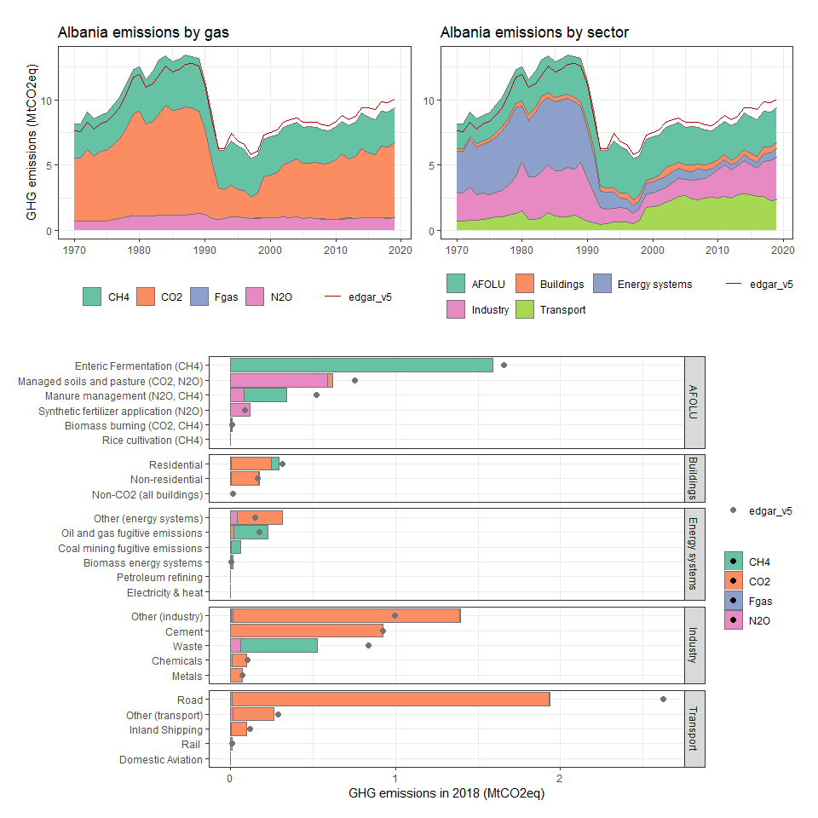

### Algeria

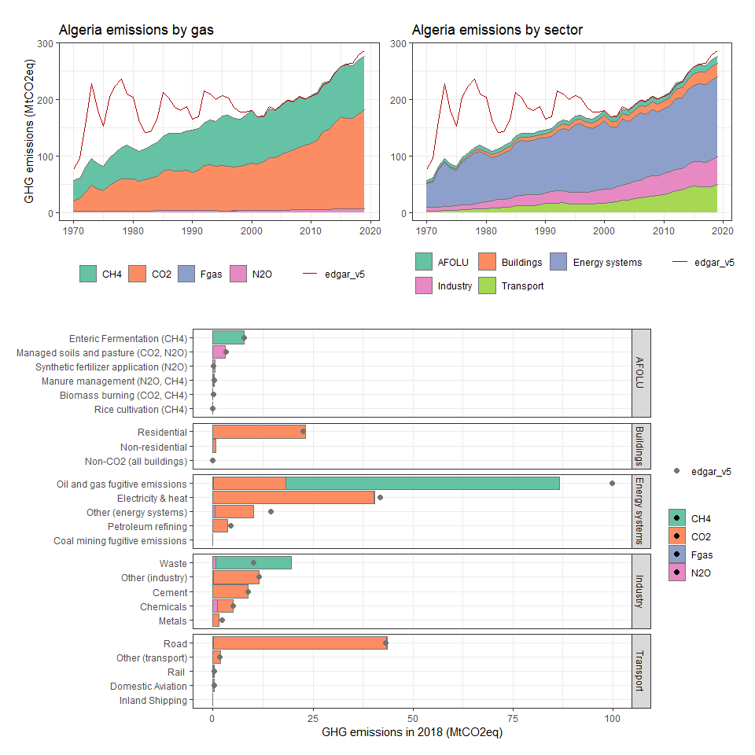

### American Samoa

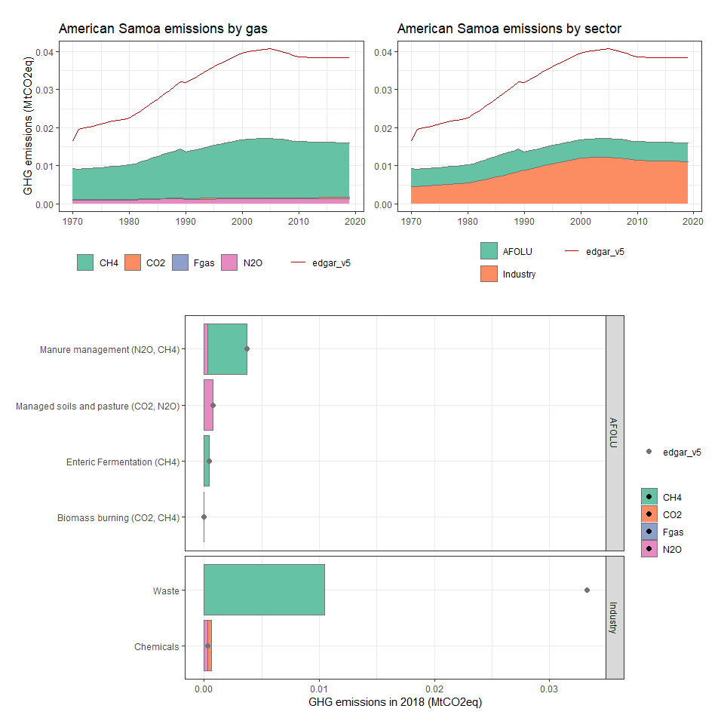

### Angola

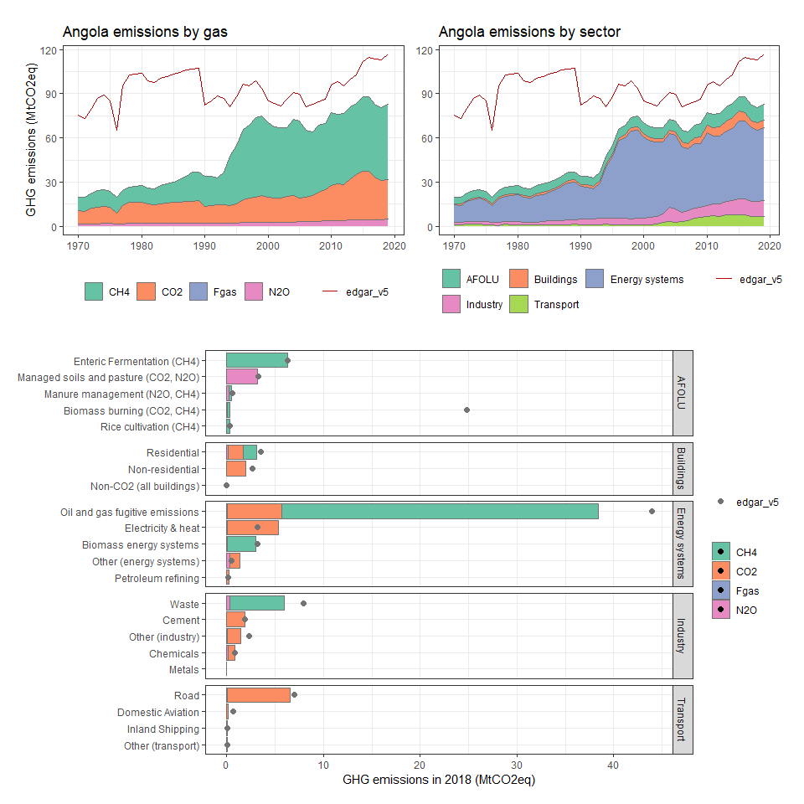

### Anguilla

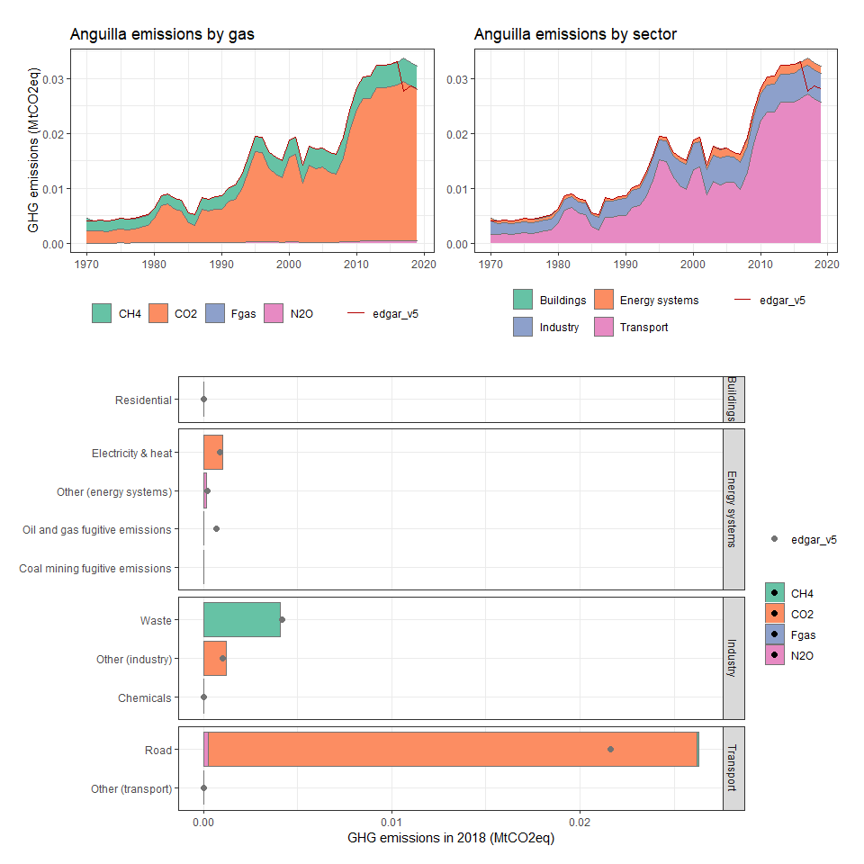

### Antigua and Barbuda

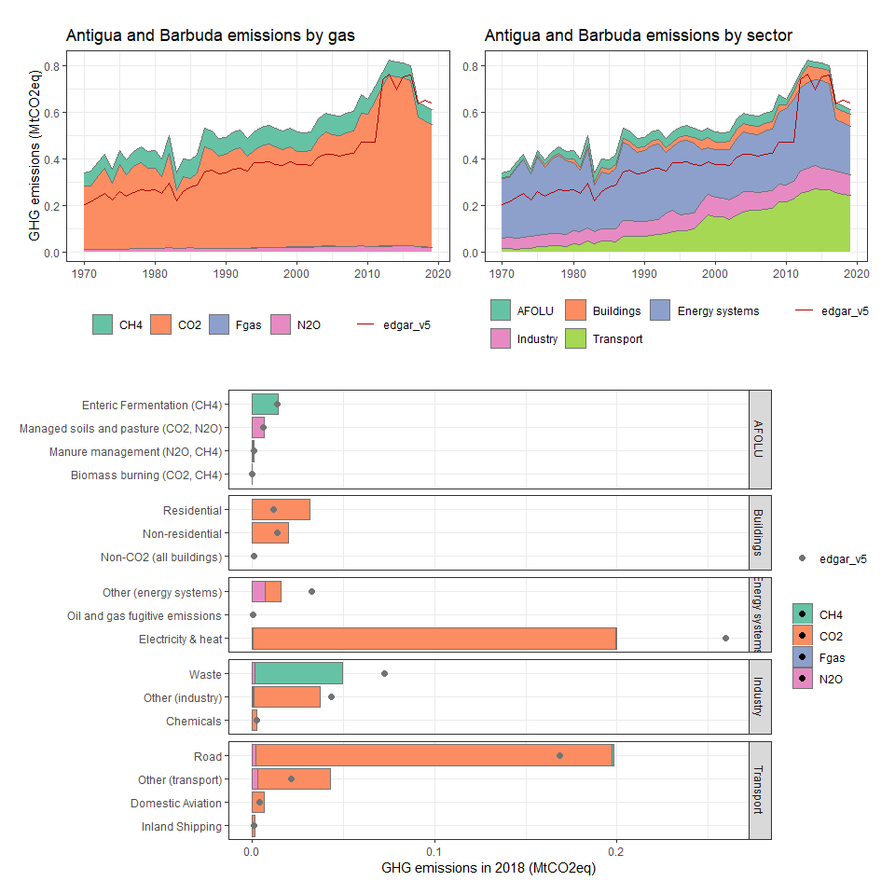

### Argentina

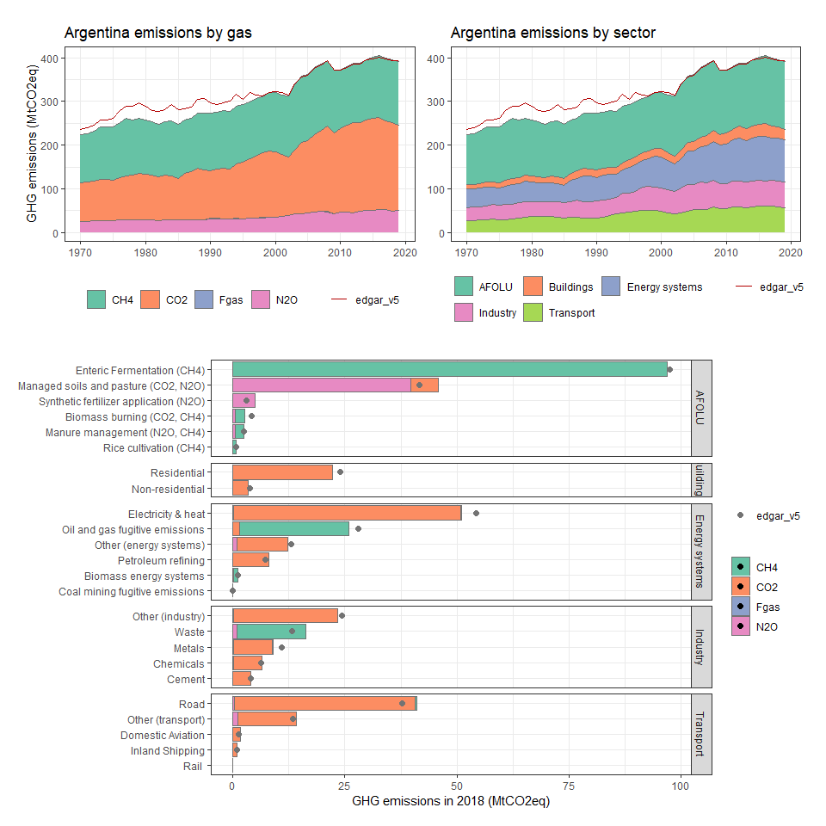

### Armenia

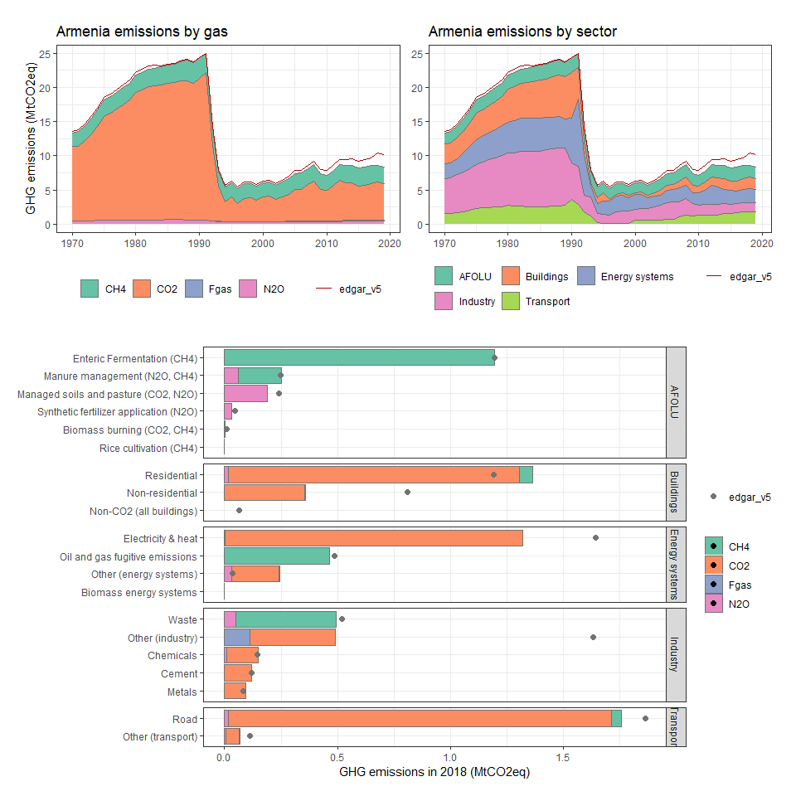

### Aruba

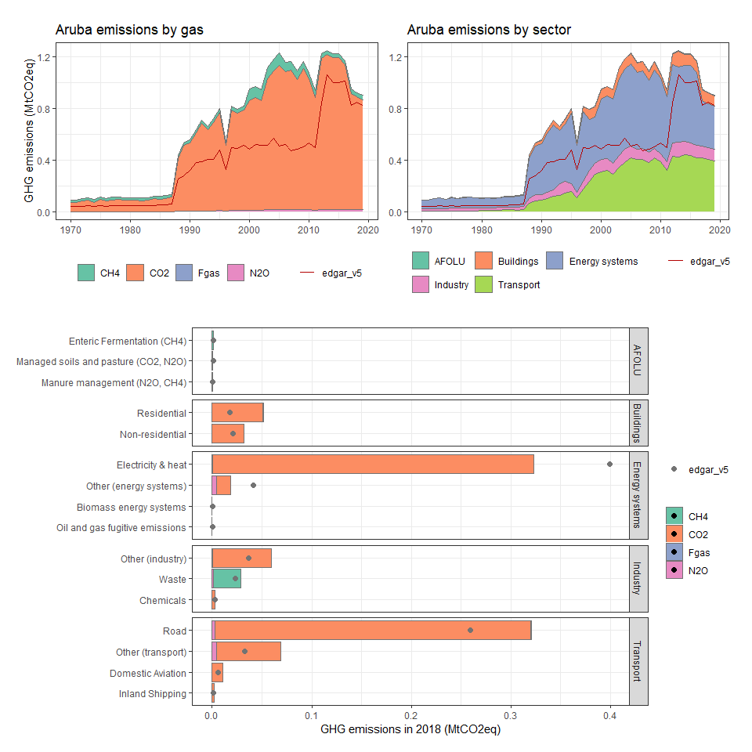

### Australia

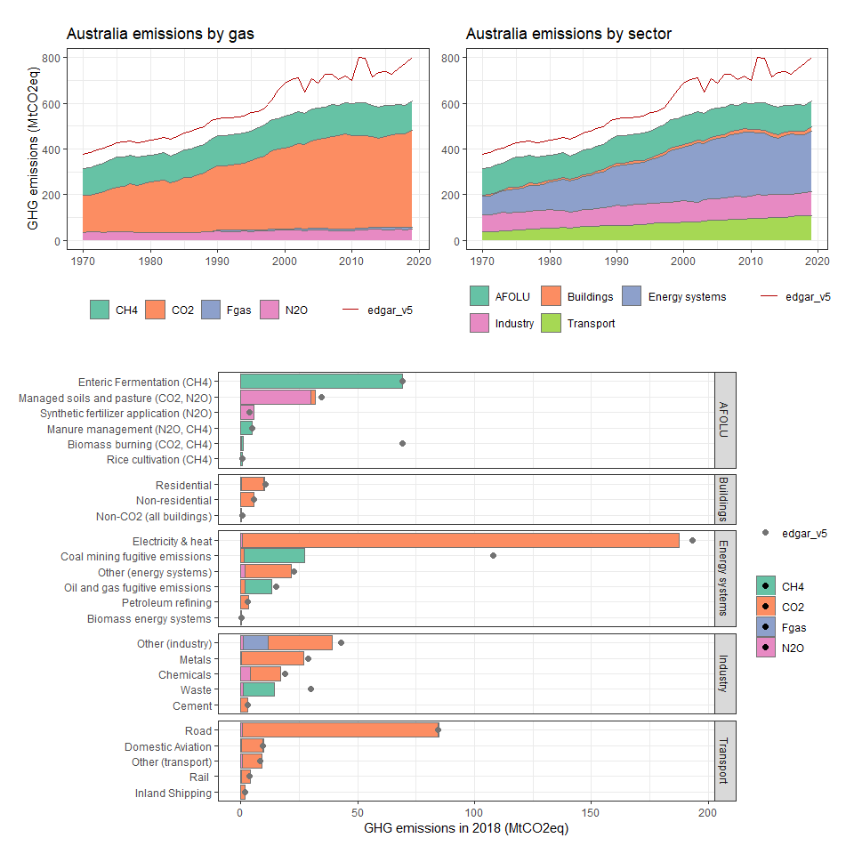

### Austria

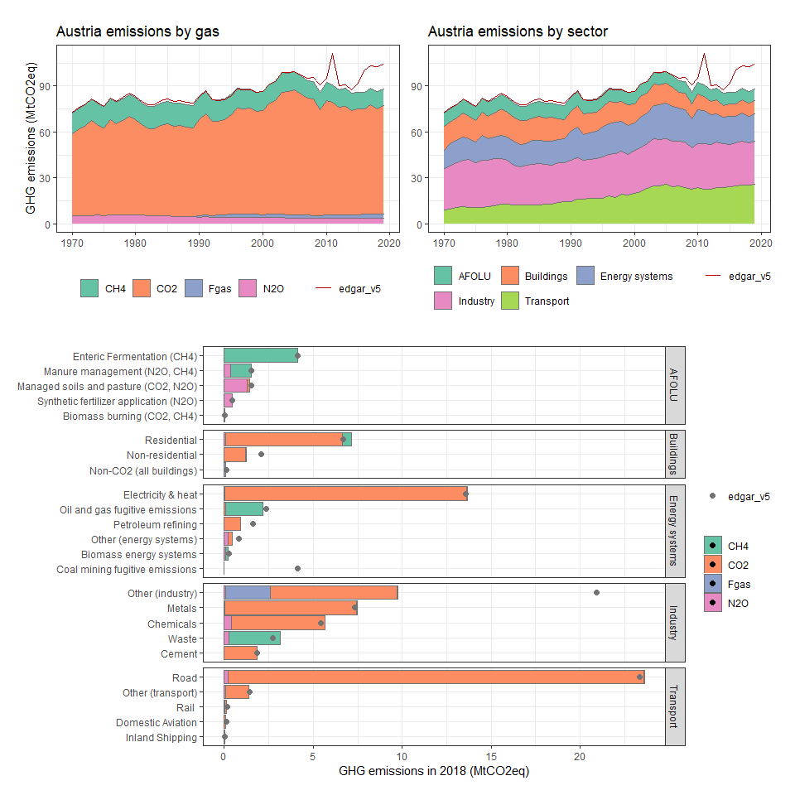

### Azerbaijan

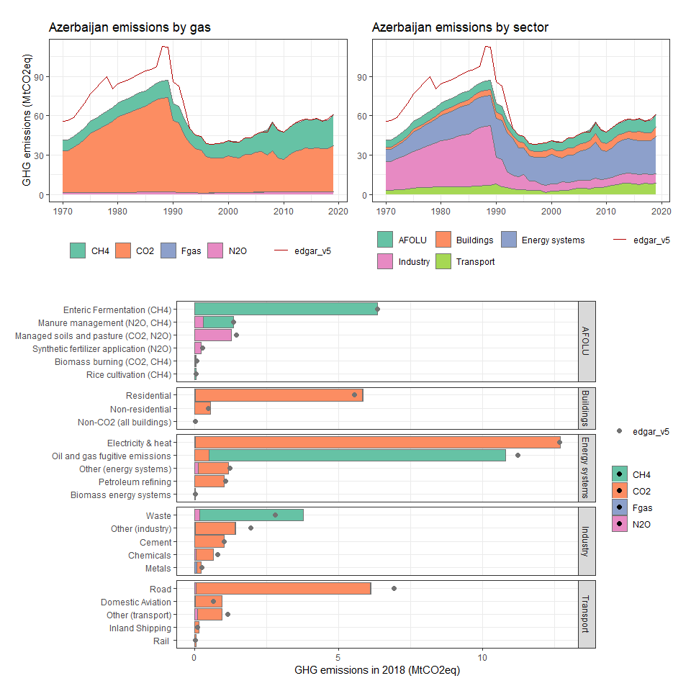

### Bahamas, The

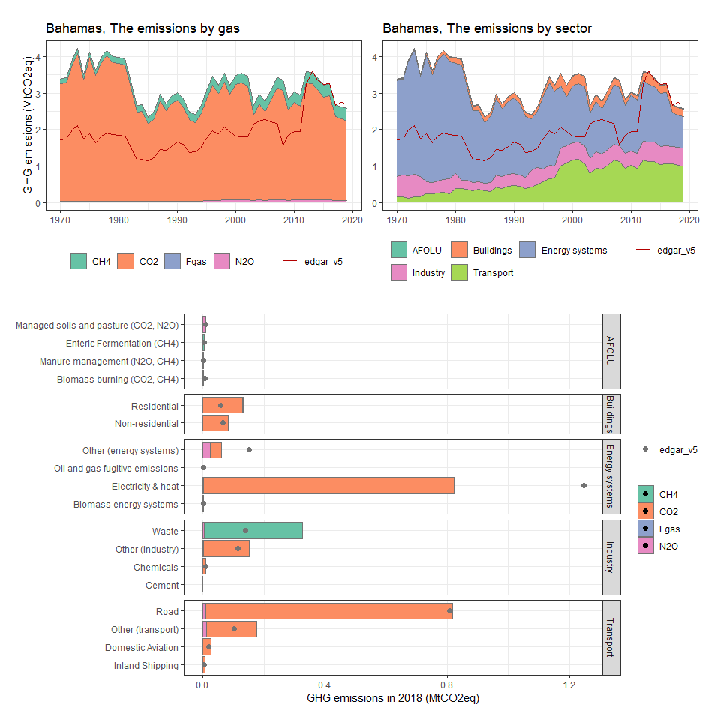

### Bahrain

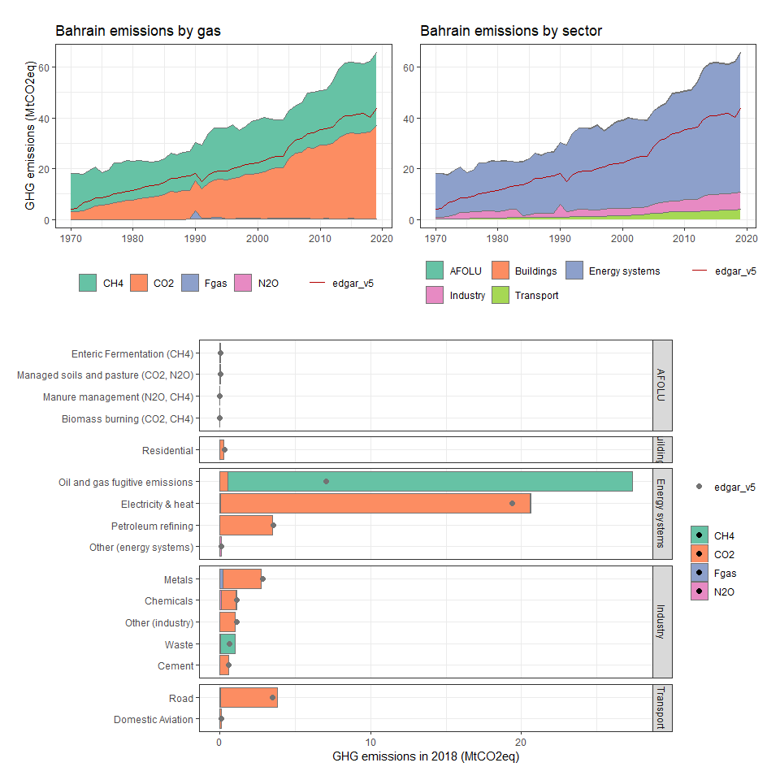

### Bangladesh

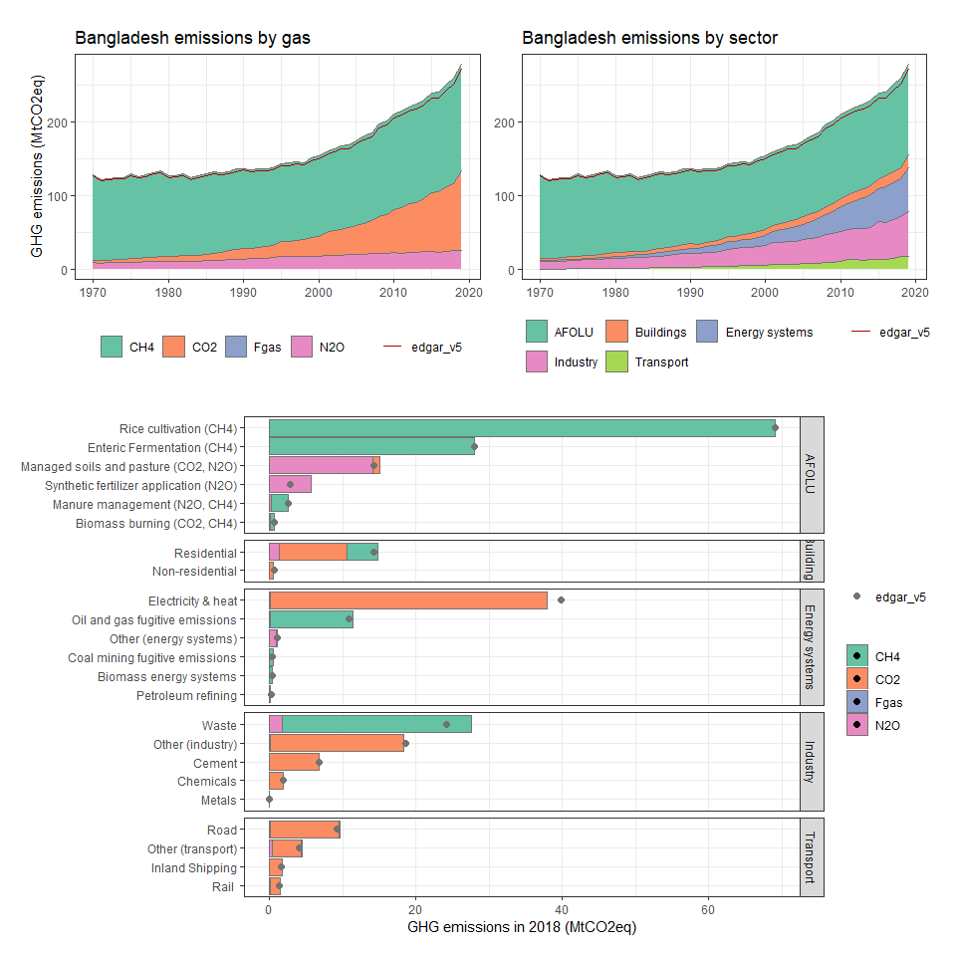

### Barbados

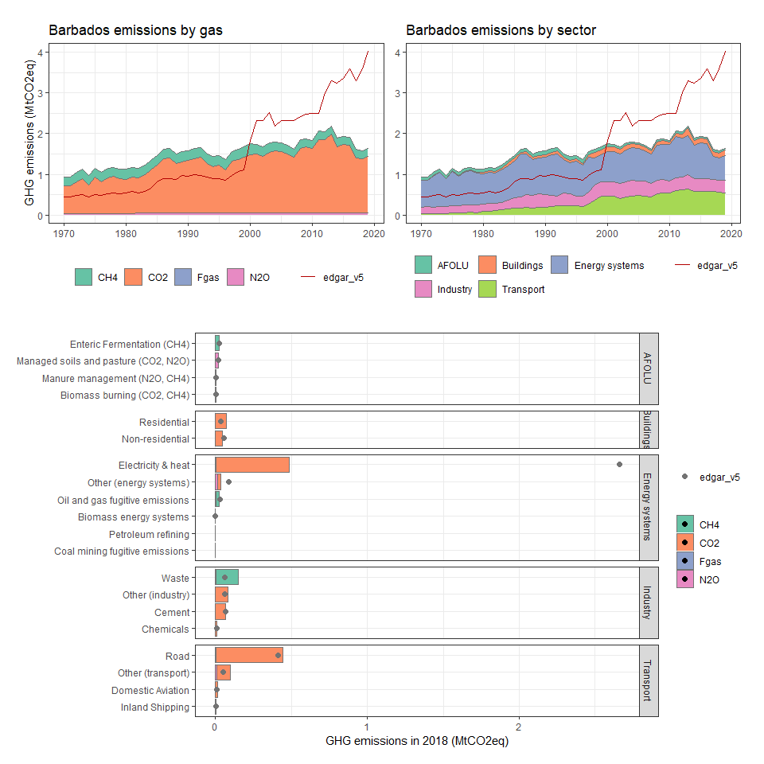

### Belarus

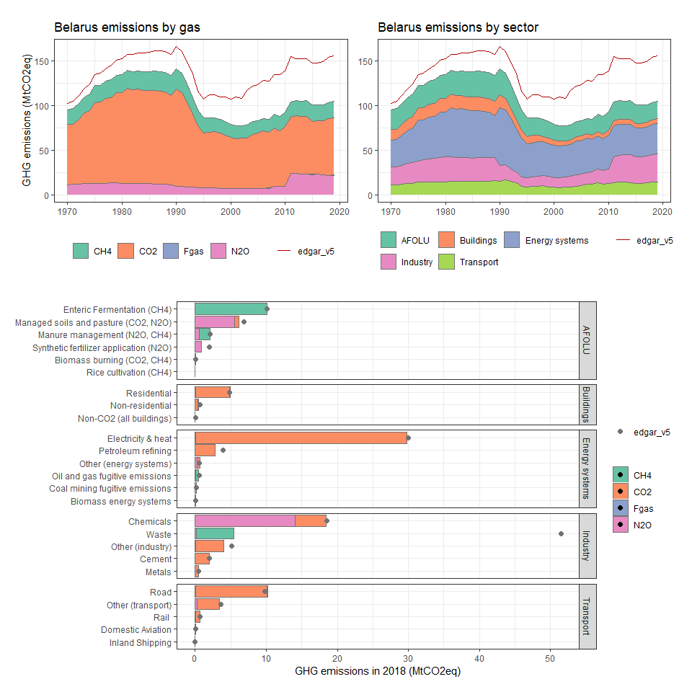

### Belgium

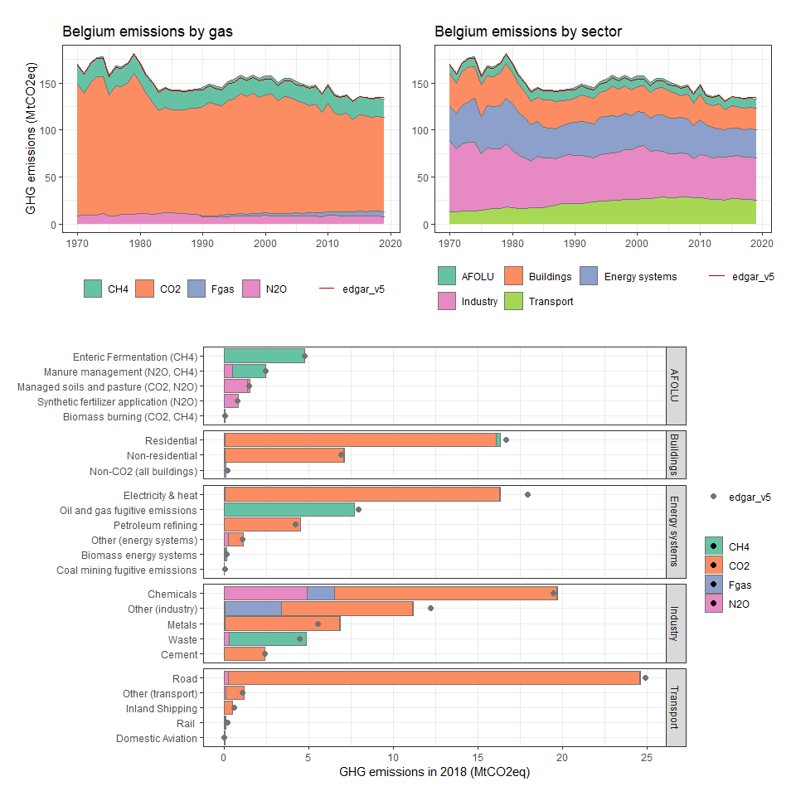

### Belize

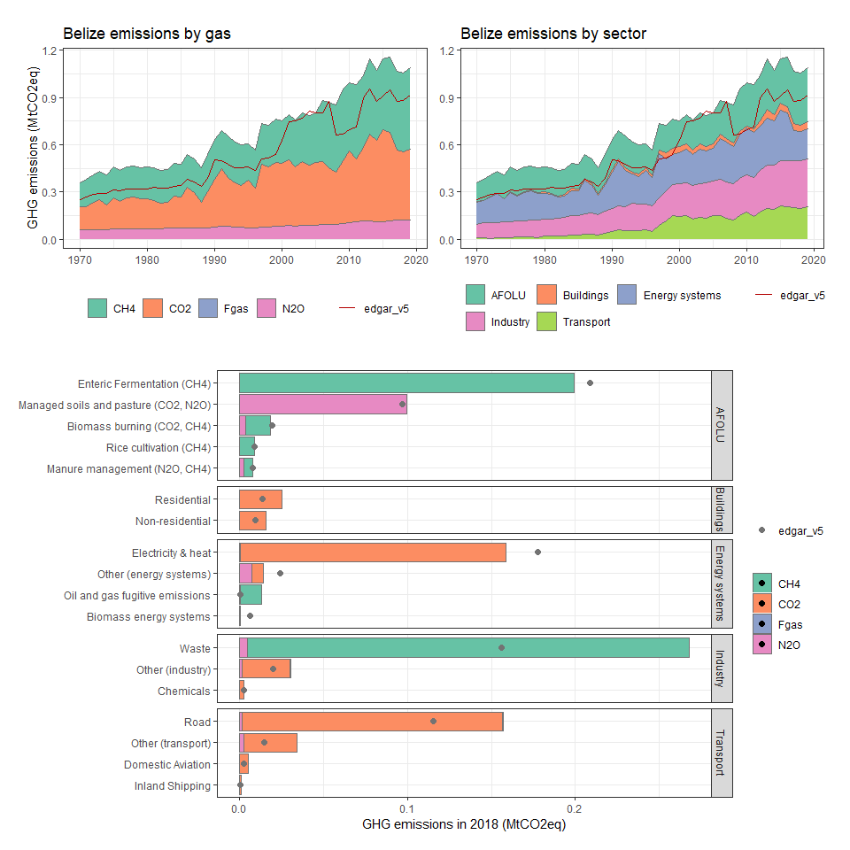

### Benin

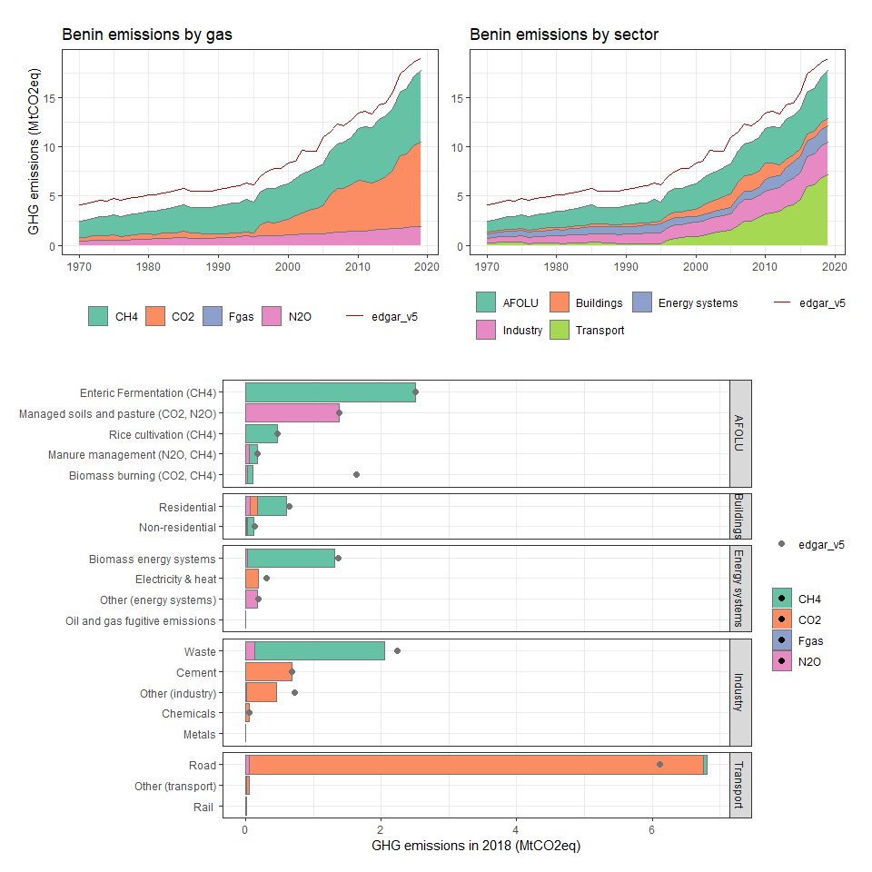

### Bermuda

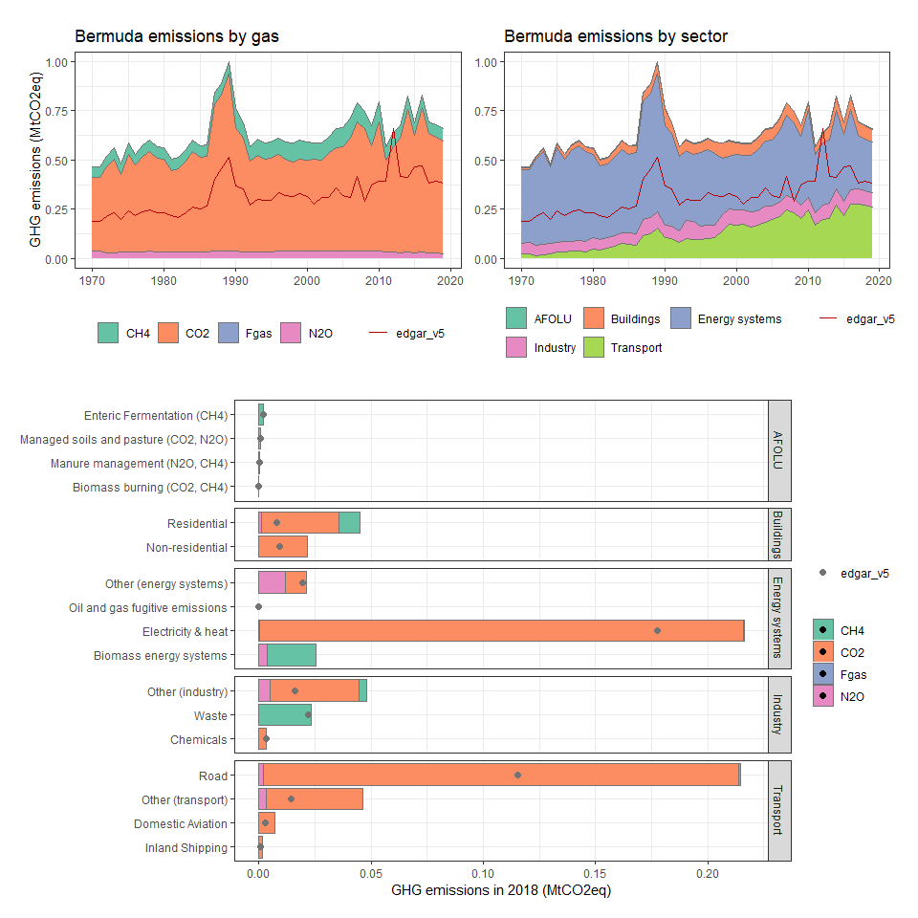

### Bhutan

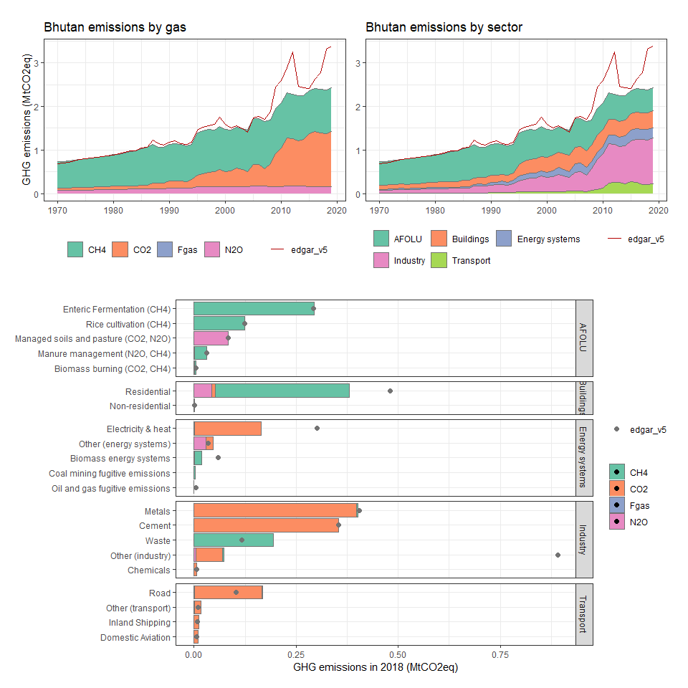

### Bolivia

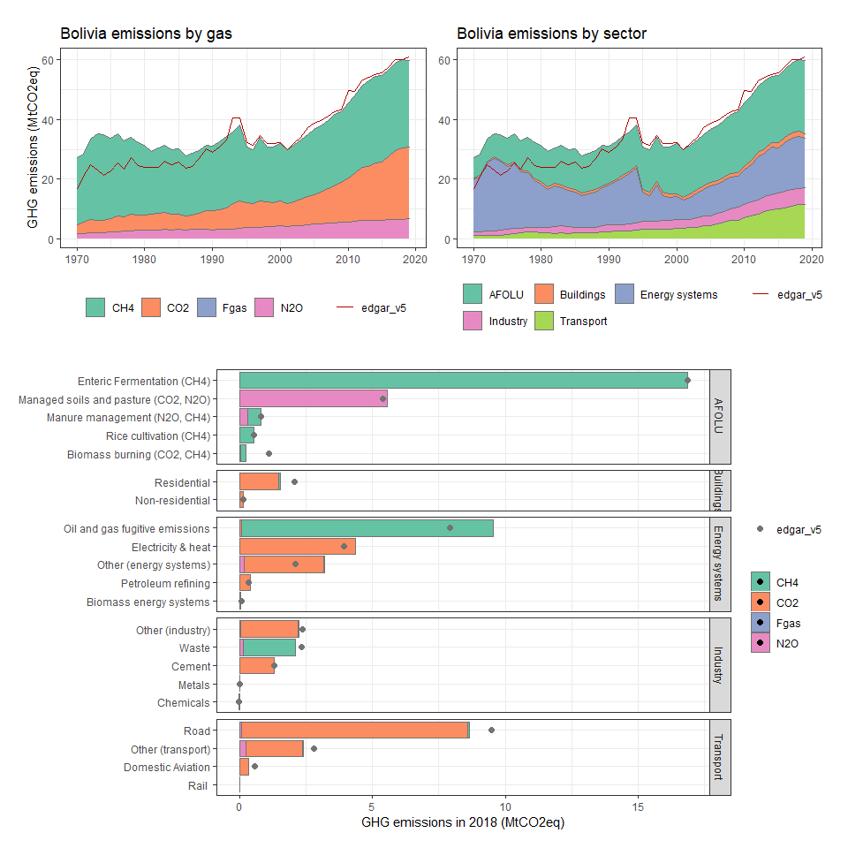

### Bosnia and Herzegovina

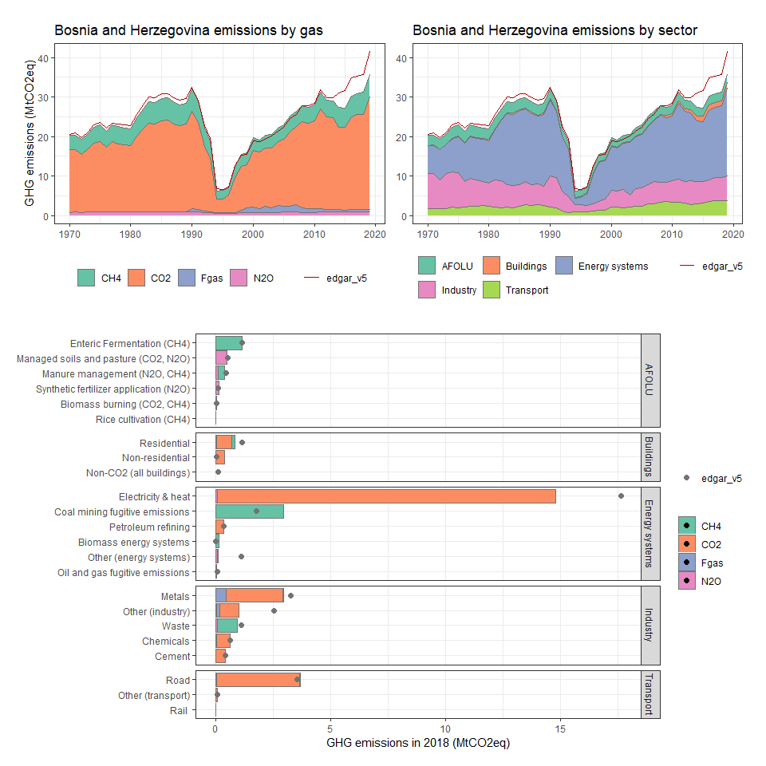

### Botswana

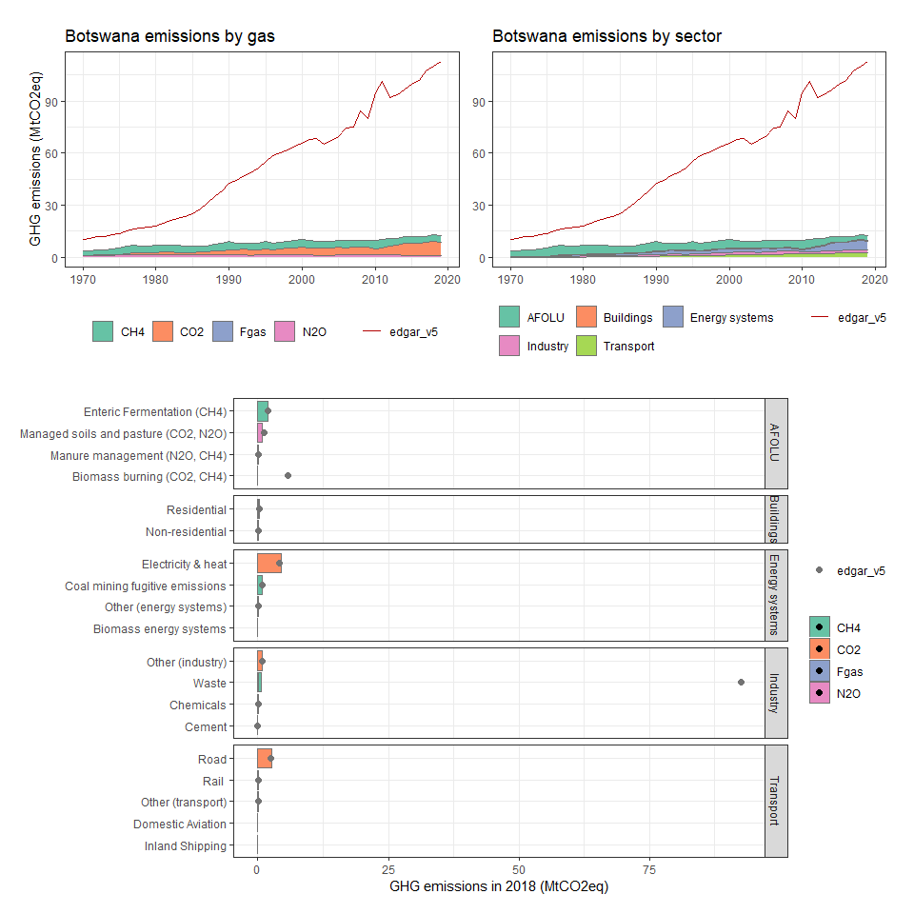

### Bouvet Island

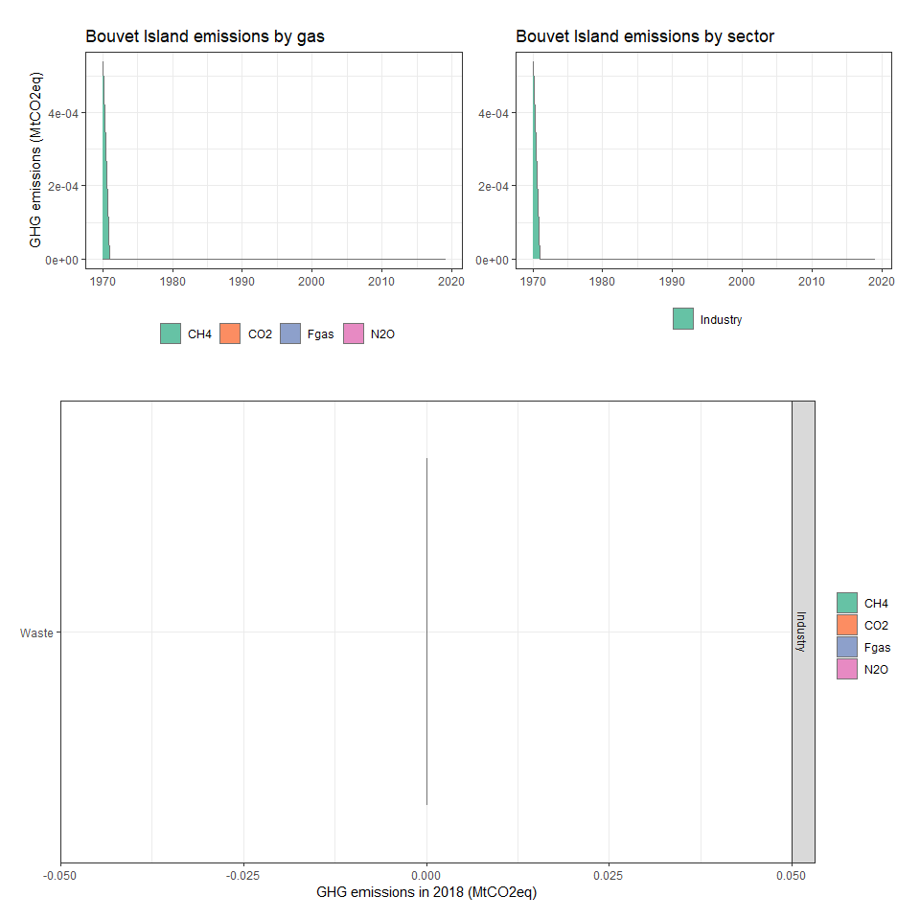

### Brazil

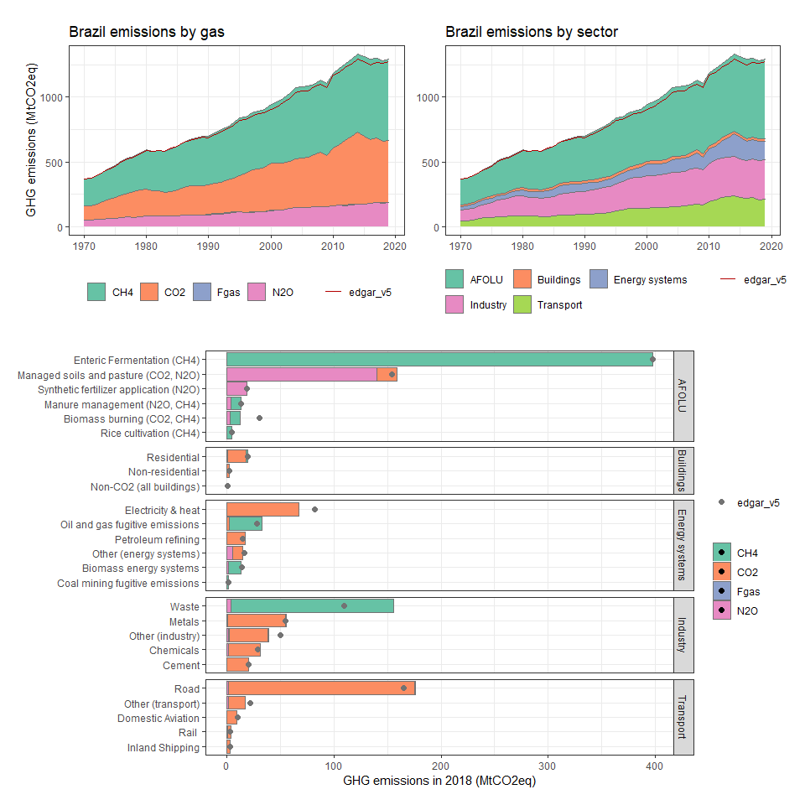

### British Virgin Islands

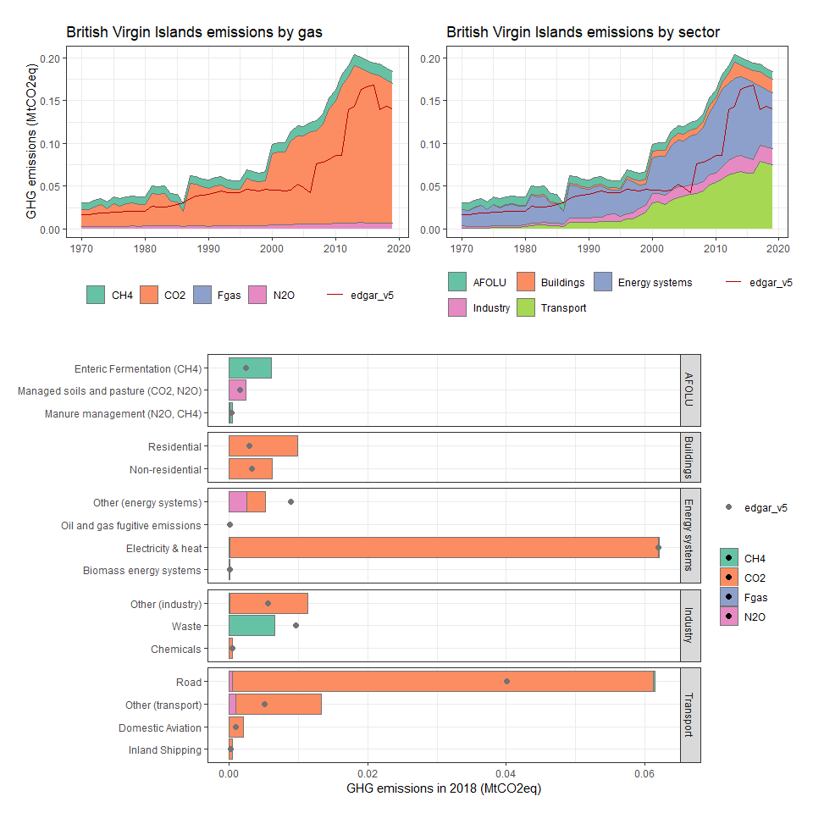

### Brunei Darussalam

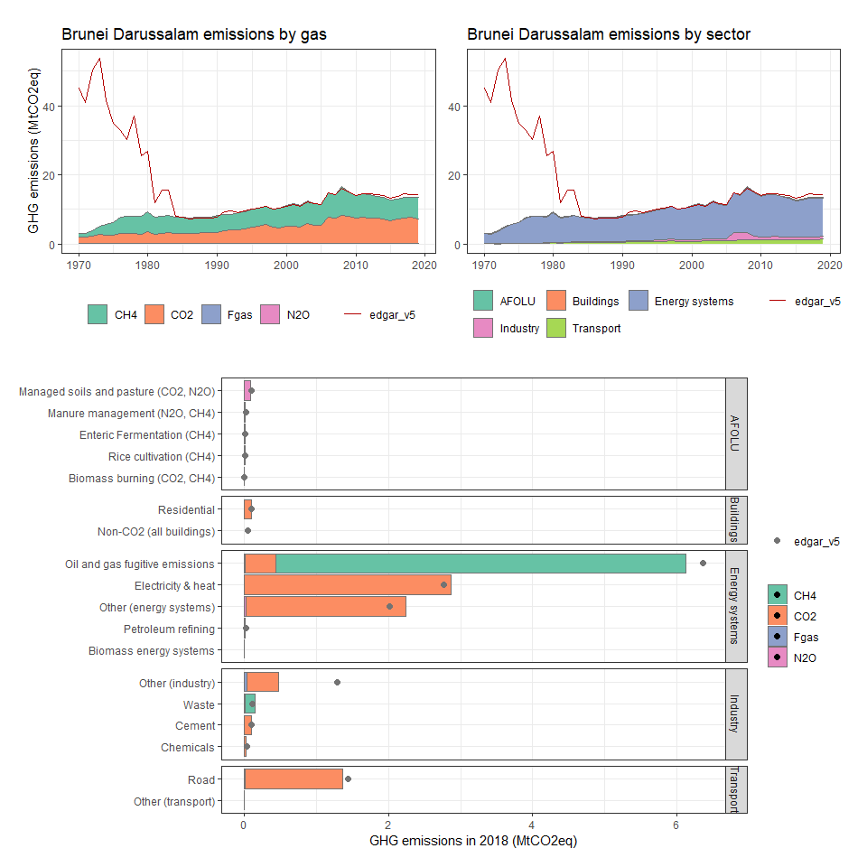

### Bulgaria

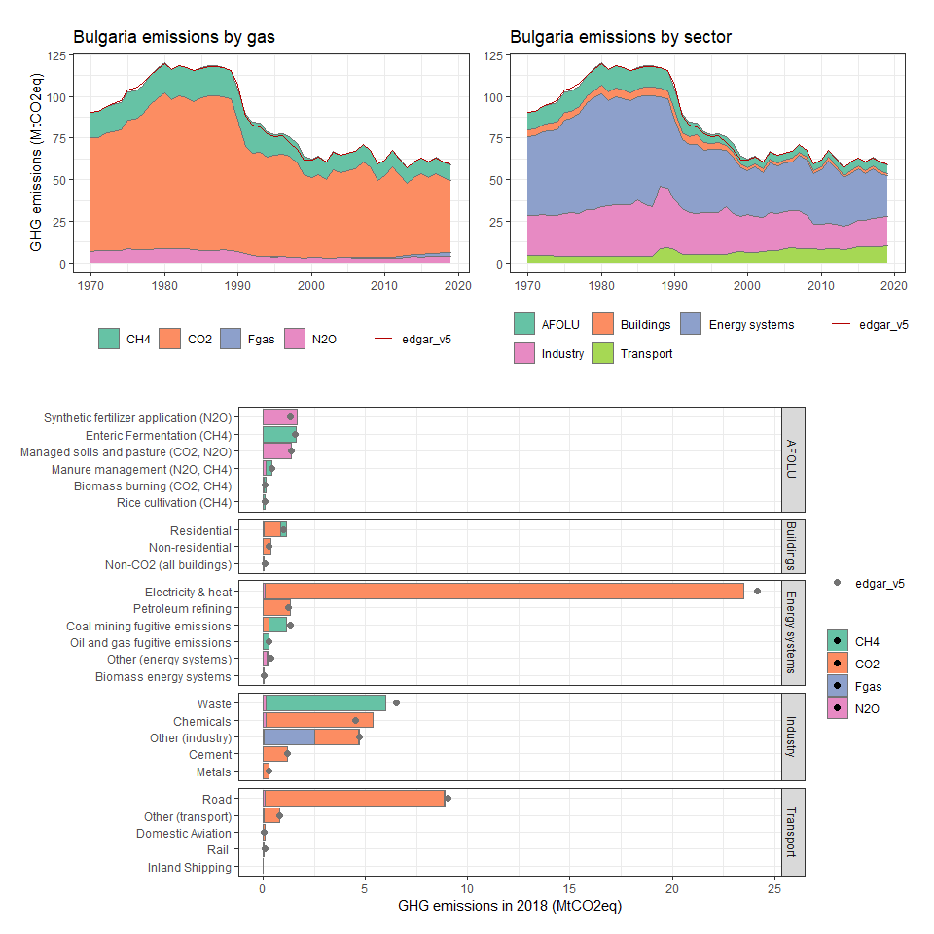

### Burkina Faso

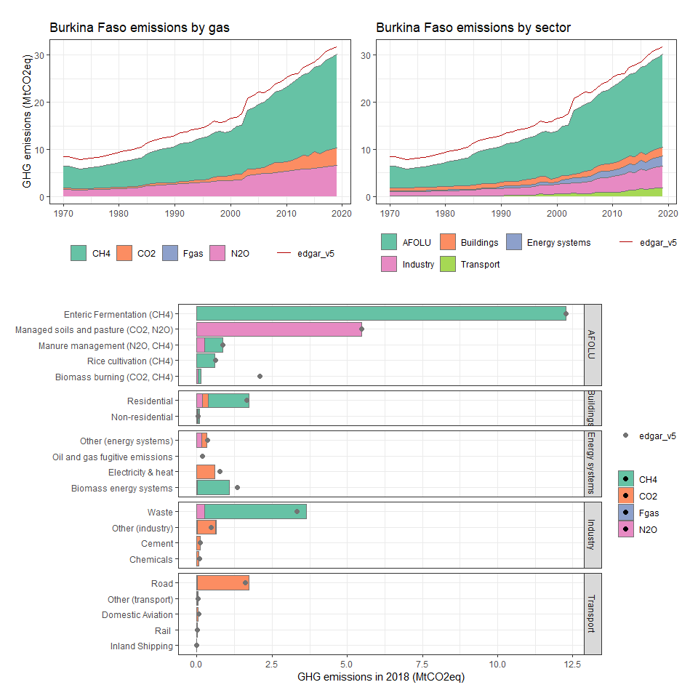

### Burundi

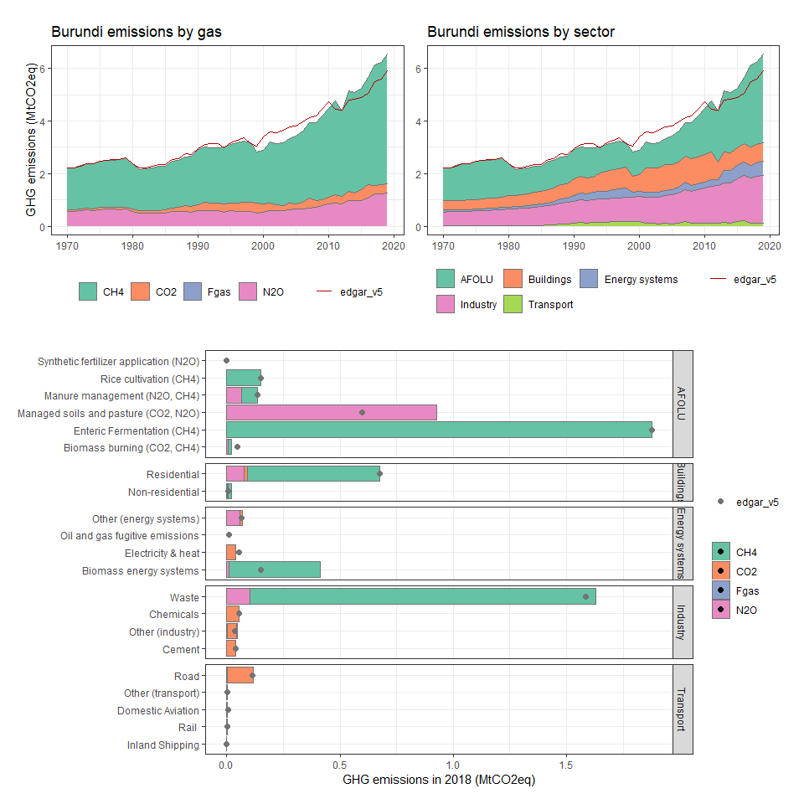

### Cabo Verde

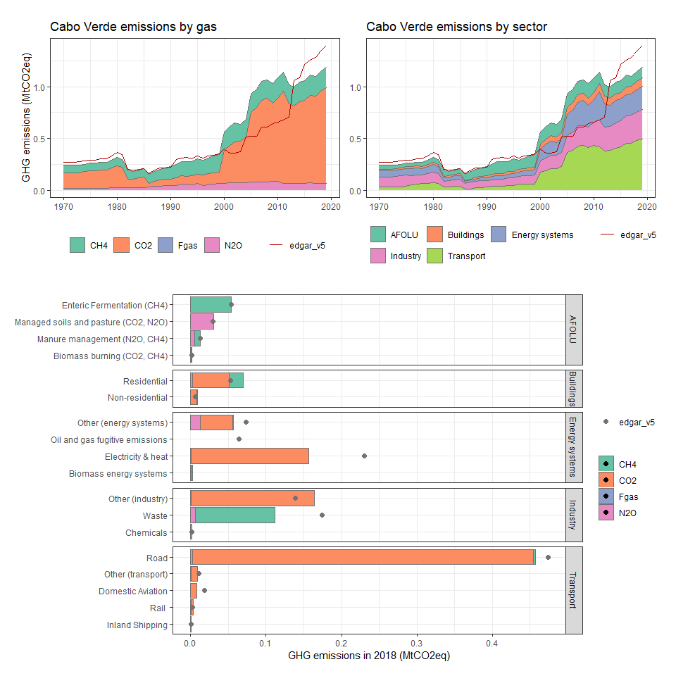

### Cambodia

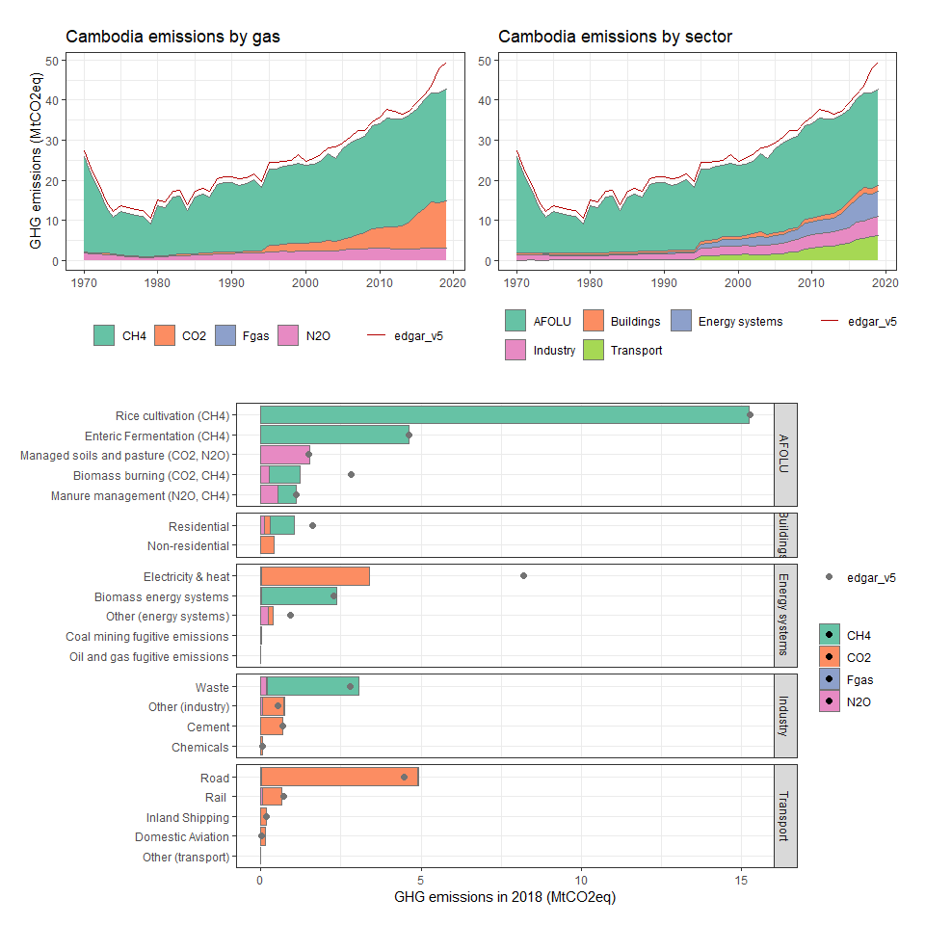

### Cameroon

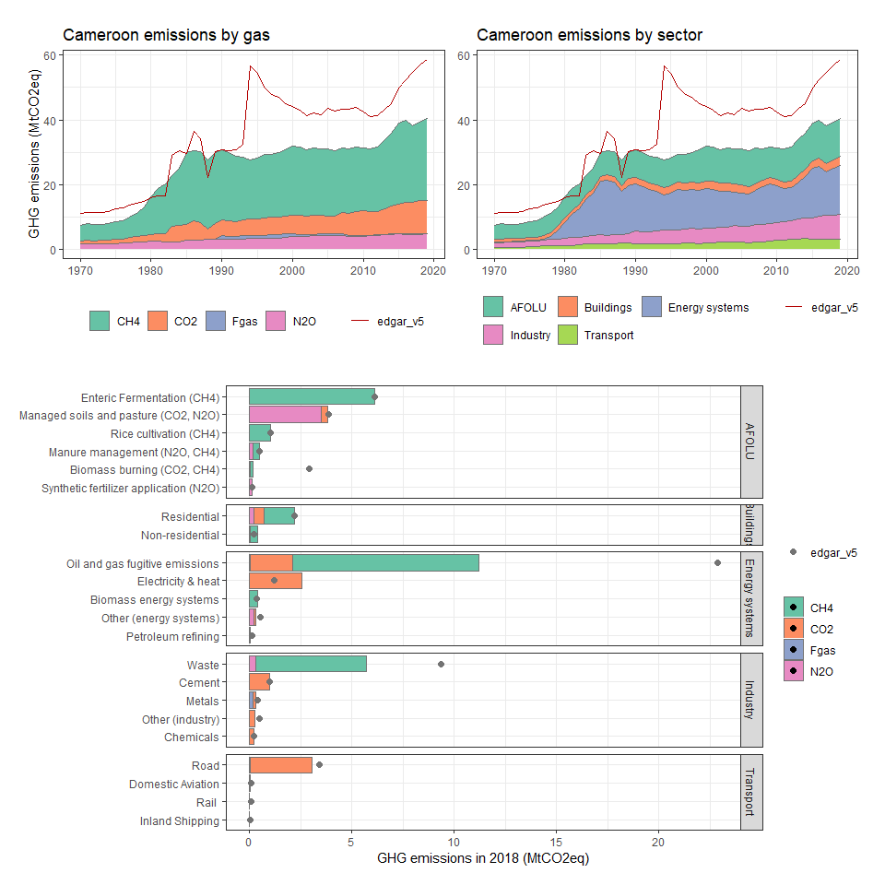

### Canada

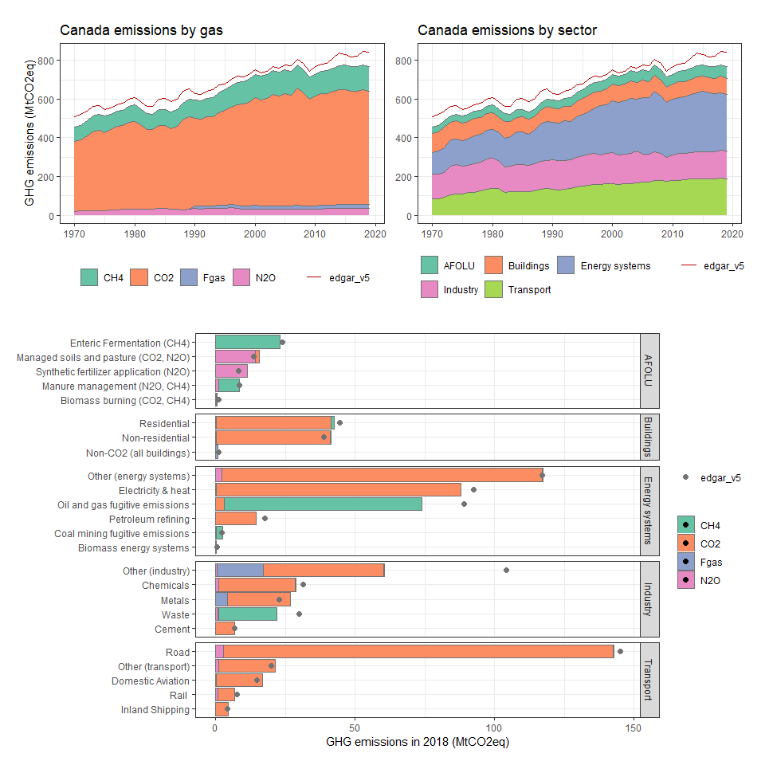

### Cayman Islands

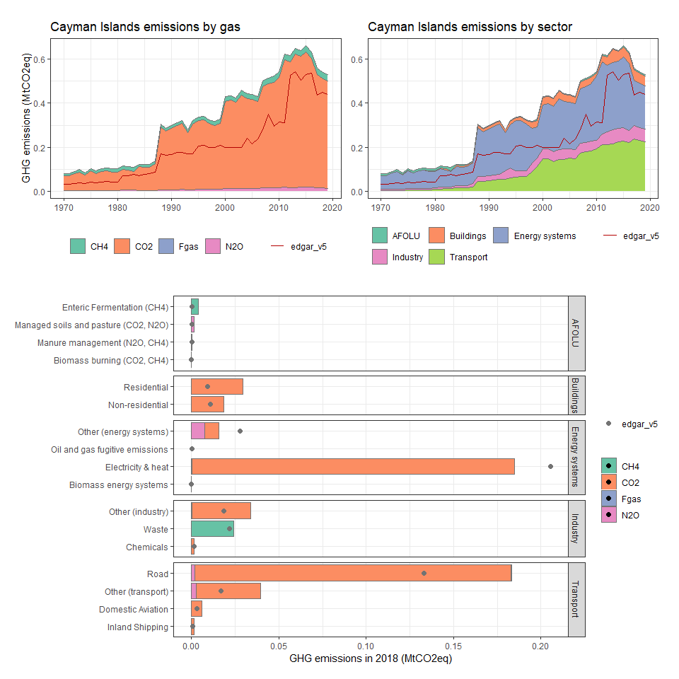

### Central African Republic

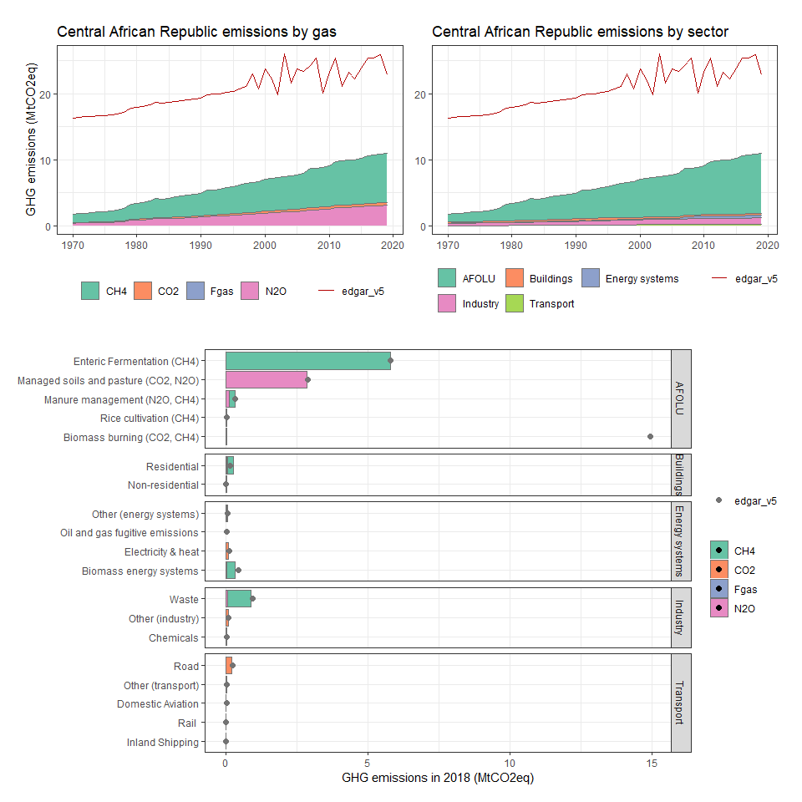

### Chad

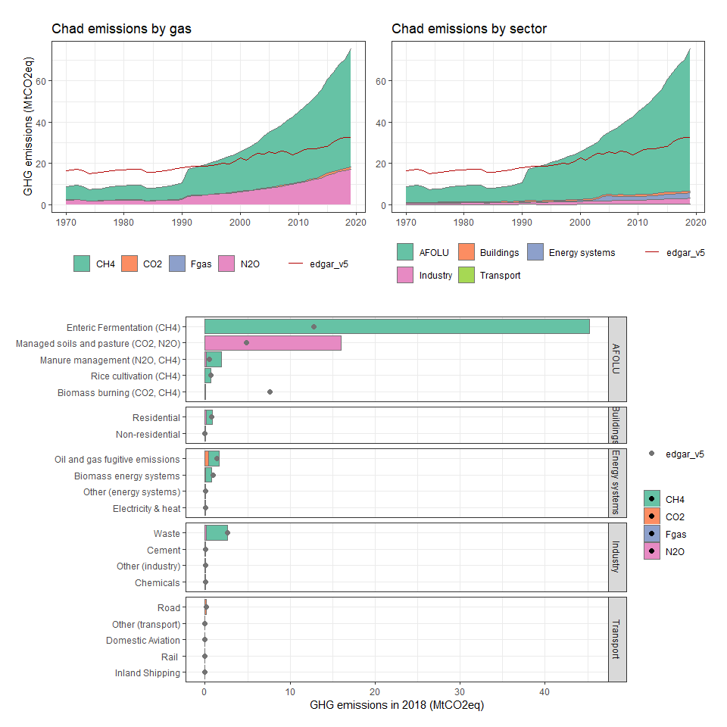

### Chile

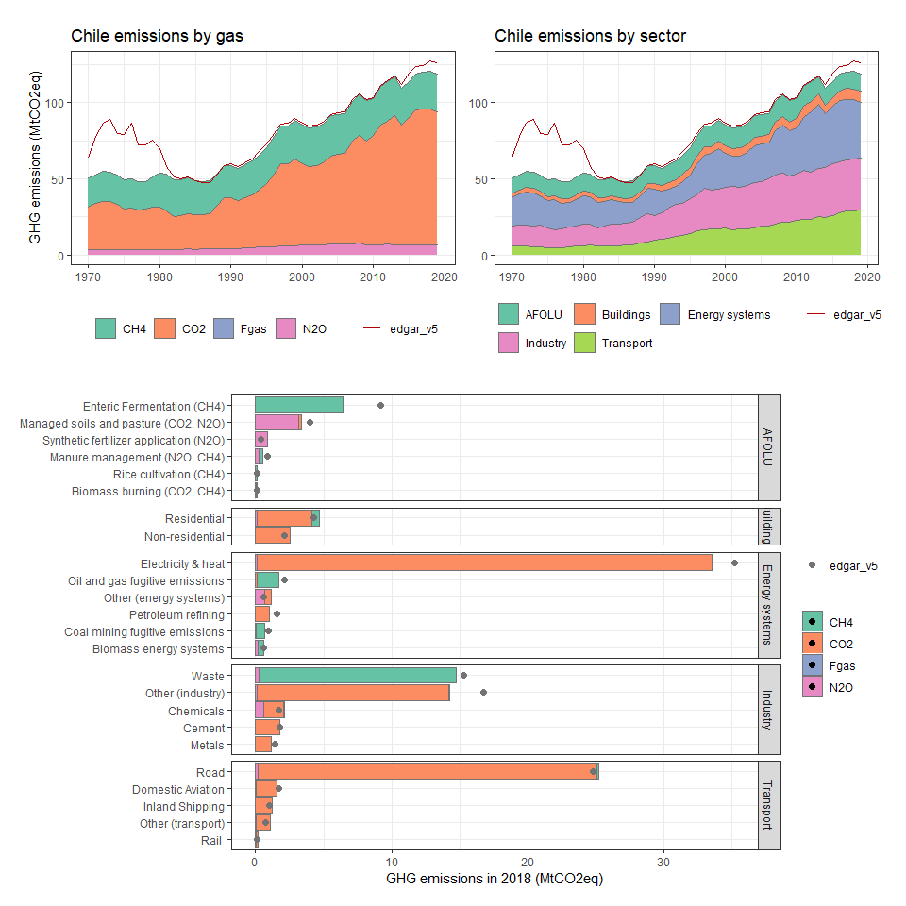

### China

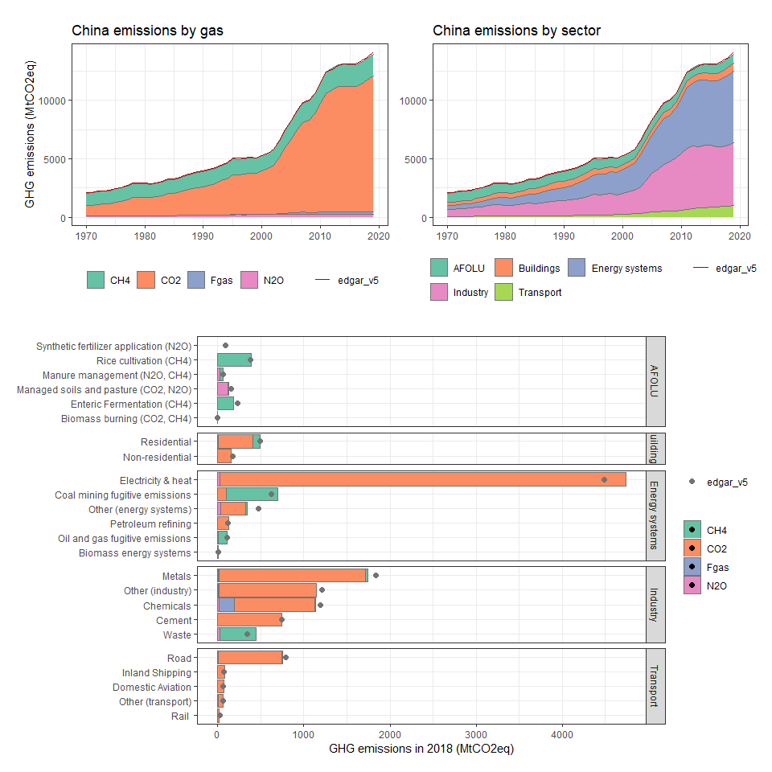

### Christmas Island

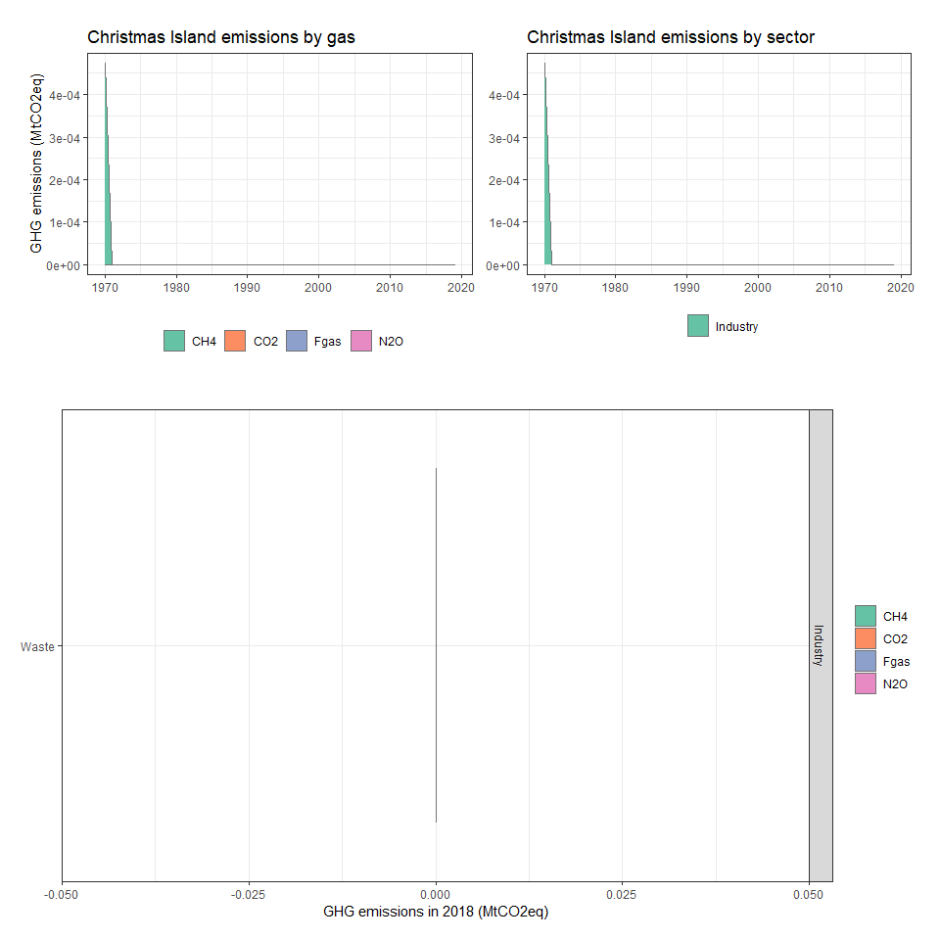

### Cocos (Keeling) Islands

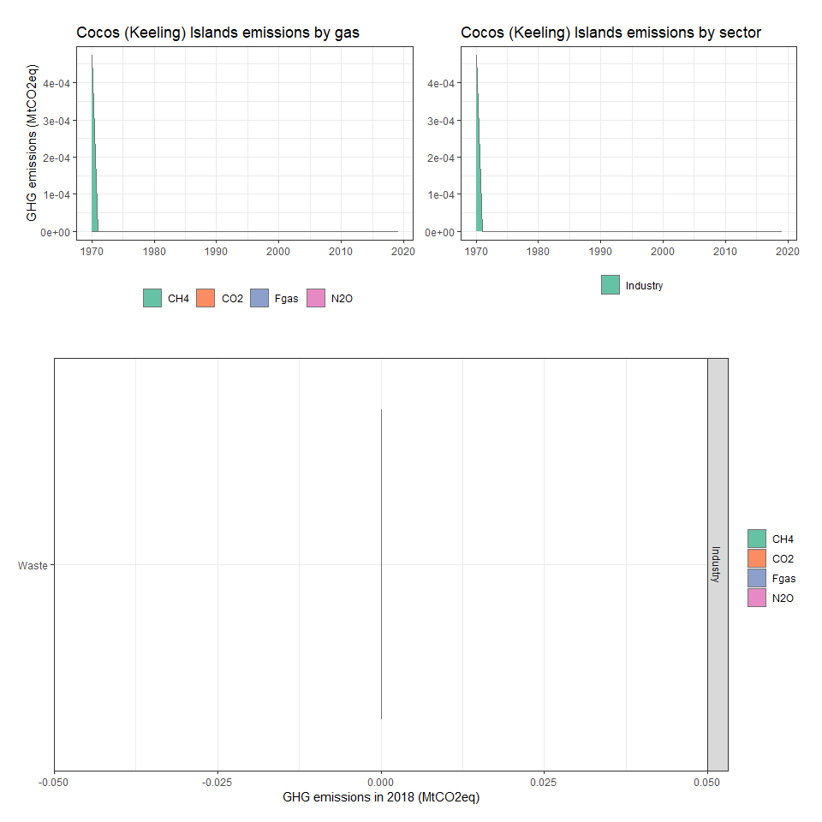

### Colombia

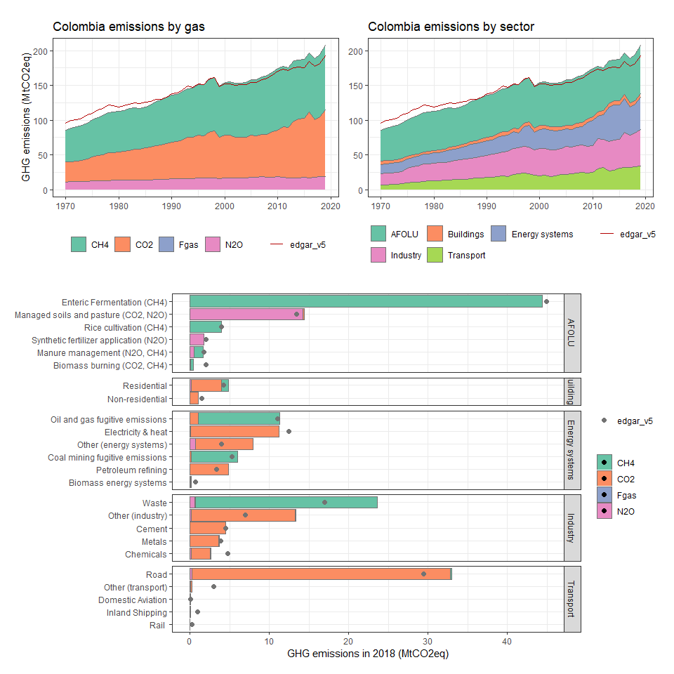

### Comoros

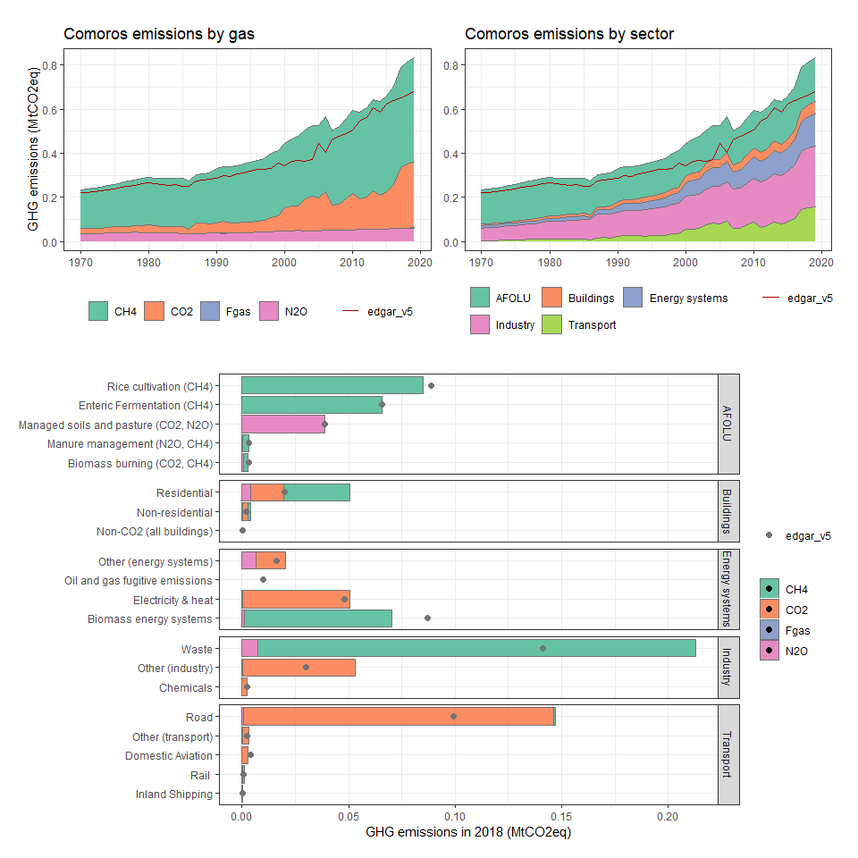

### Congo, Dem. Rep.

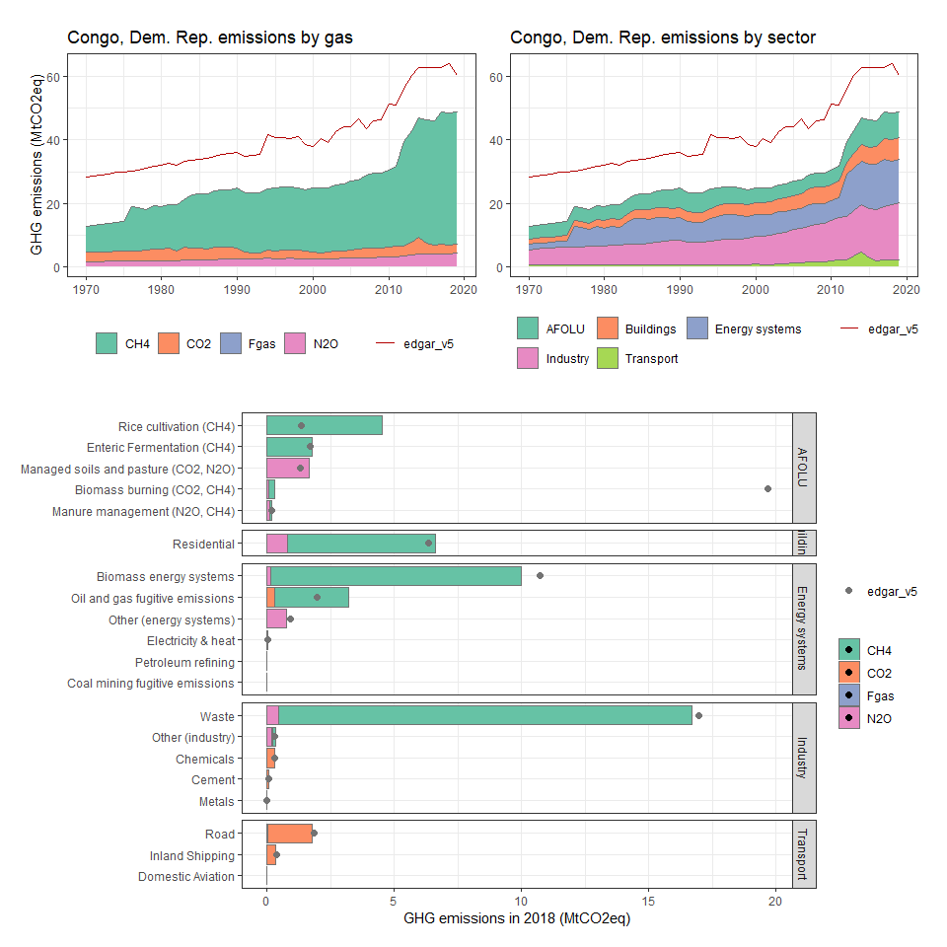

### Congo, Rep.

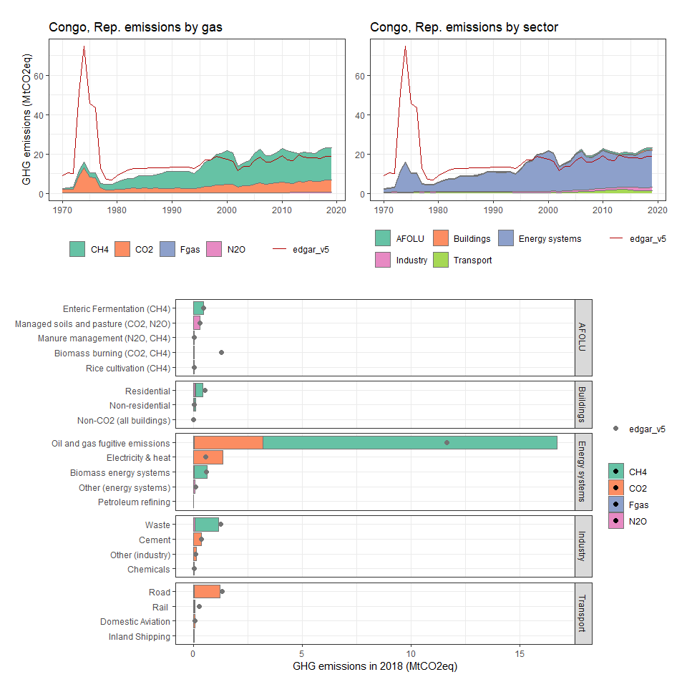

### Cook Islands

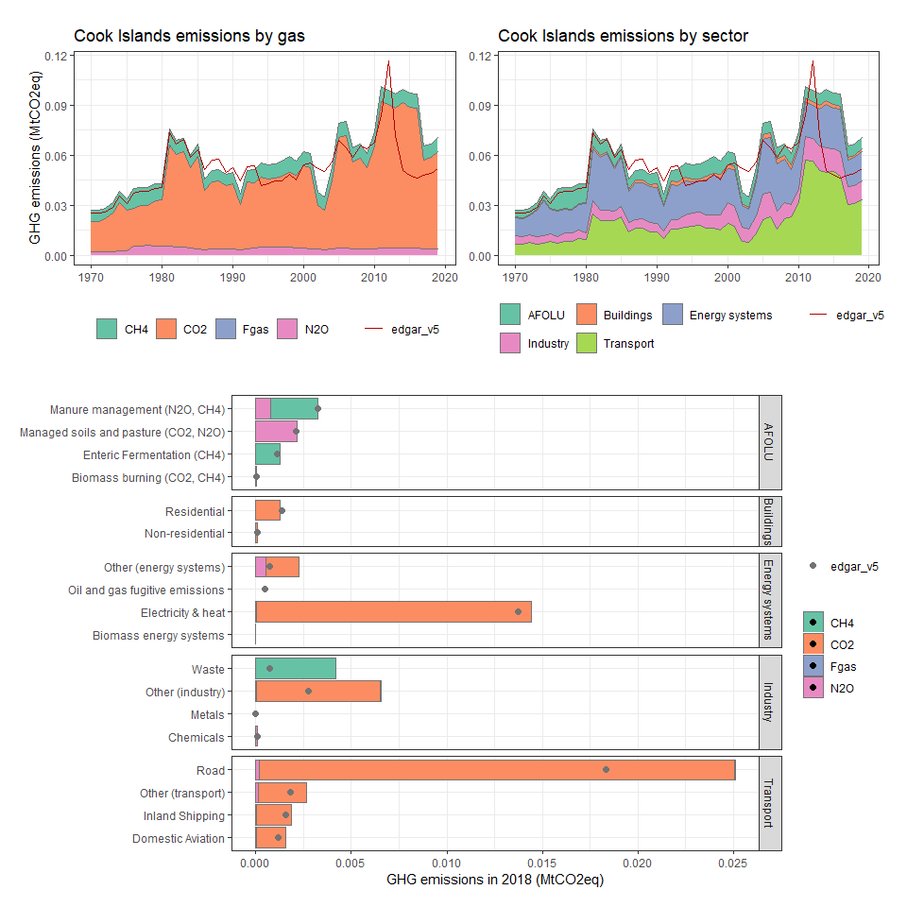

### Costa Rica

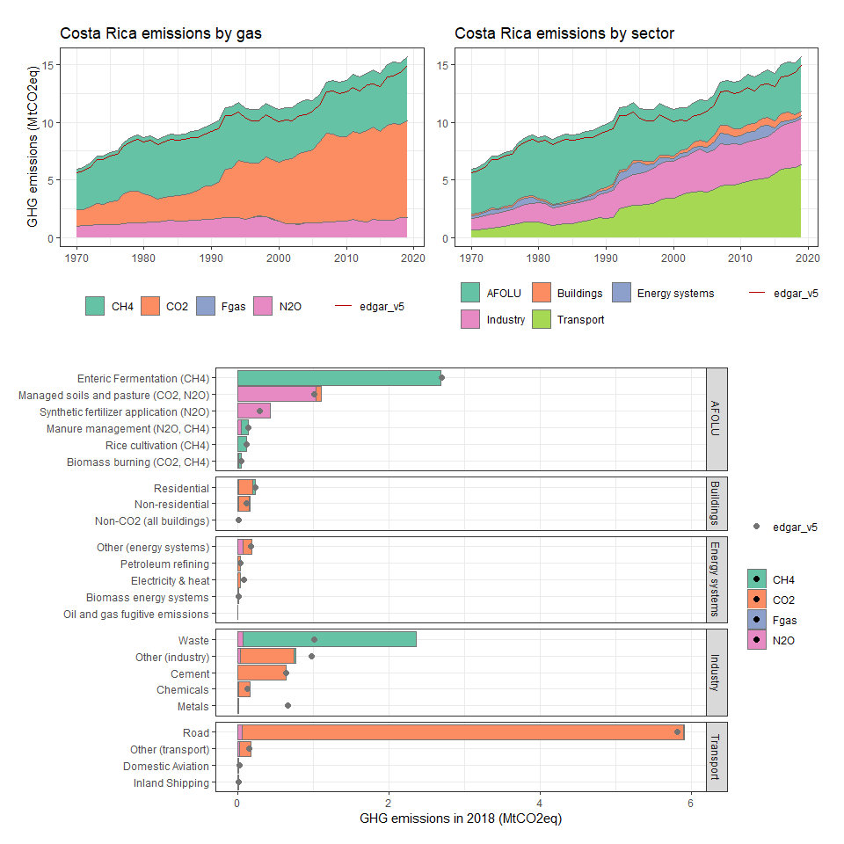

### Côte d’Ivoire

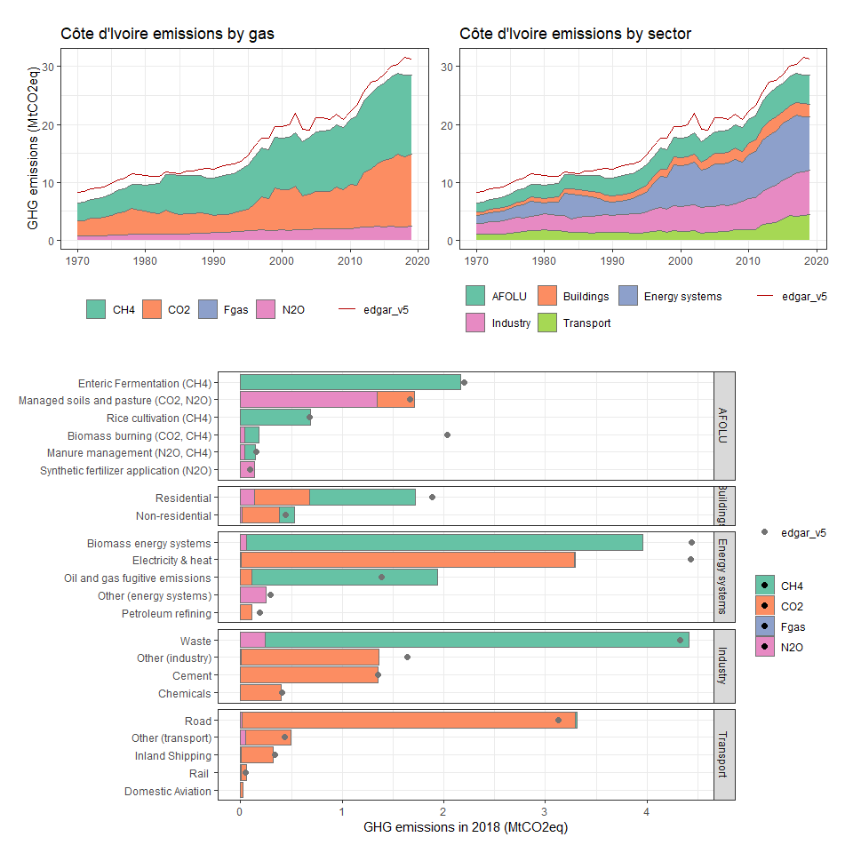

### Croatia

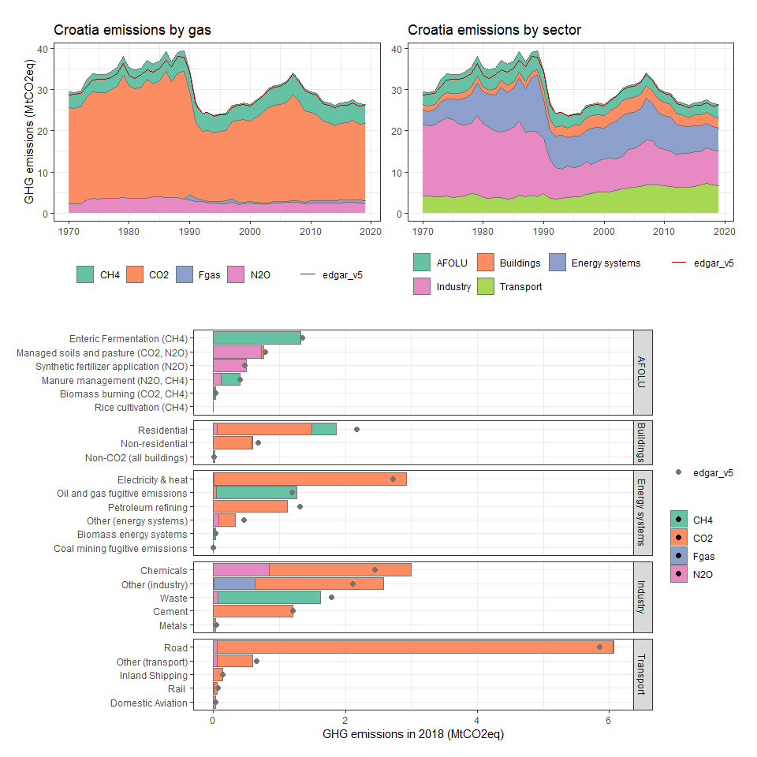

### Cuba

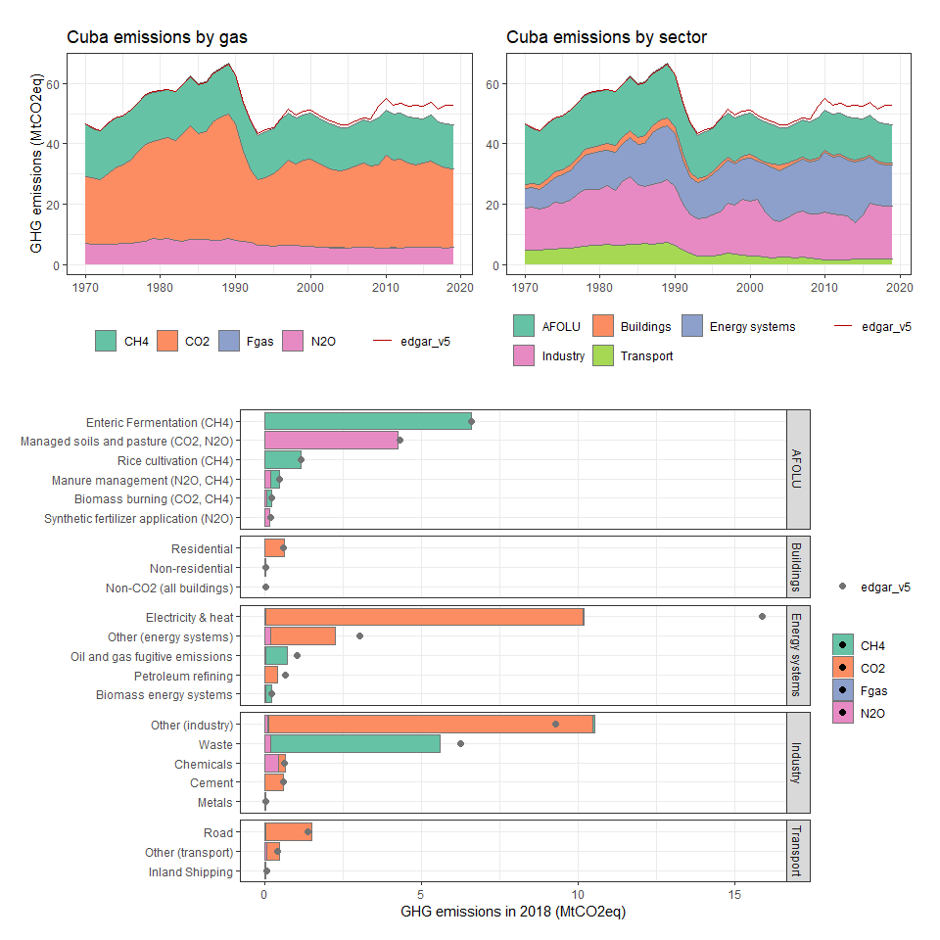

### Curaçao

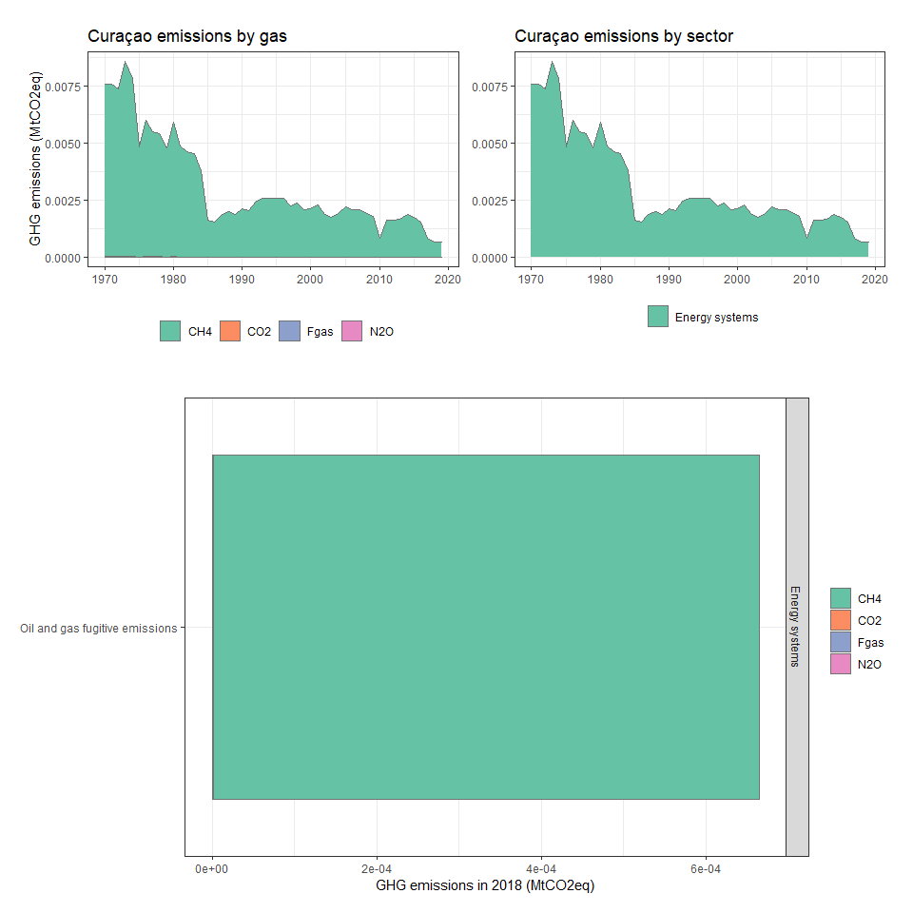

### Cyprus

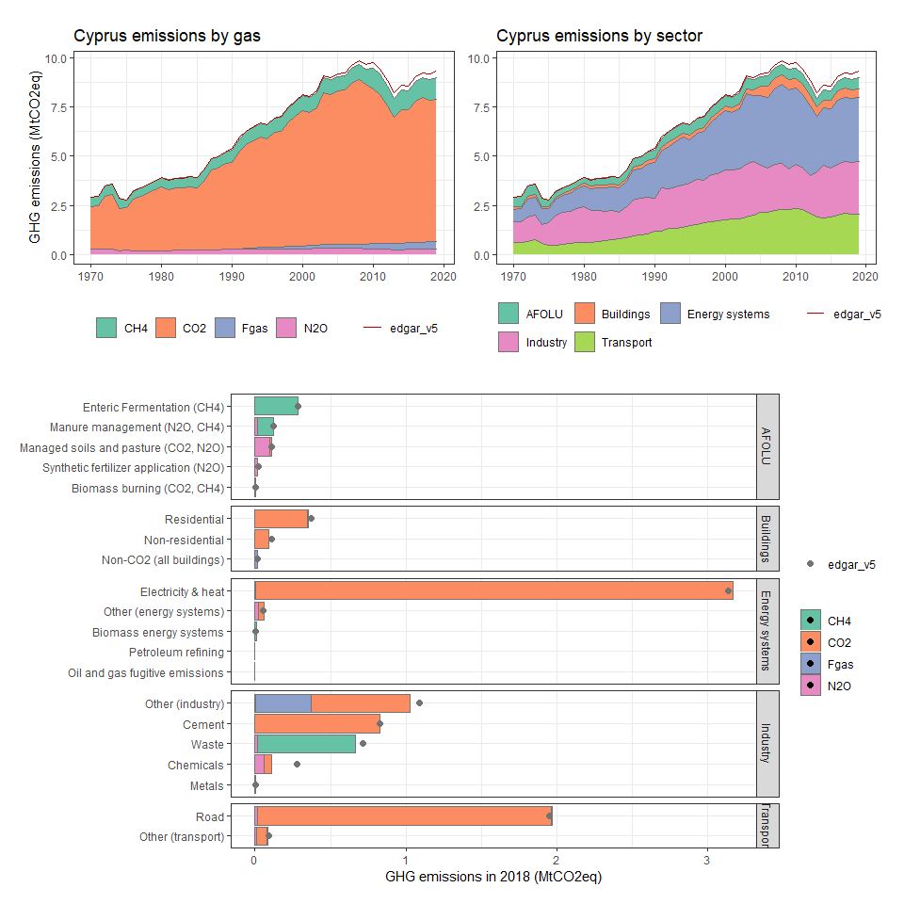

### Czech Republic

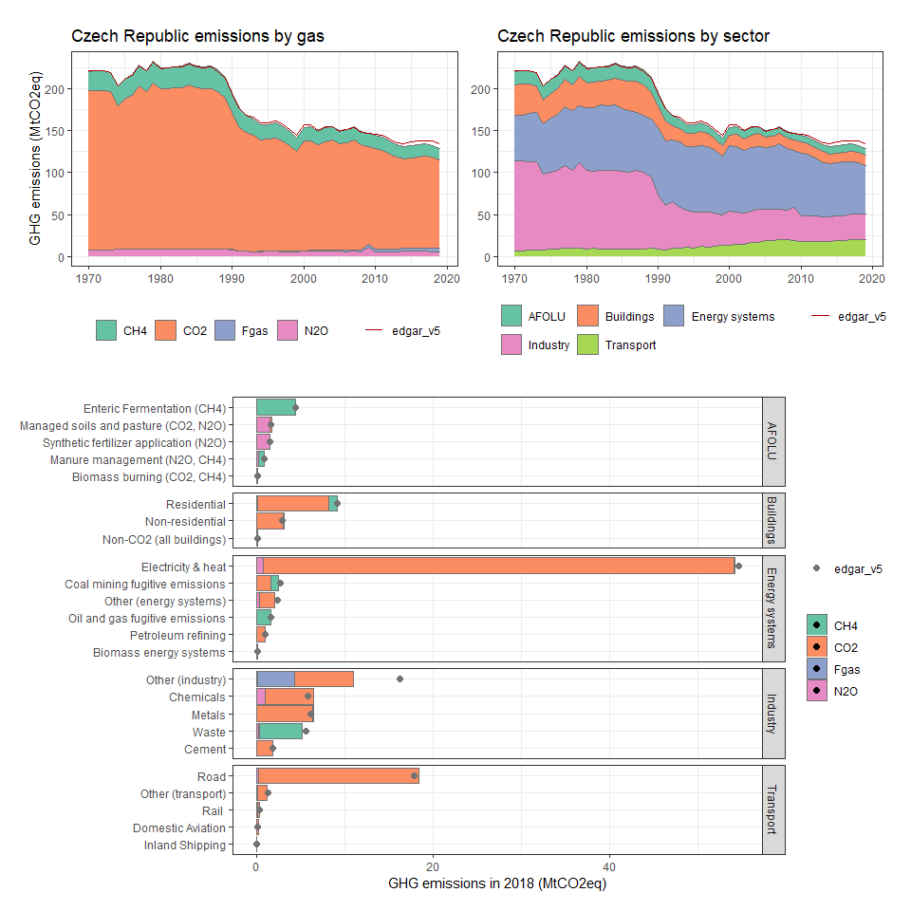

### Denmark

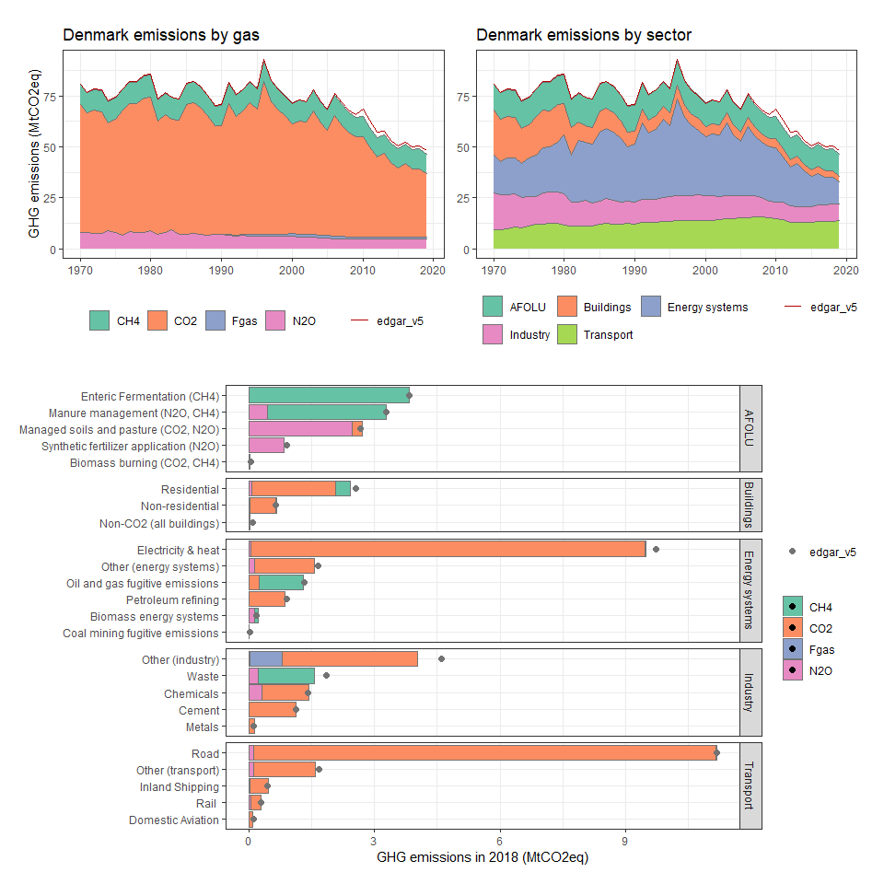

### Djibouti

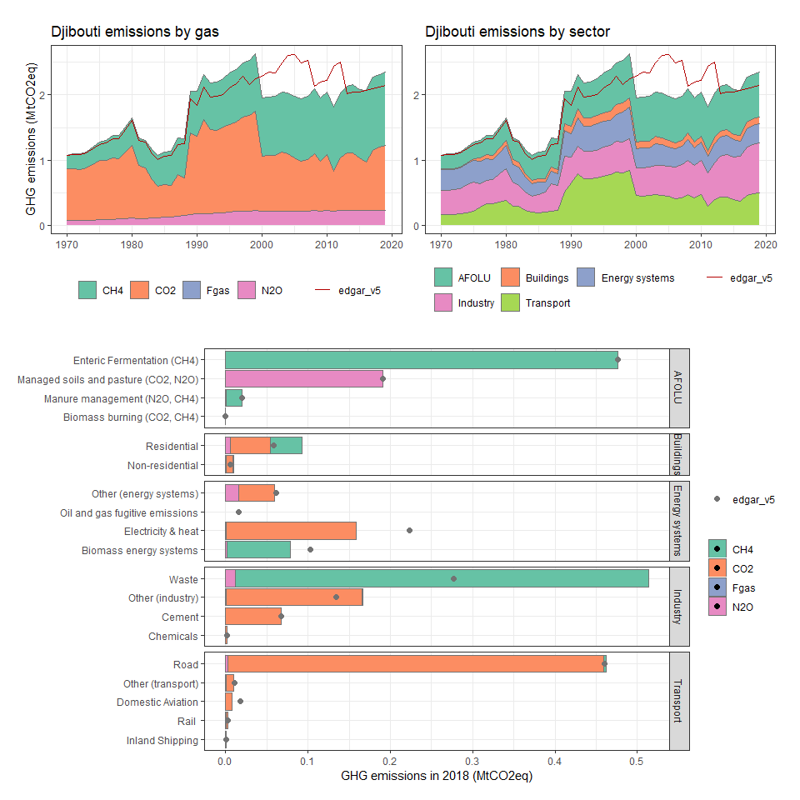

### Dominica

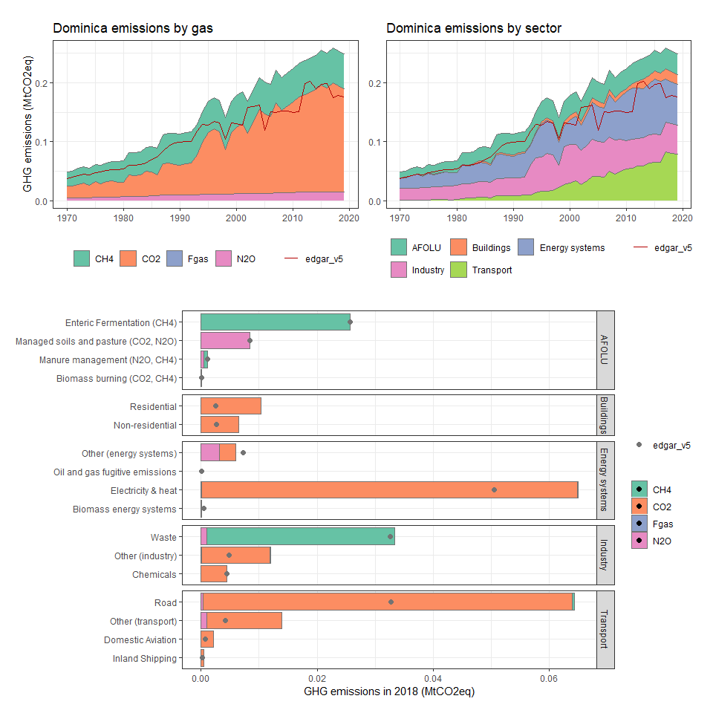

### Dominican Republic

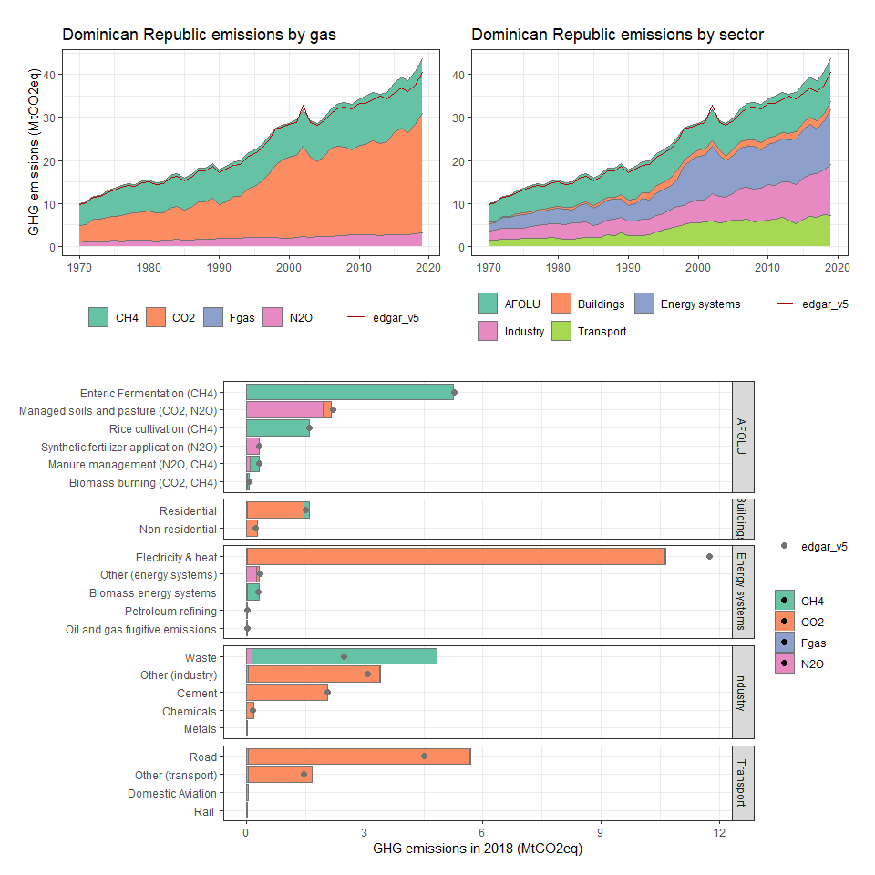

### Ecuador

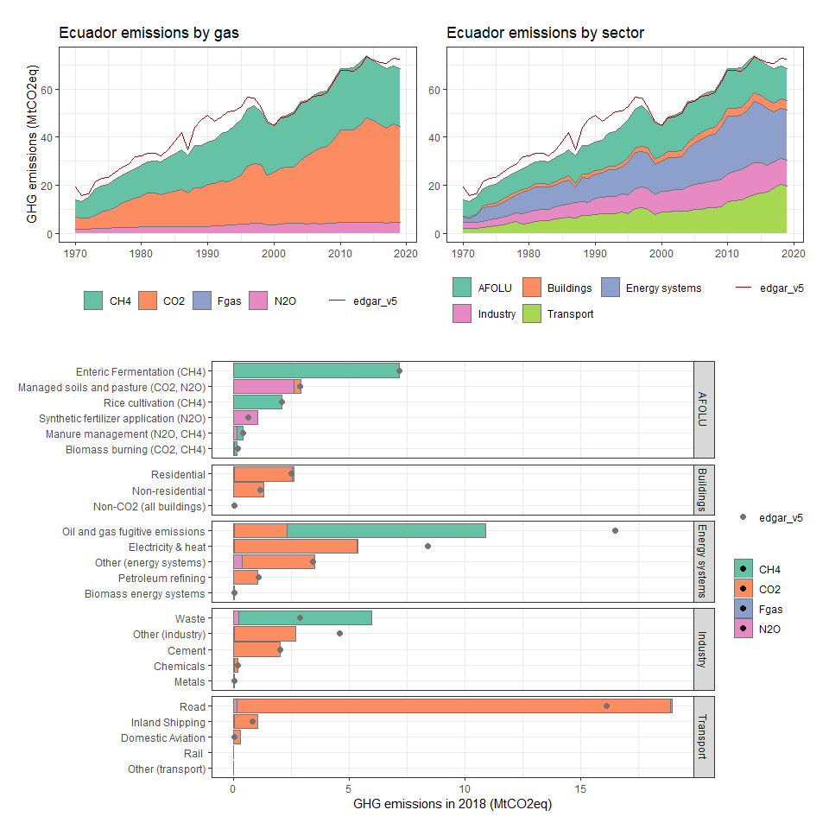

### Egypt, Arab Rep.

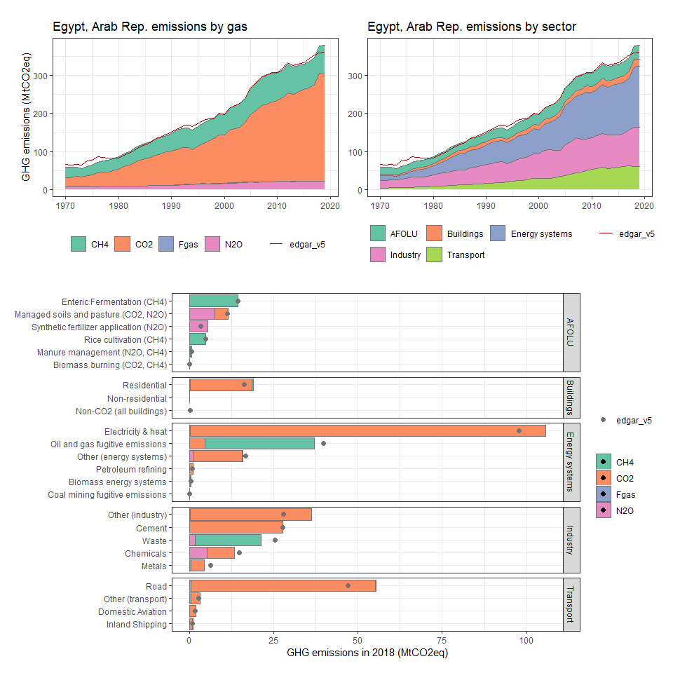

### El Salvador

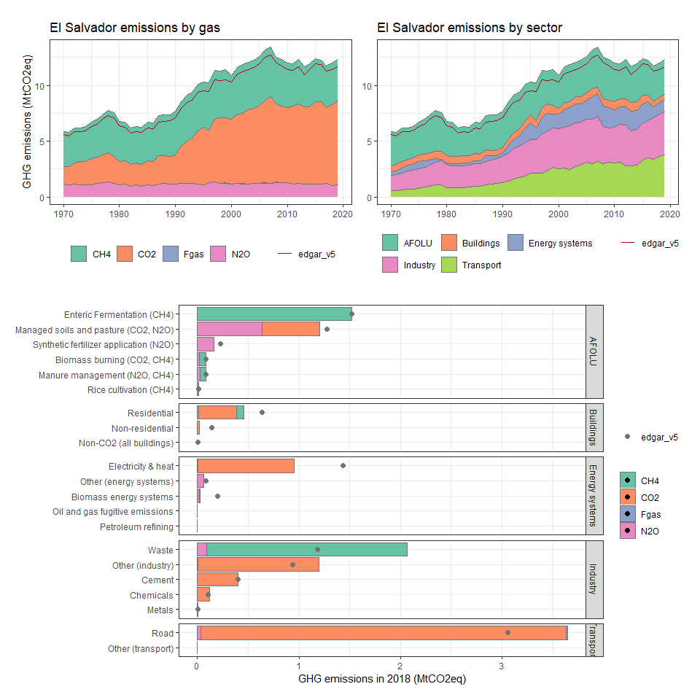

### Equatorial Guinea

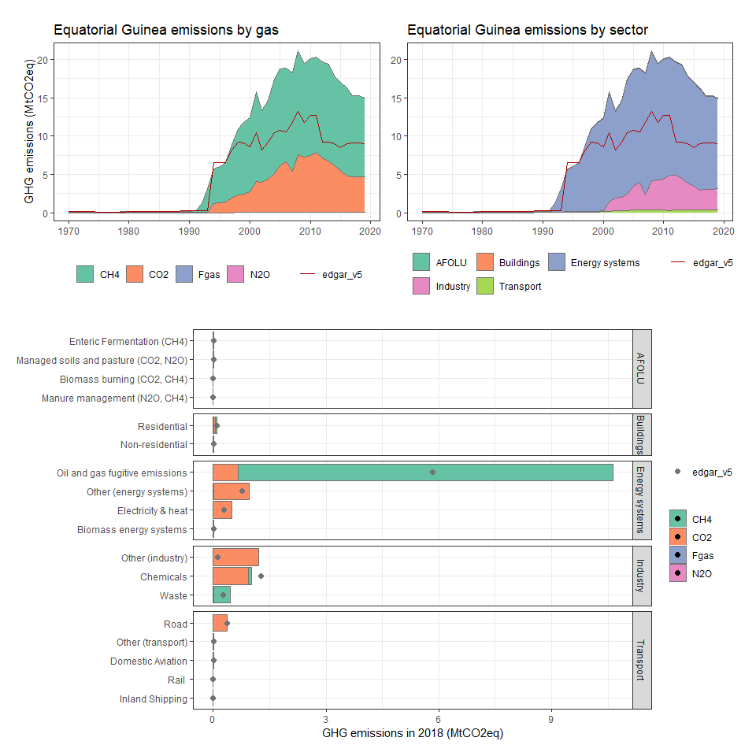

### Eritrea

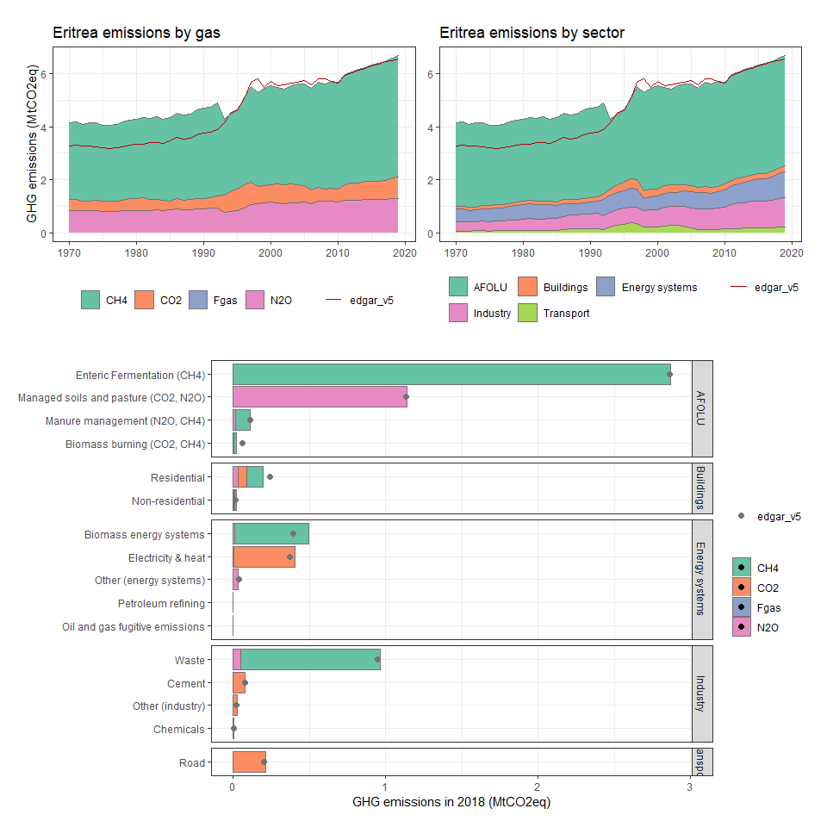

### Estonia

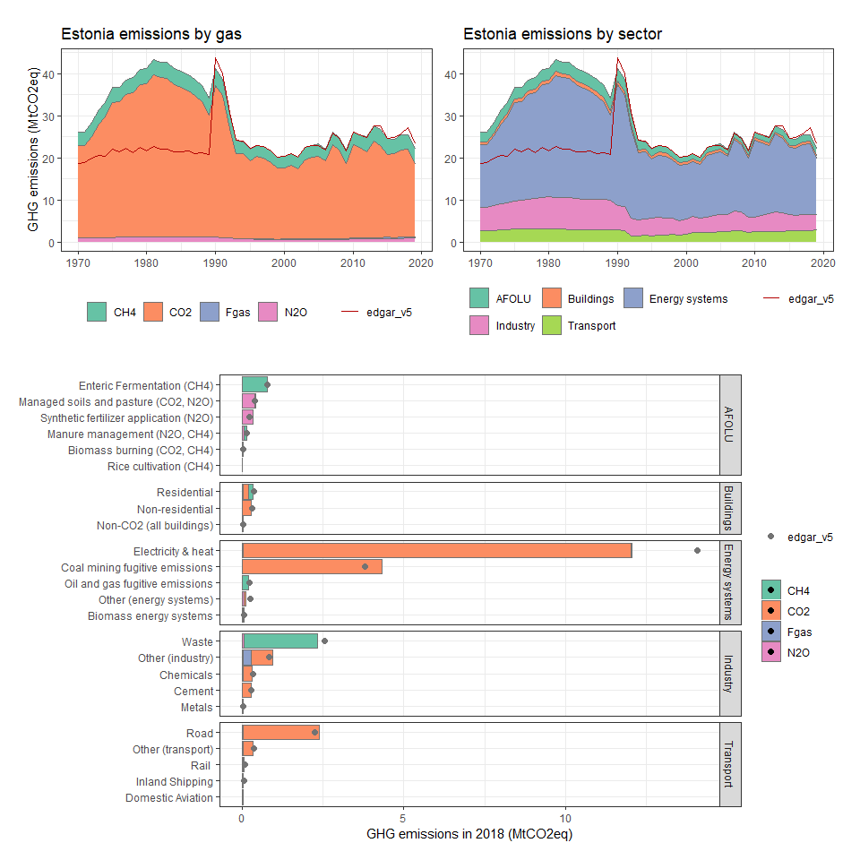

### Ethiopia

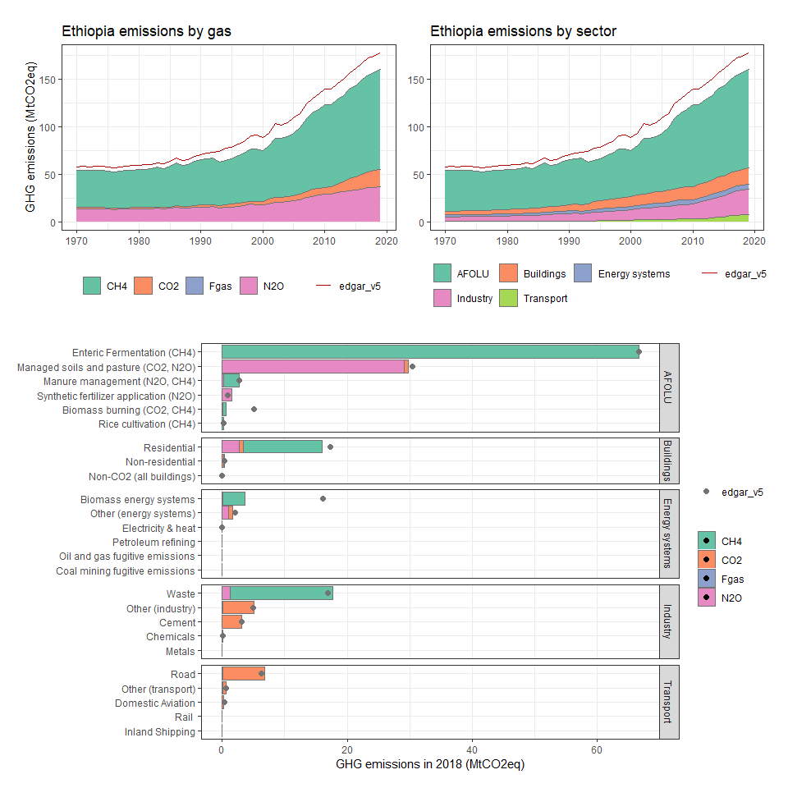

### Falkland Islands (Malvinas)

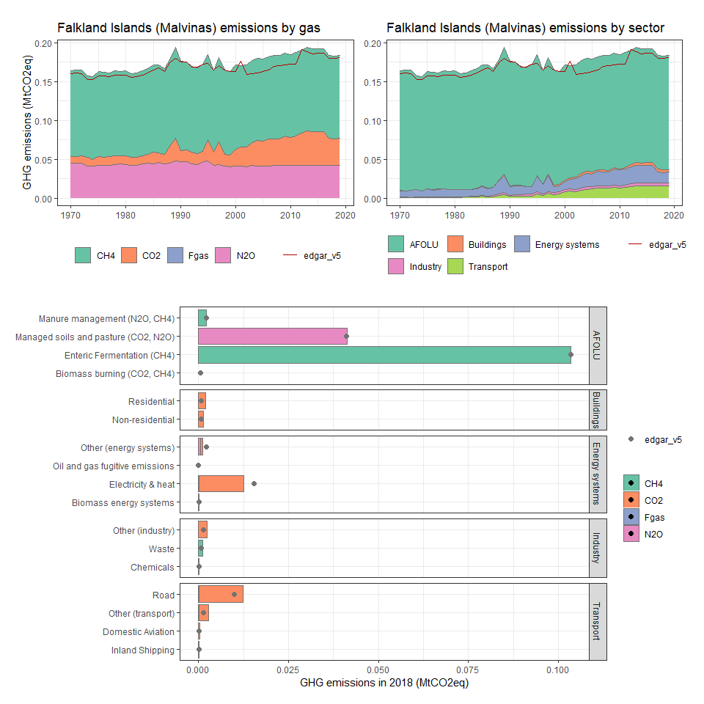

### Faroe Islands

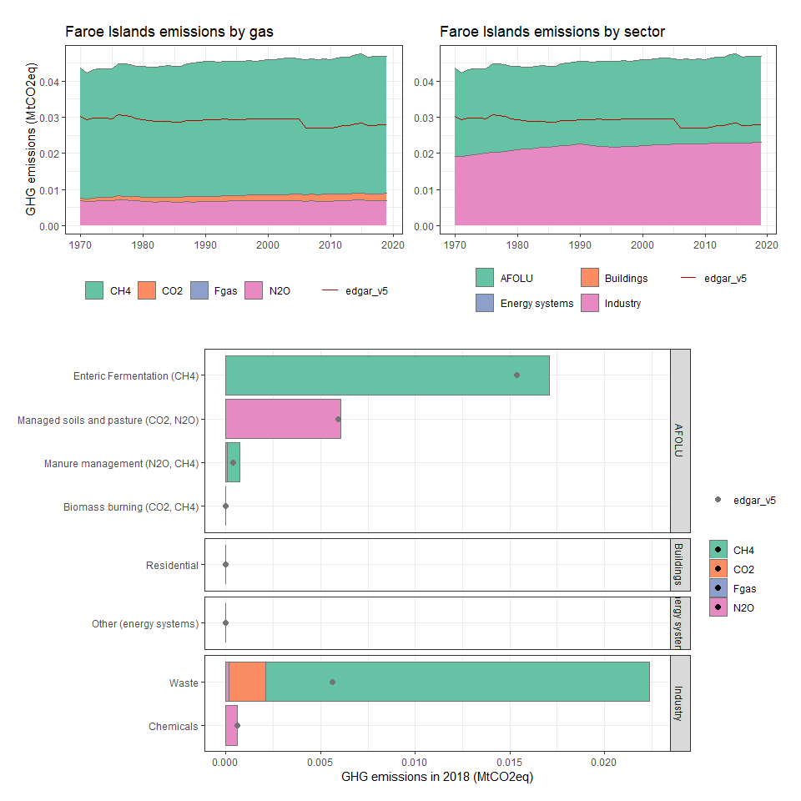

### Fiji

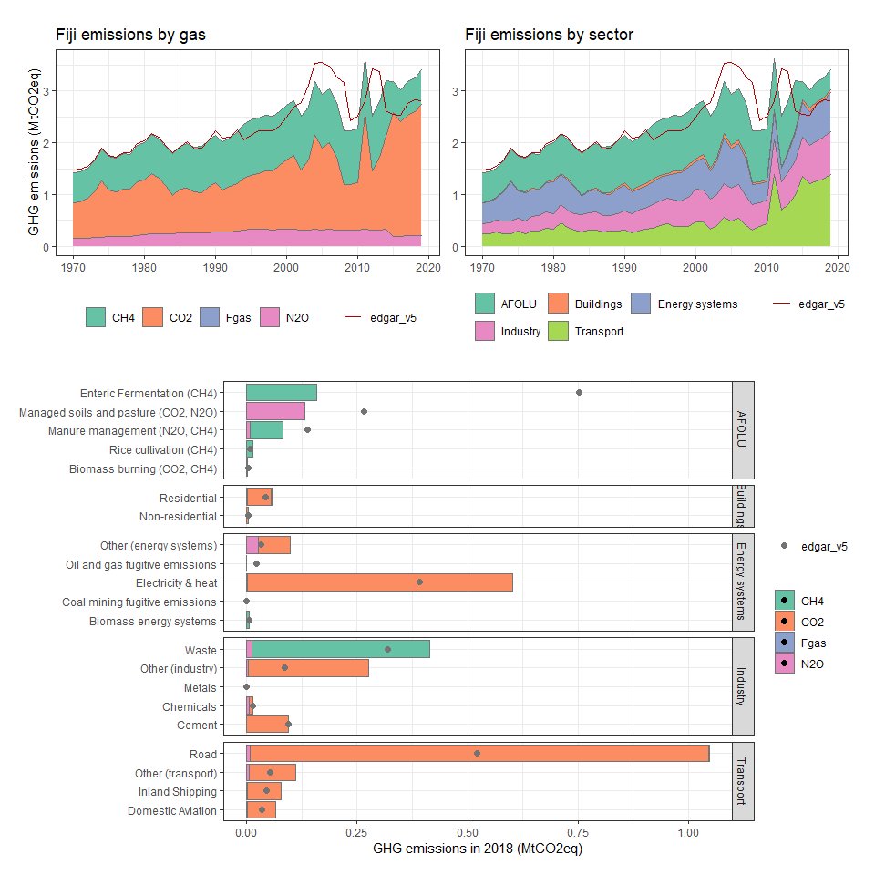

### Finland

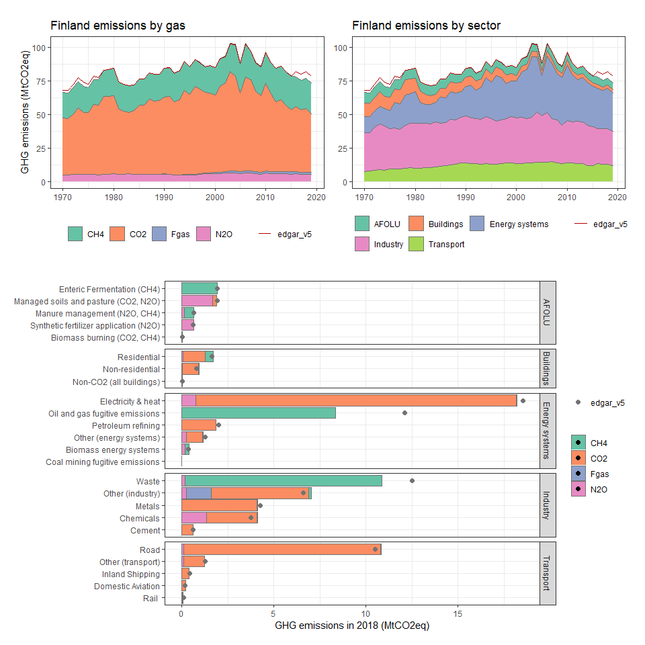

### France

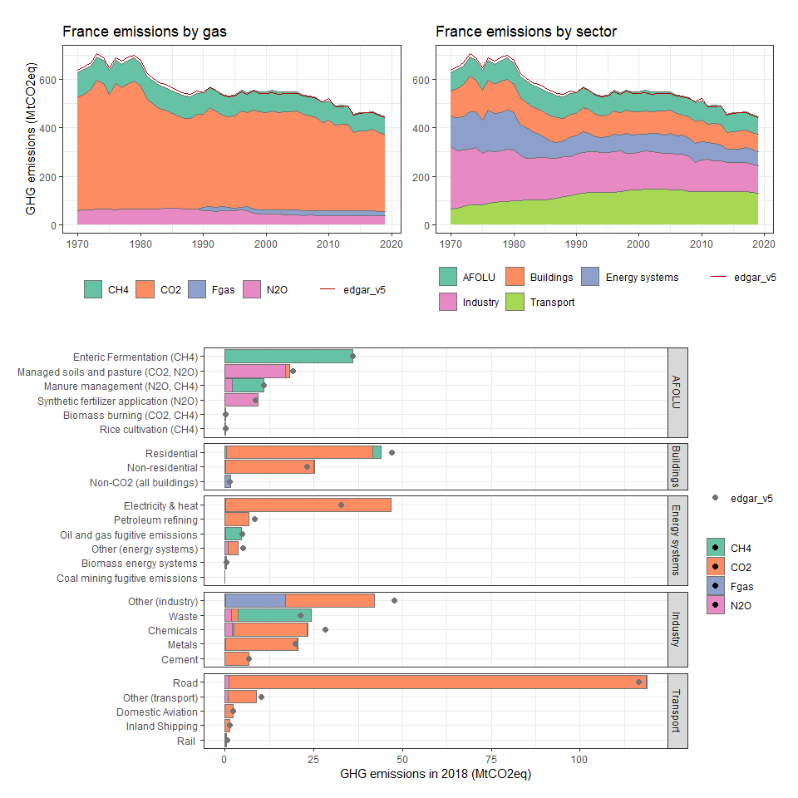

### French Guiana

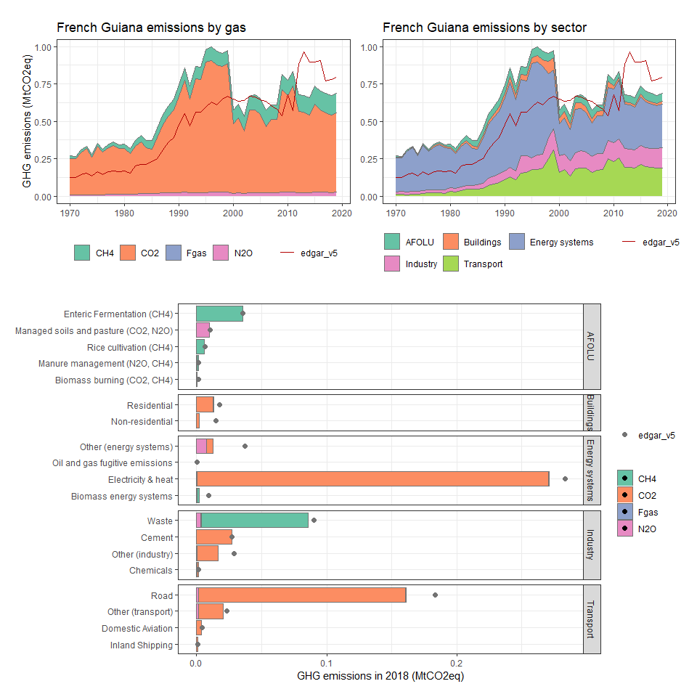

### French Polynesia

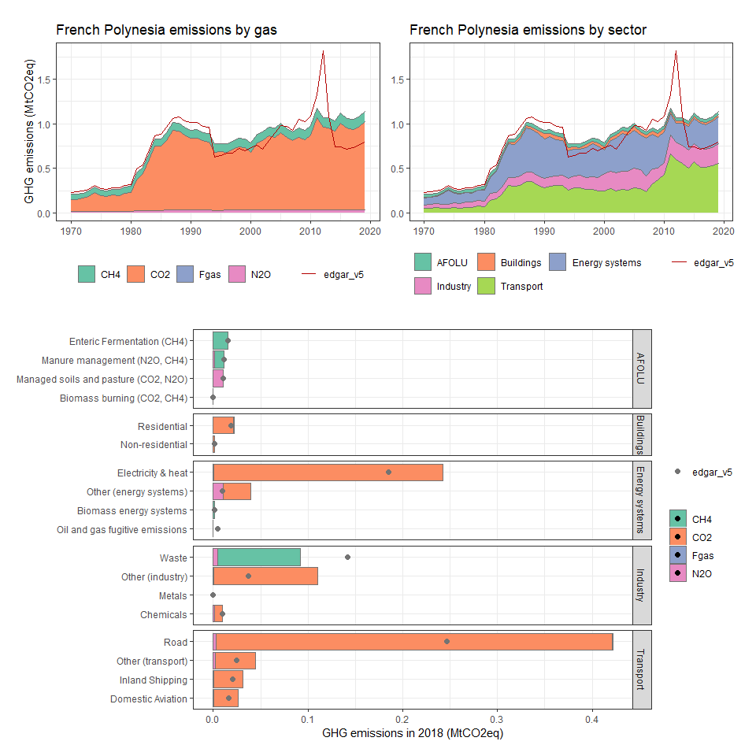

### French Southern Territories

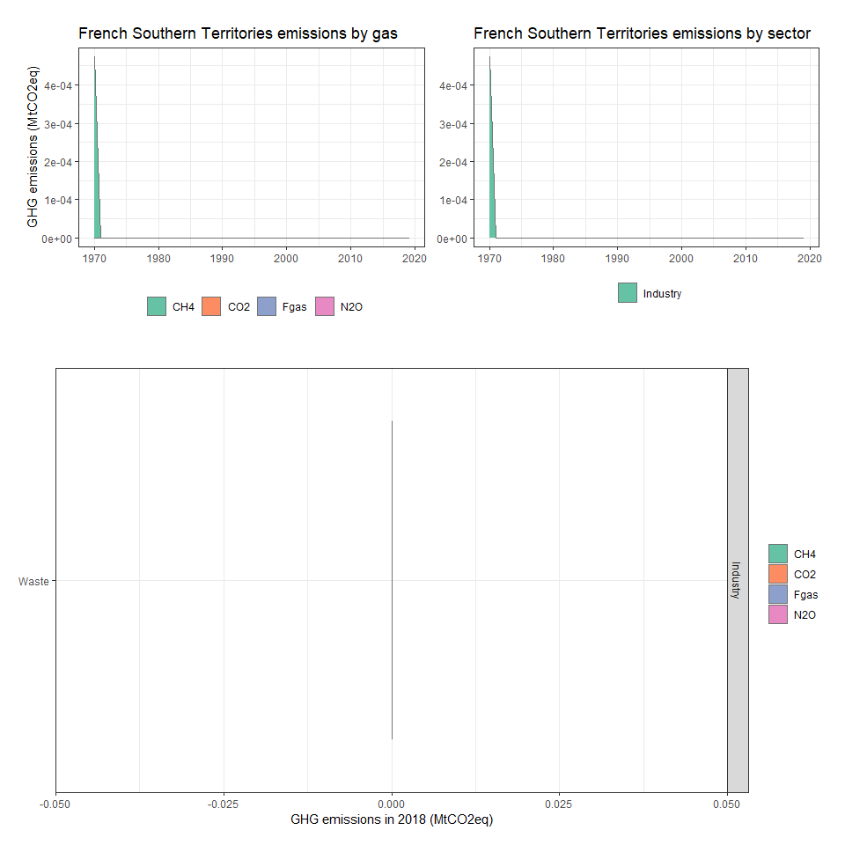

### Gabon

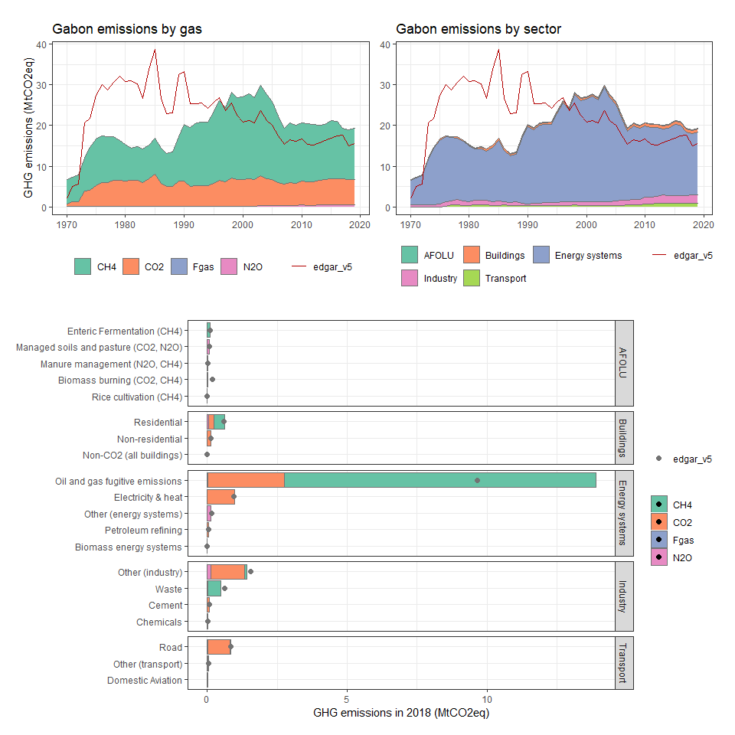

### Gambia, The

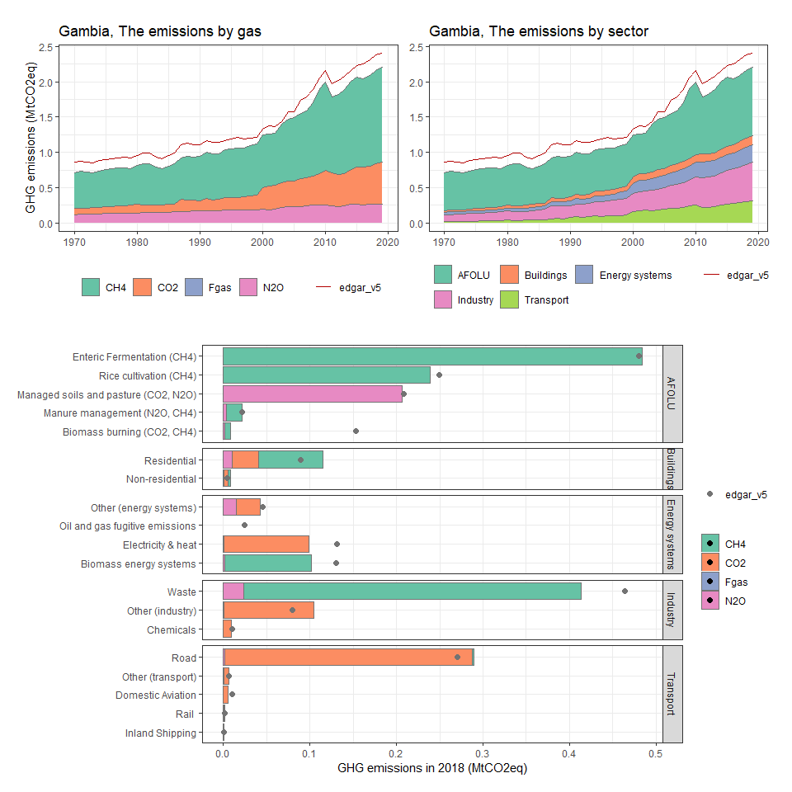

### Georgia

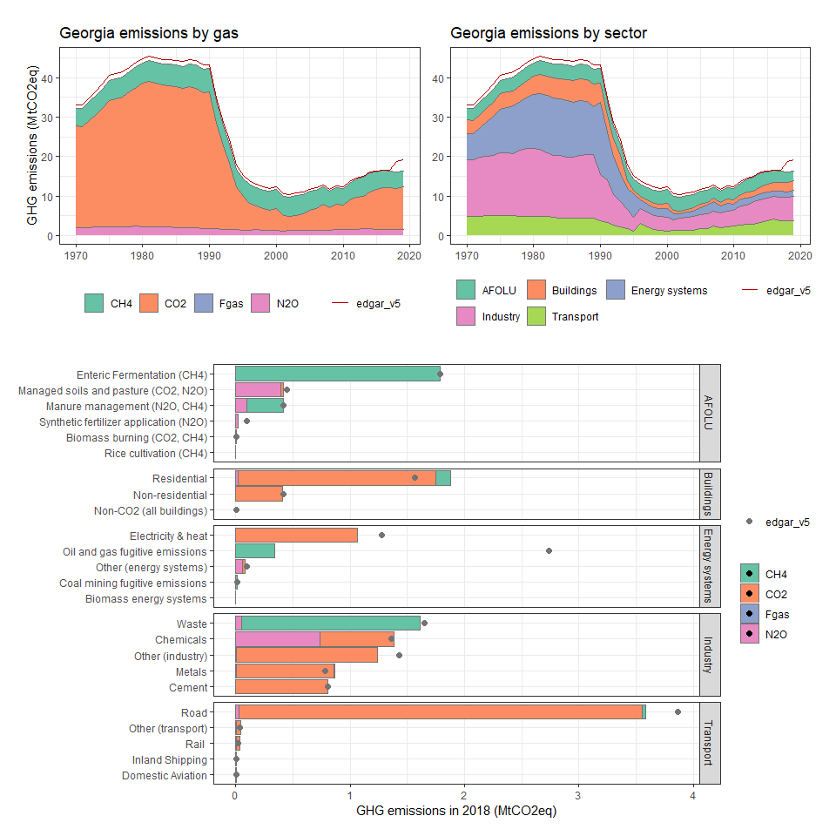

### Germany

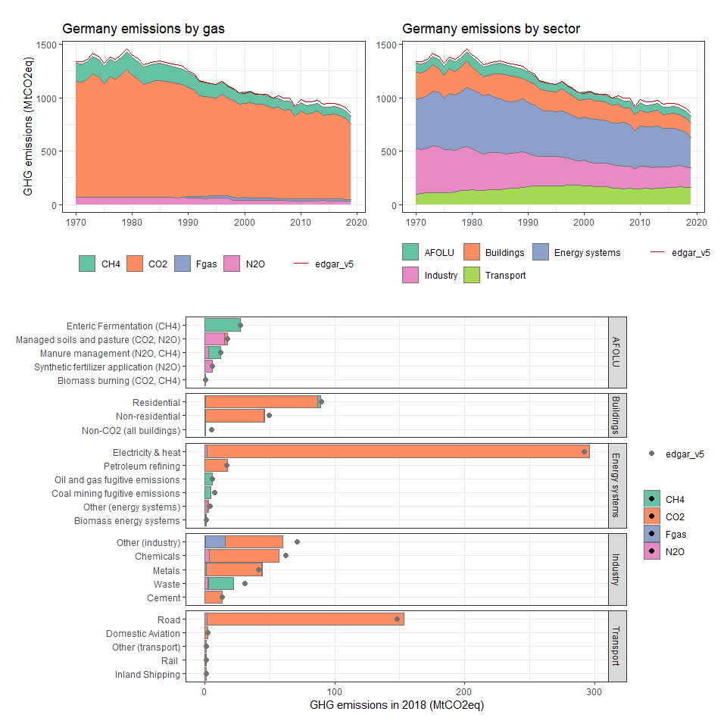

### Ghana

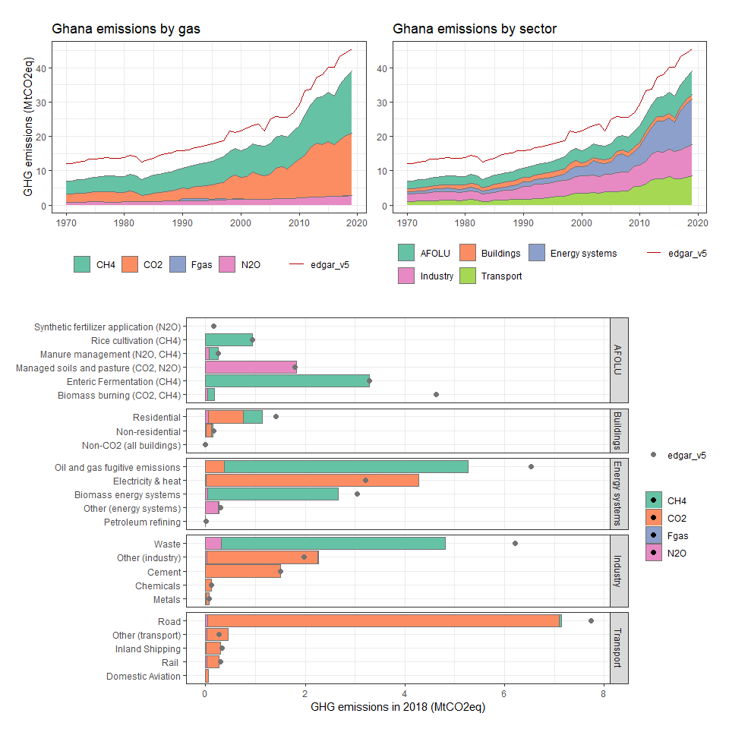

### Gibraltar

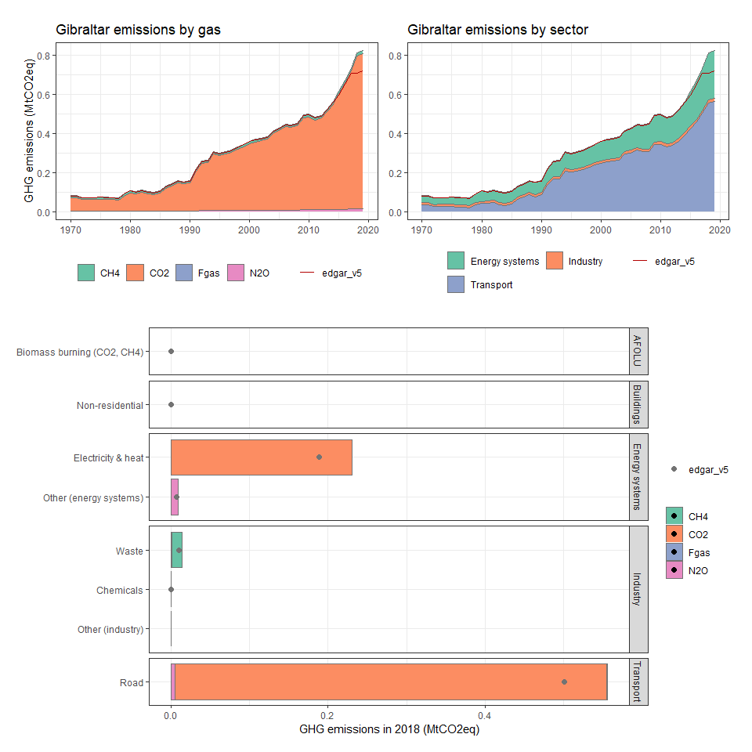

### Greece

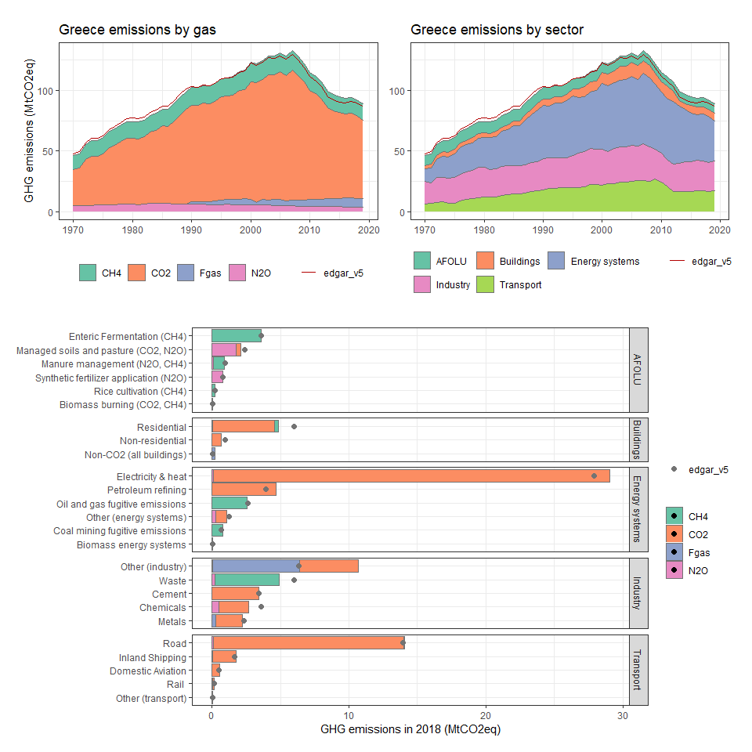

### Greenland

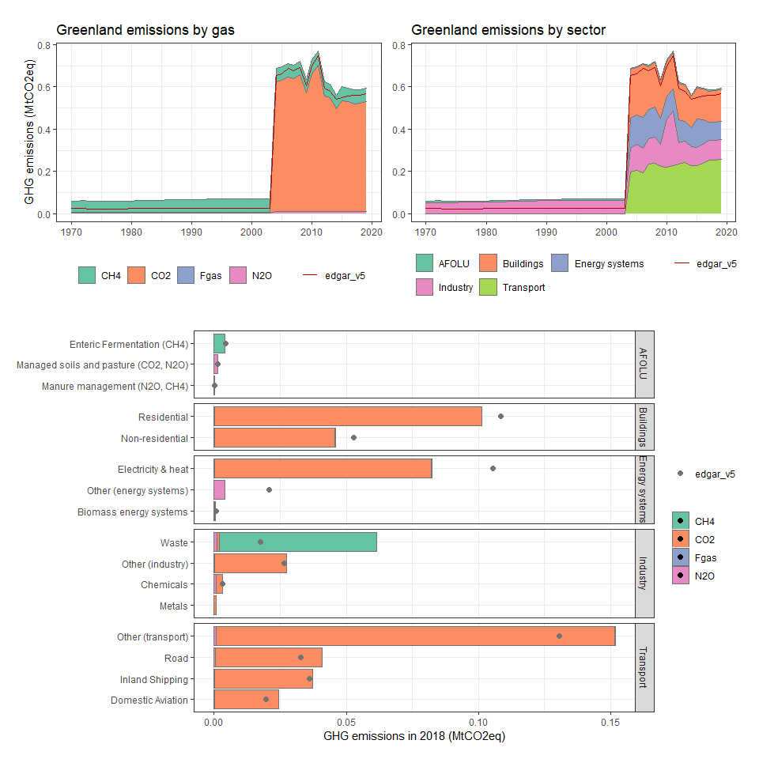

### Grenada

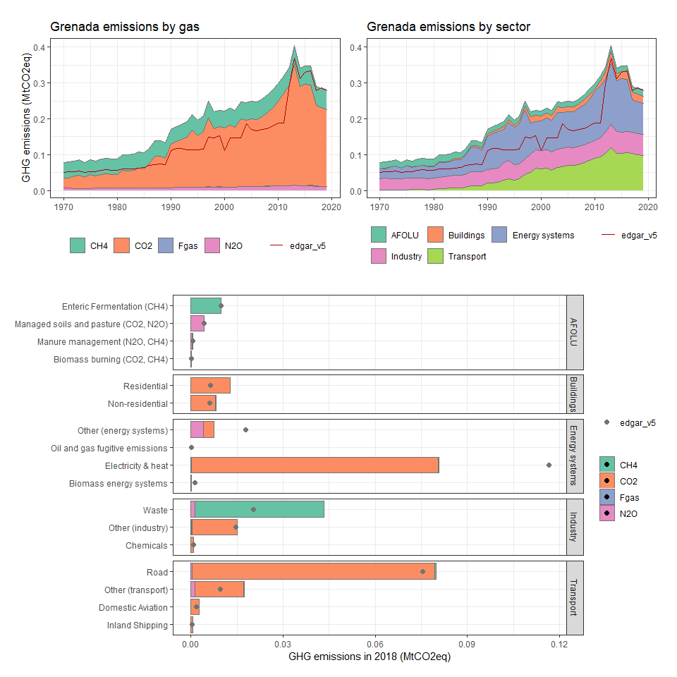

### Guadeloupe

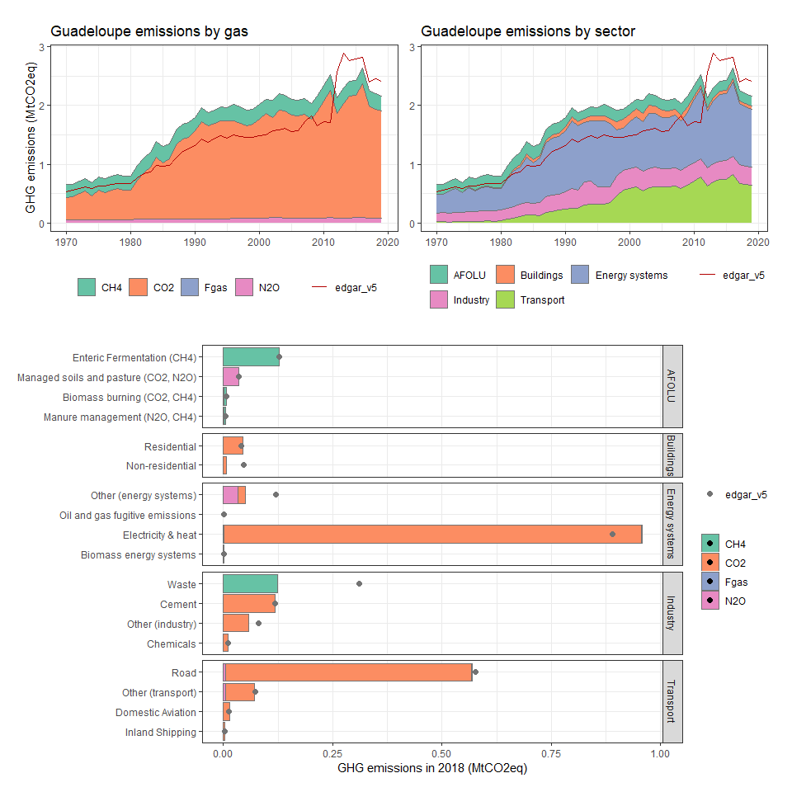

### Guam

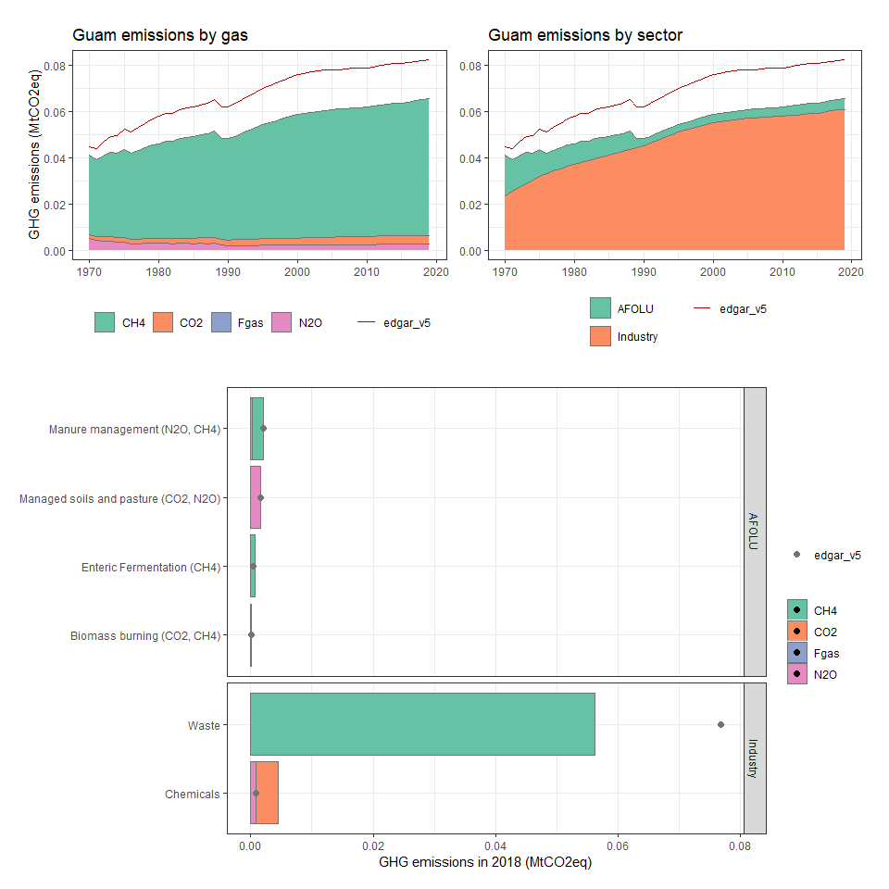

### Guatemala

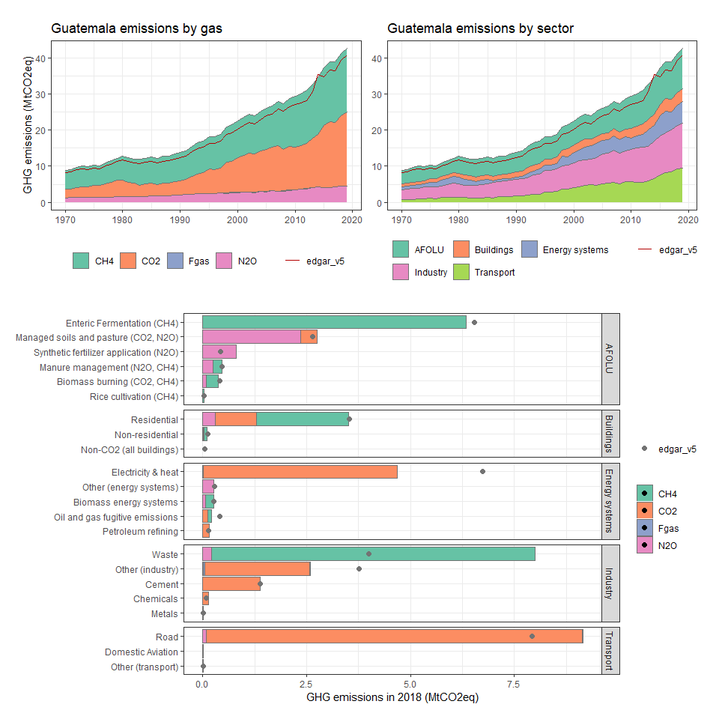

### Guinea

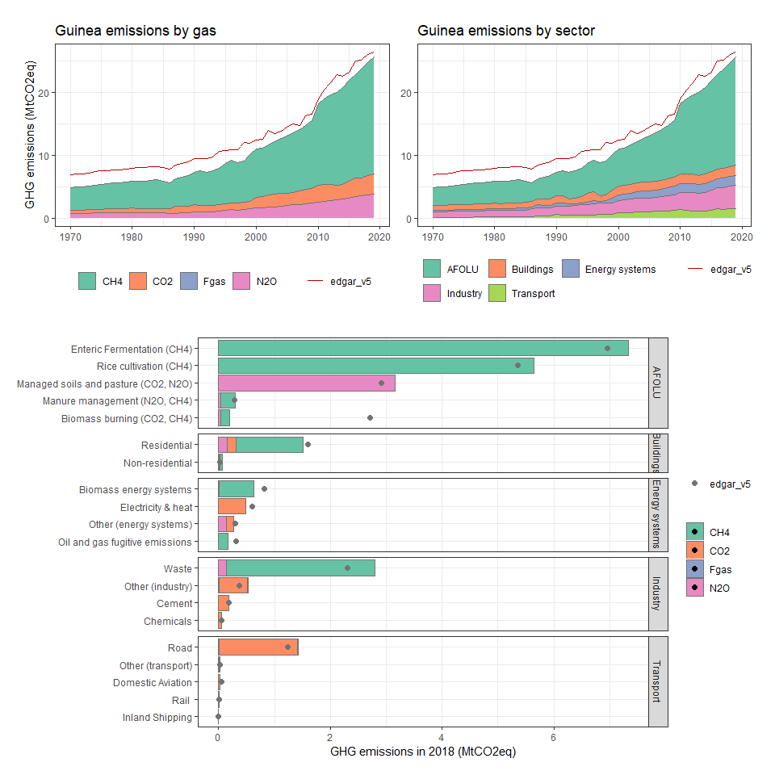

### Guinea-Bissau

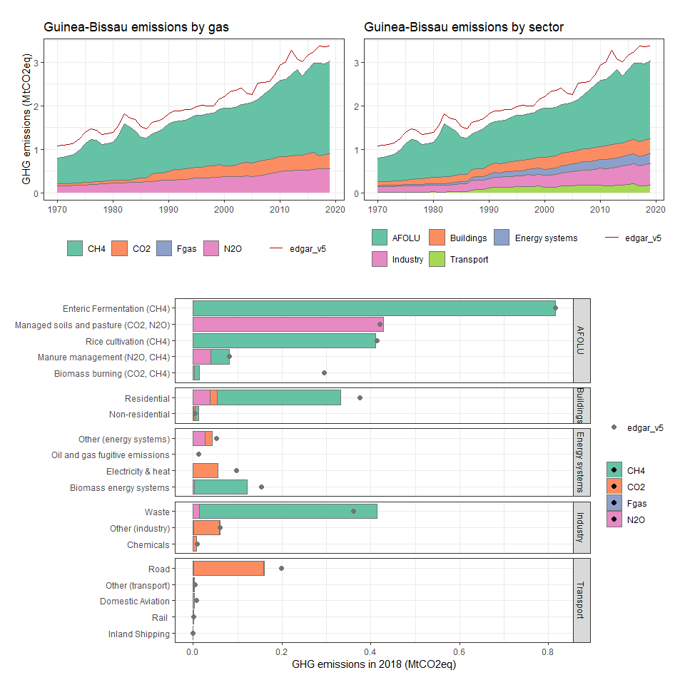

### Guyana

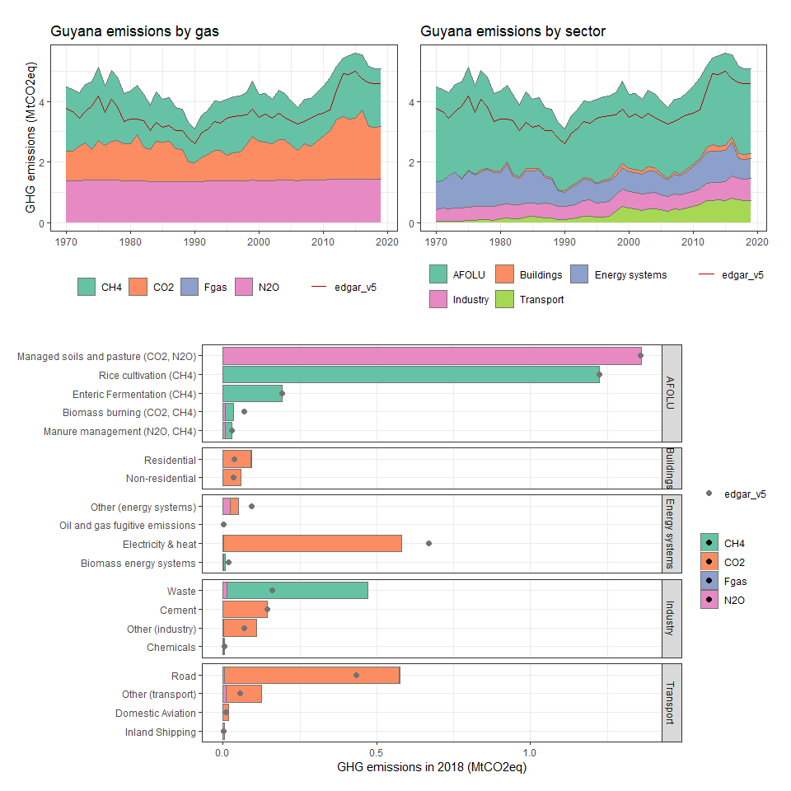

### Haiti

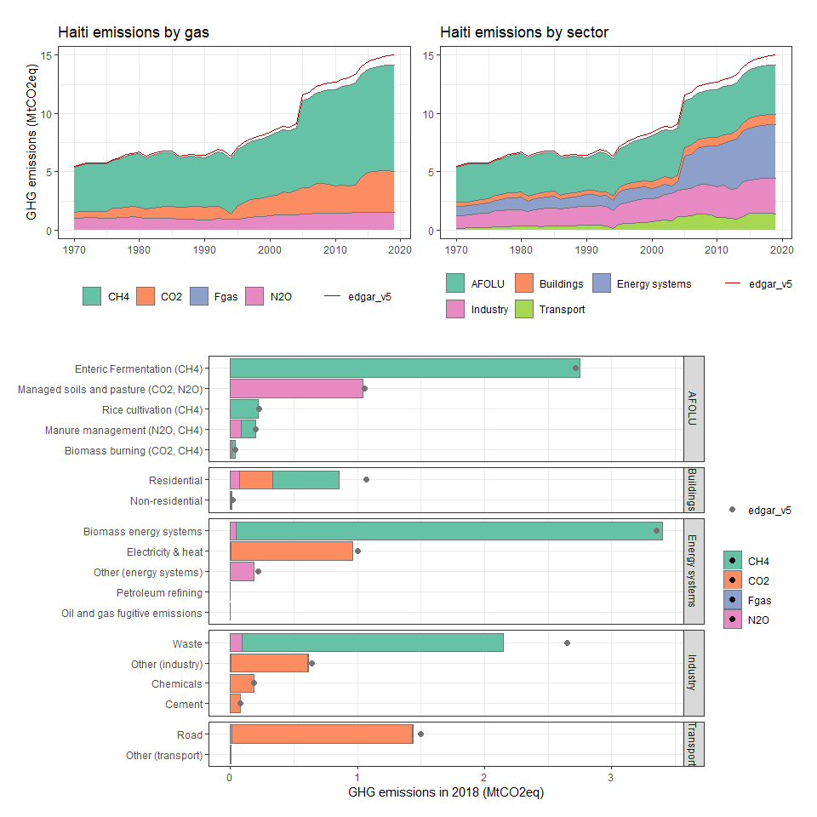

### Heard Island and McDonald Islands

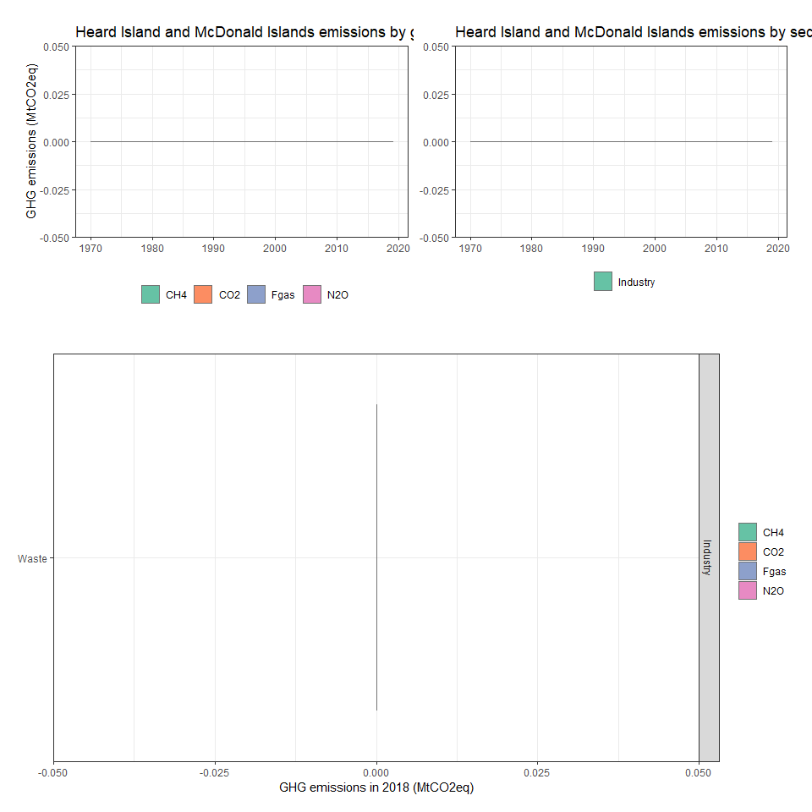

### Honduras

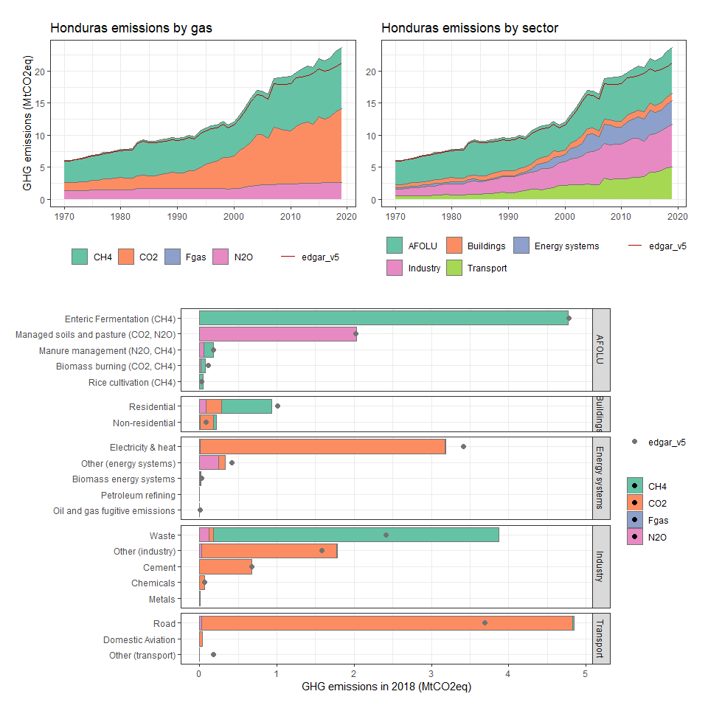

### Hong Kong SAR, China

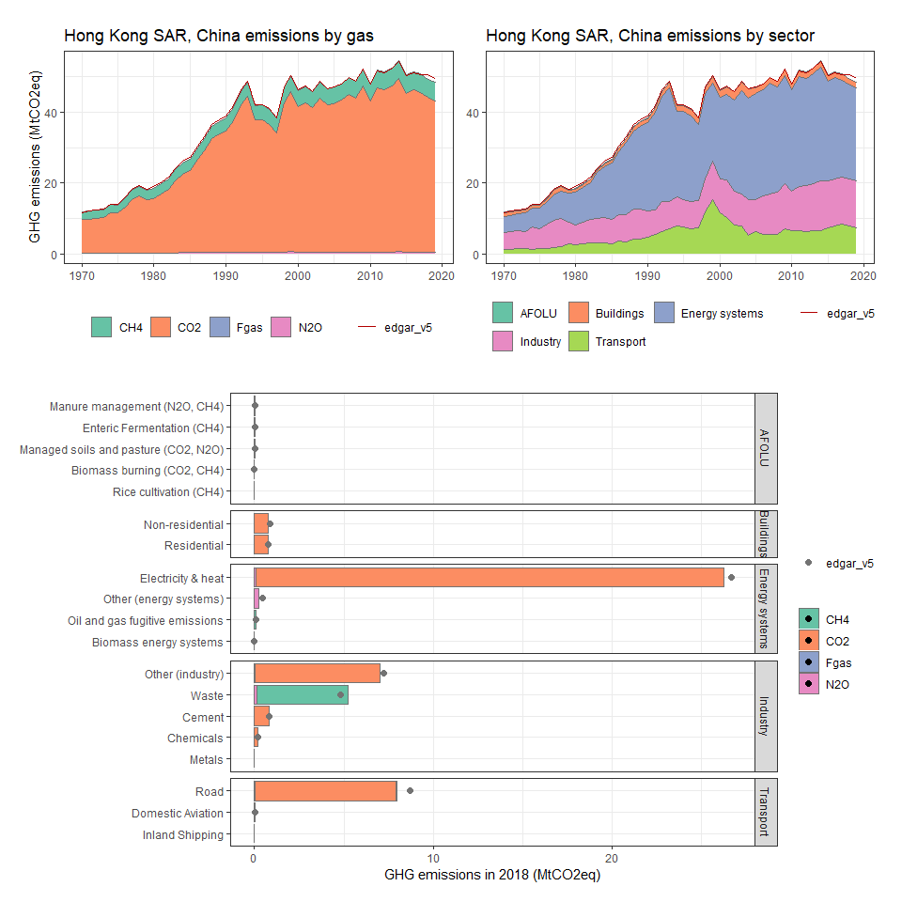

### Hungary

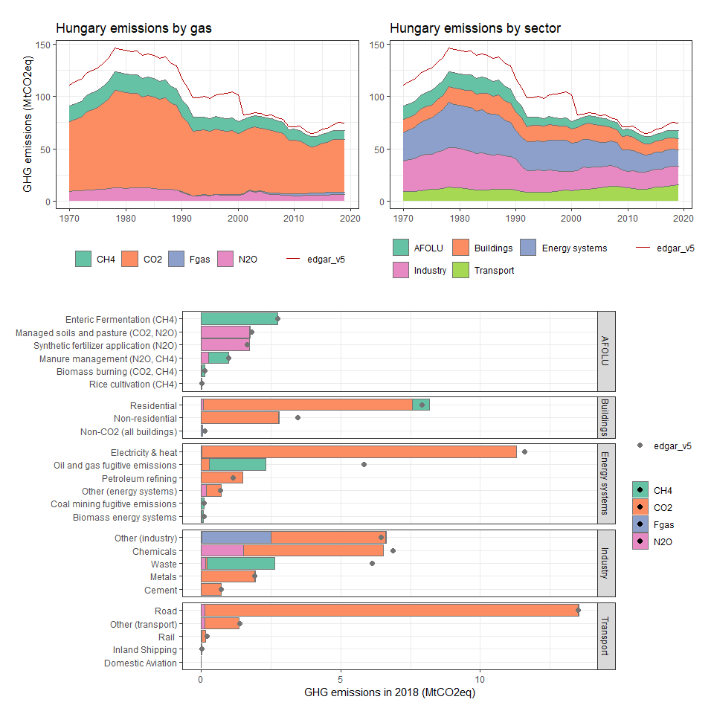

### Iceland

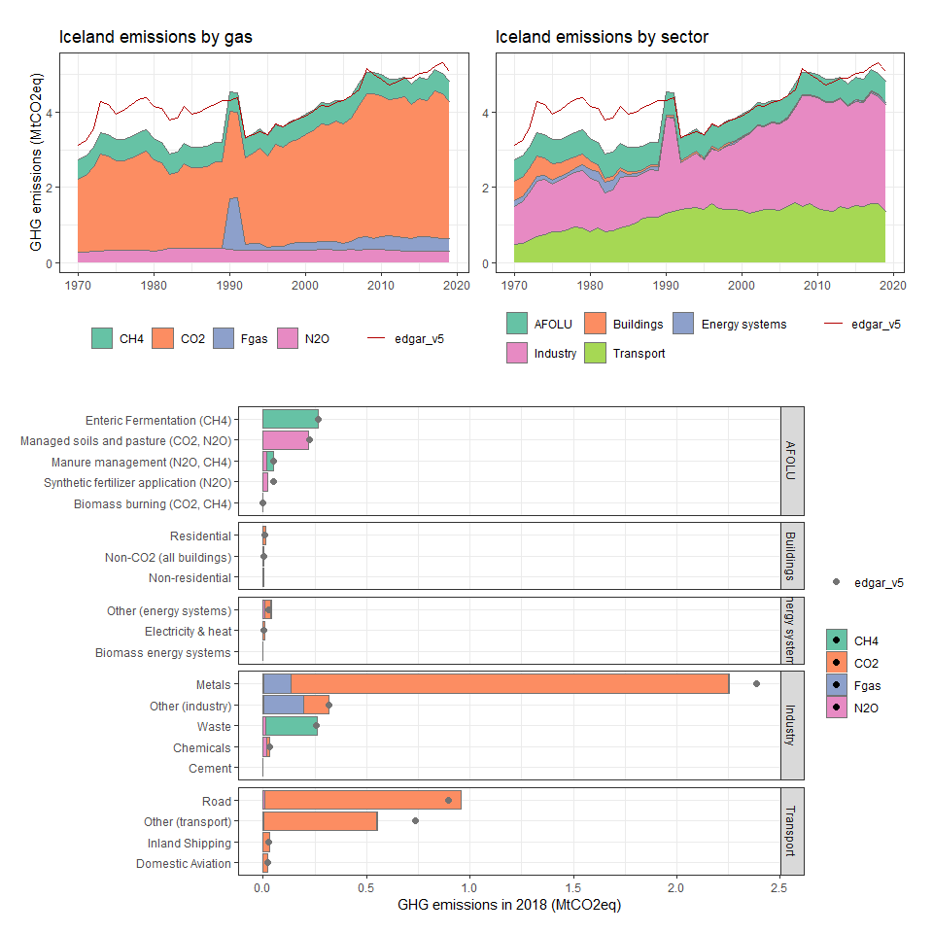

### India

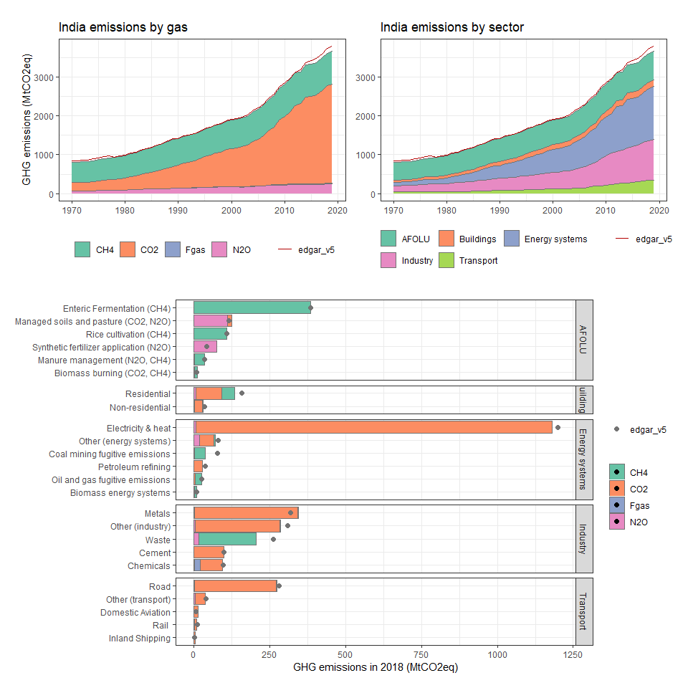

### Indonesia

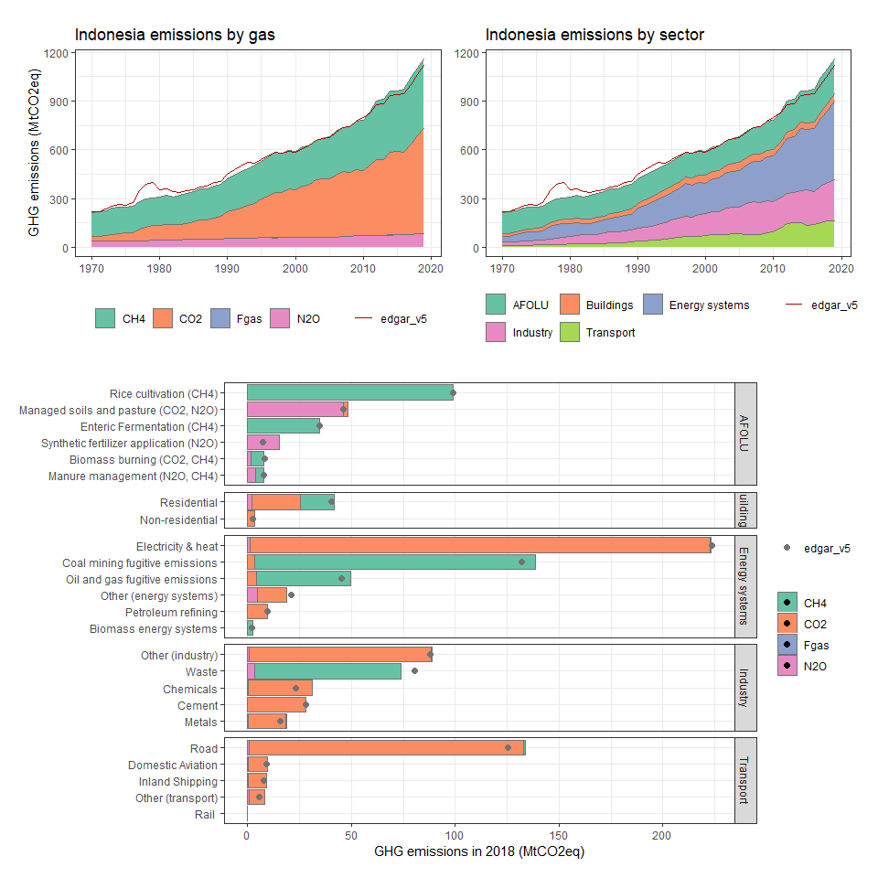

### Int. Aviation

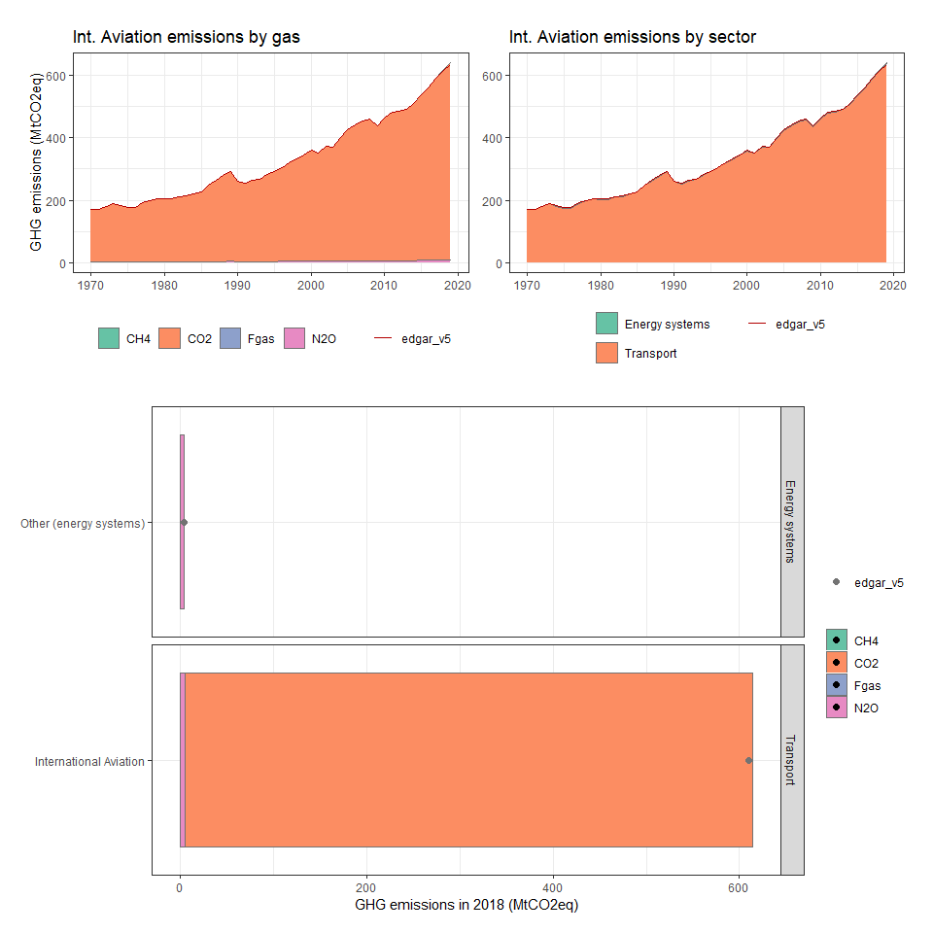

### Int. Shipping

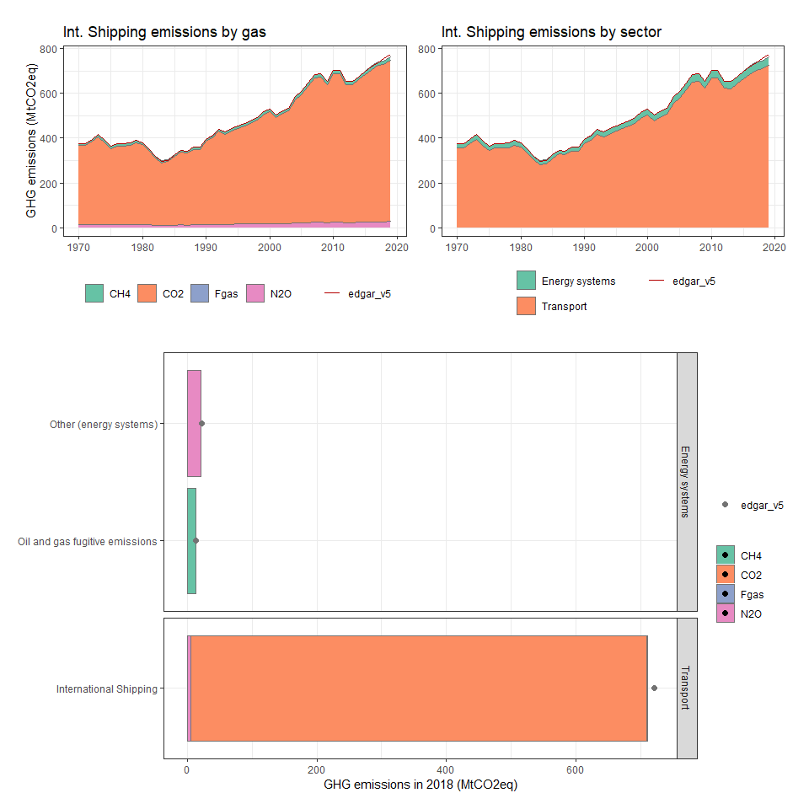

### Iran, Islamic Rep.

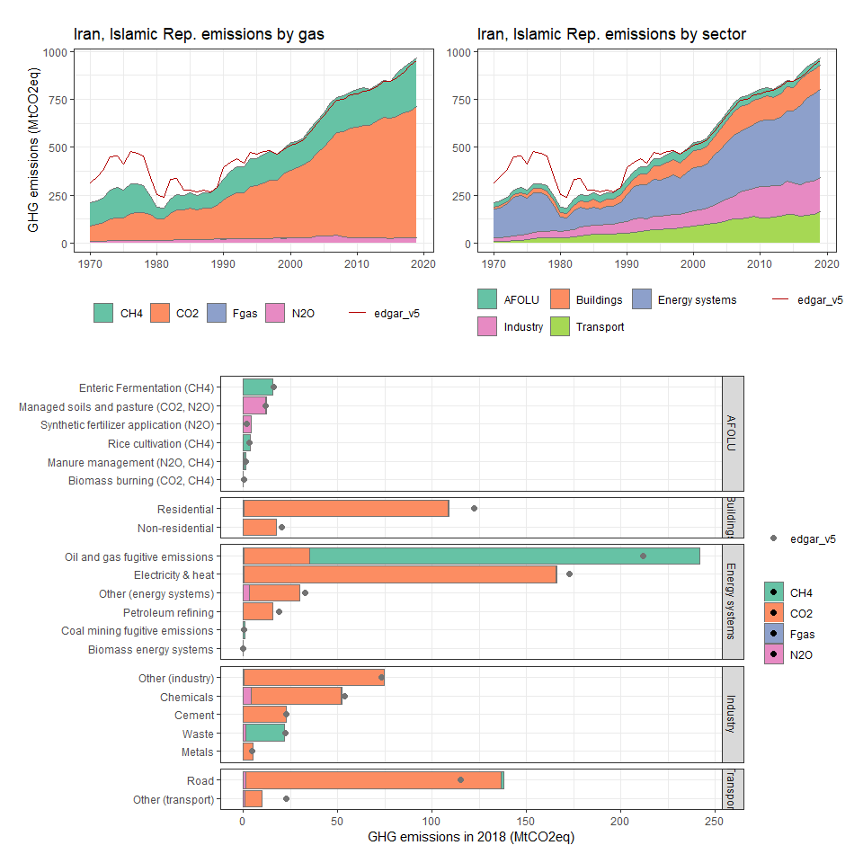

### Iraq

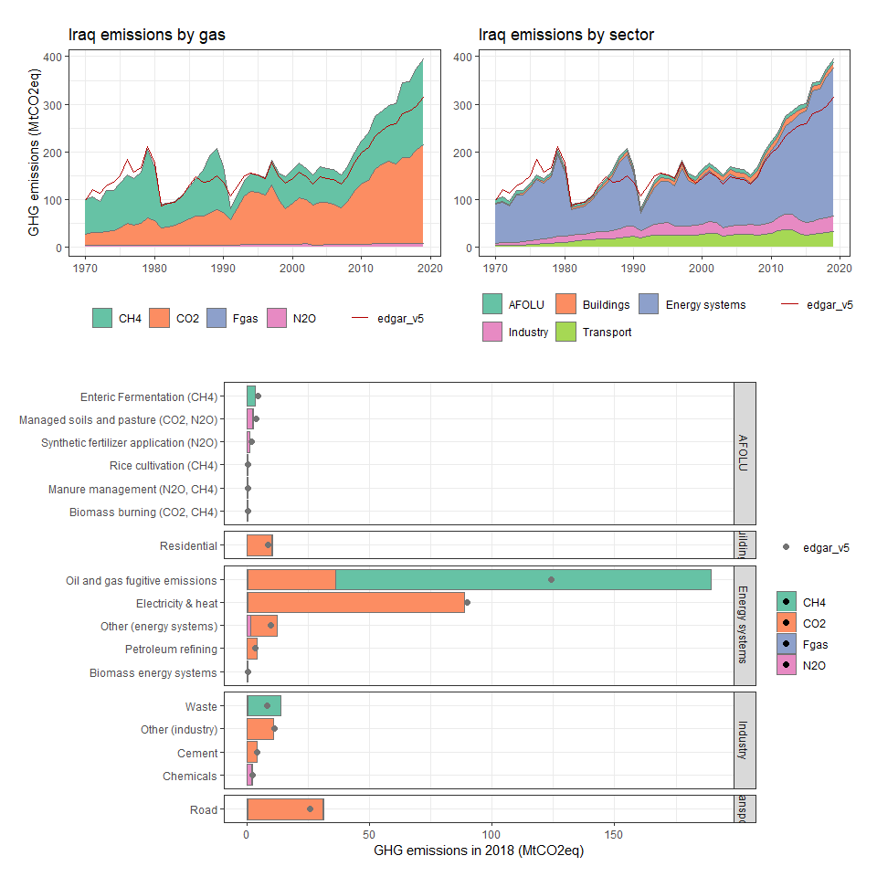

### Ireland

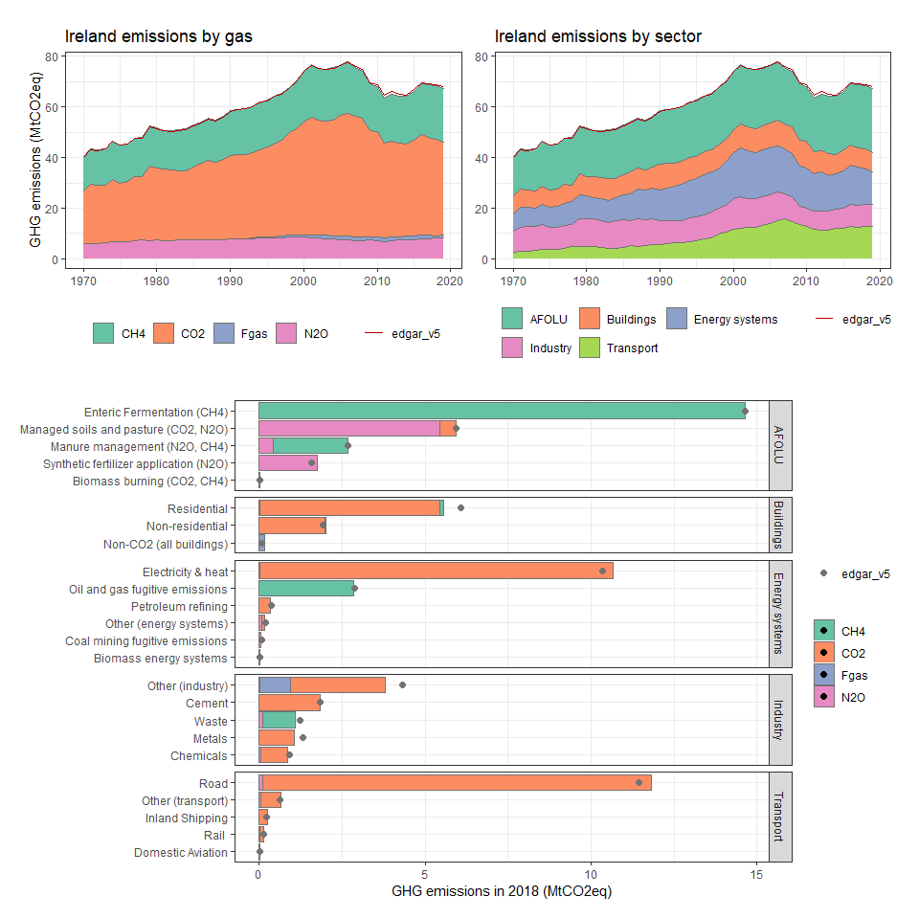

### Israel

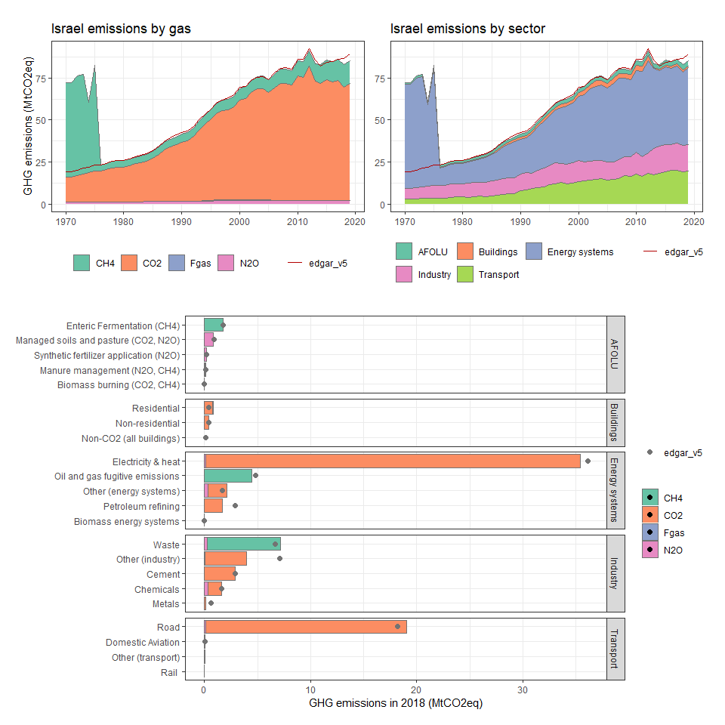

### Italy

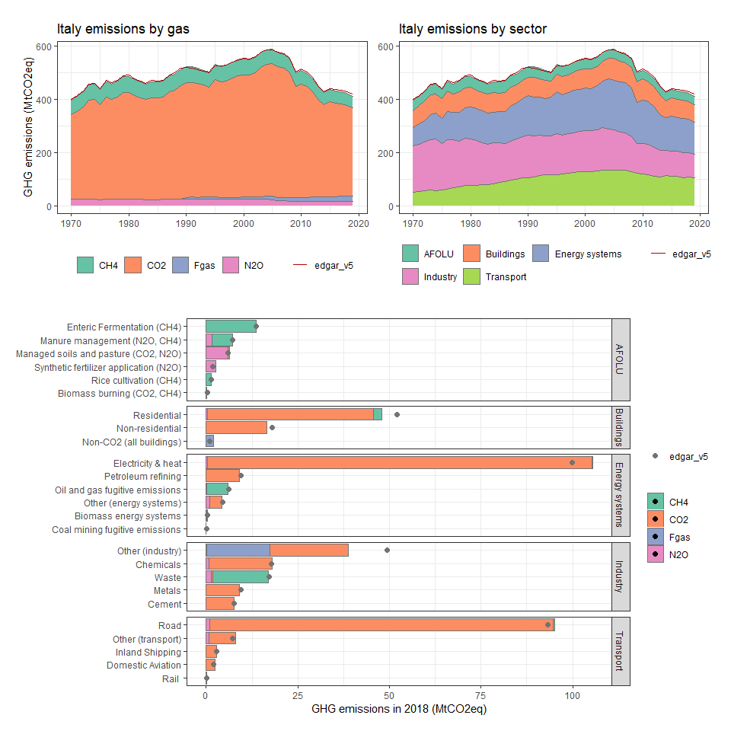

### Jamaica

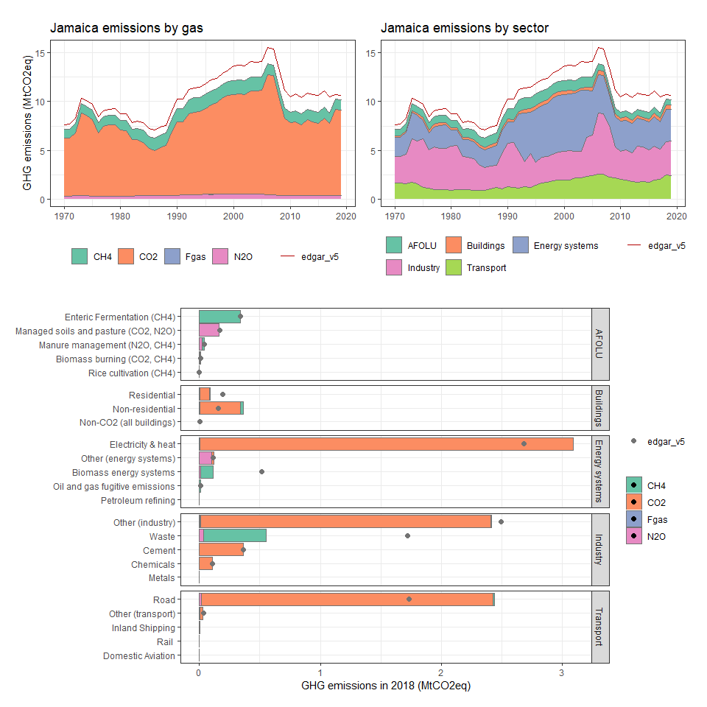

### Japan

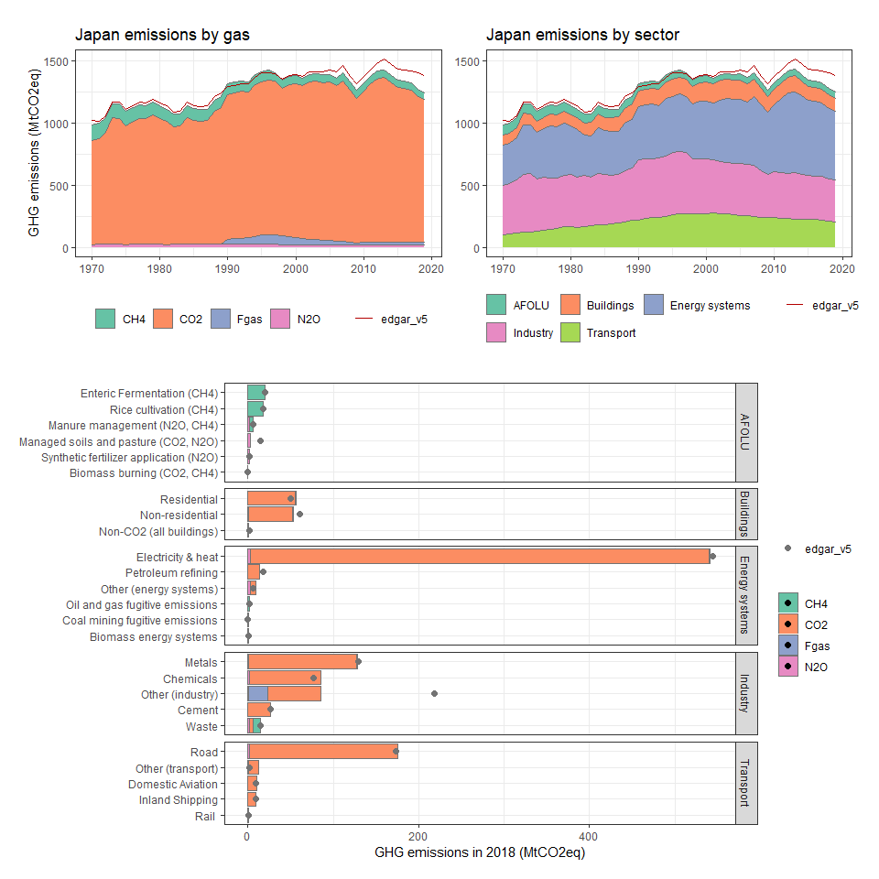

### Jordan

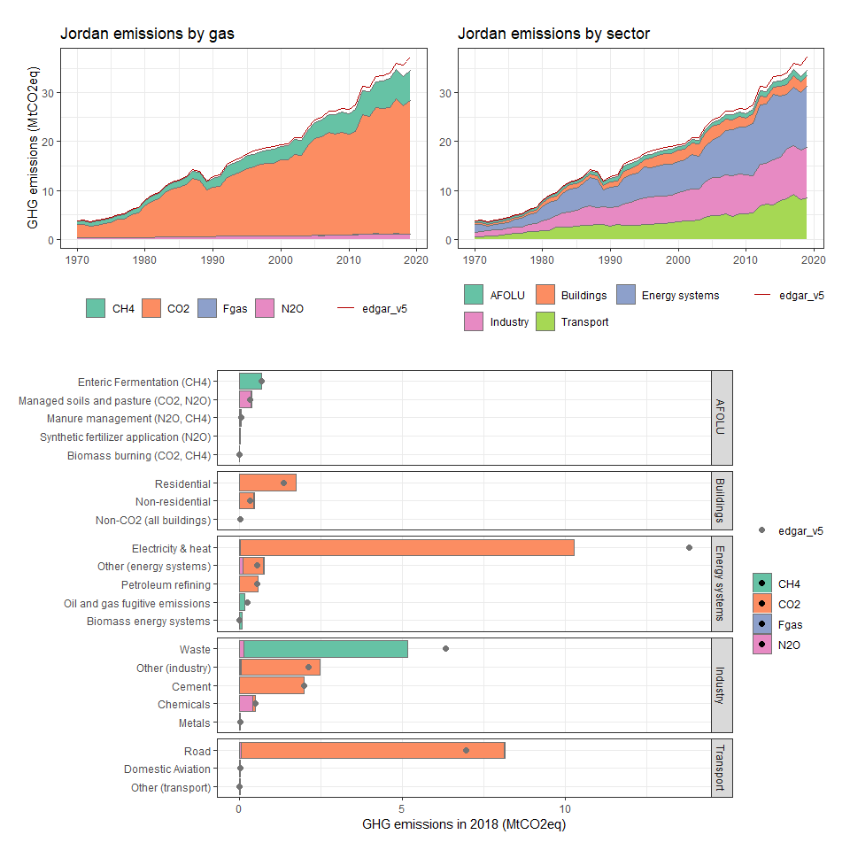

### Kazakhstan

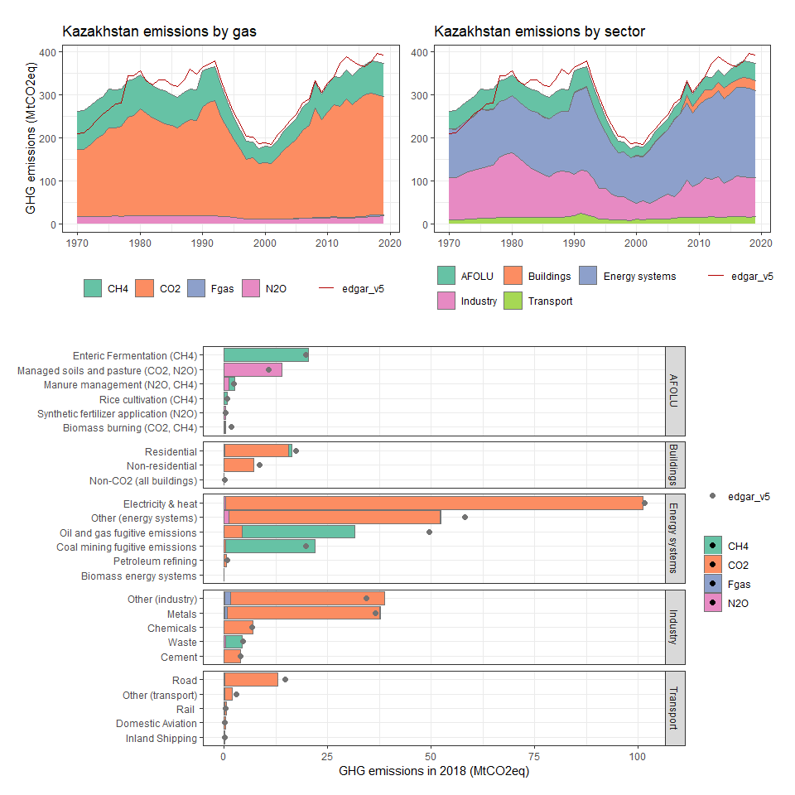

### Kenya

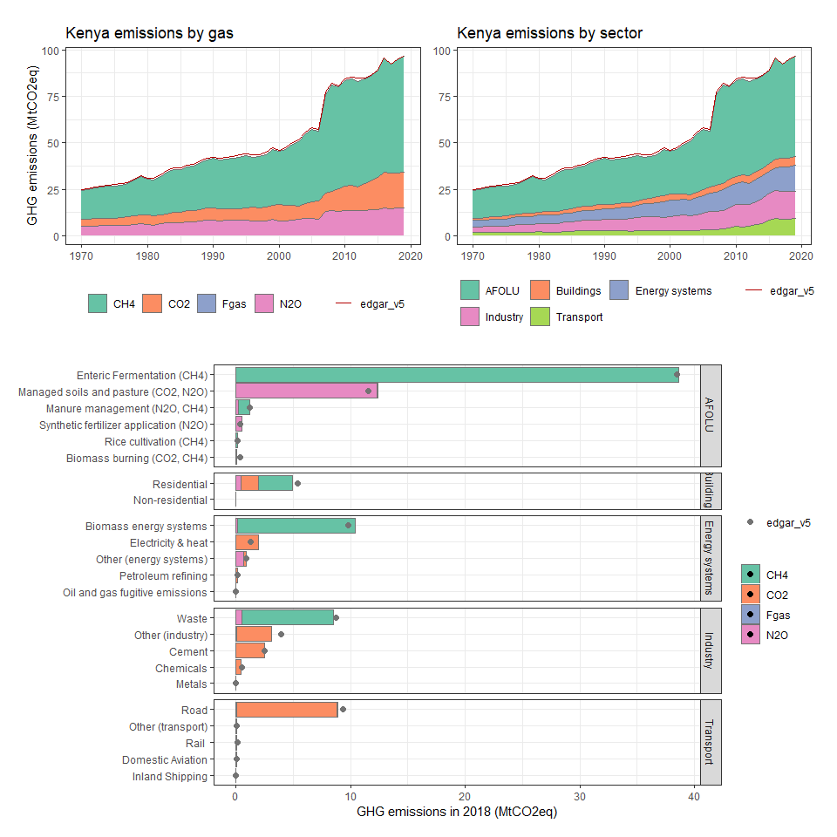

### Kiribati

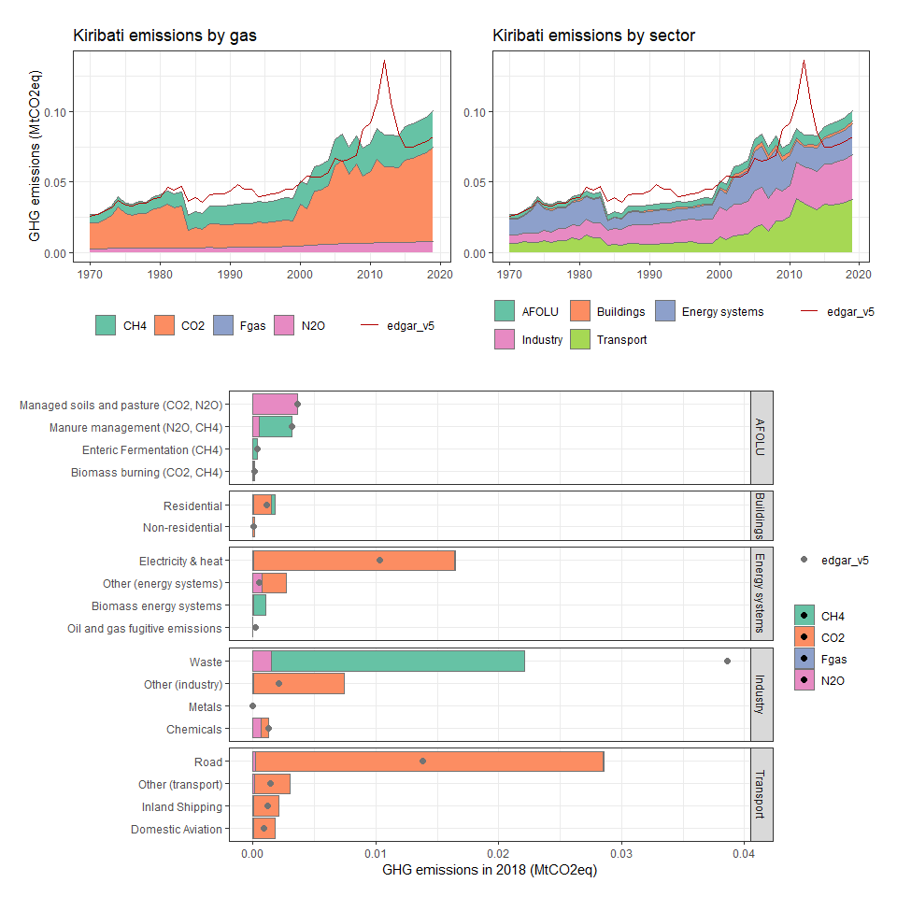

### Korea, Dem. People’s Rep.

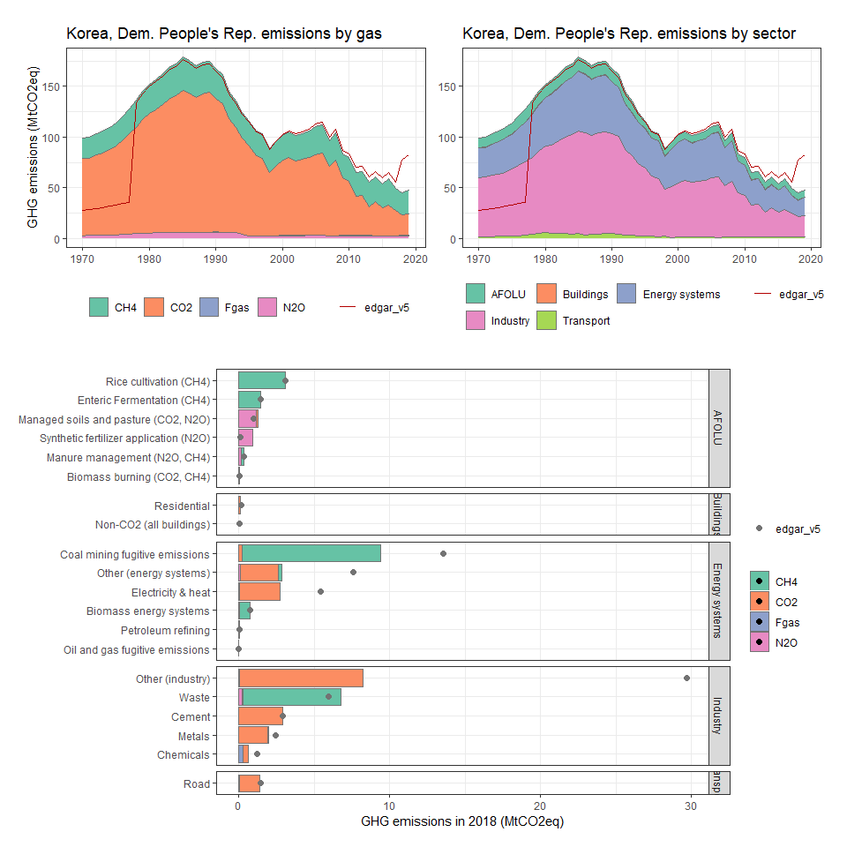

### Korea, Rep.

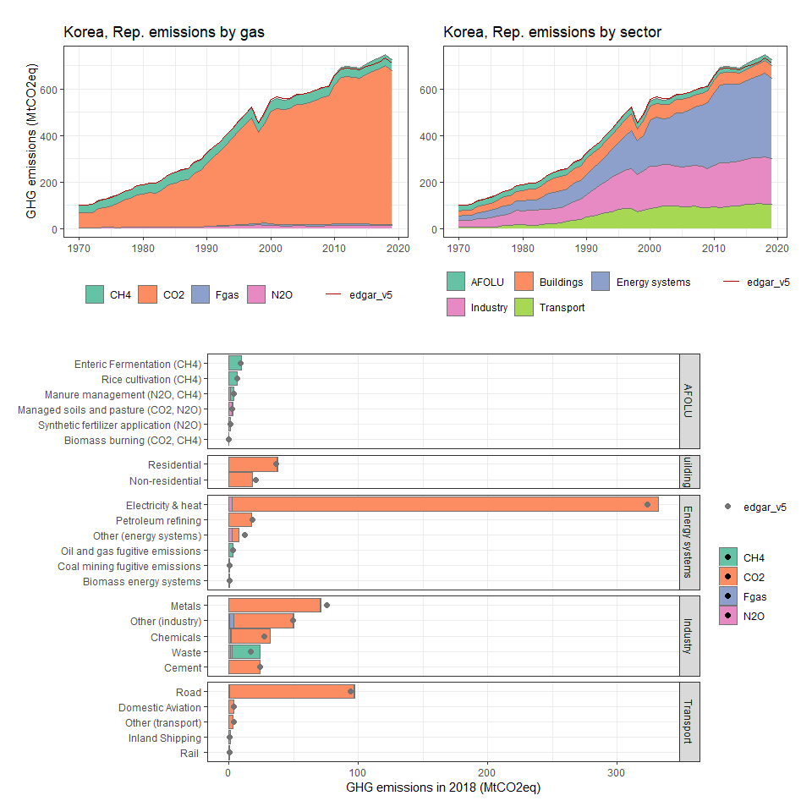

### Kuwait

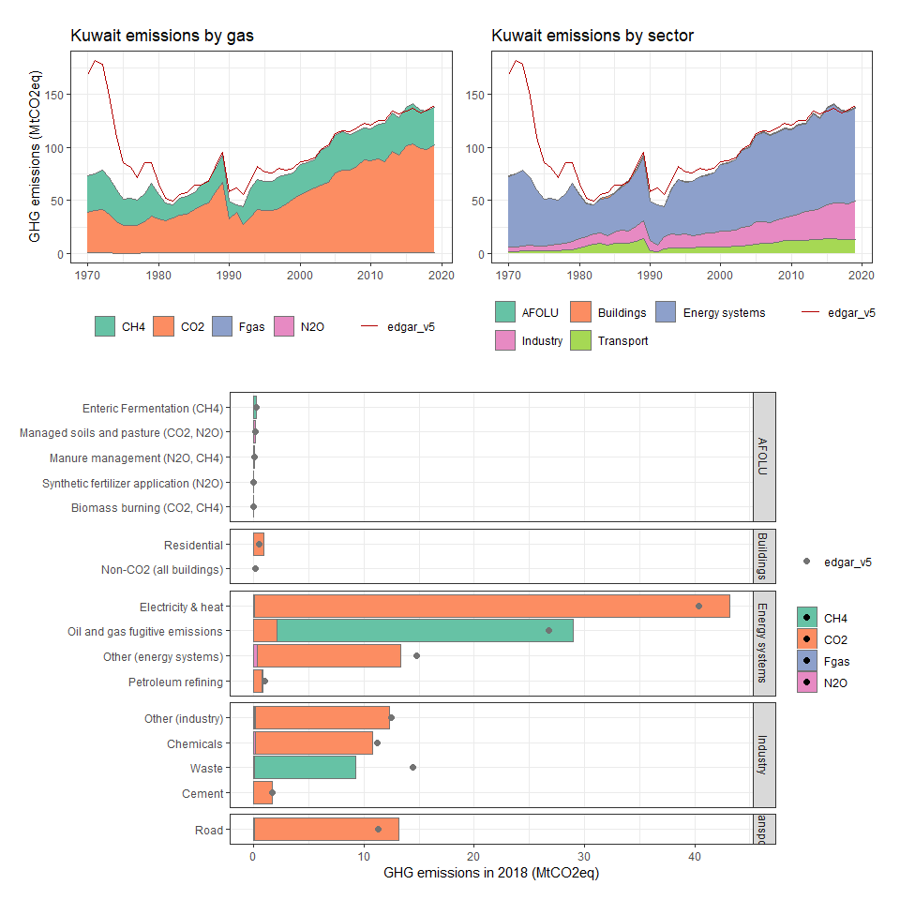

### Kyrgyz Republic

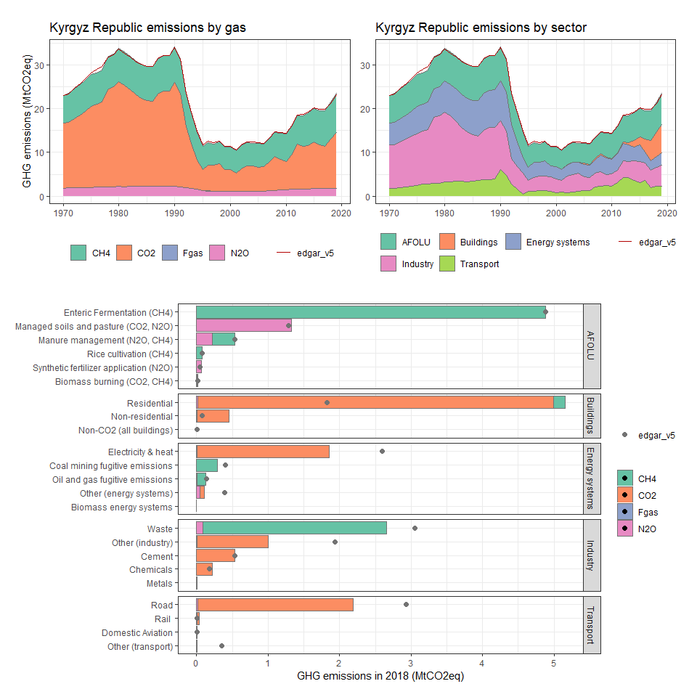

### Lao PDR

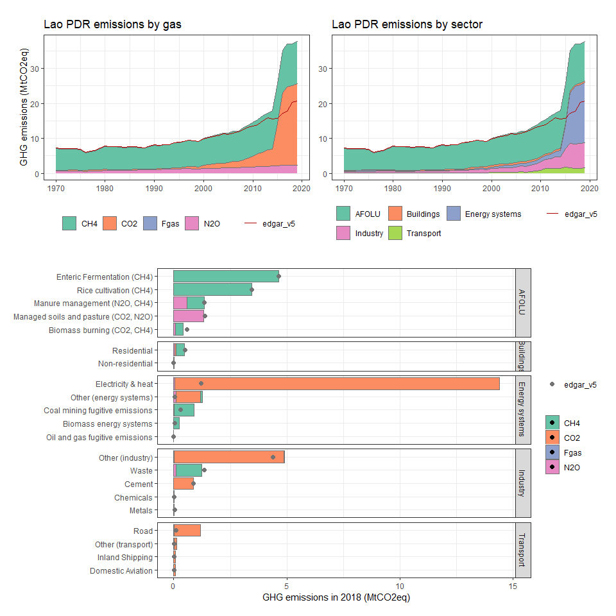

### Latvia

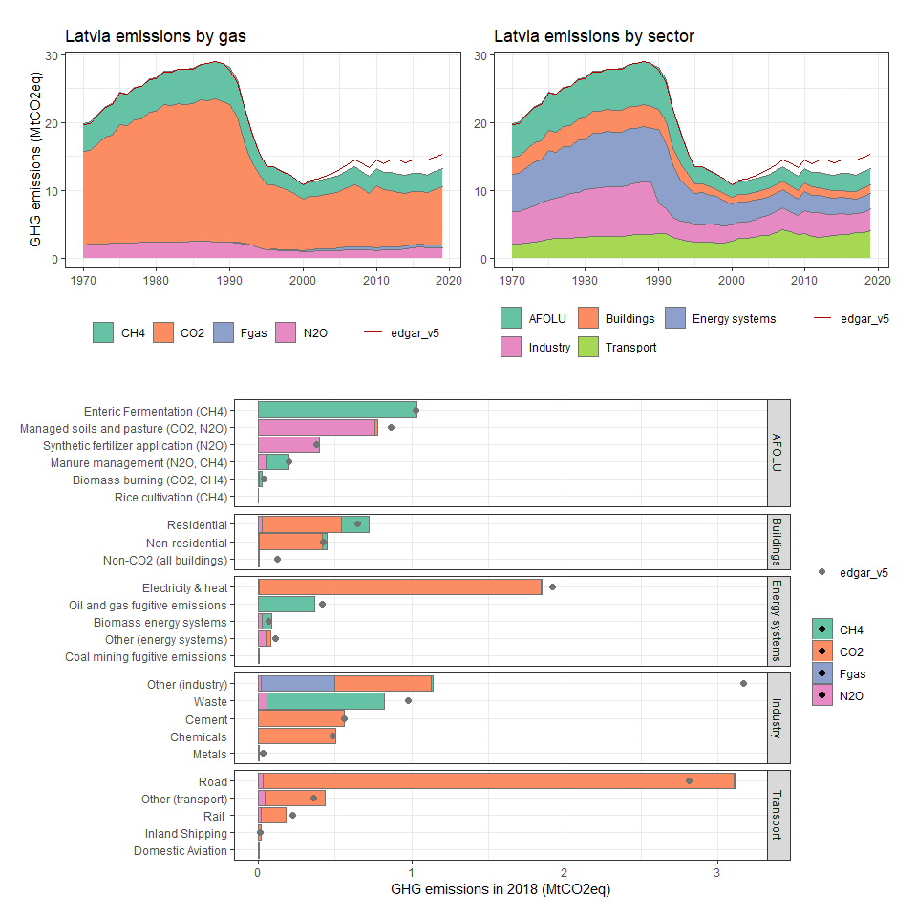

### Lebanon

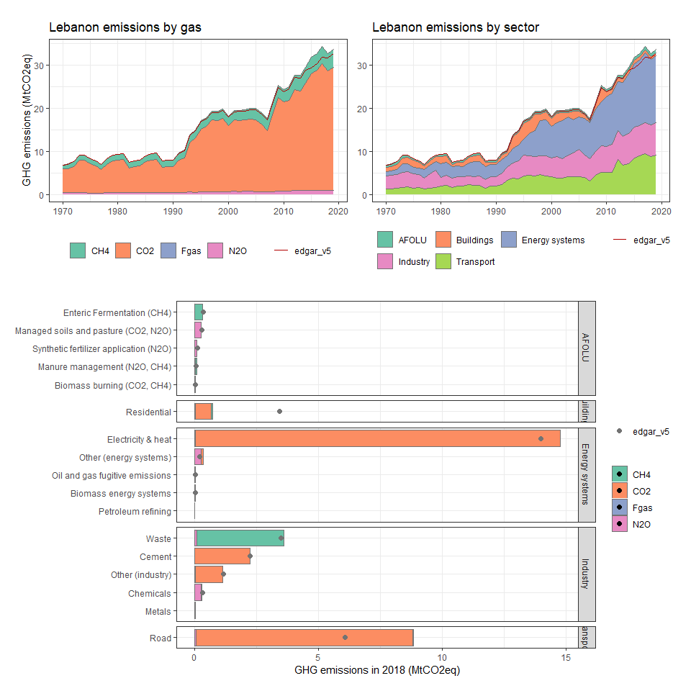

### Lesotho

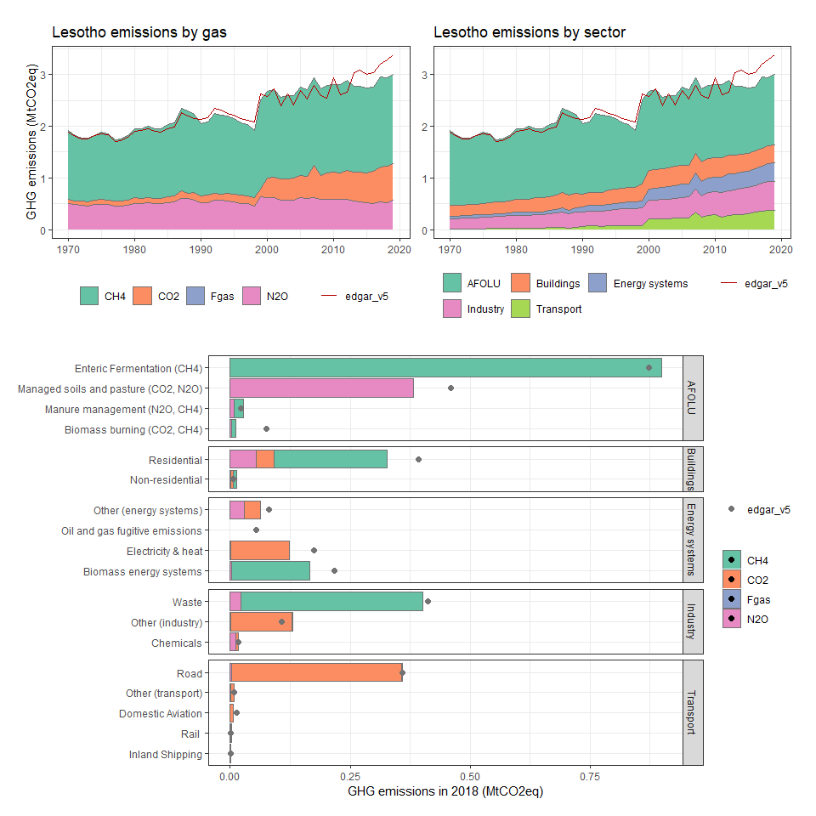

### Liberia

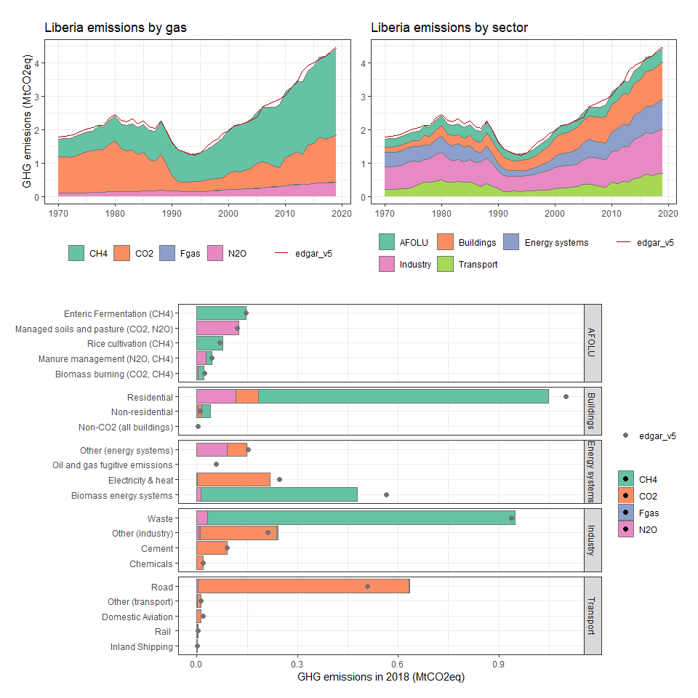

### Libya

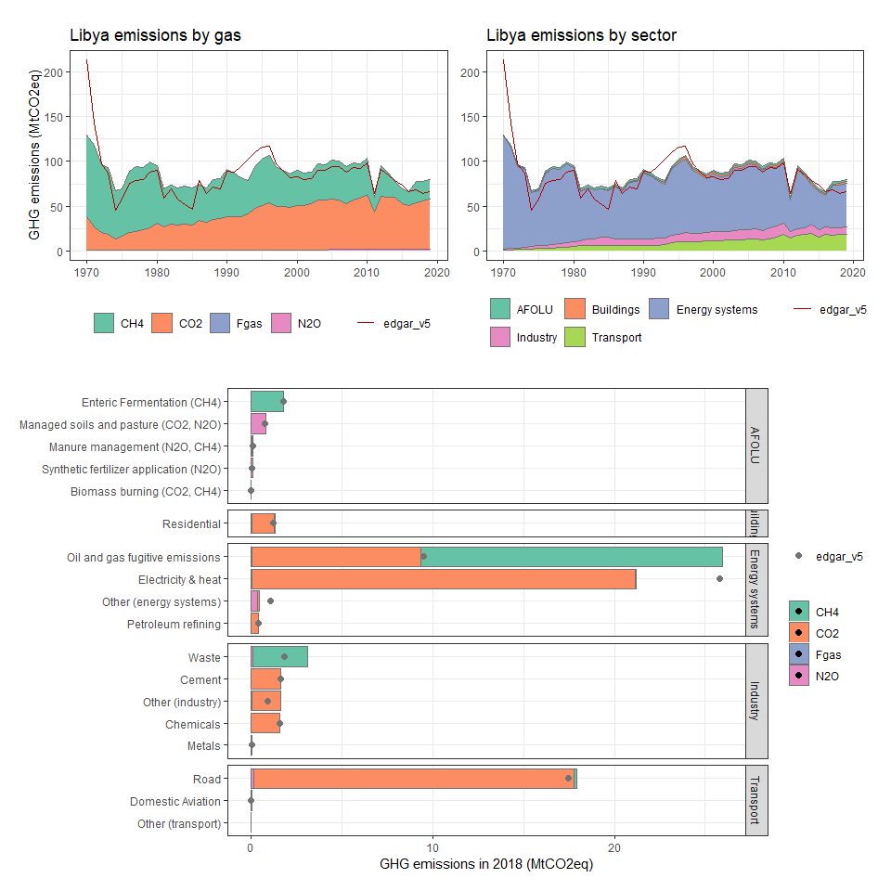

### Lithuania

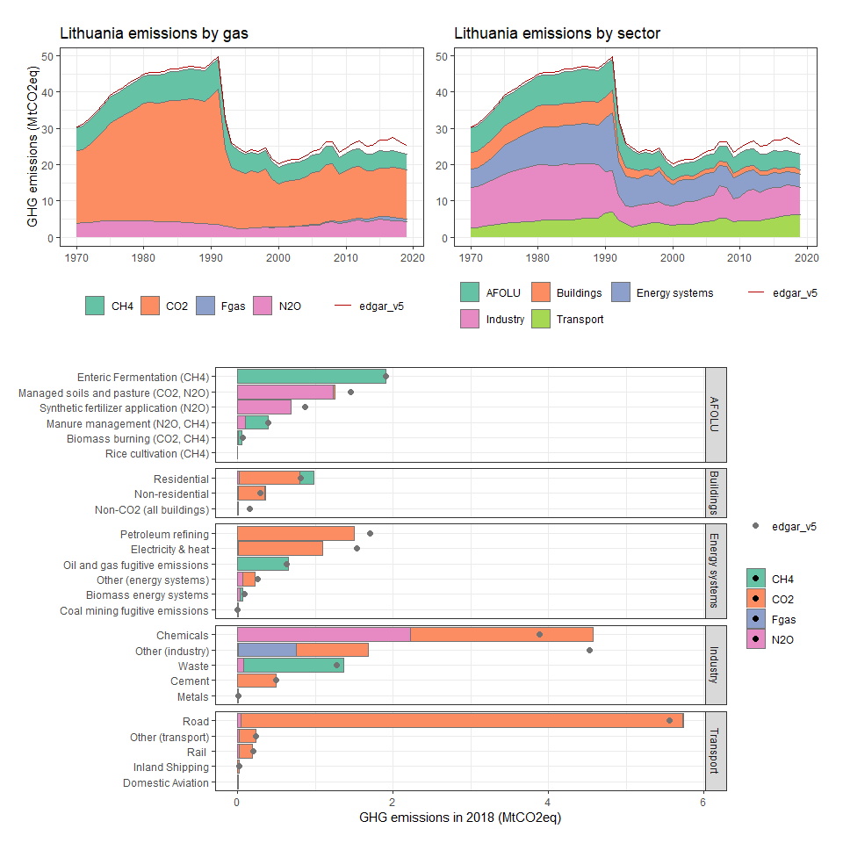

### Luxembourg

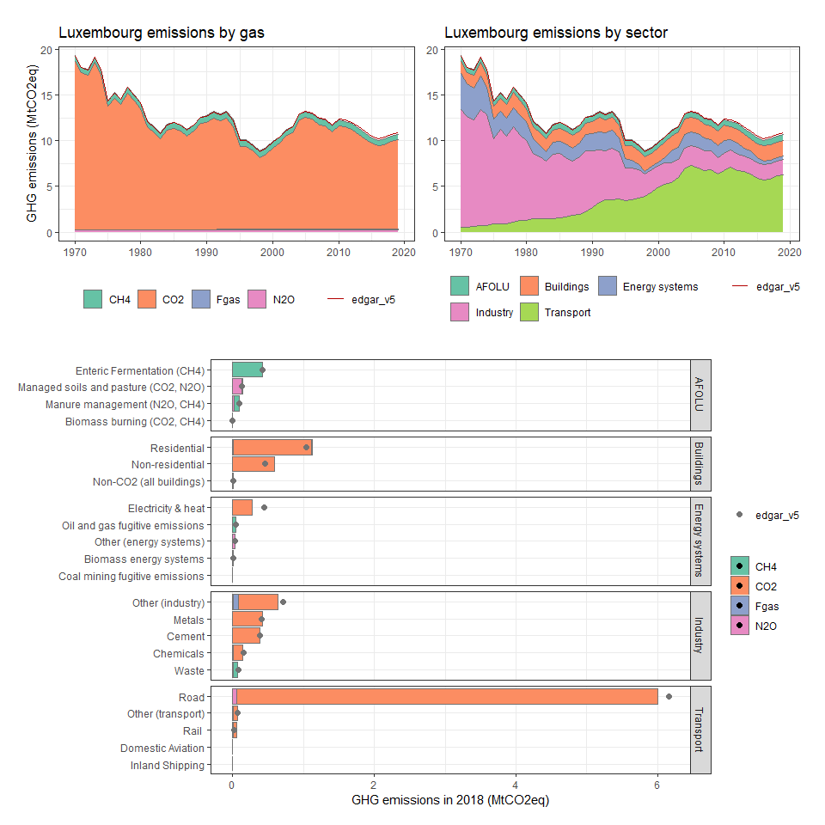

### Macao SAR, China

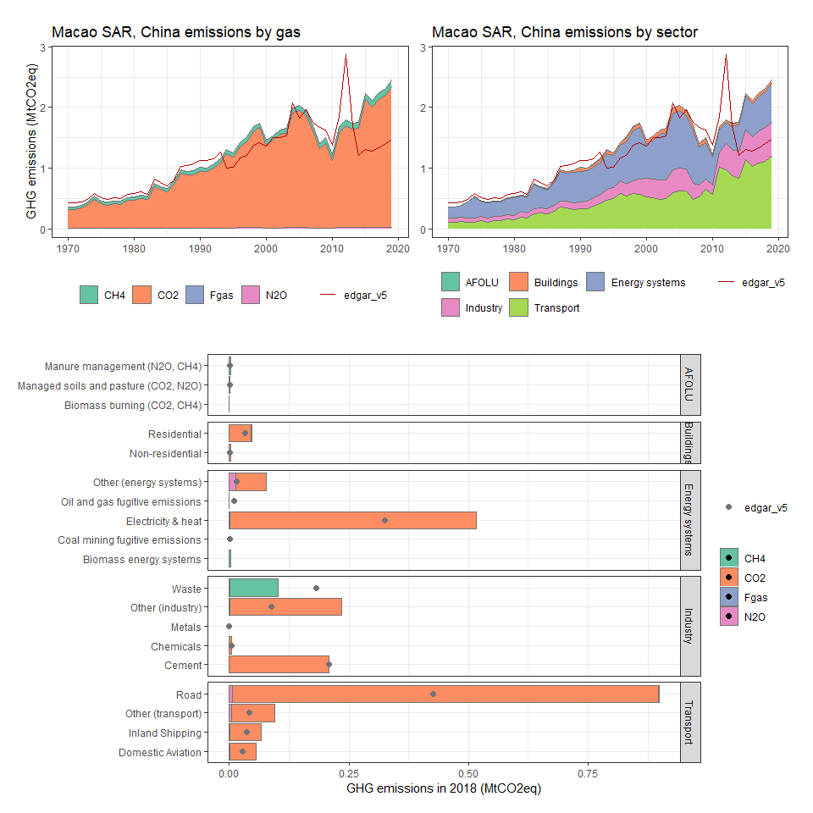

### Macedonia, FYR

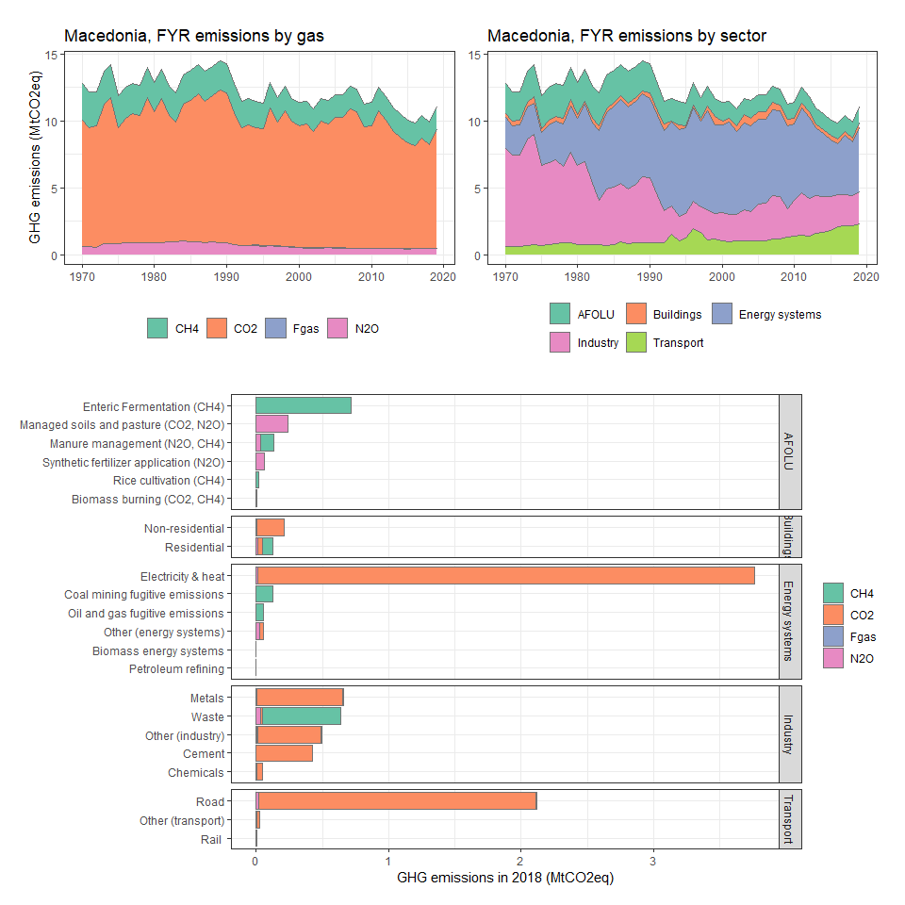

### Madagascar

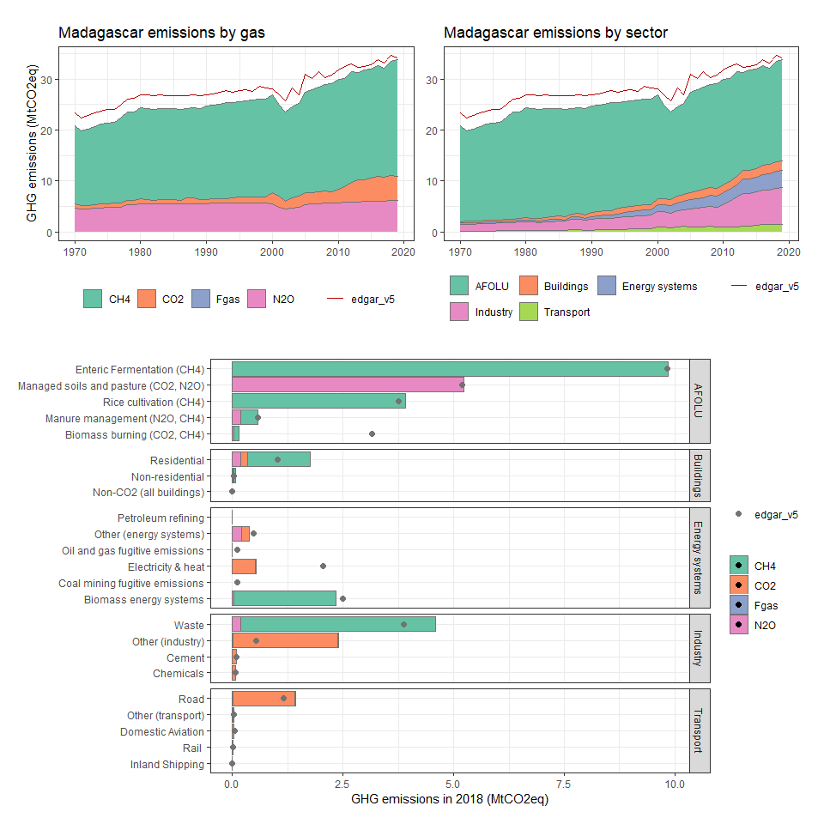

### Malawi

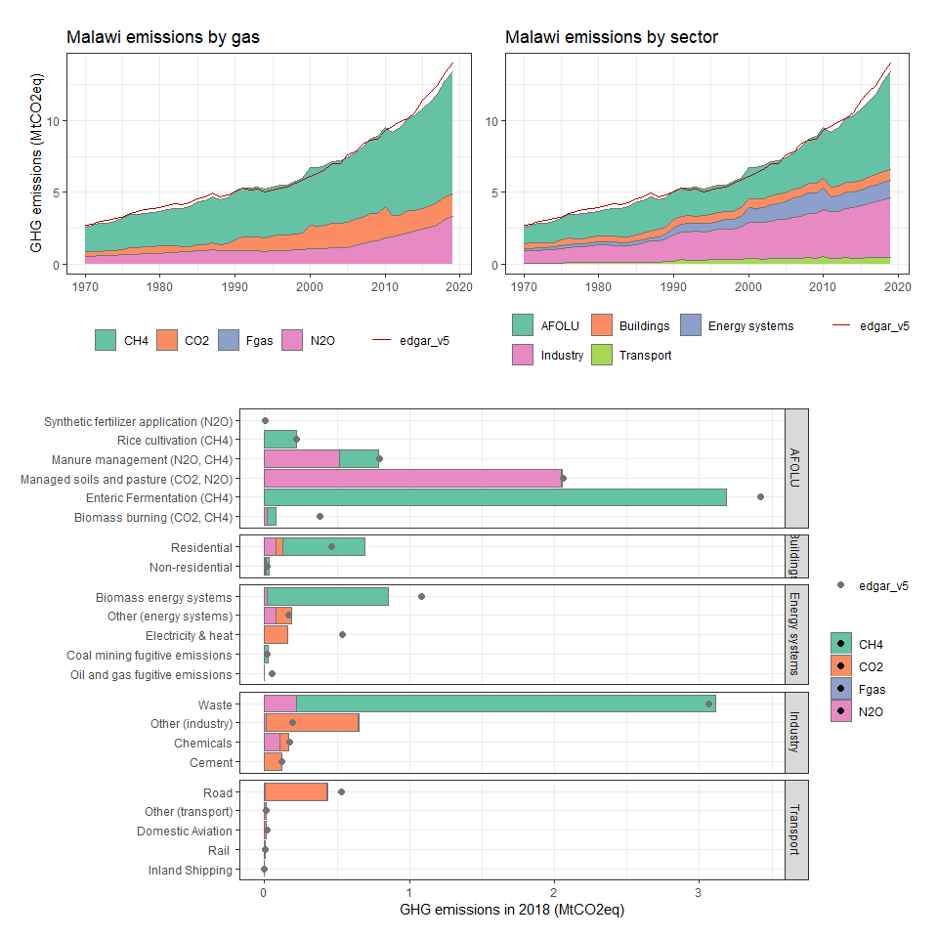

### Malaysia

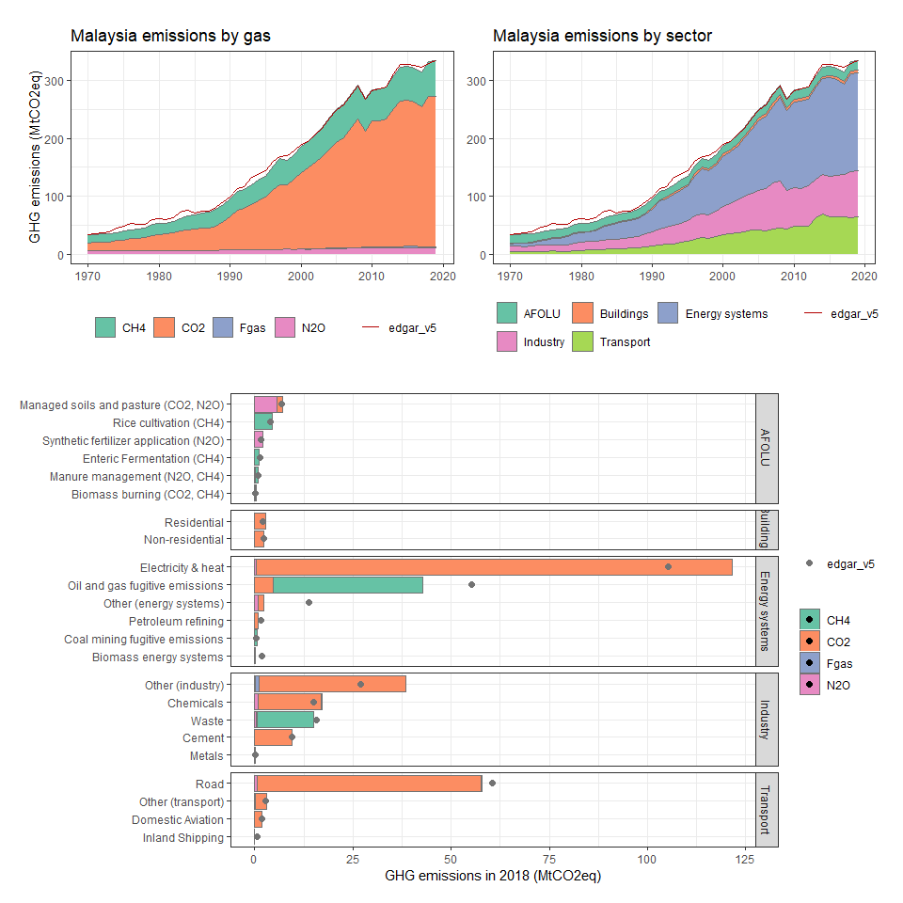

### Maldives

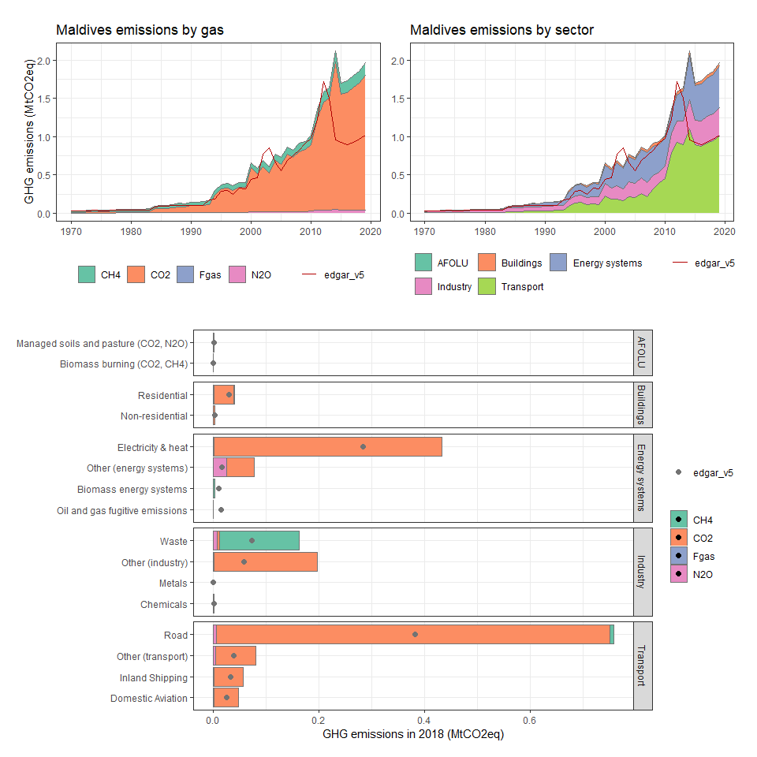

### Mali

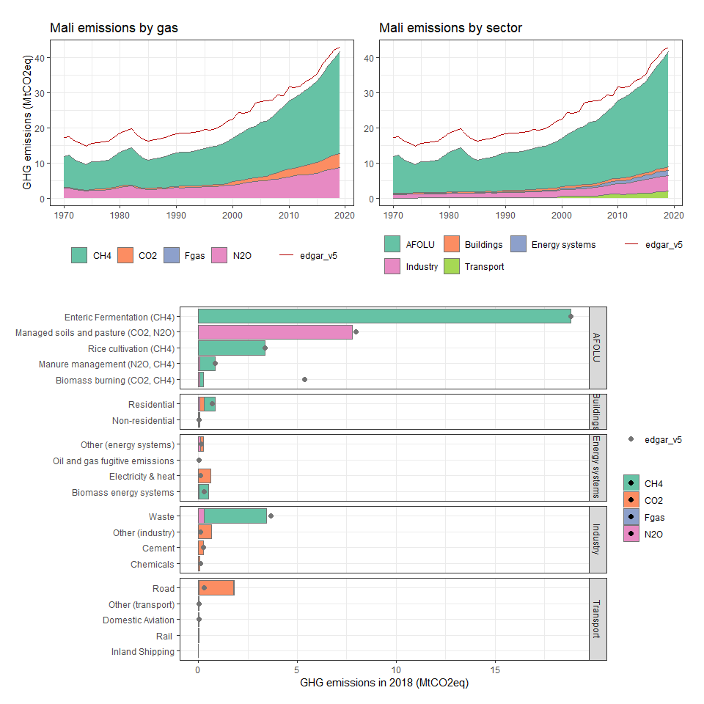

### Malta

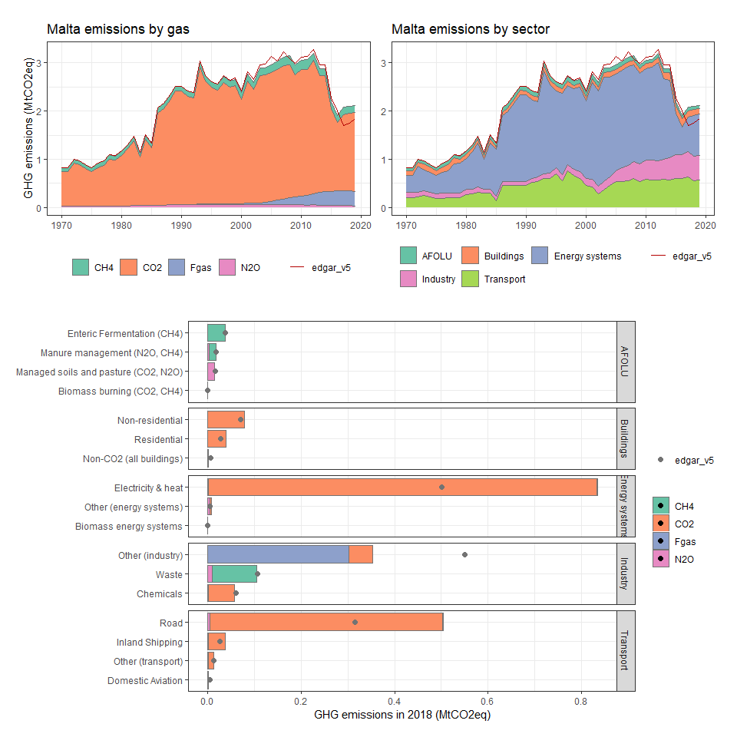

### Marshall Islands

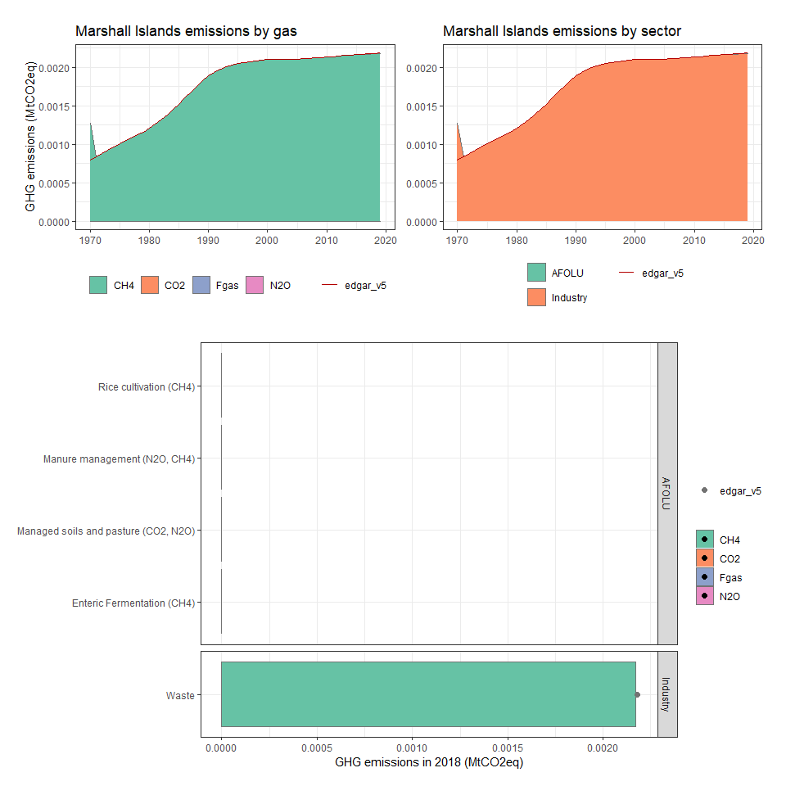

### Martinique

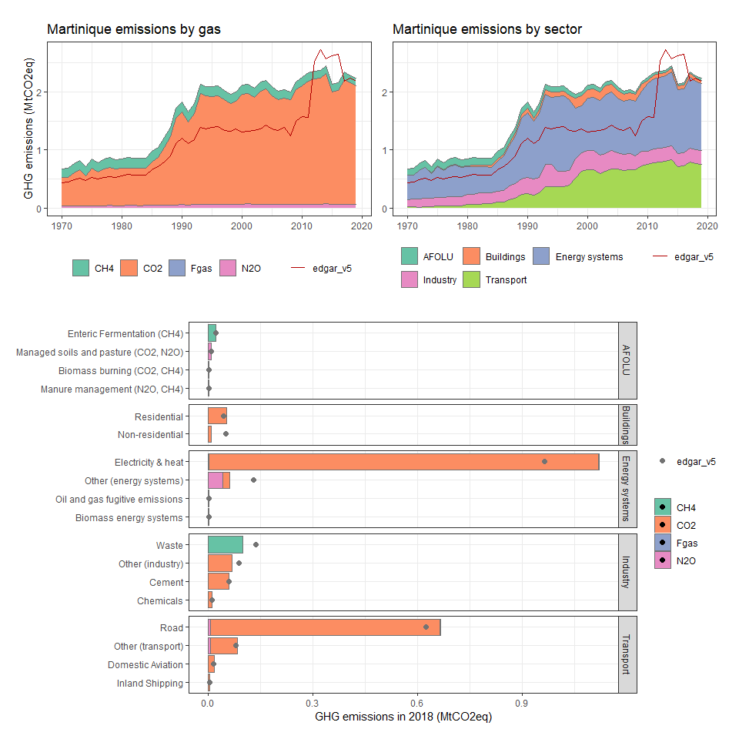

### Mauritania

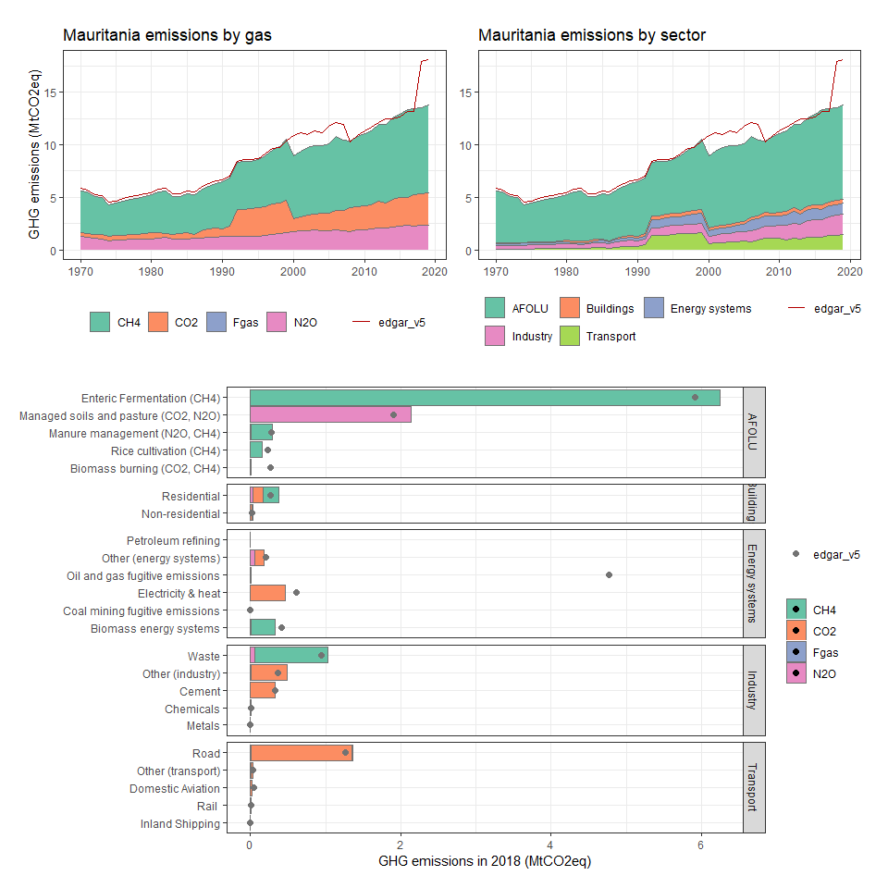

### Mauritius

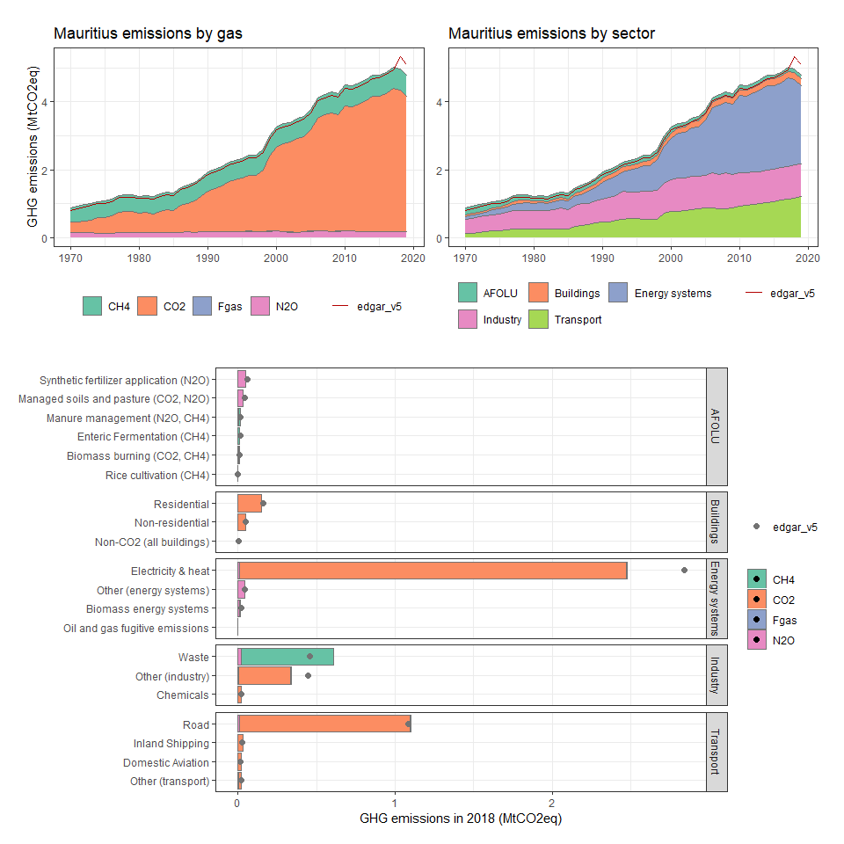

### Mayotte

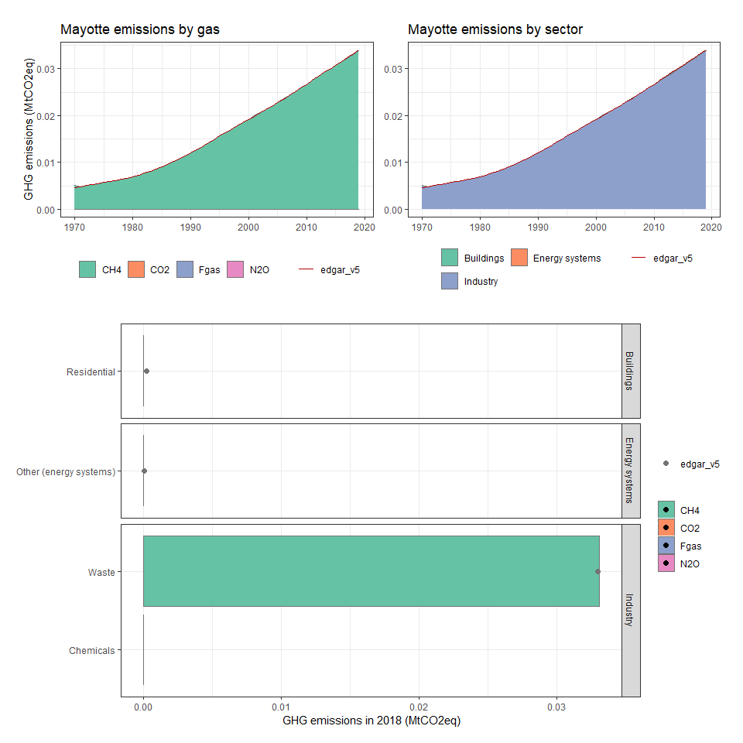

### Mexico

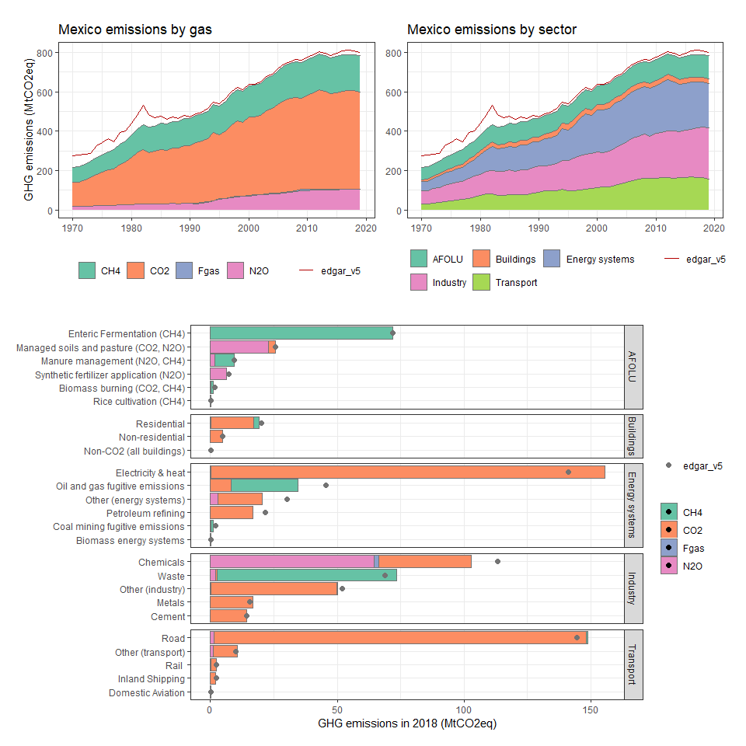

### Micronesia, Fed. Sts.

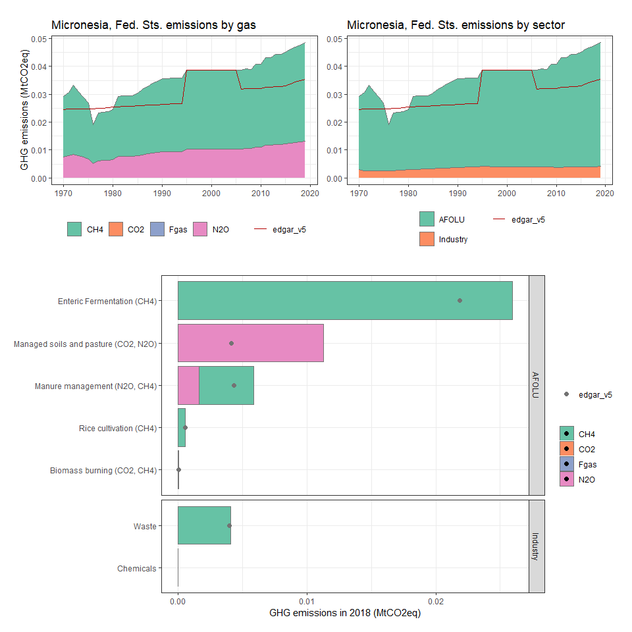

### Moldova

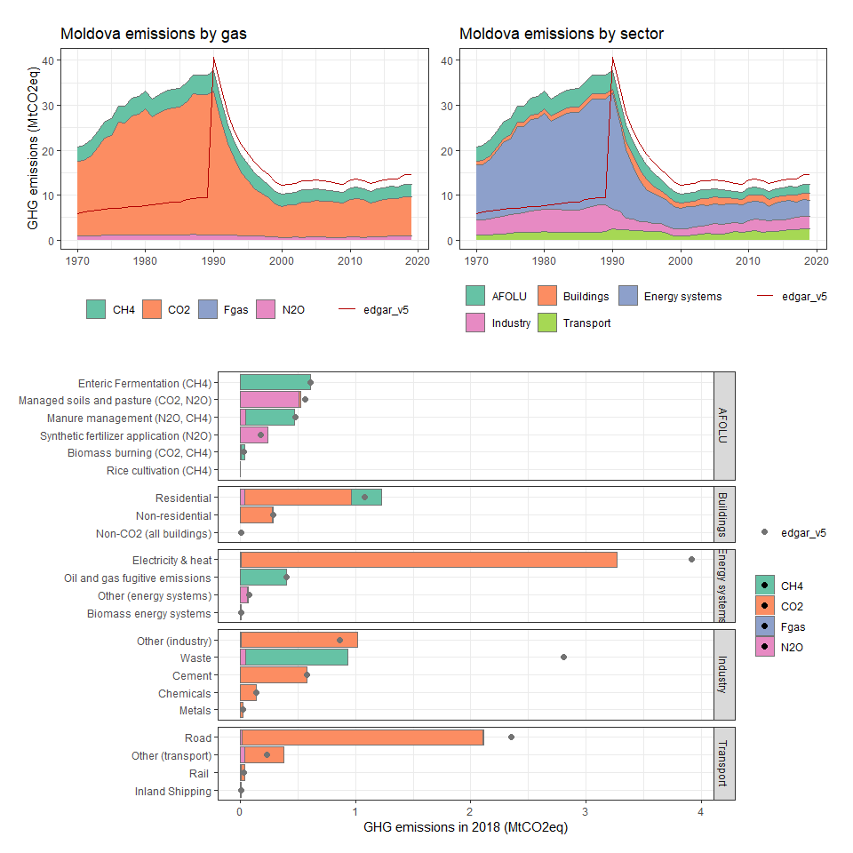

### Mongolia

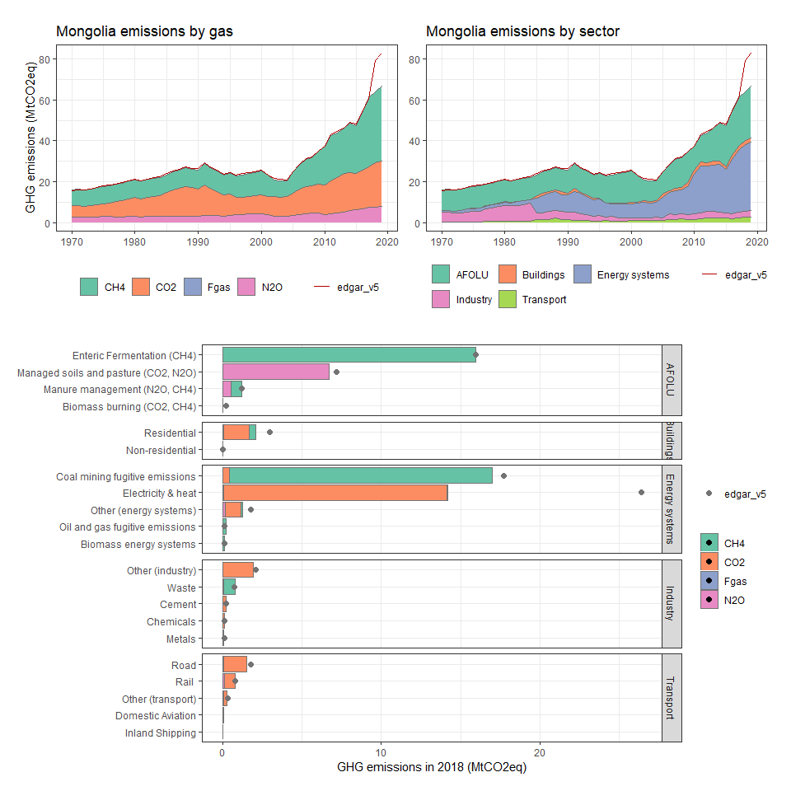

### Montserrat

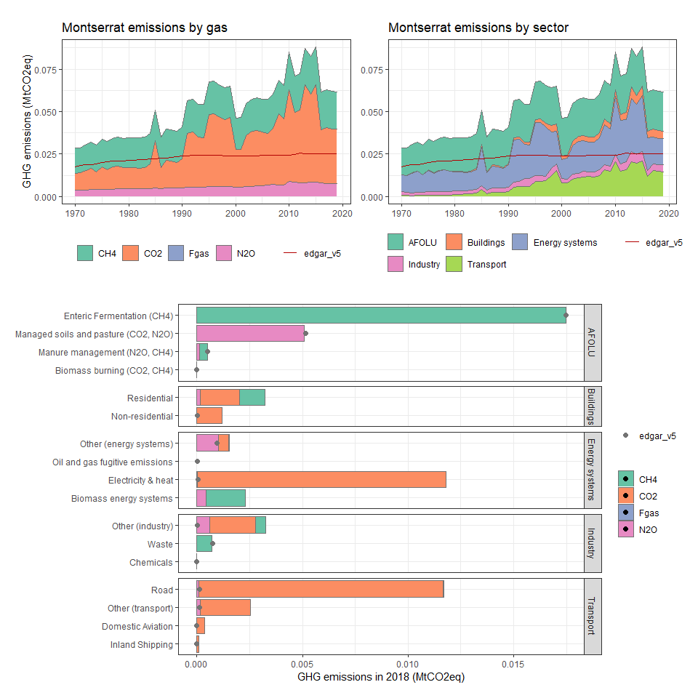

### Morocco

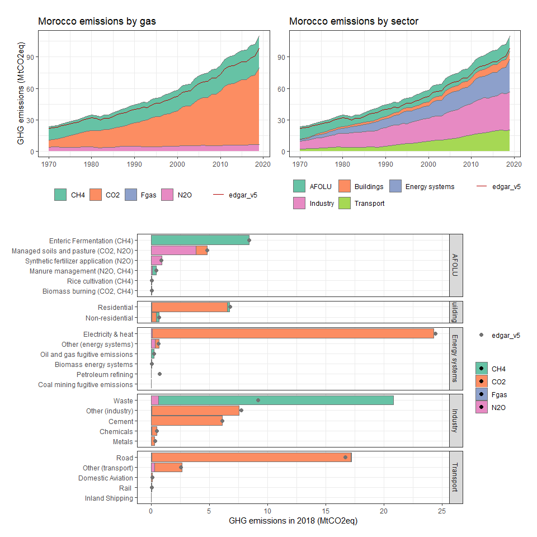

### Mozambique

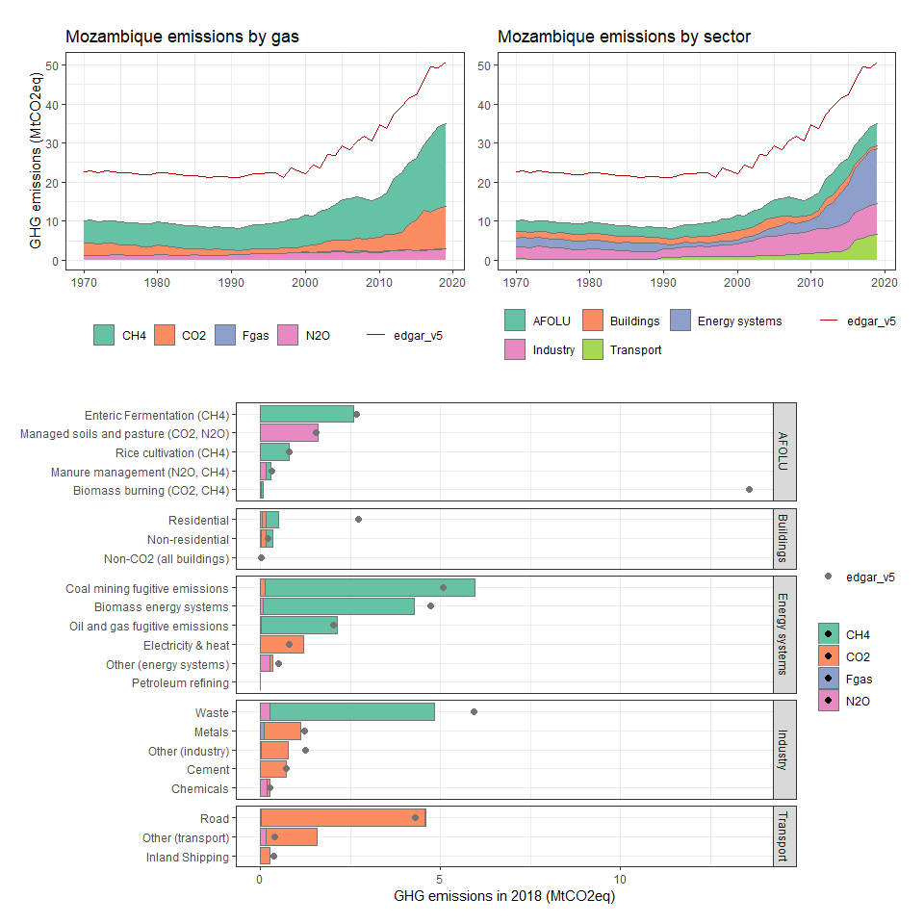

### Myanmar

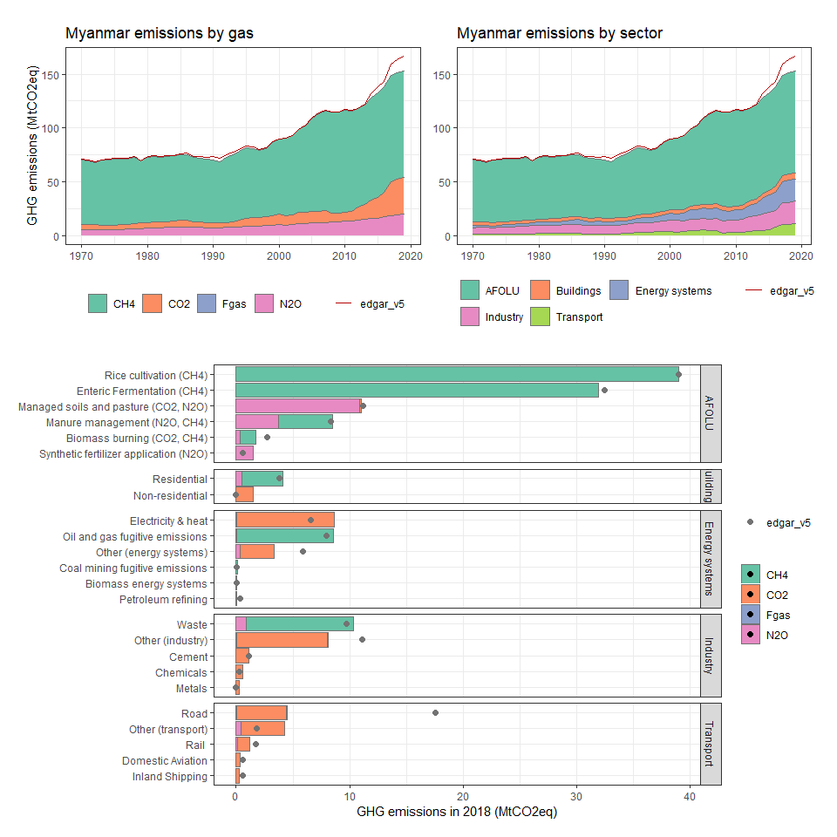

### Namibia

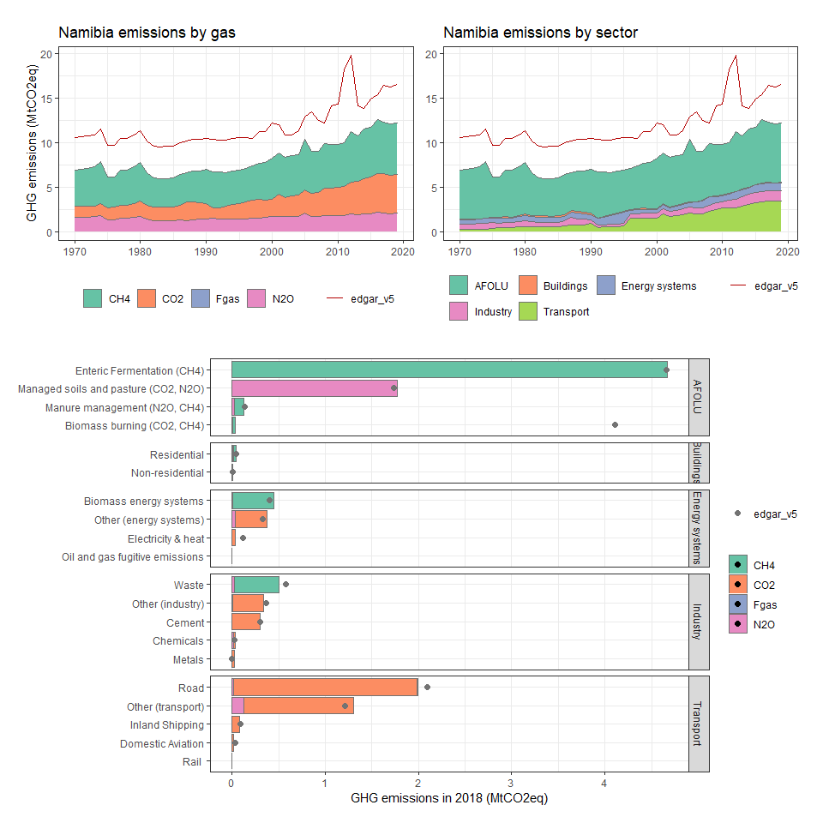

### Nauru

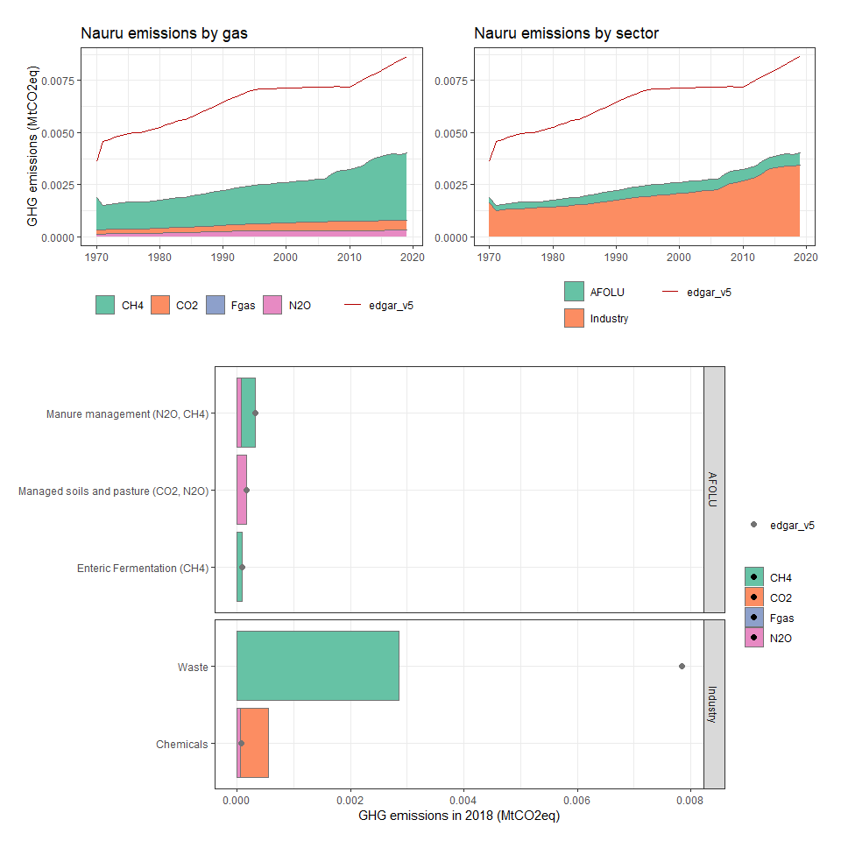

### Nepal

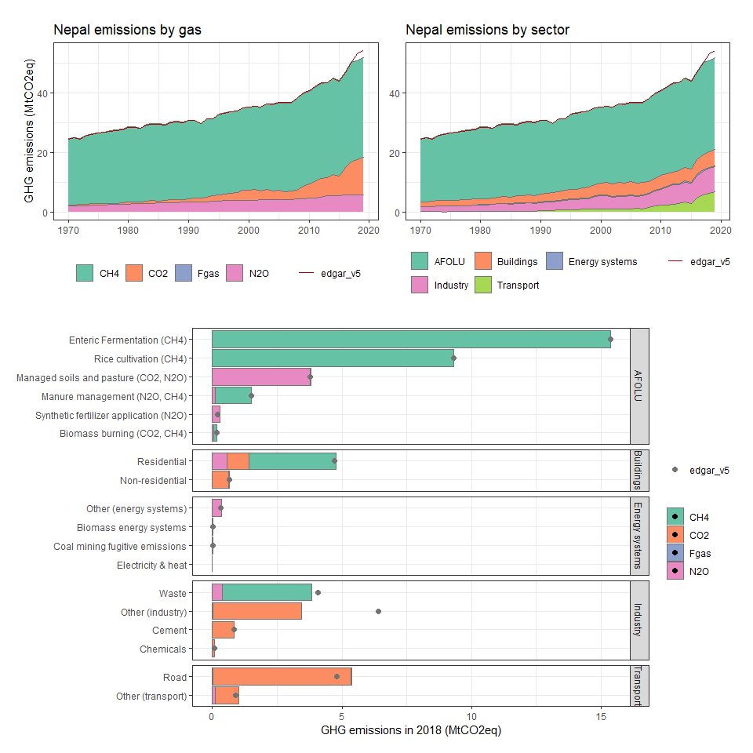

### Netherlands

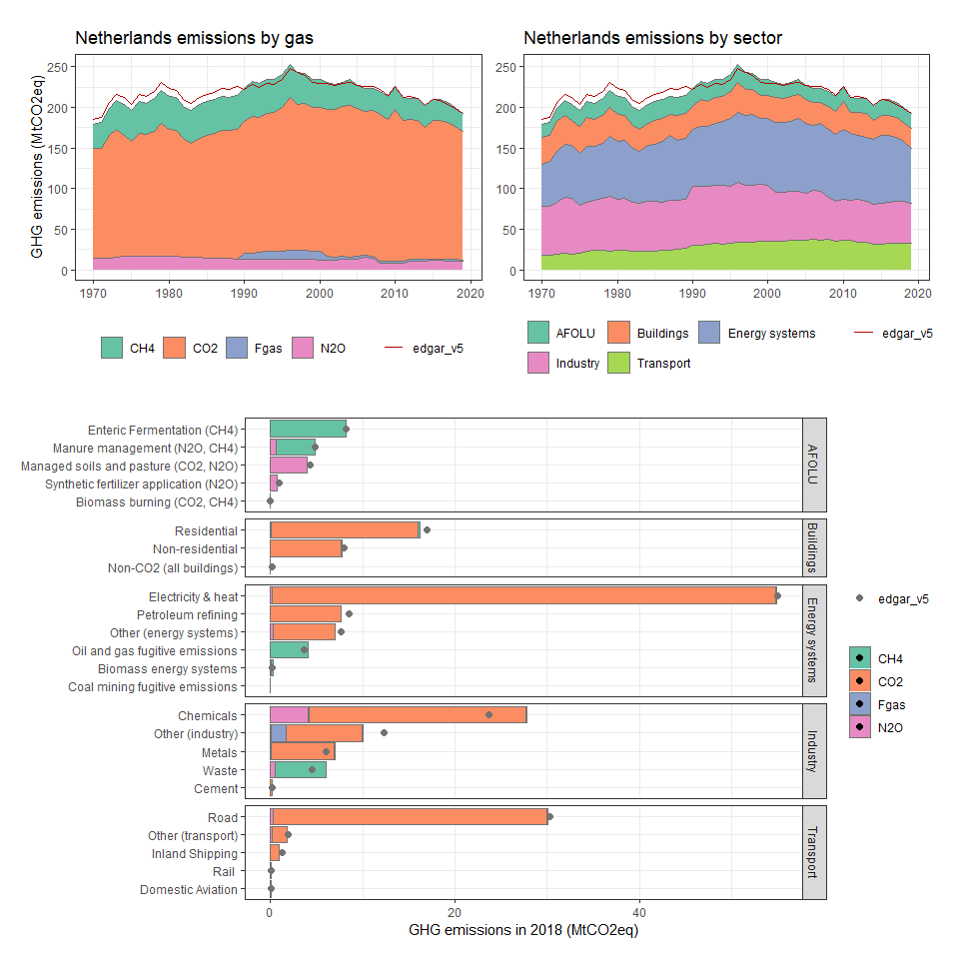

### Netherlands Antilles

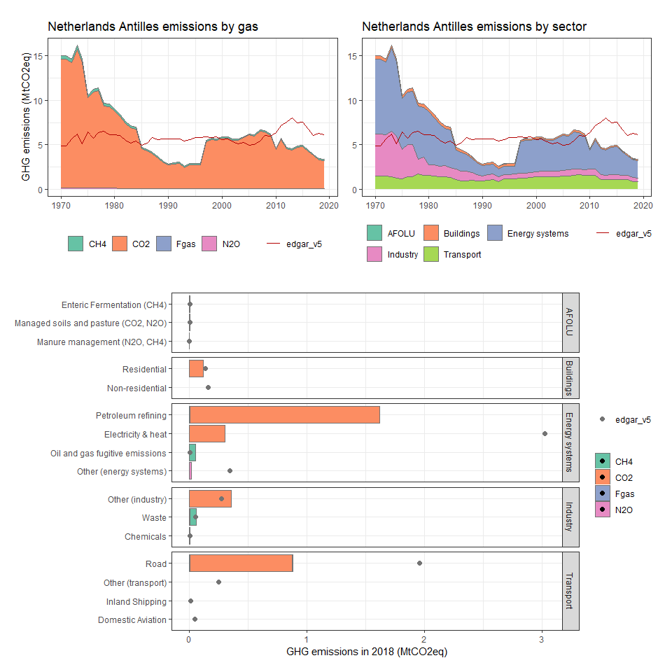

### New Caledonia

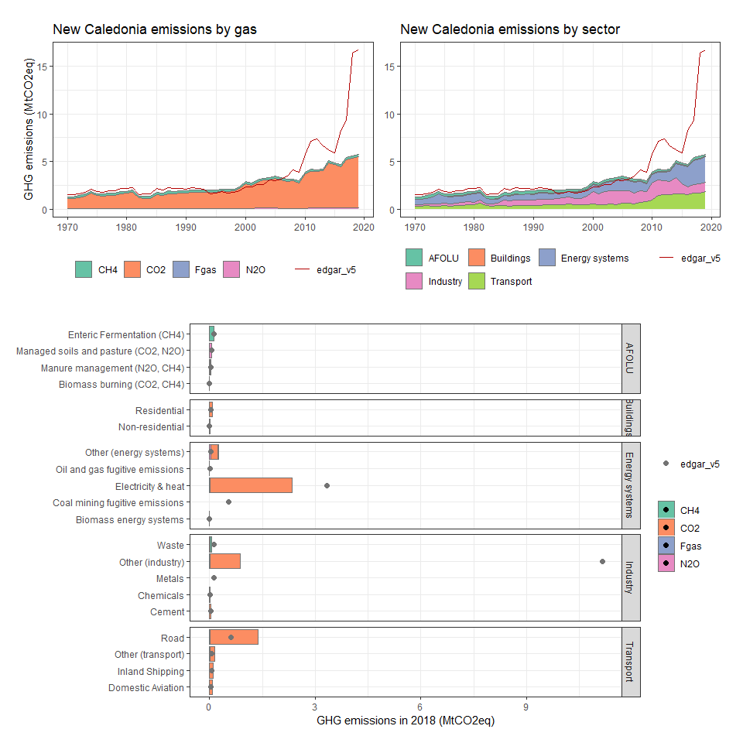

### New Zealand

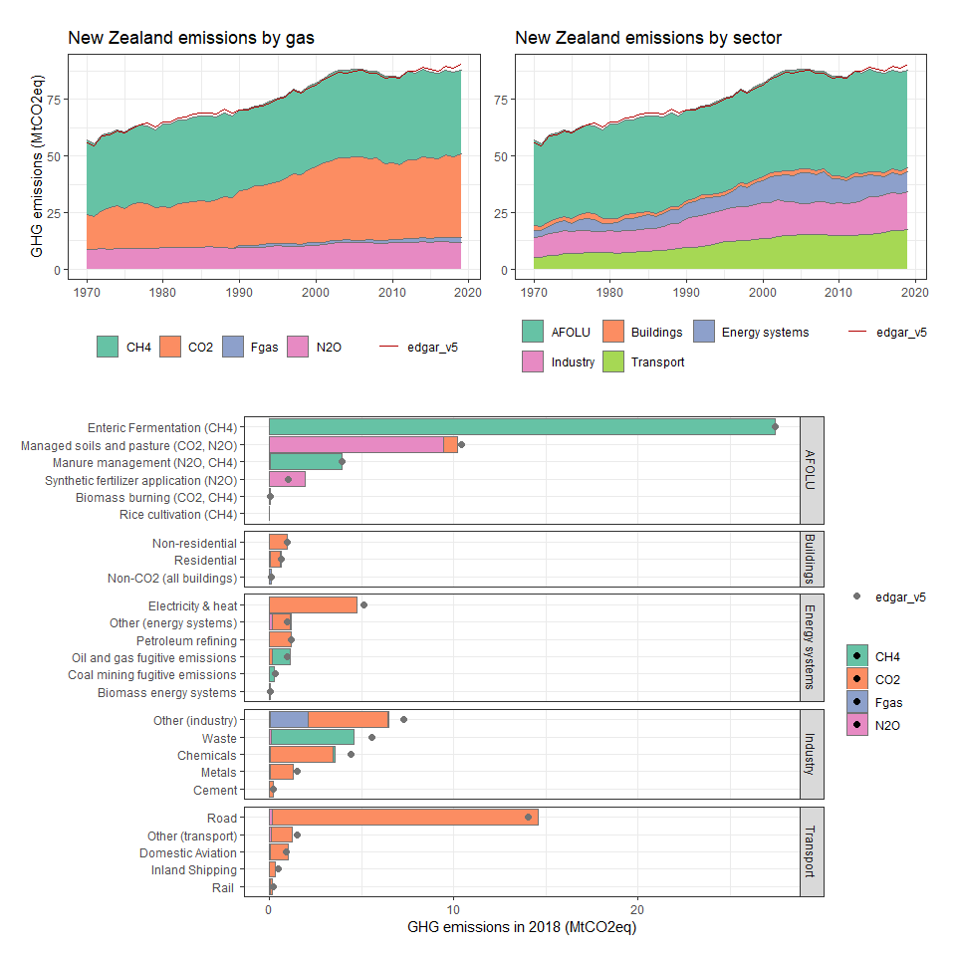

### Nicaragua

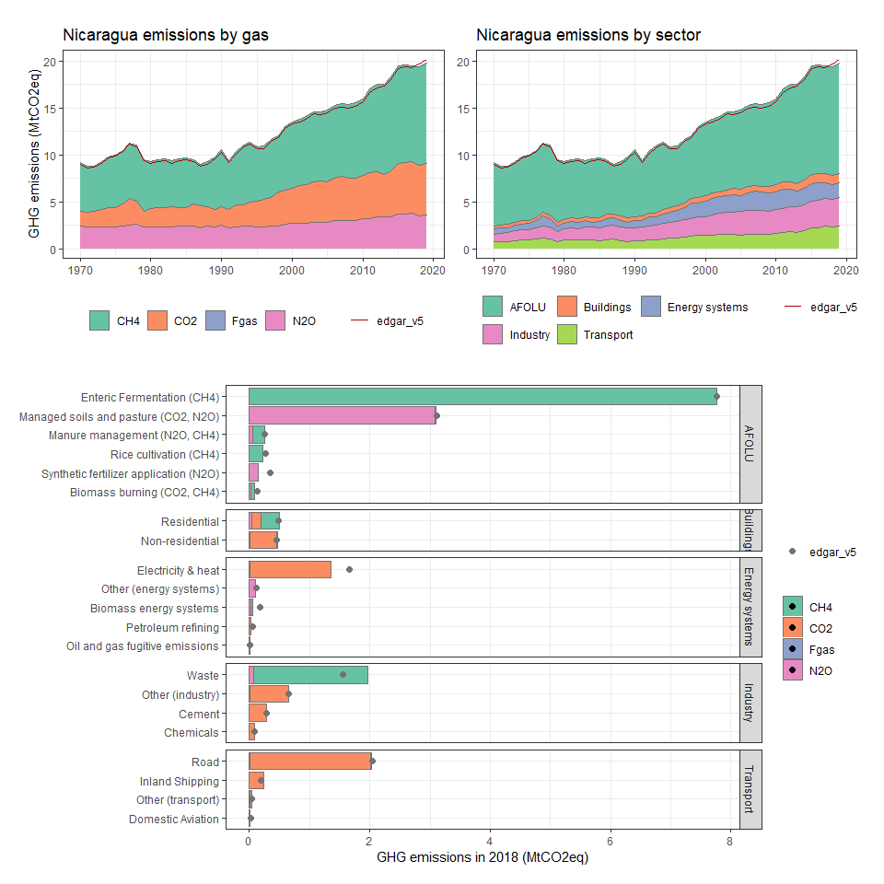

### Niger

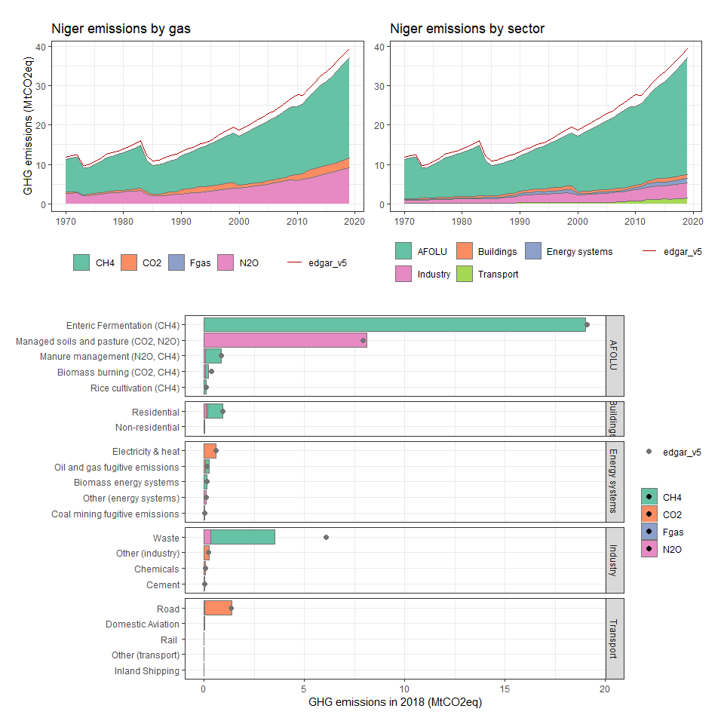

### Nigeria

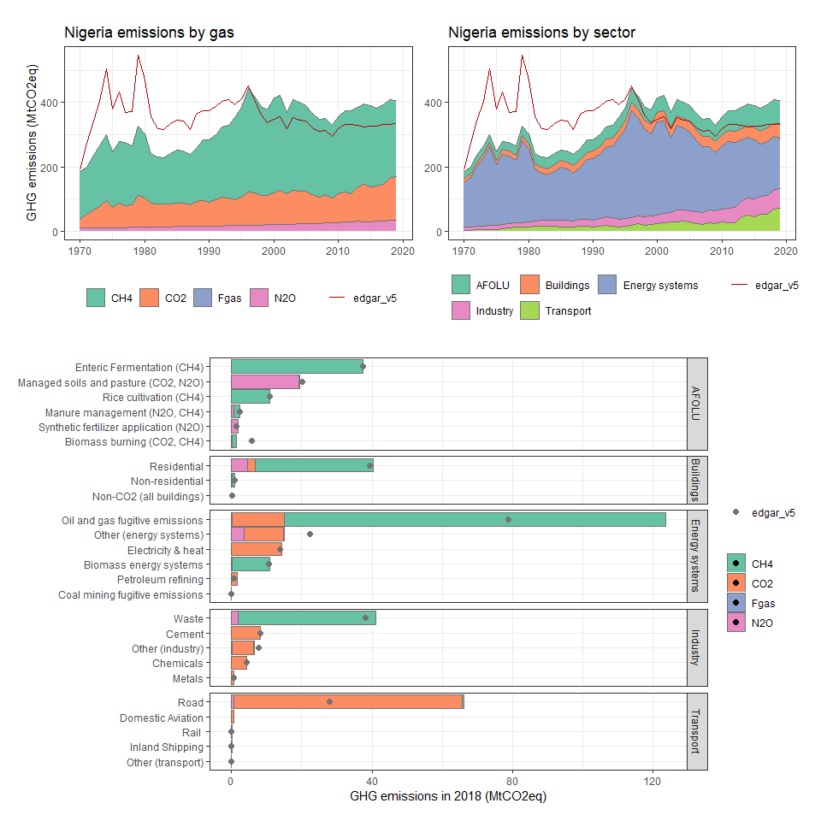

### Niue

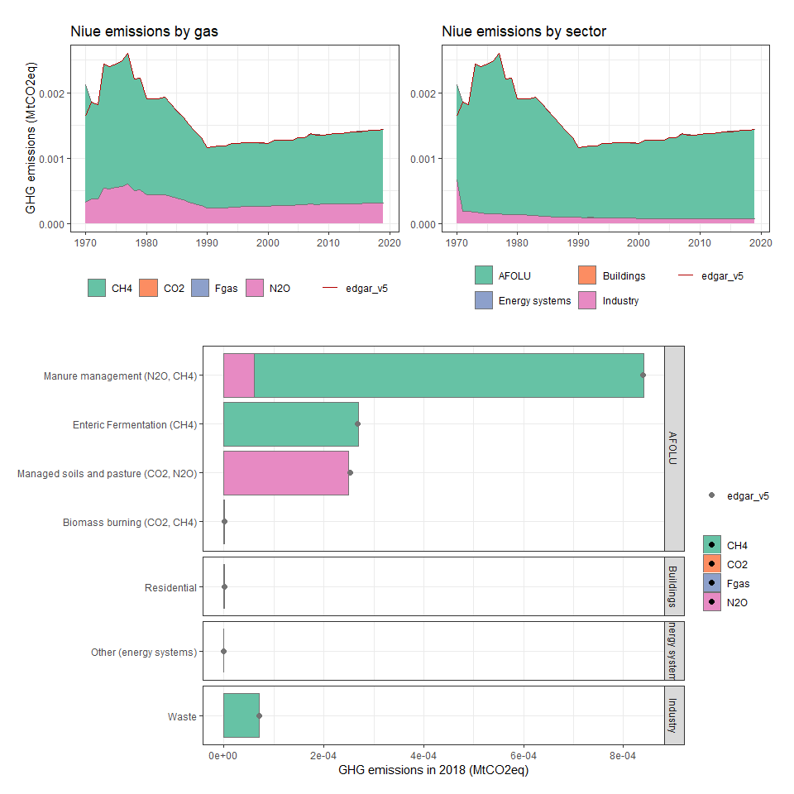

### Norfolk Island

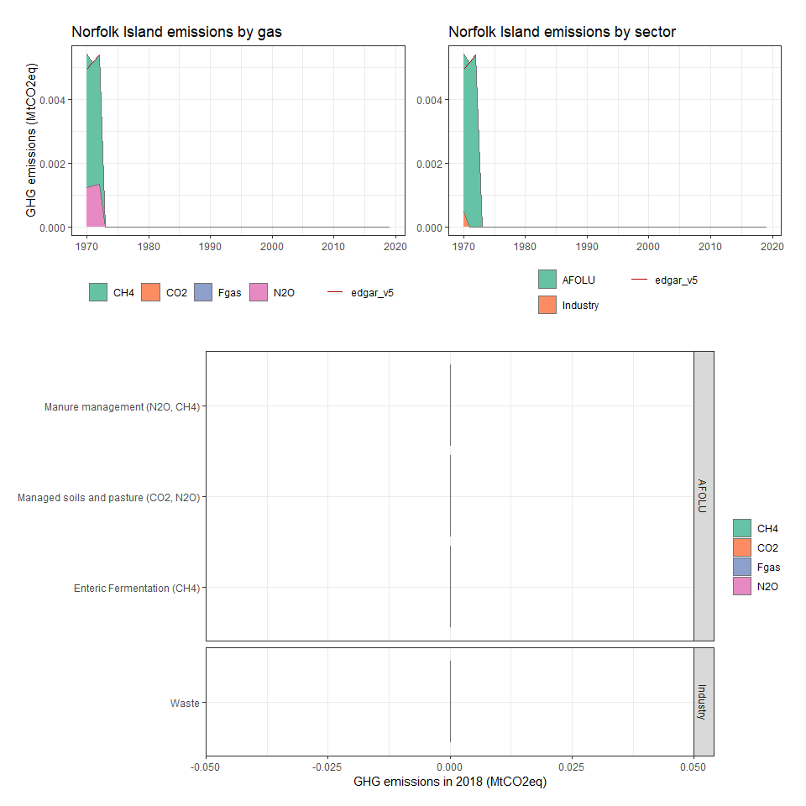

### Northern Mariana Islands

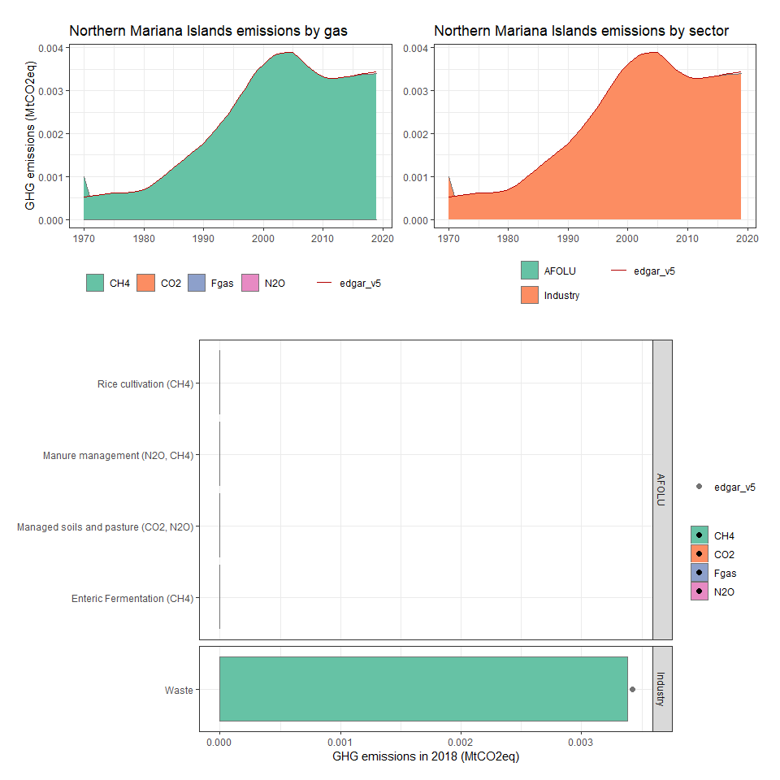

### Norway

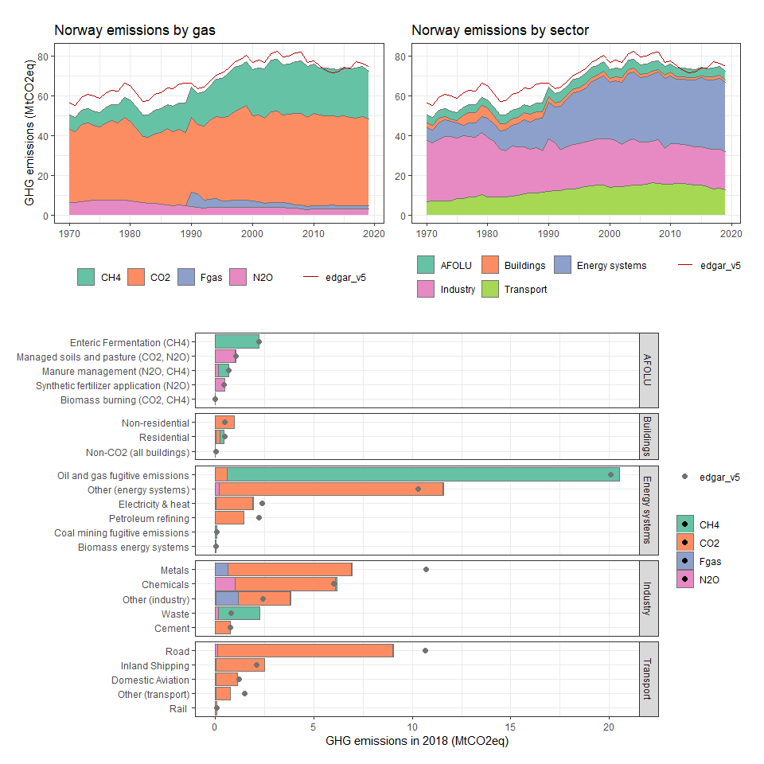

### Oman

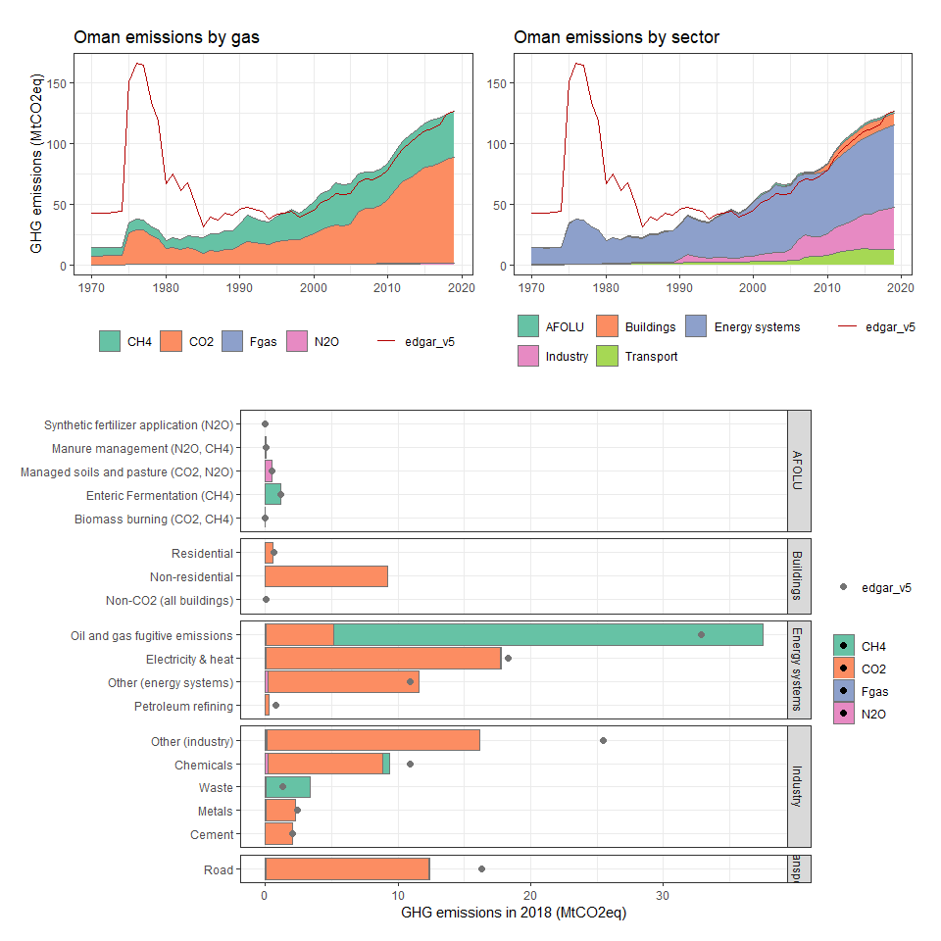

### Pakistan

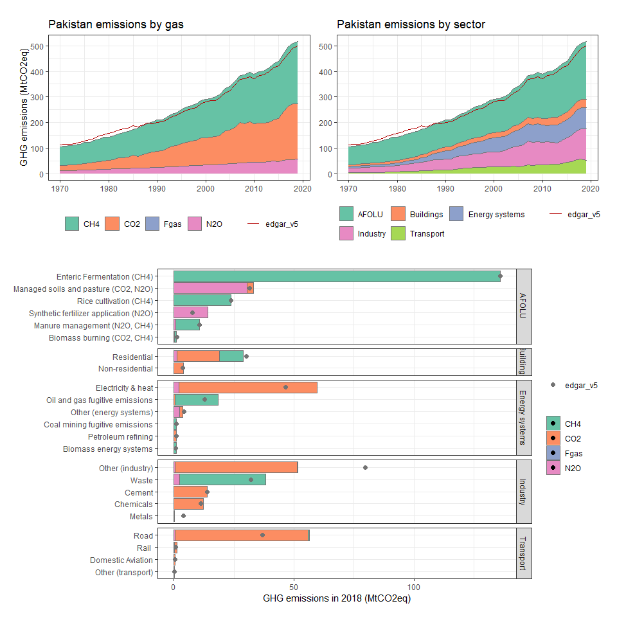

### Palau

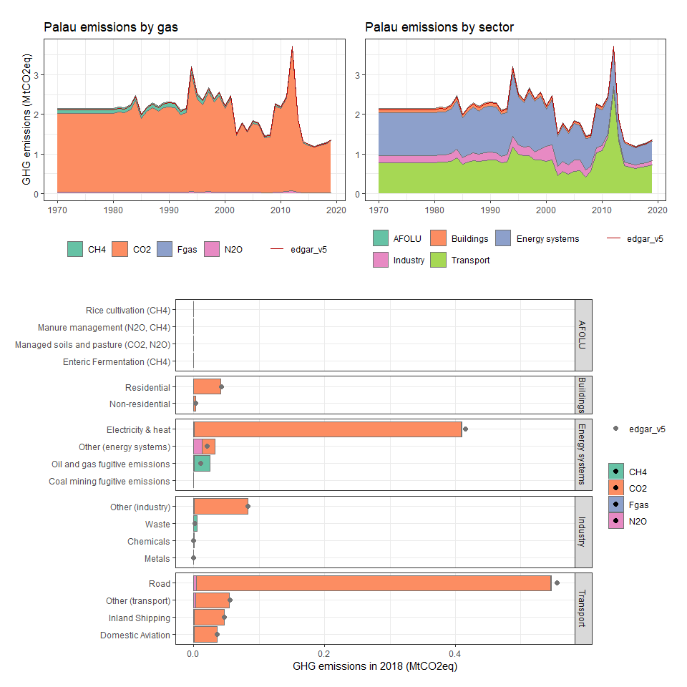

### Panama

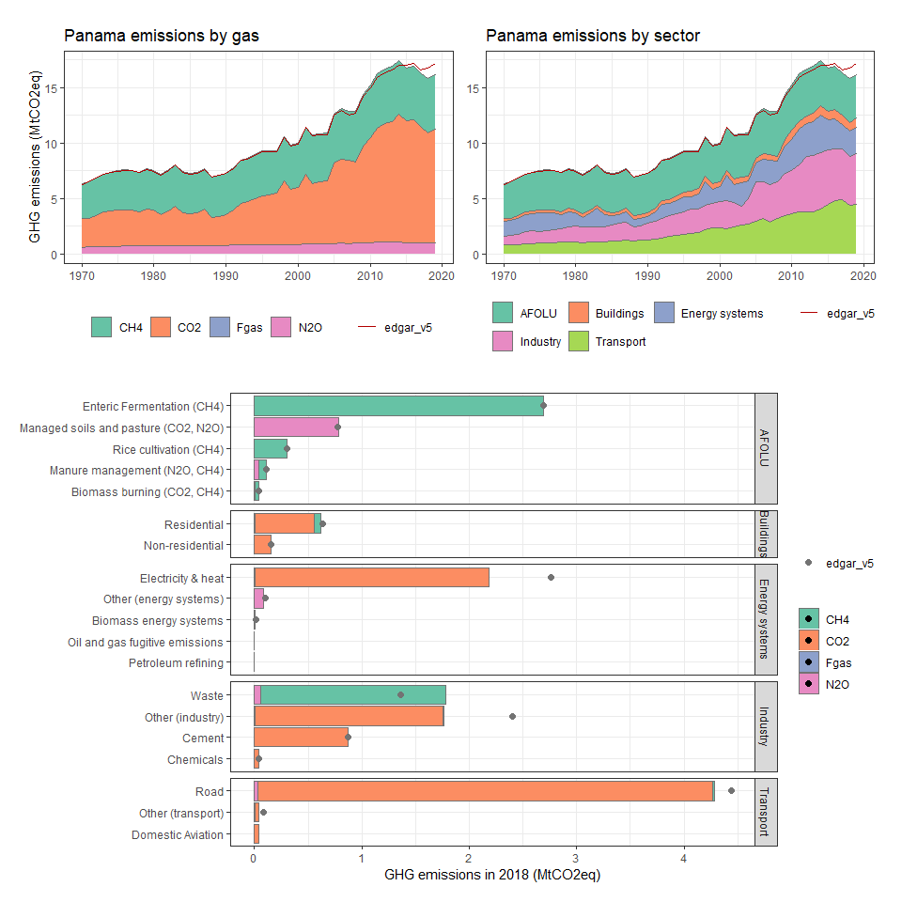

### Papua New Guinea

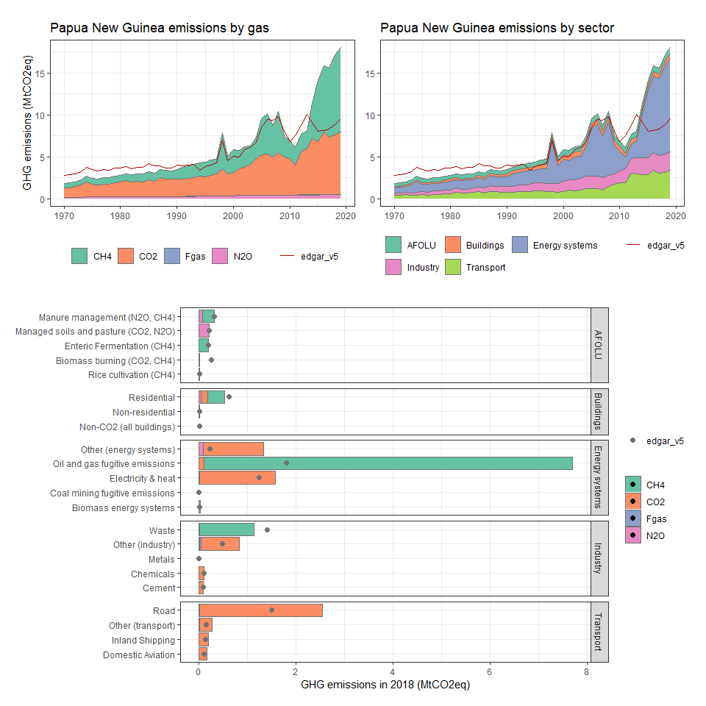

### Paraguay

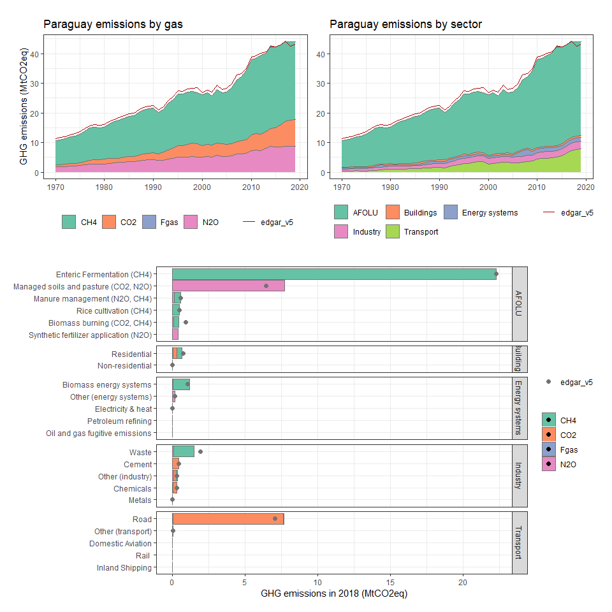

### Peru

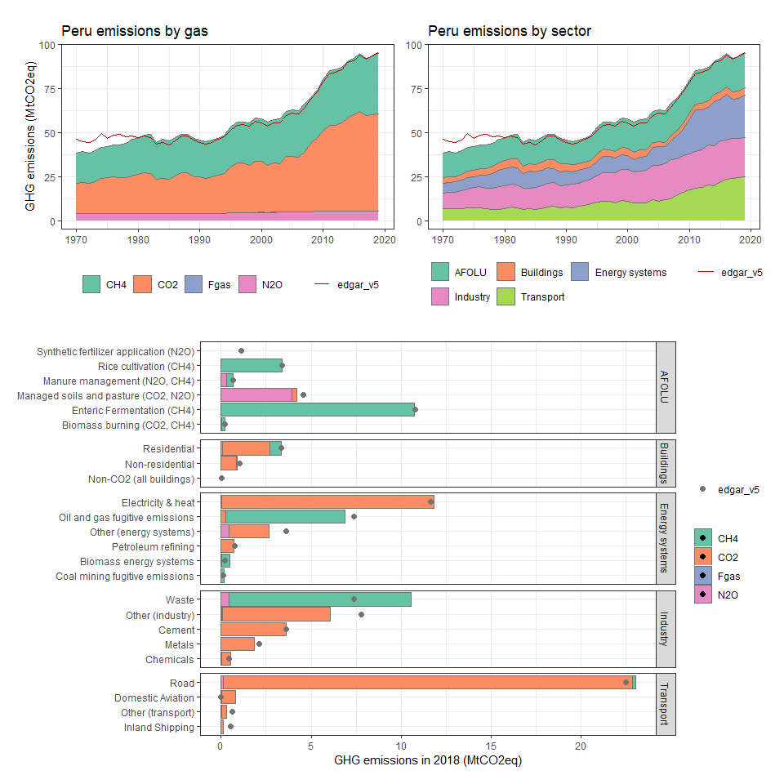

### Philippines

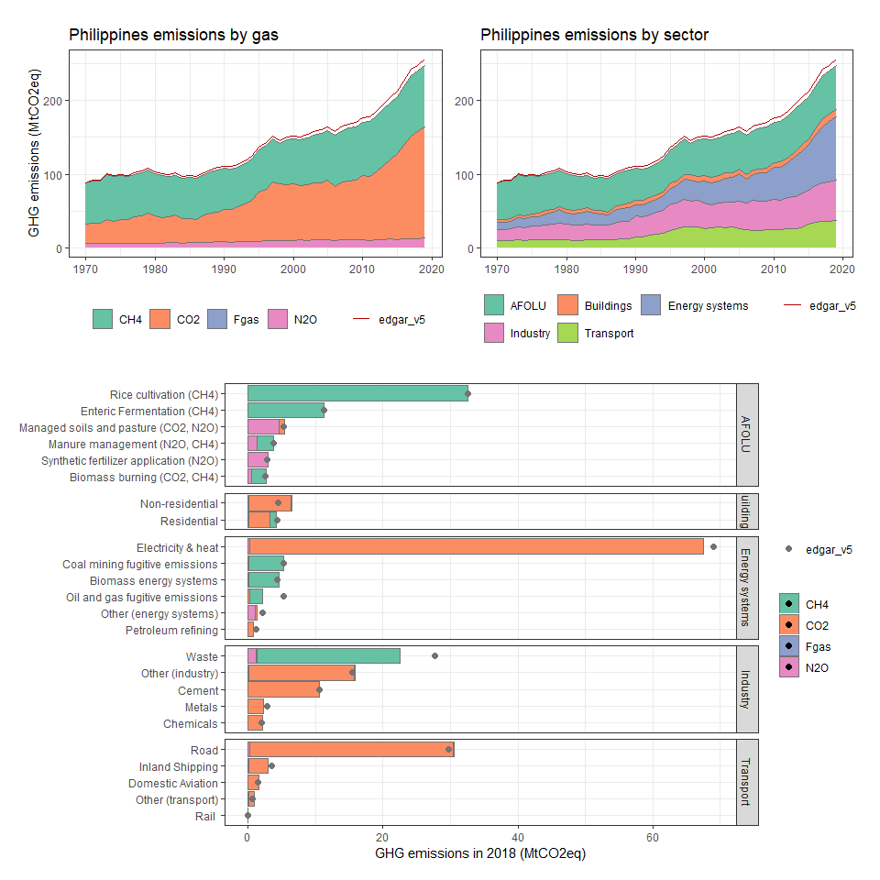

### Pitcairn

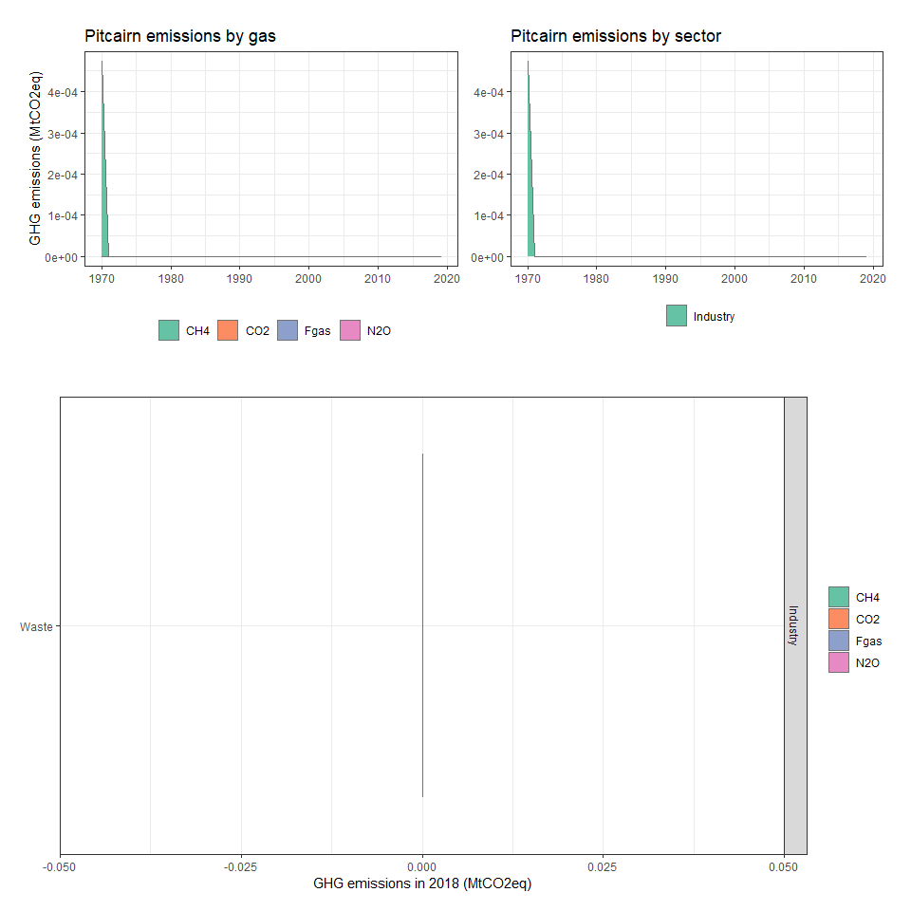

### Poland

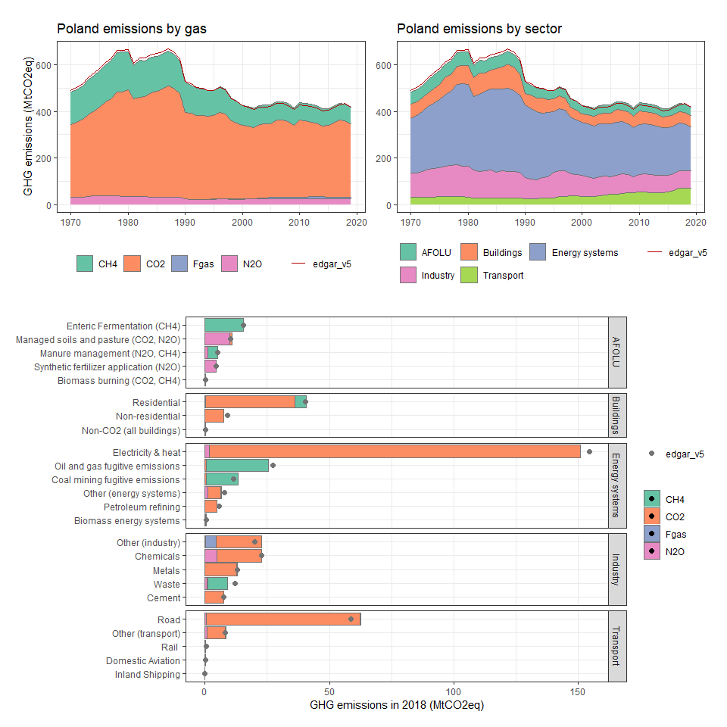

### Portugal

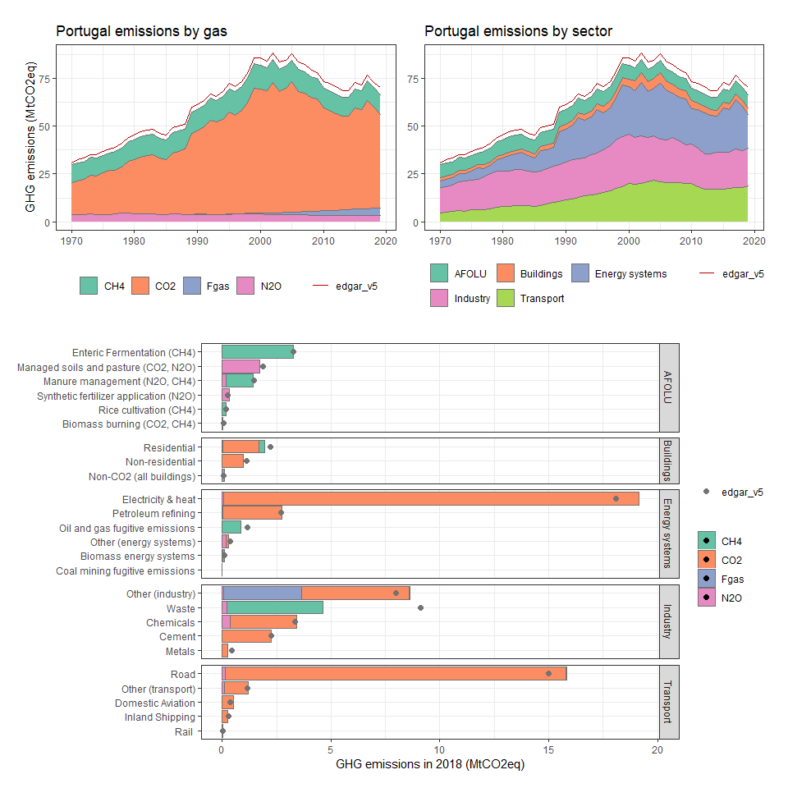

### Puerto Rico

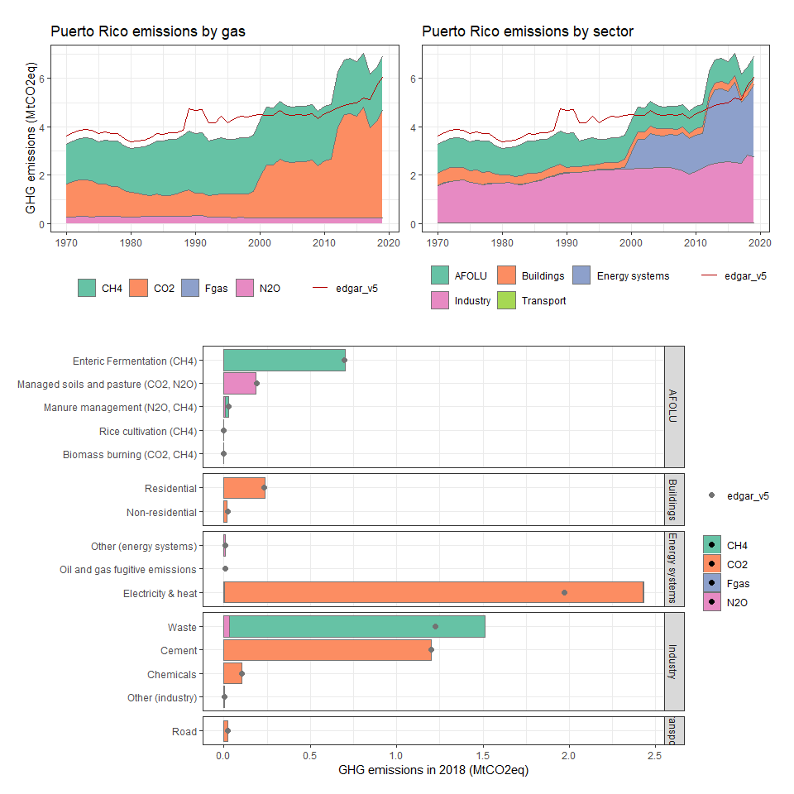

### Qatar

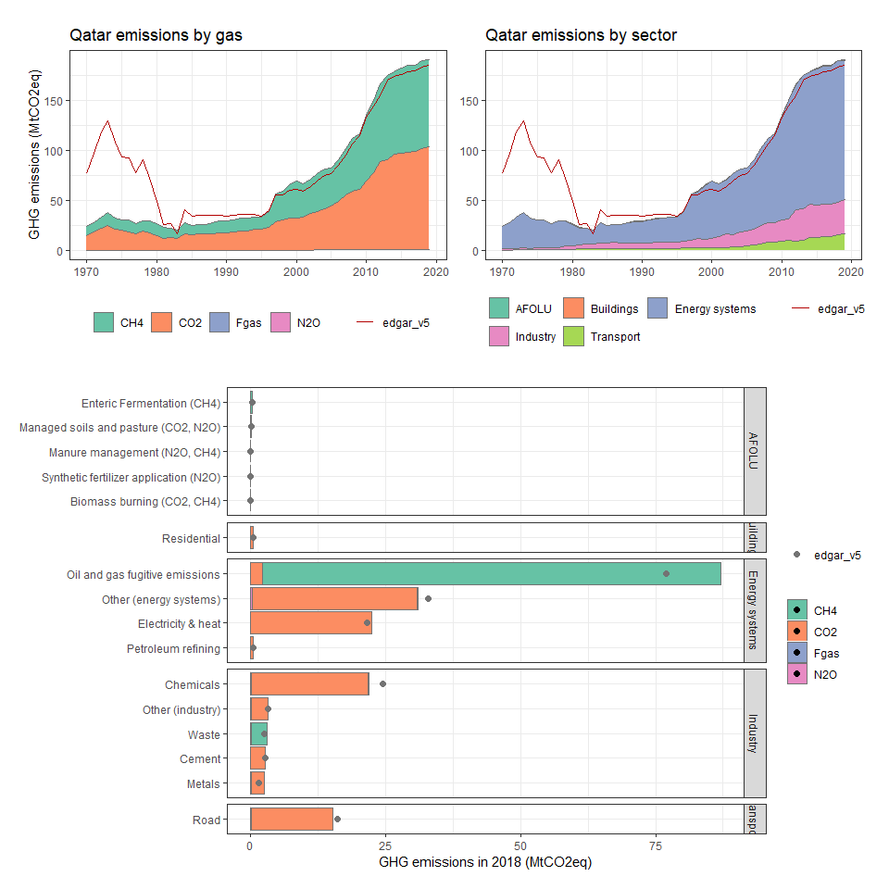

### Réunion

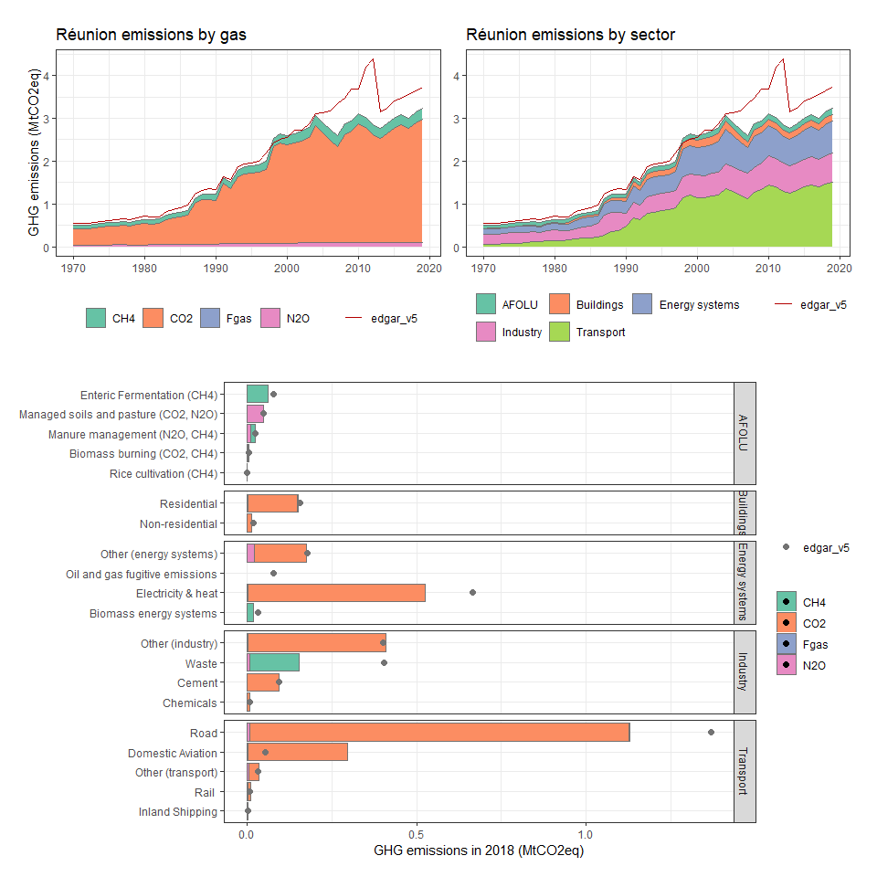

### Romania

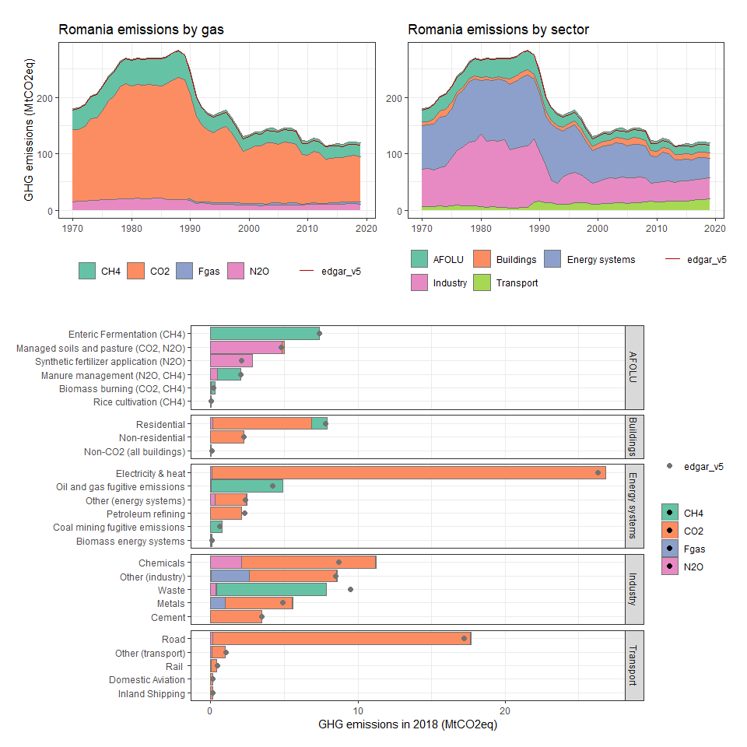

### Russian Federation

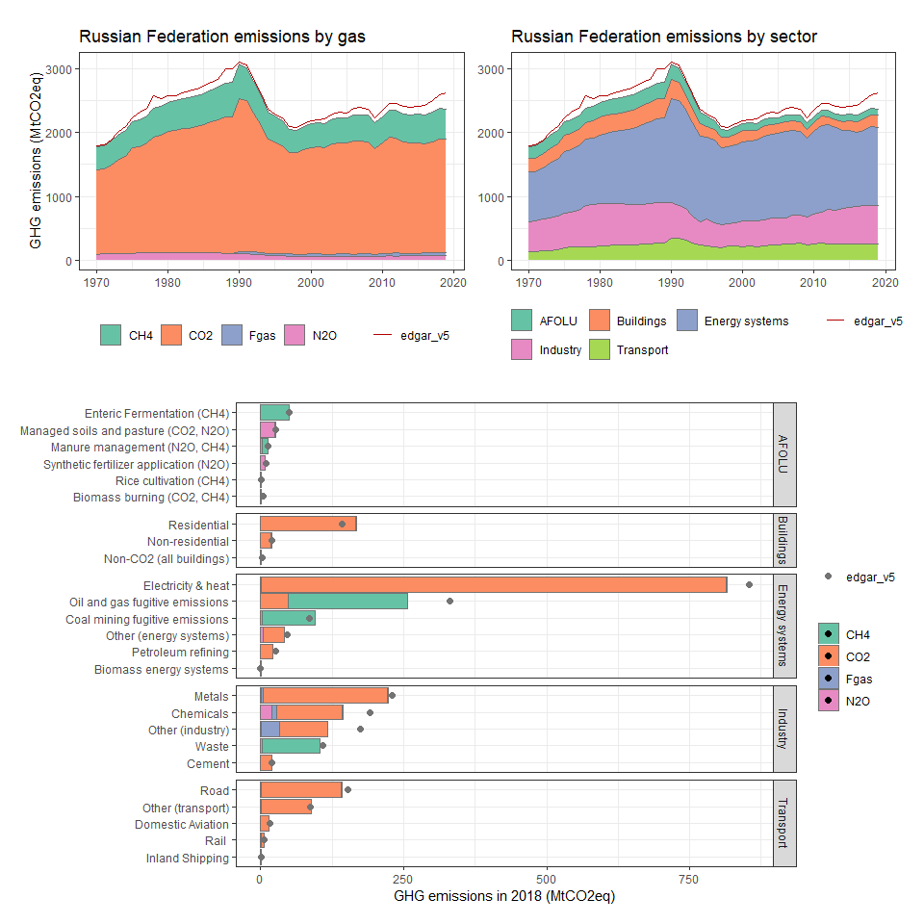

### Rwanda

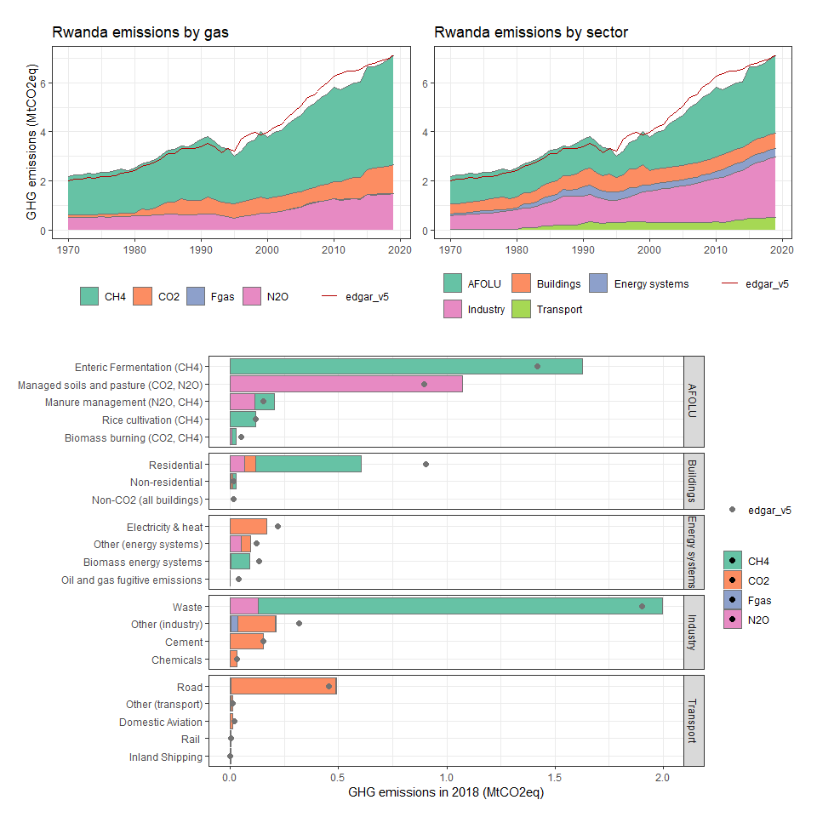

### Saint Helena, Ascension and Tristan da Cunha

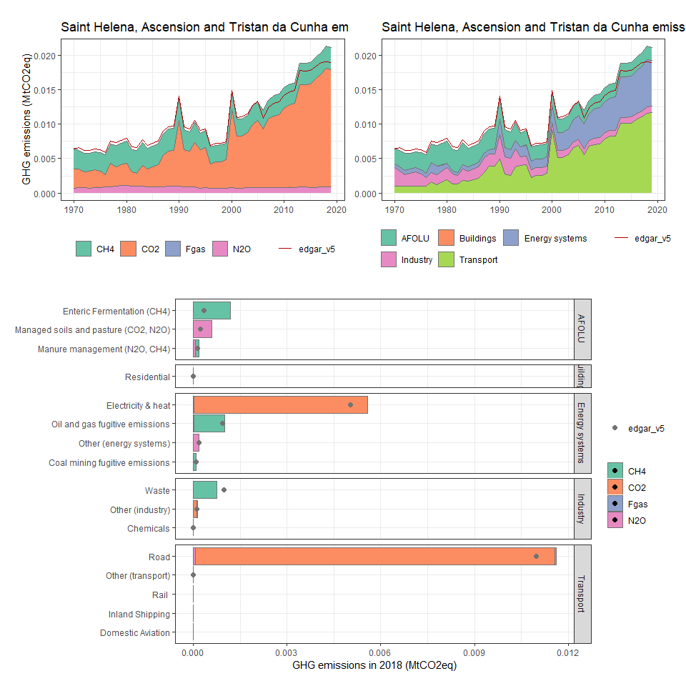

### Saint Pierre and Miquelon

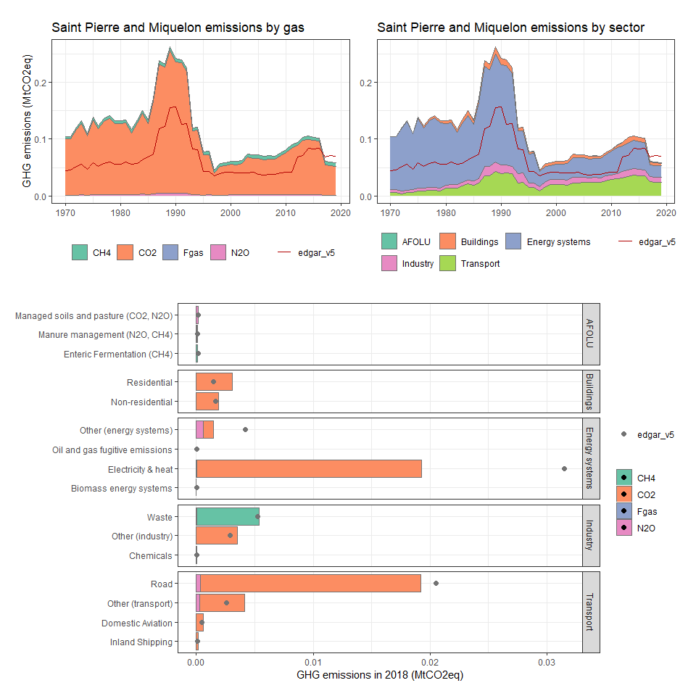

### Samoa

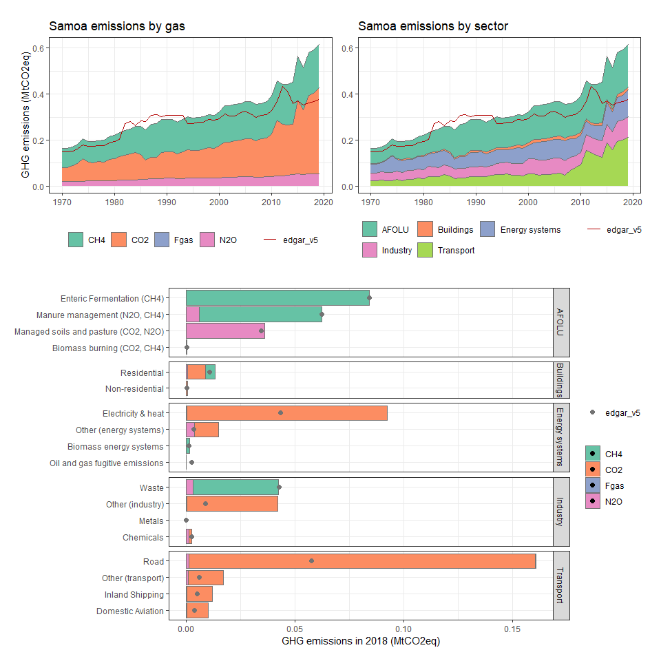

### São Tomé and Principe

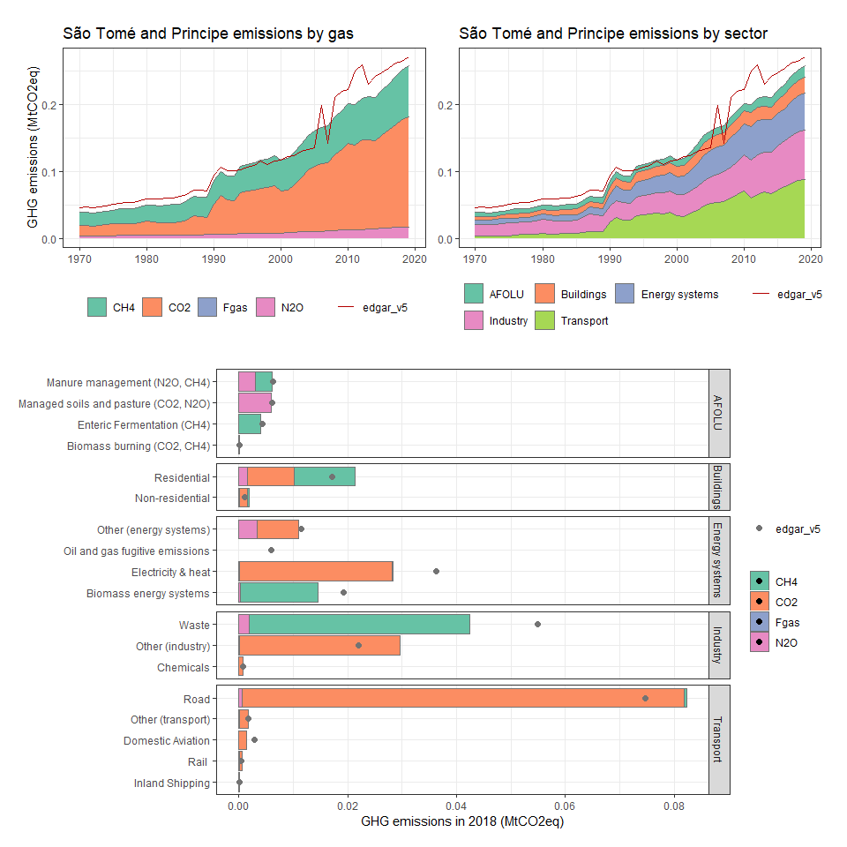

### Saudi Arabia

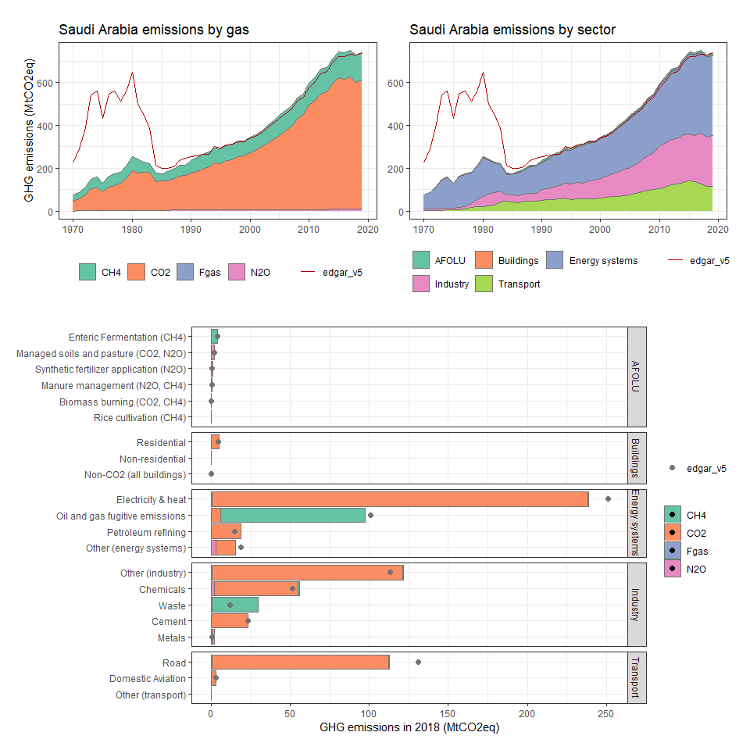

### Senegal

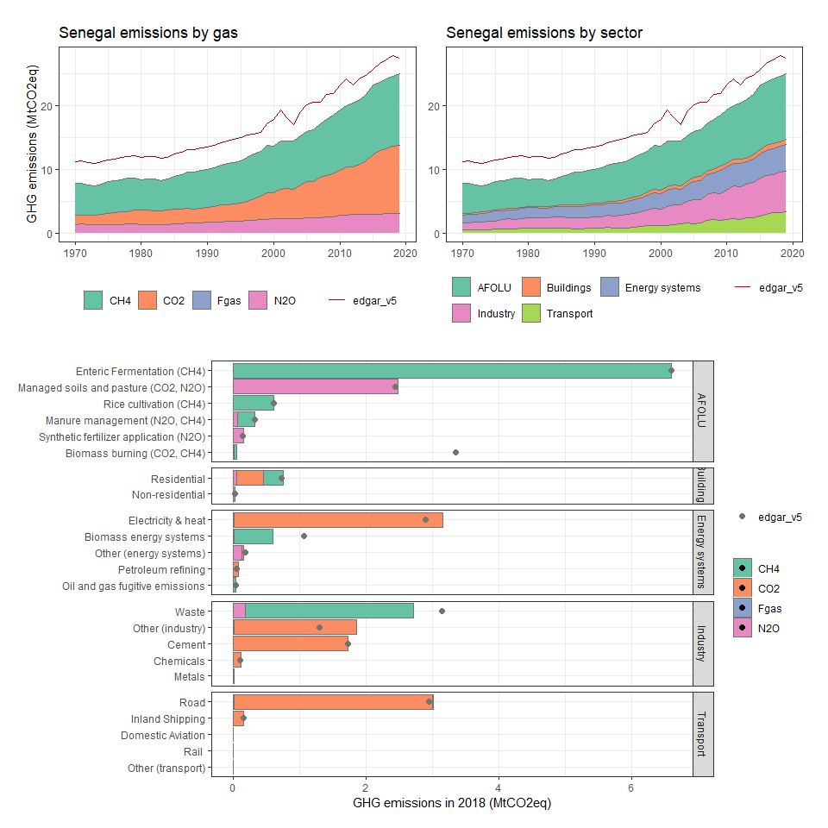

### Serbia and Montenegro

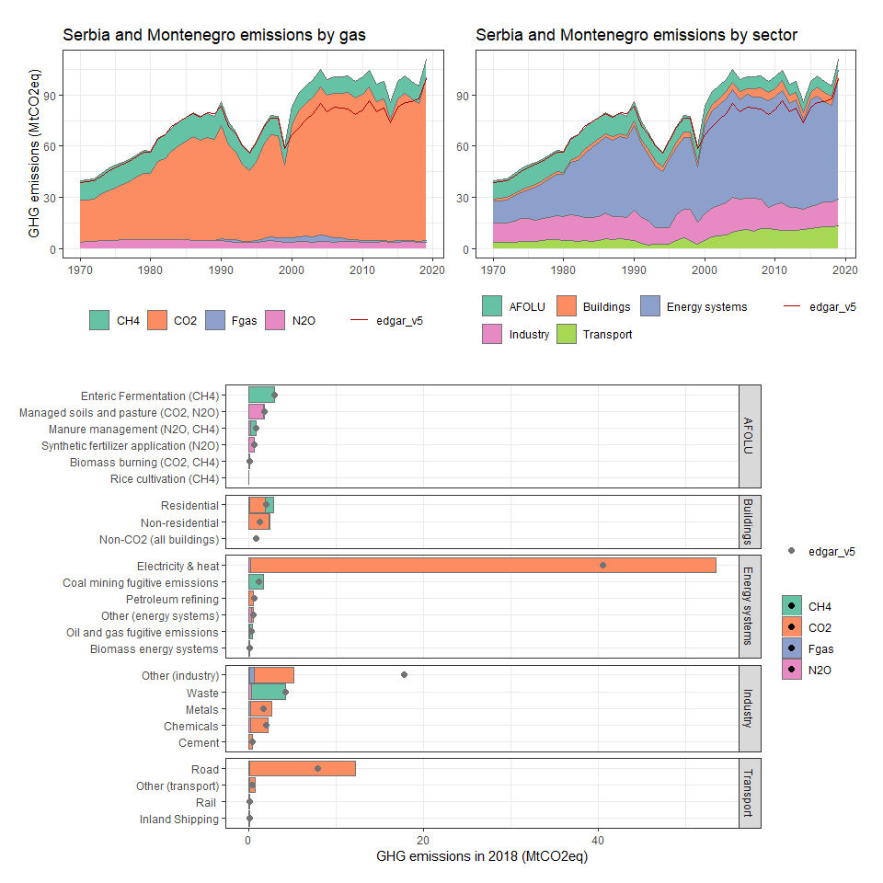

### Seychelles

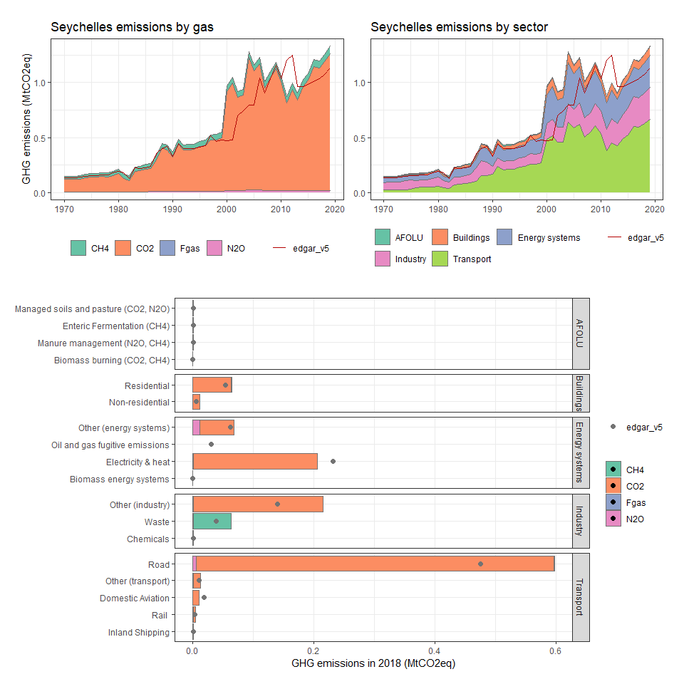

### Sierra Leone

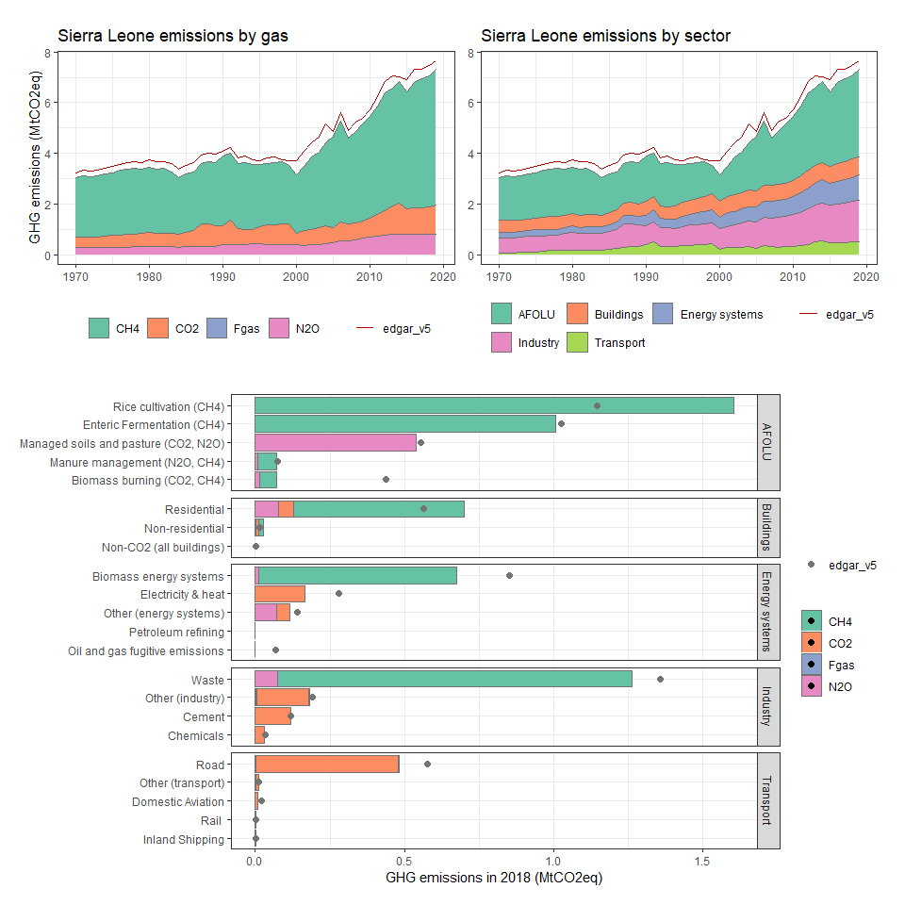

### Singapore

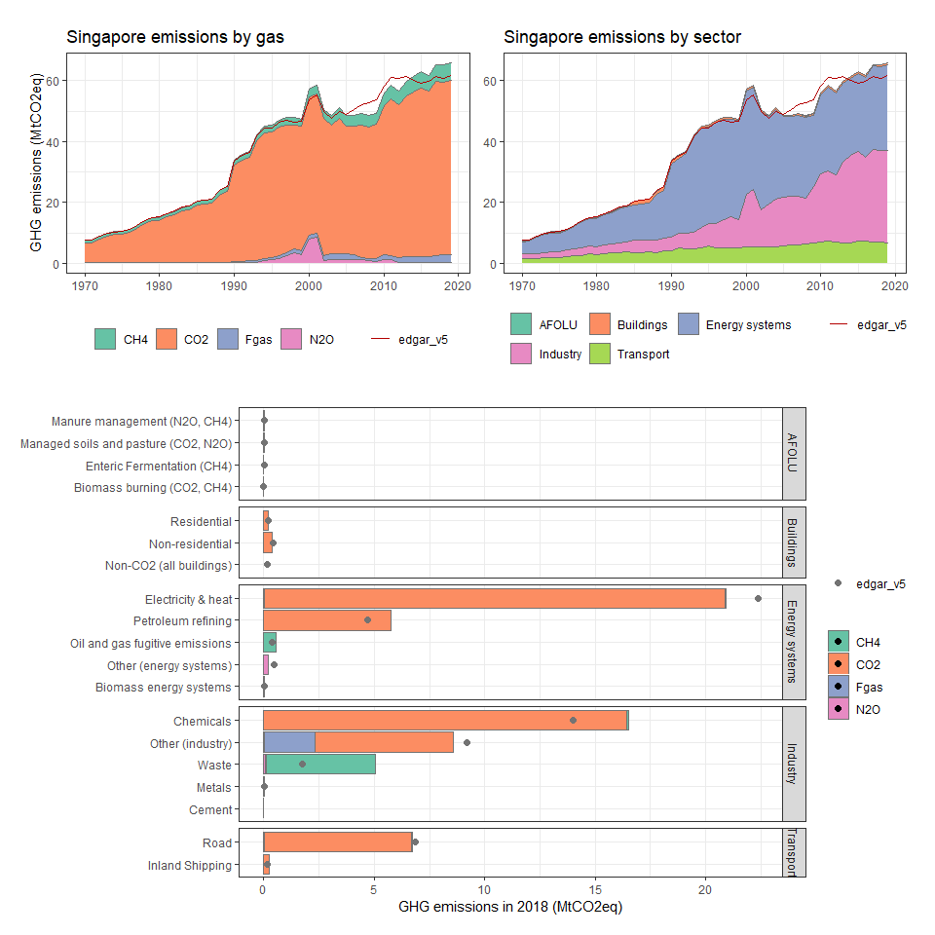

### Slovak Republic

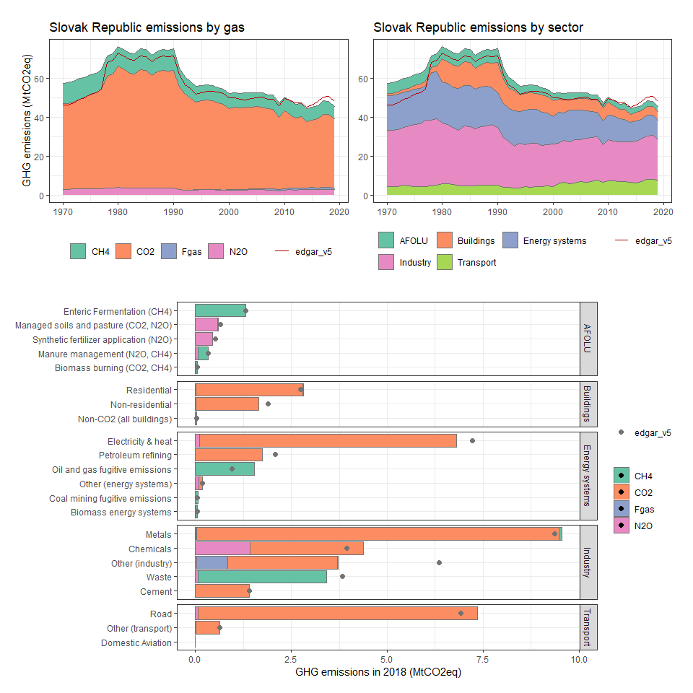

### Slovenia

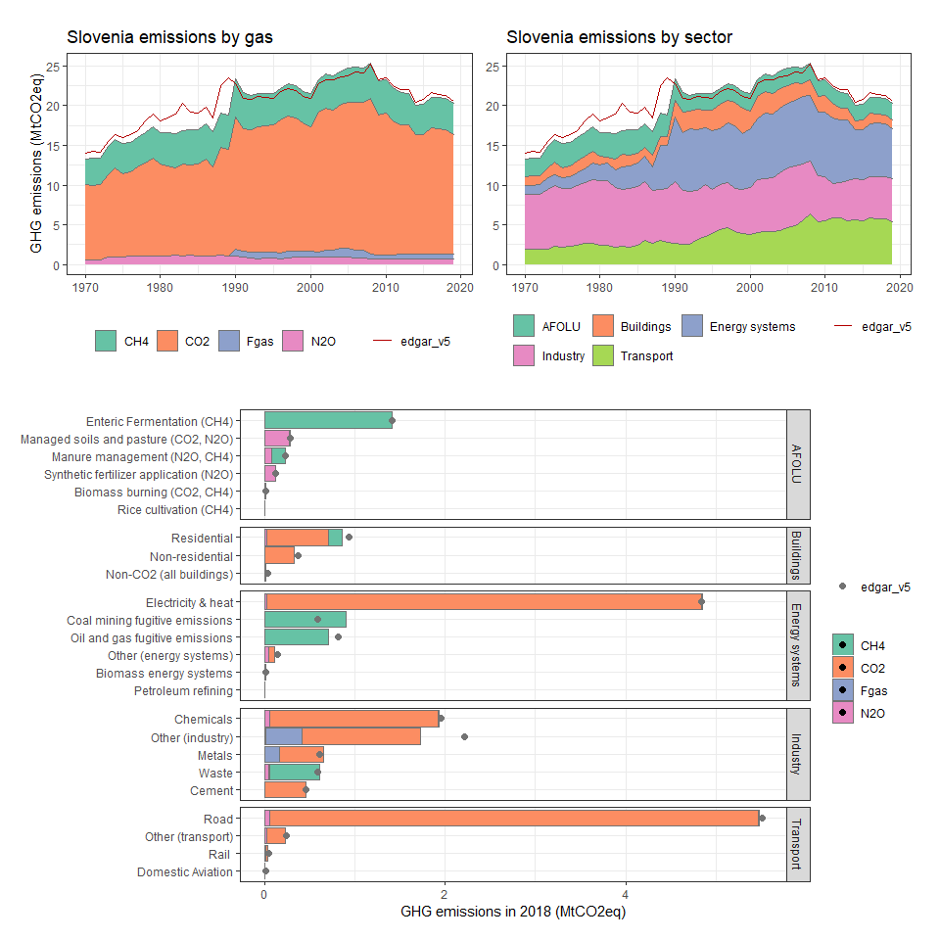

### Solomon Islands

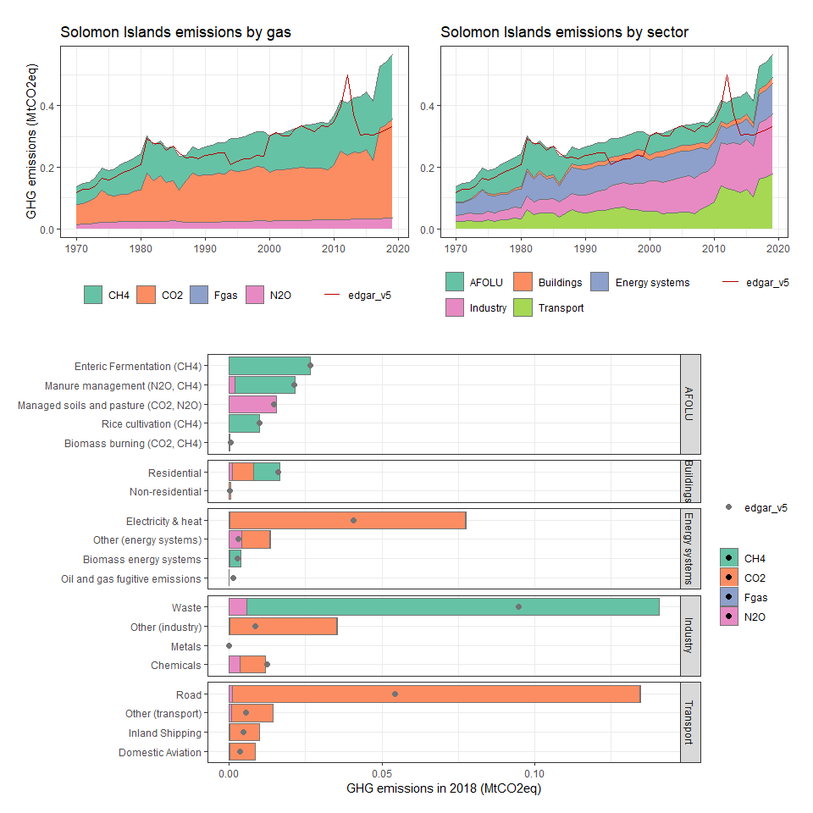

### Somalia

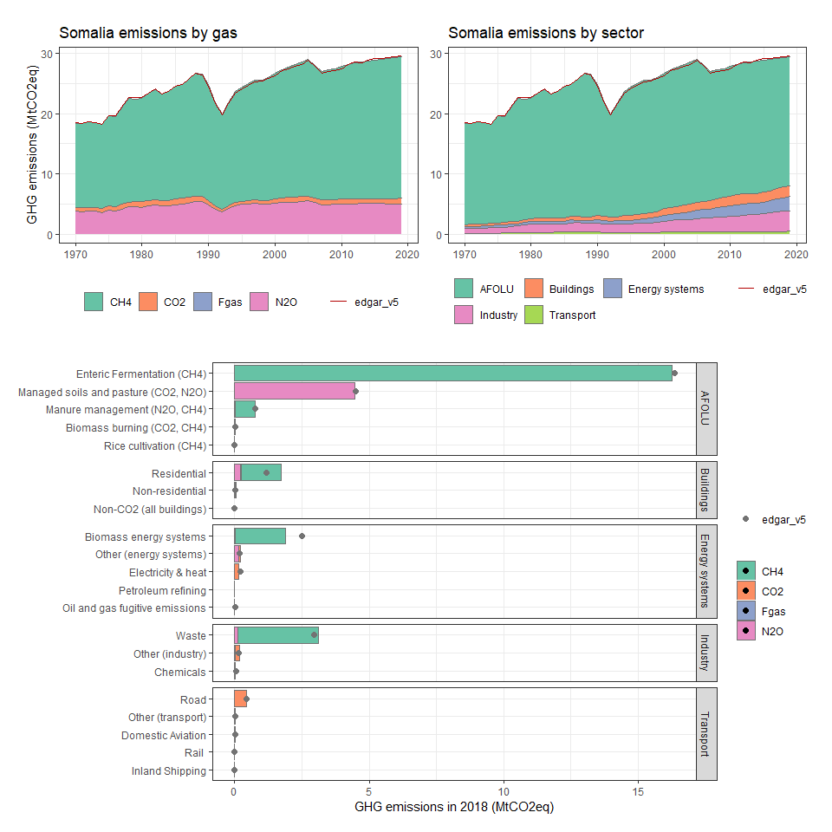

### South Africa

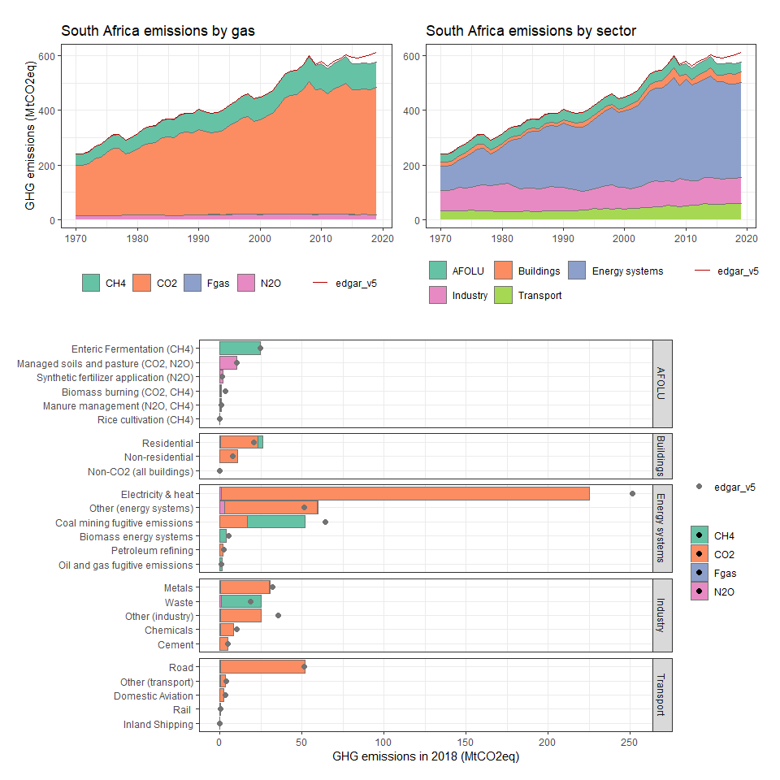

### South Georgia and the South Sandwich Islands

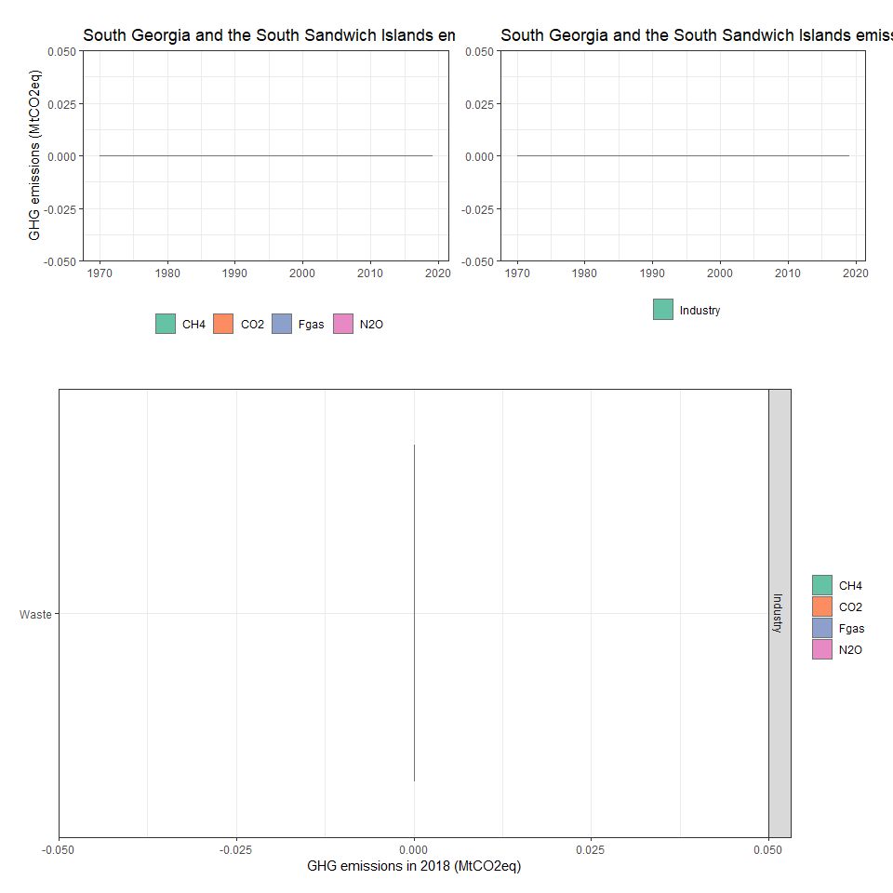

### Spain

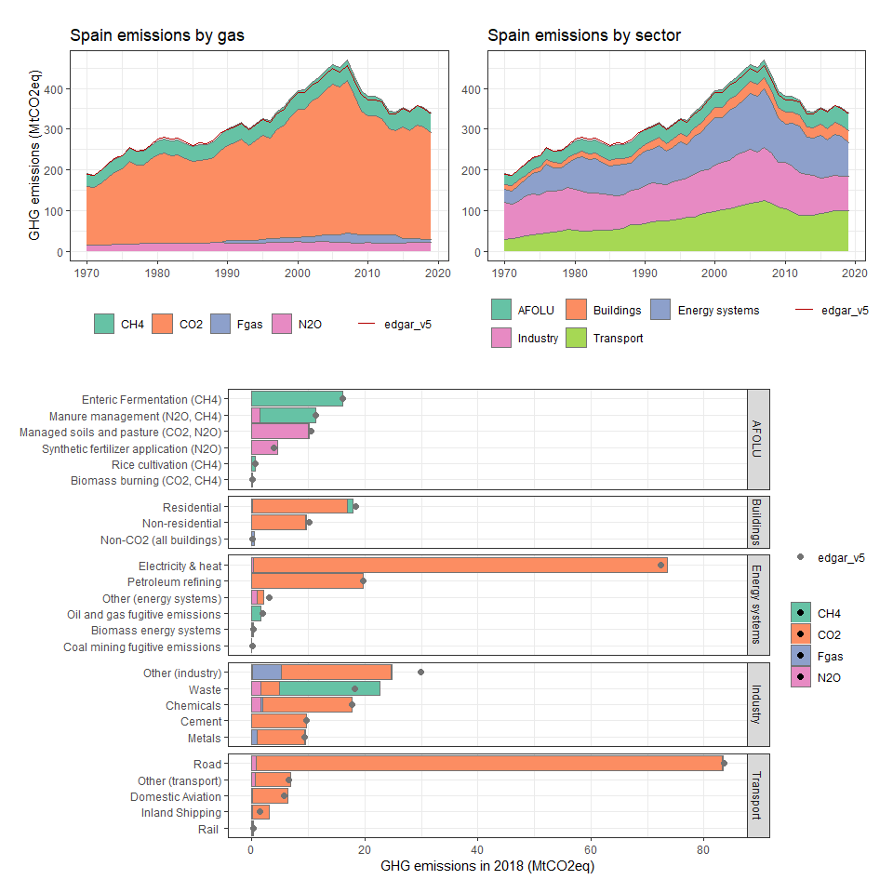

### Sri Lanka

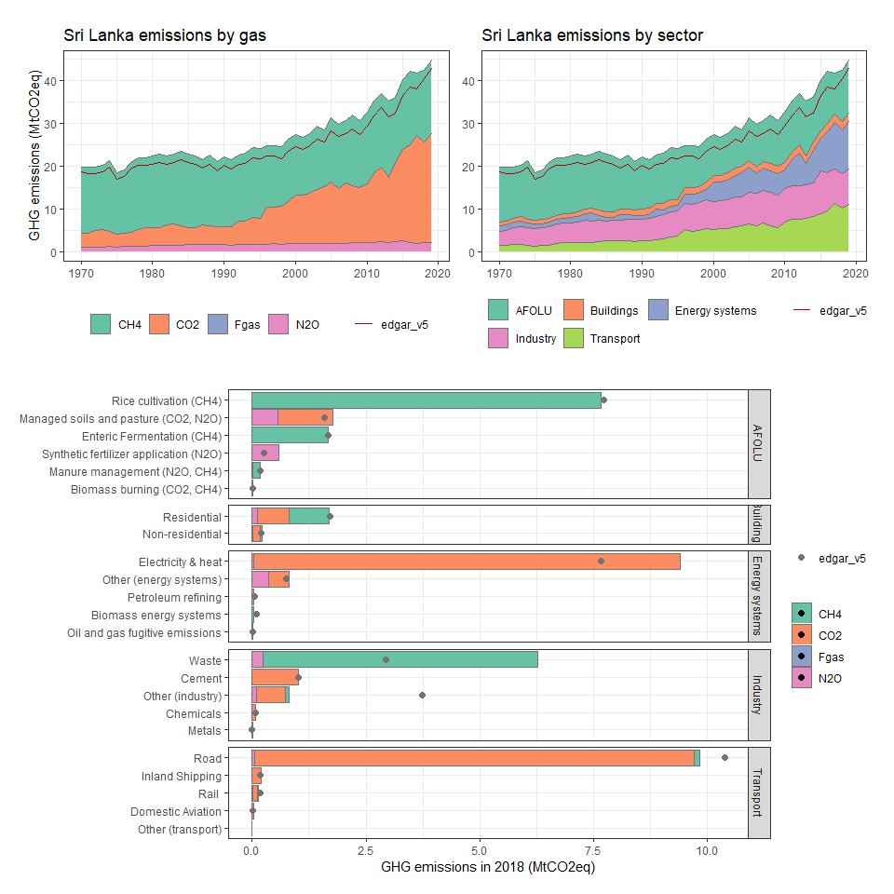

### St. Kitts and Nevis

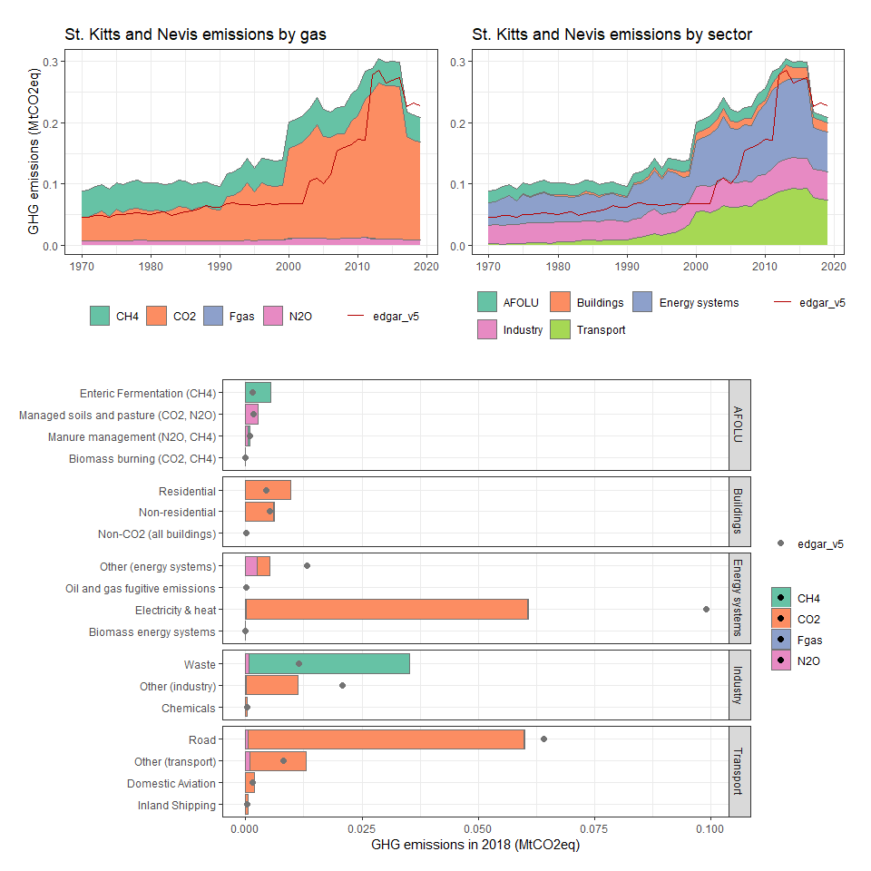

### St. Lucia

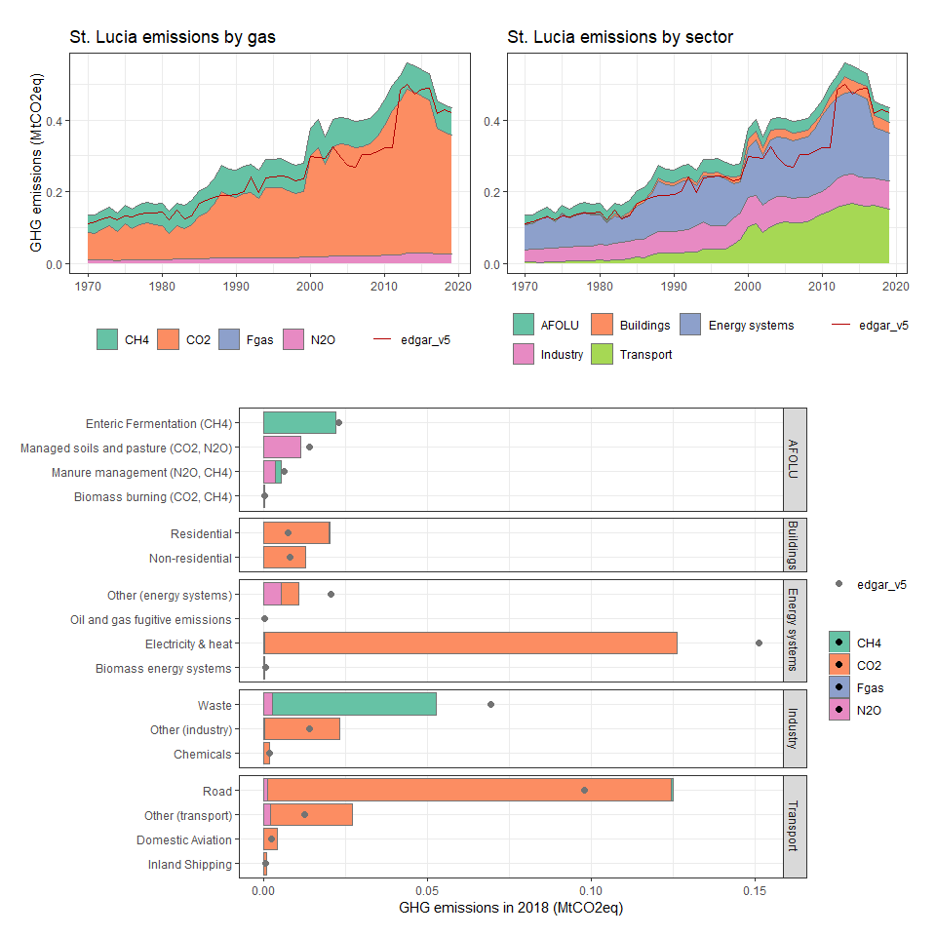

### St. Vincent and the Grenadines

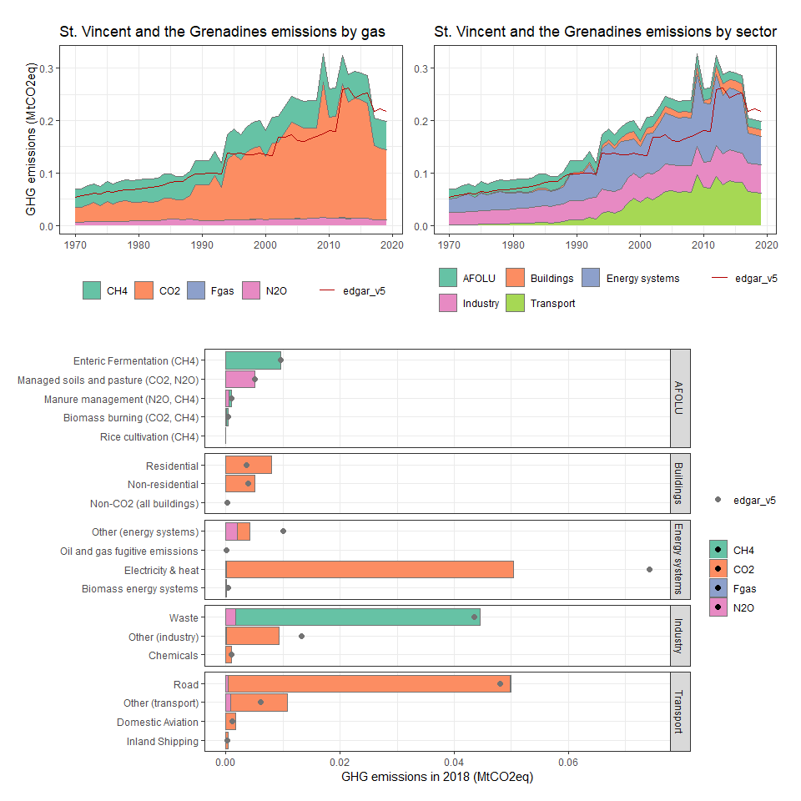

### Sudan

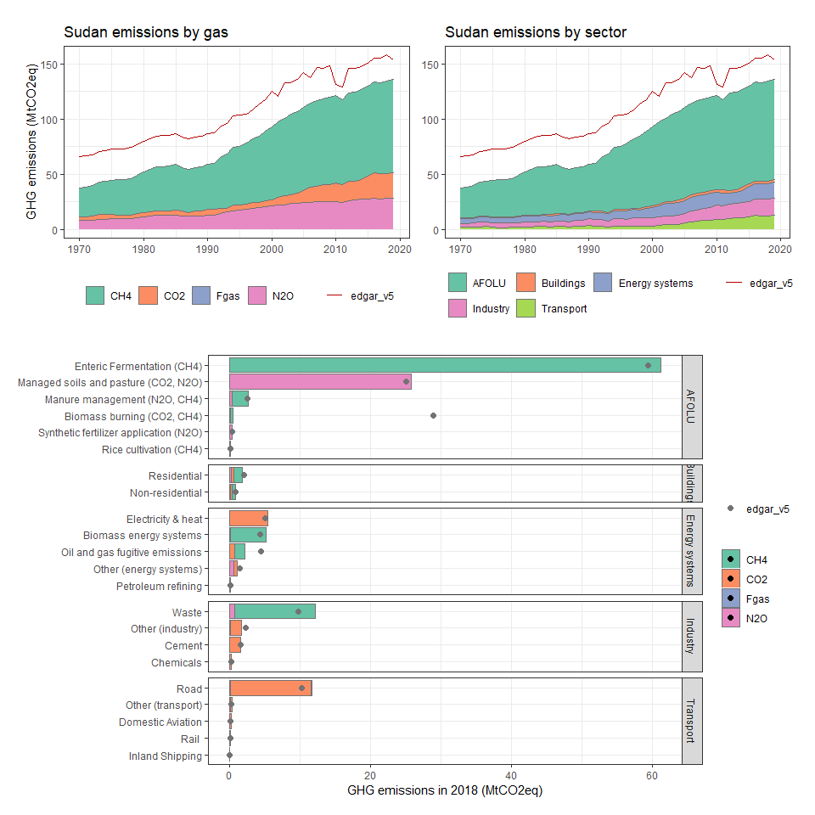

### Suriname

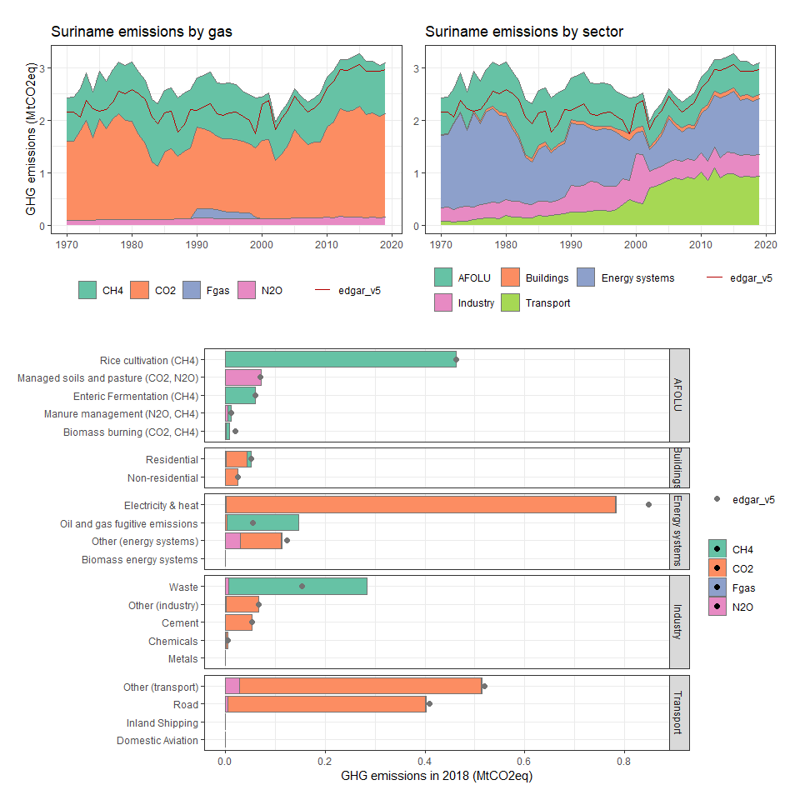

### Swaziland

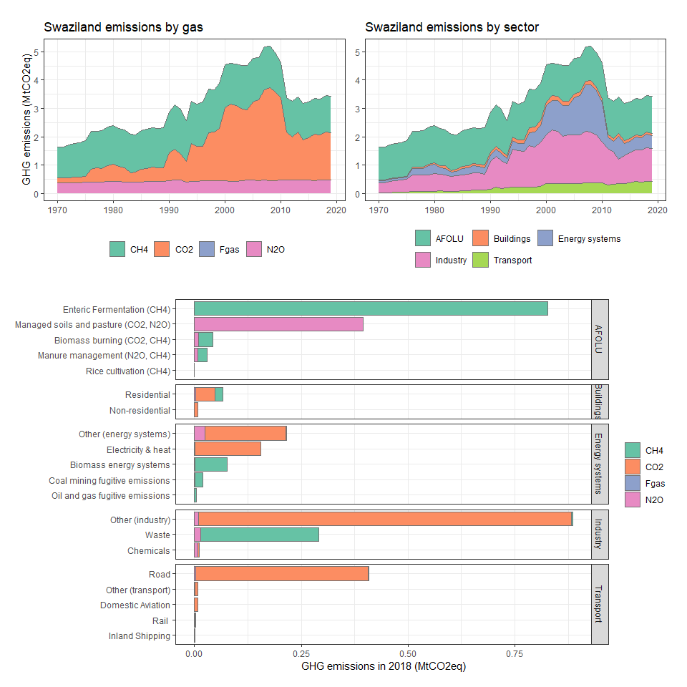

### Sweden

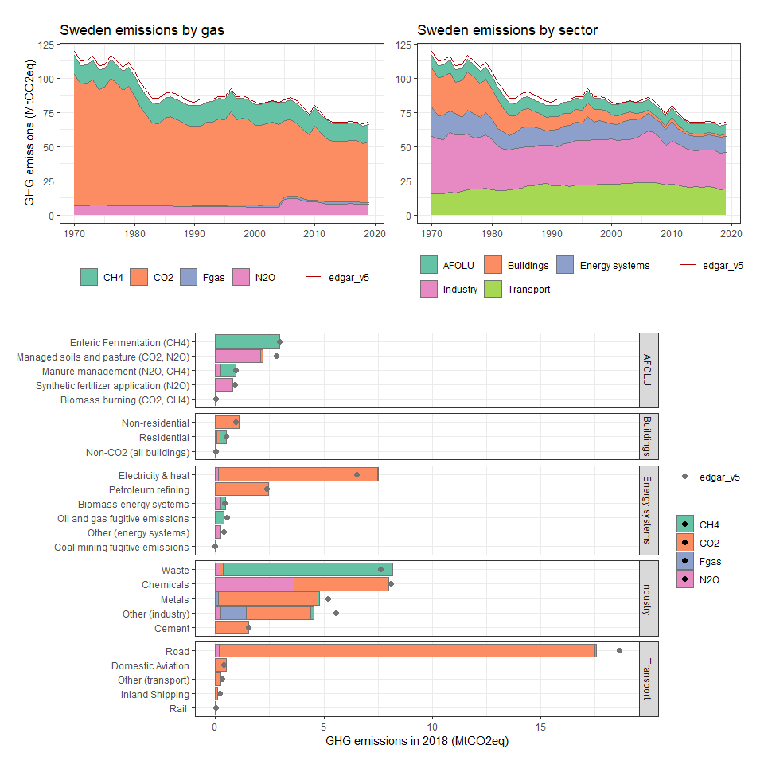

### Switzerland

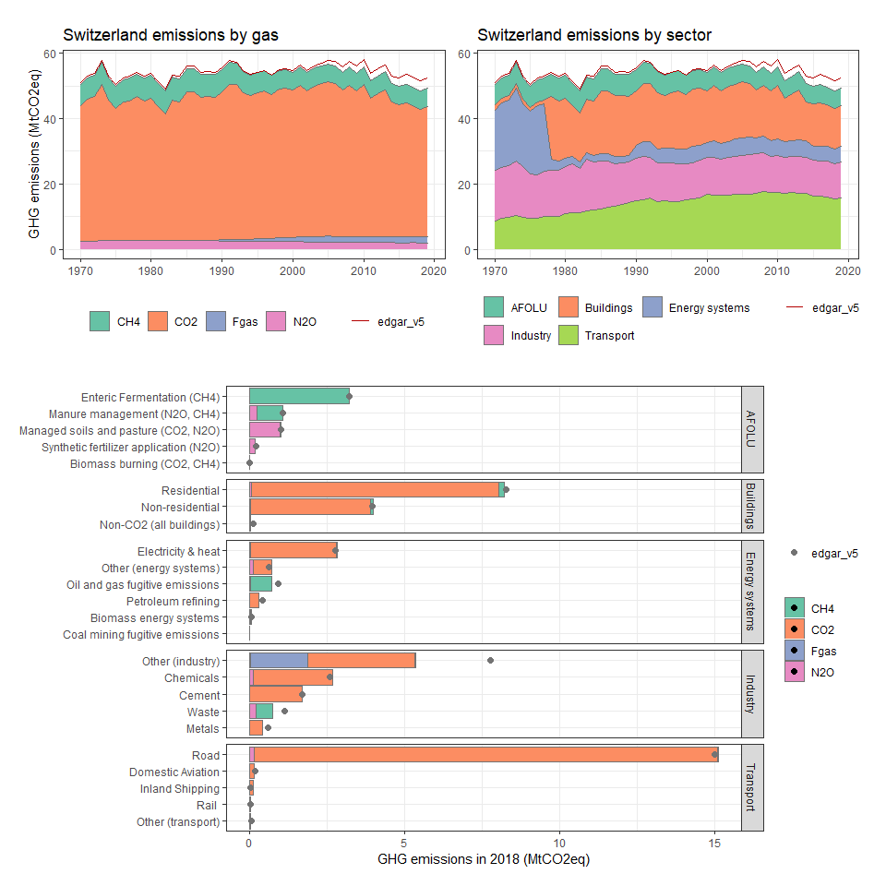

### Syrian Arab Republic

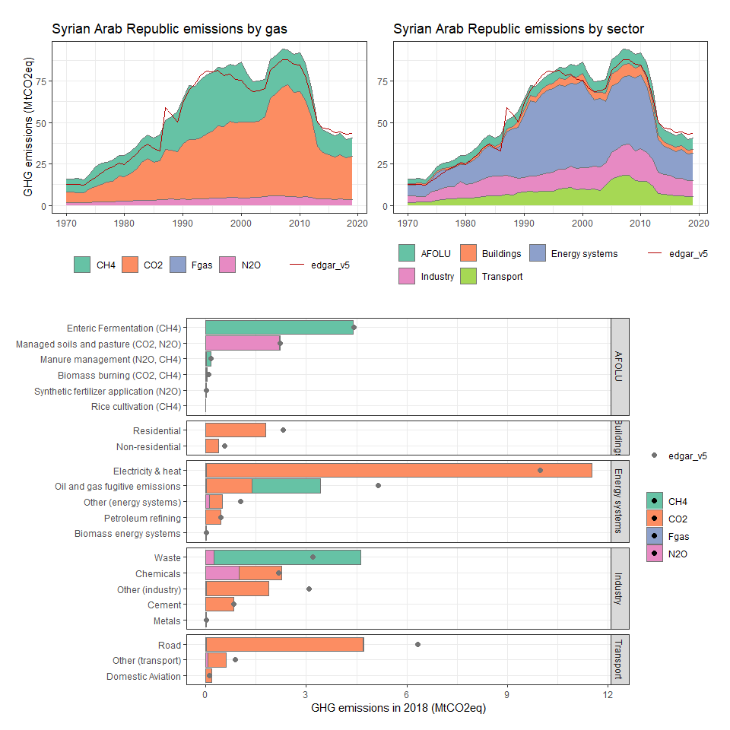

### Taiwan, China

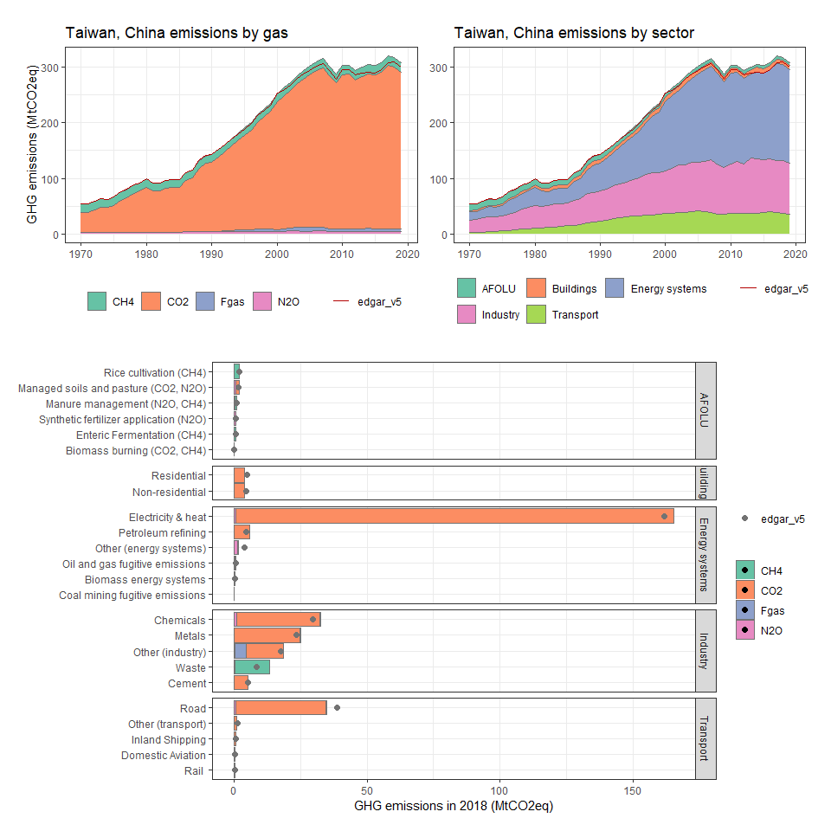

### Tajikistan

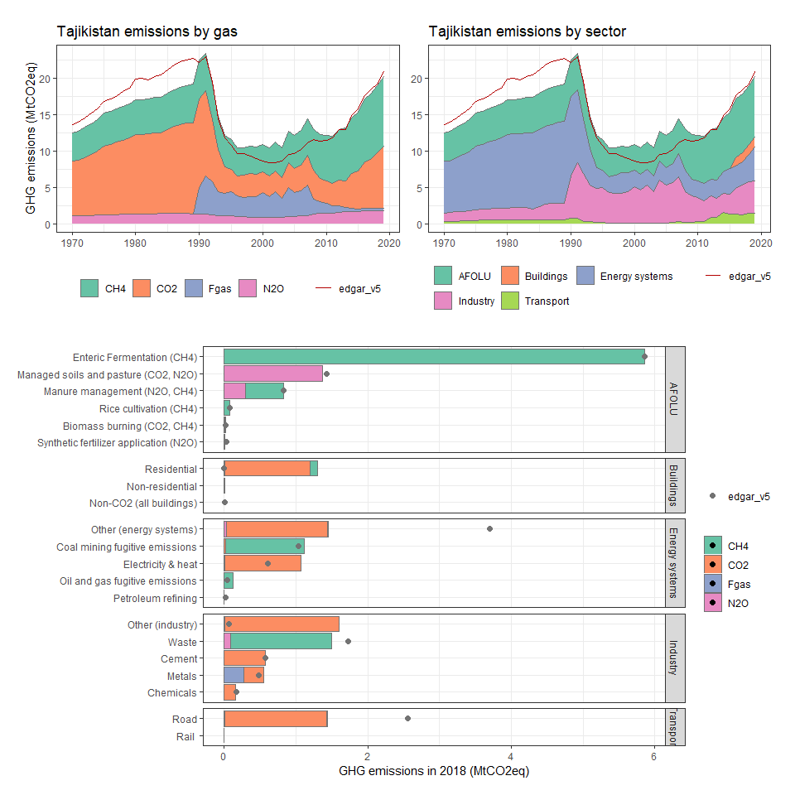

### Tanzania

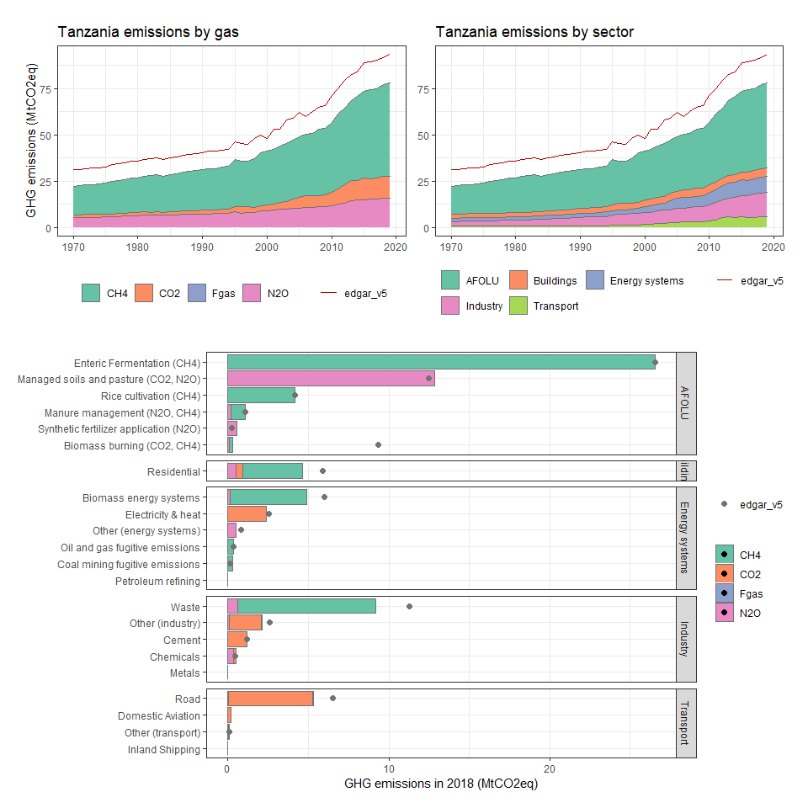

### Thailand

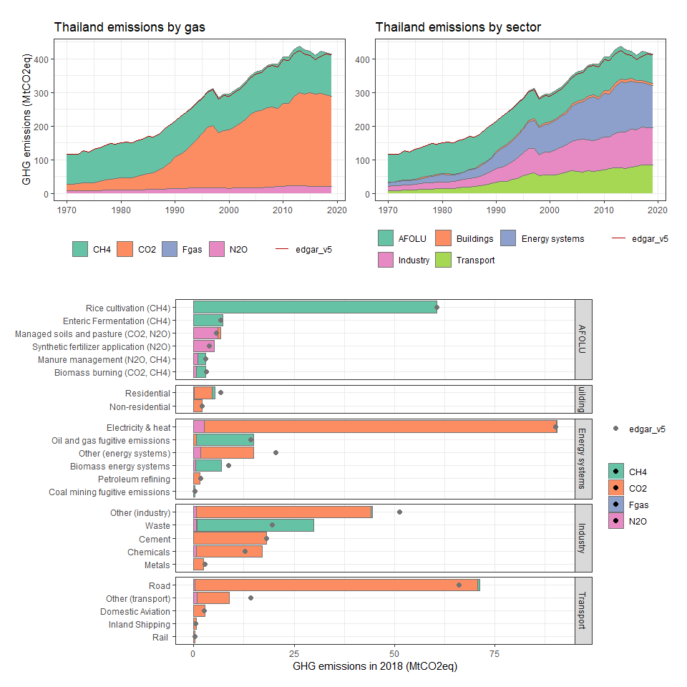

### Timor-Leste

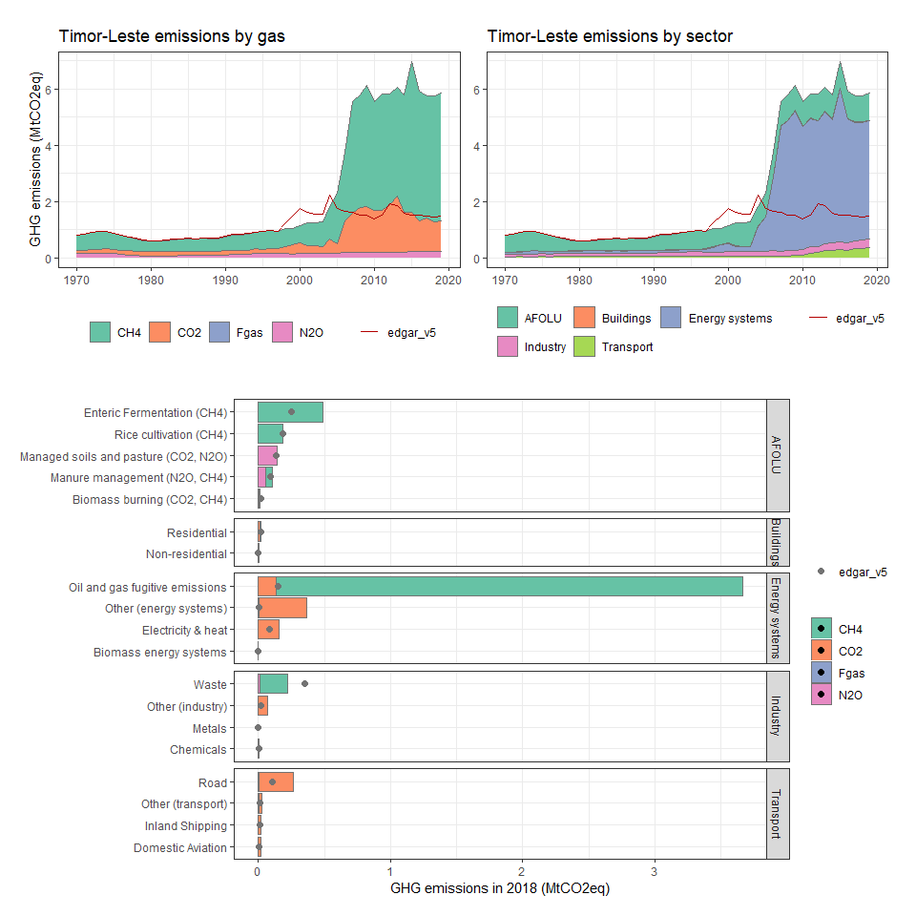

### Togo

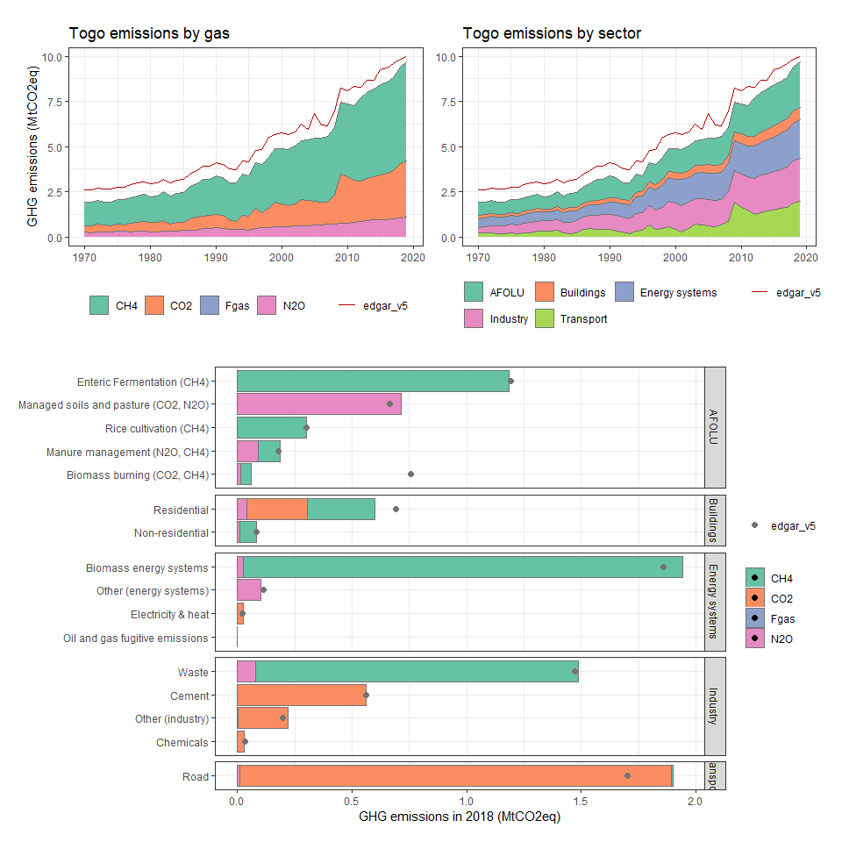

### Tokelau

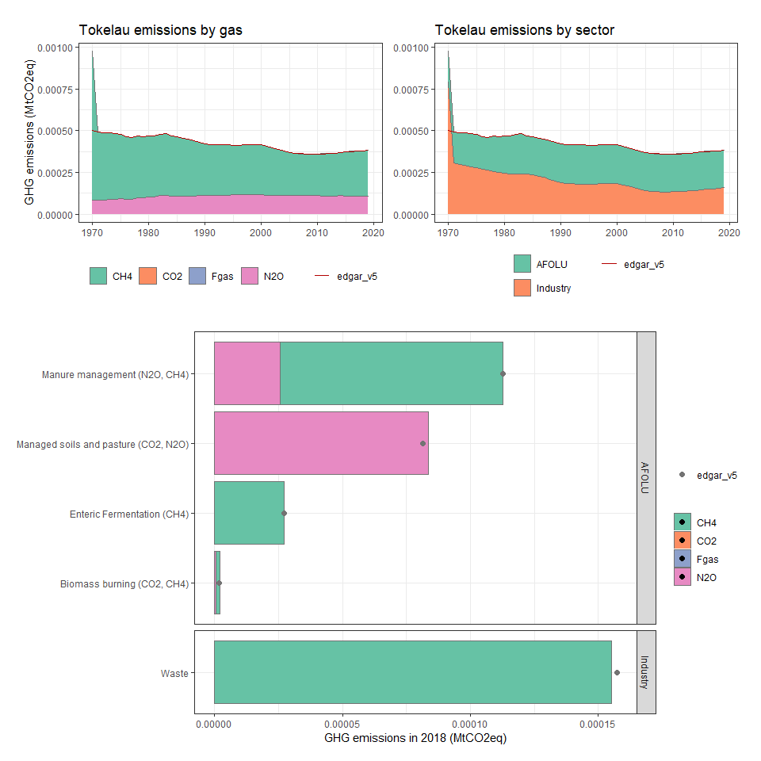

### Tonga

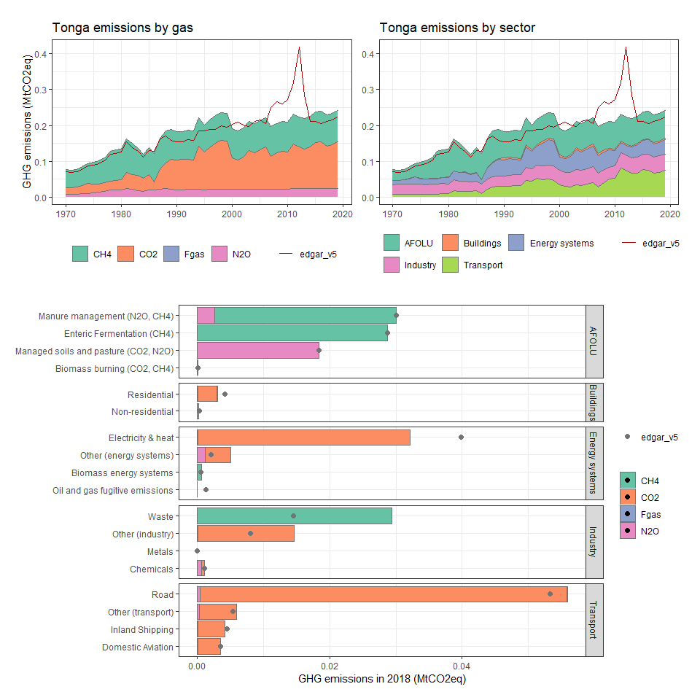

### Trinidad and Tobago

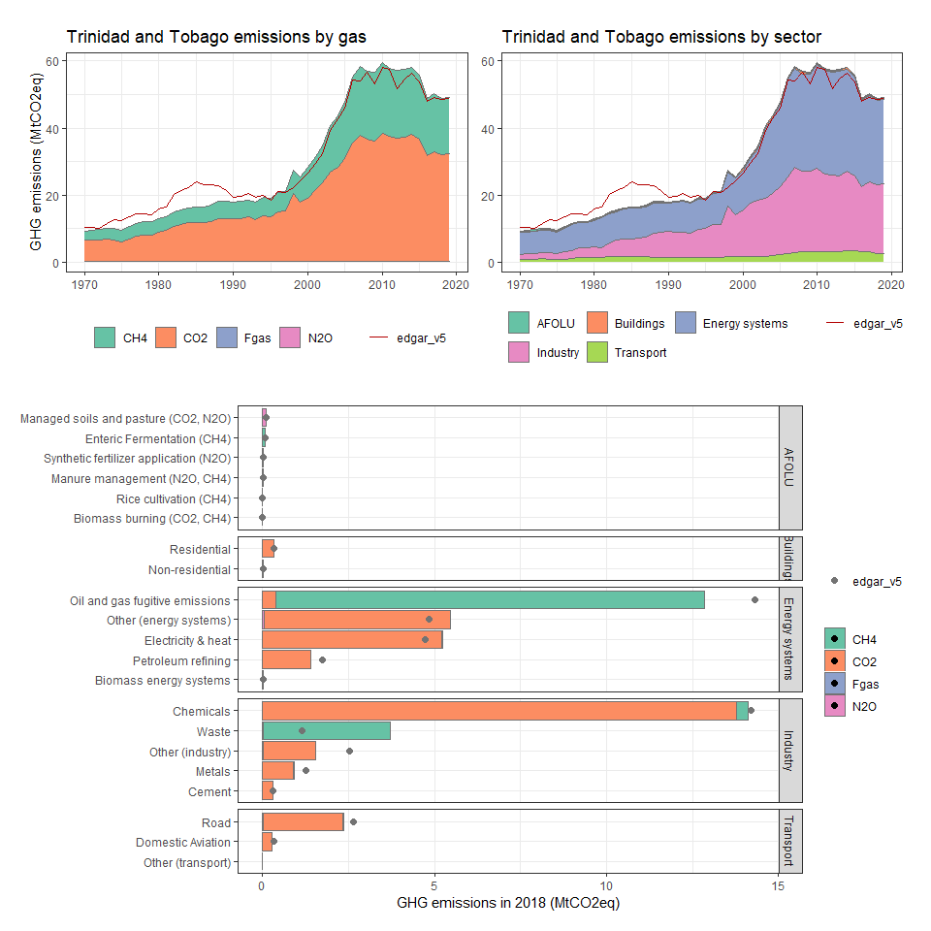

### Tunisia

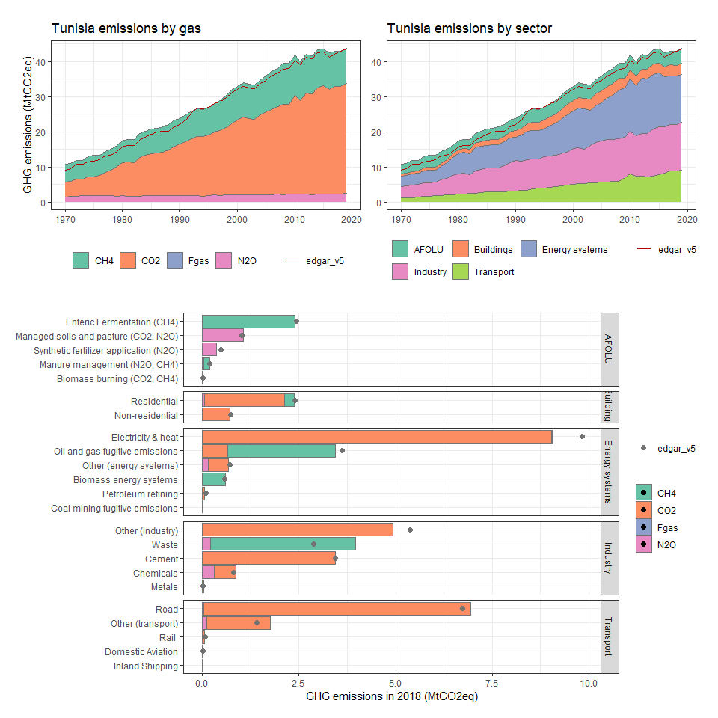

### Turkey

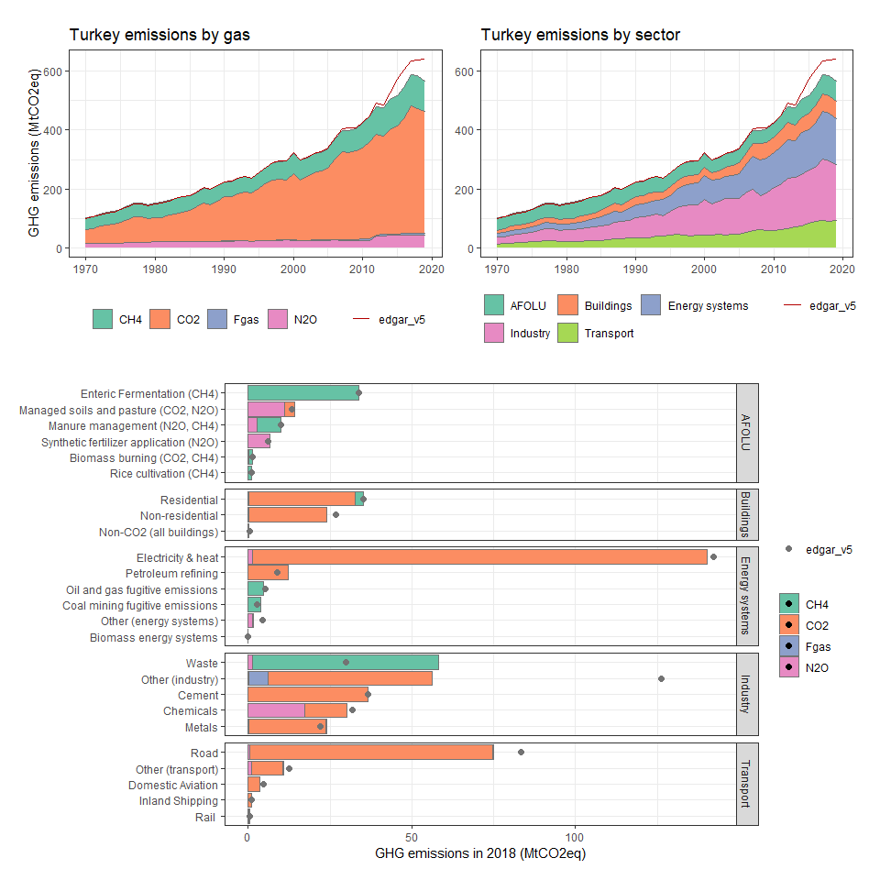

### Turkmenistan

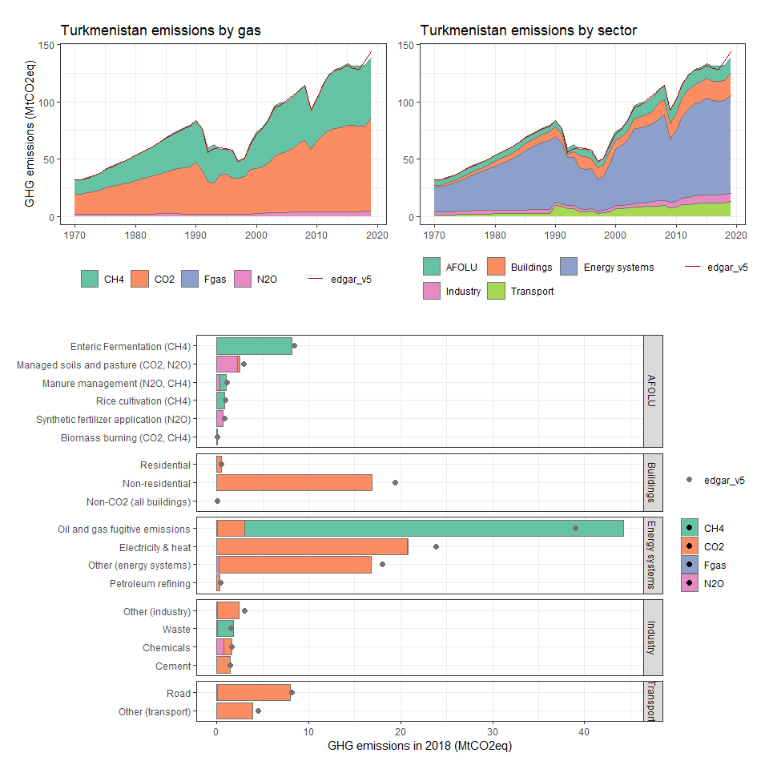

### Turks and Caicos Islands

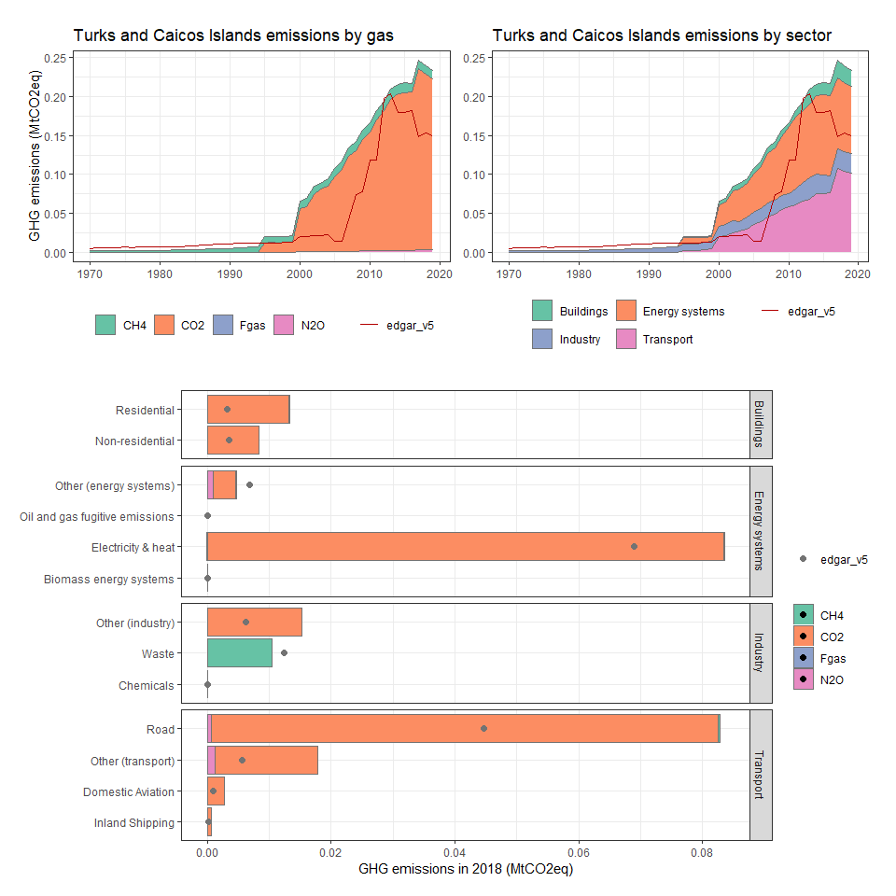

### Tuvalu

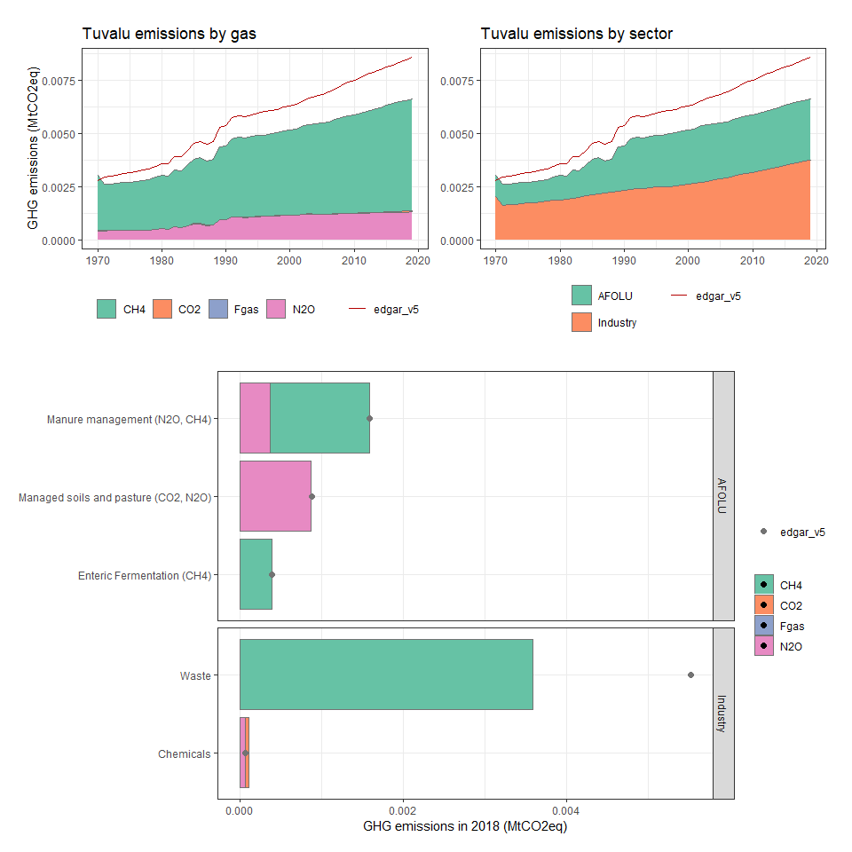

### Uganda

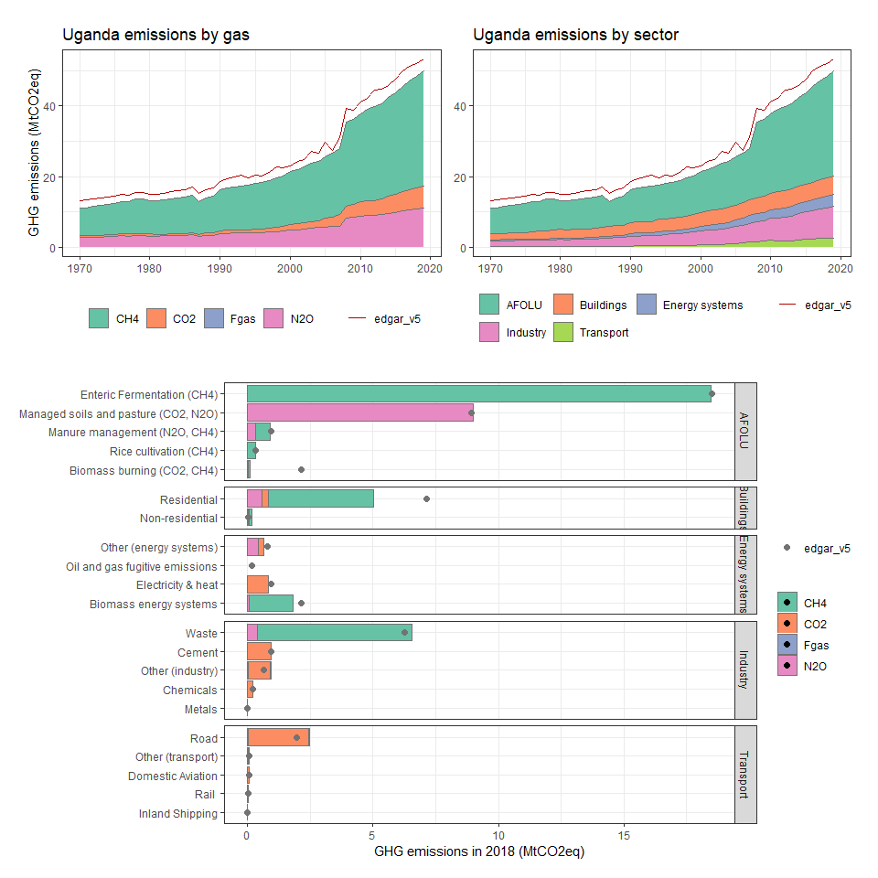

### Ukraine

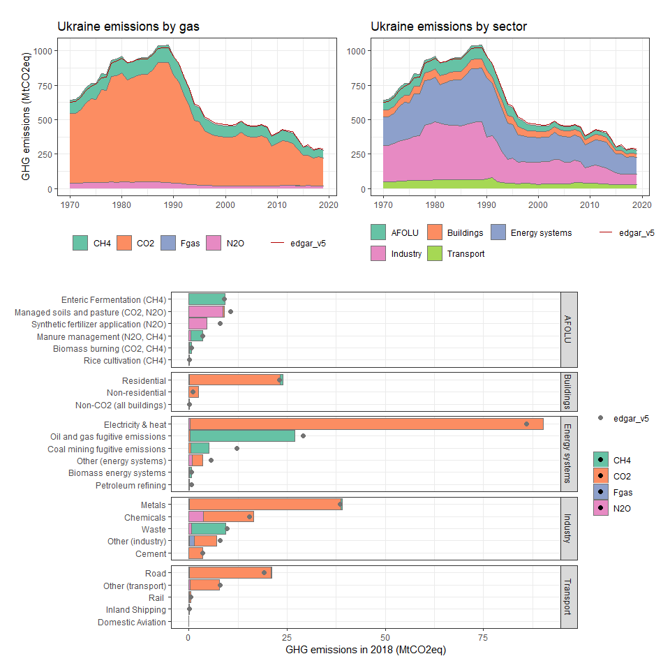

### United Arab Emirates

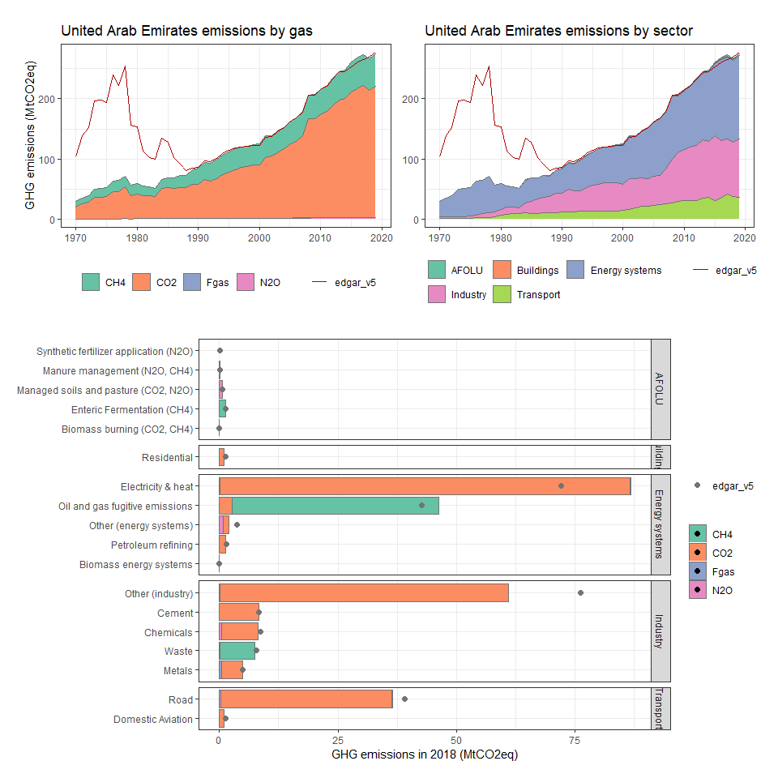

### United Kingdom

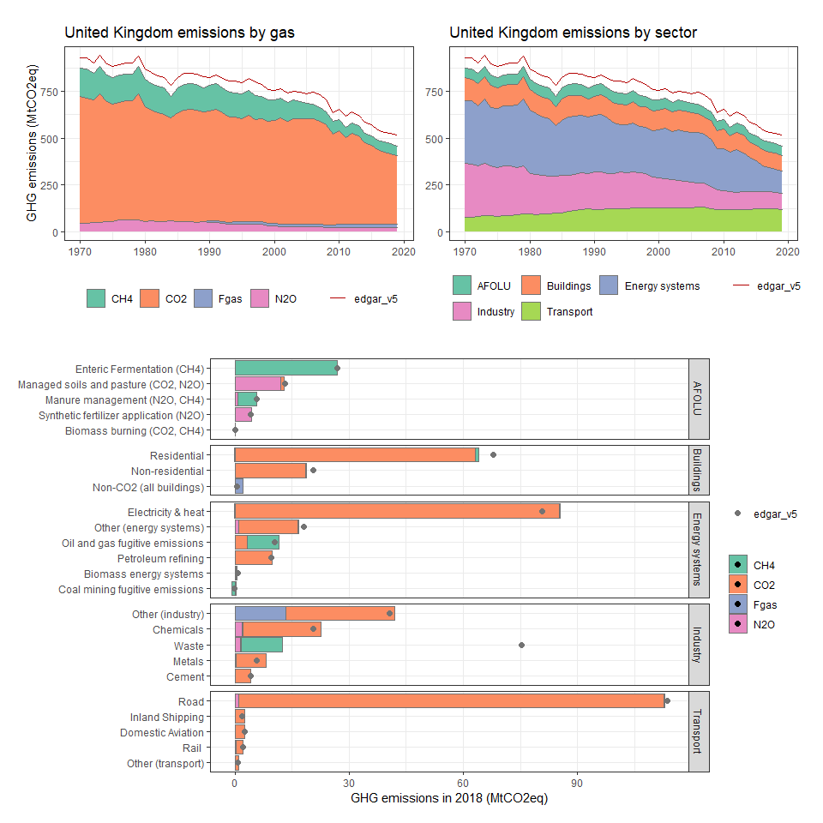

### United States

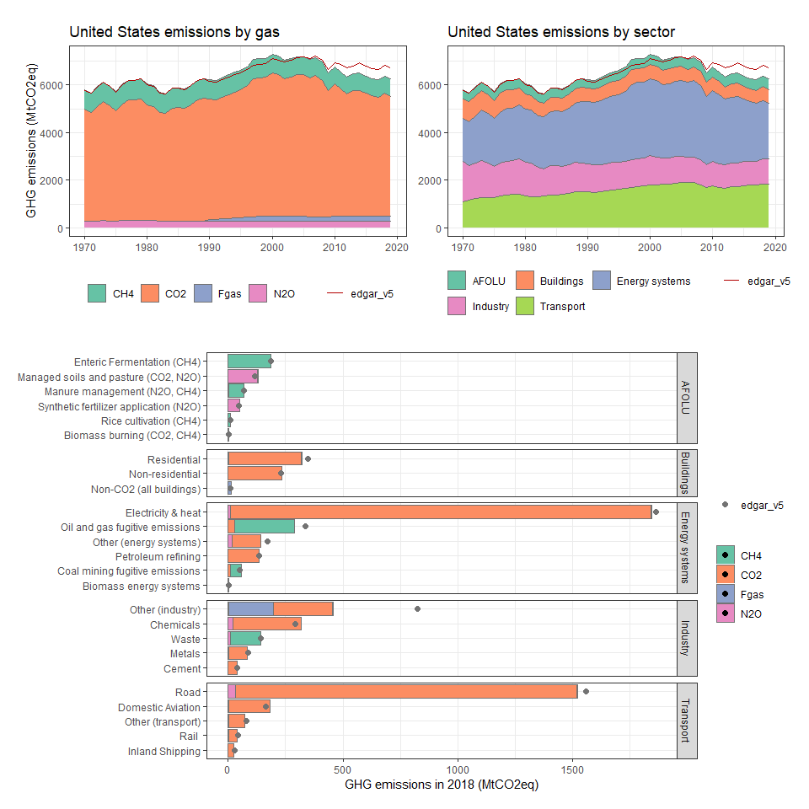

### United States Minor Outlying Islands

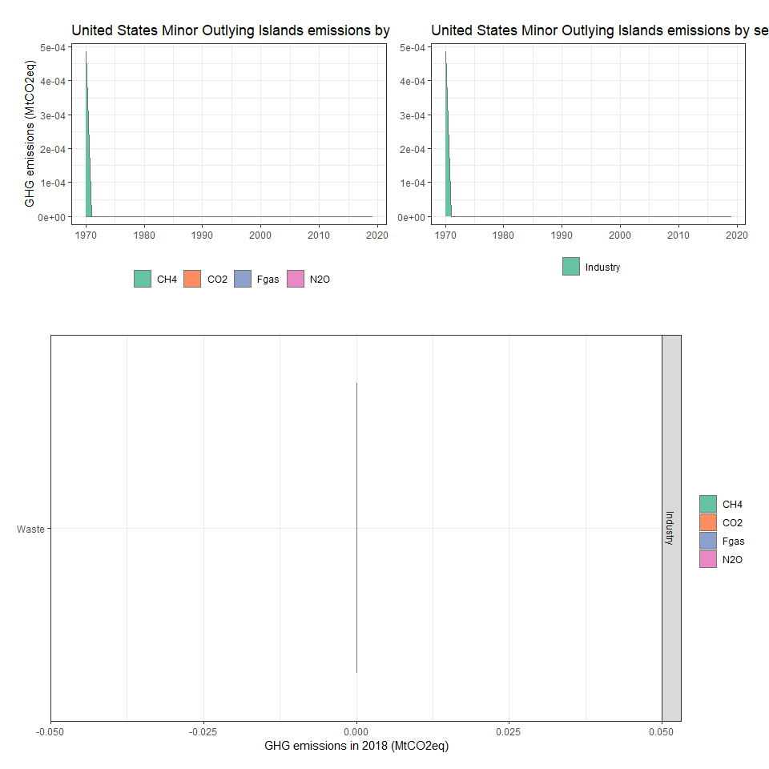

### Uruguay

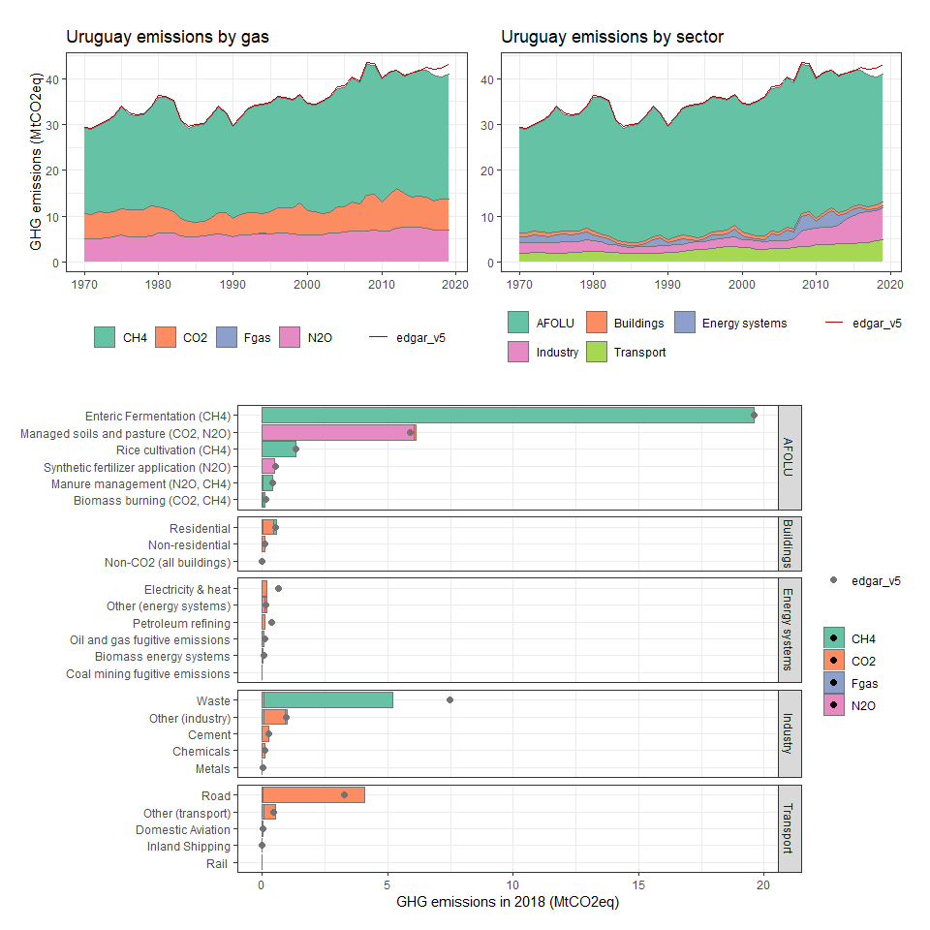

### Uzbekistan

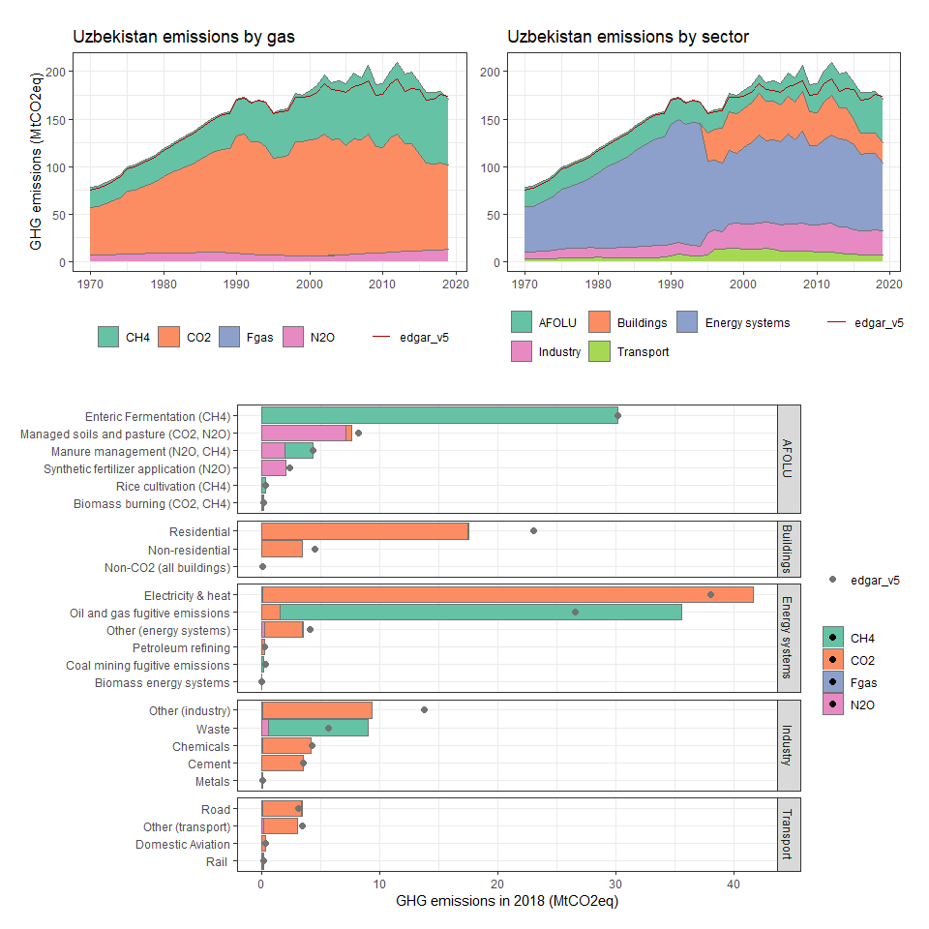

### Vanuatu

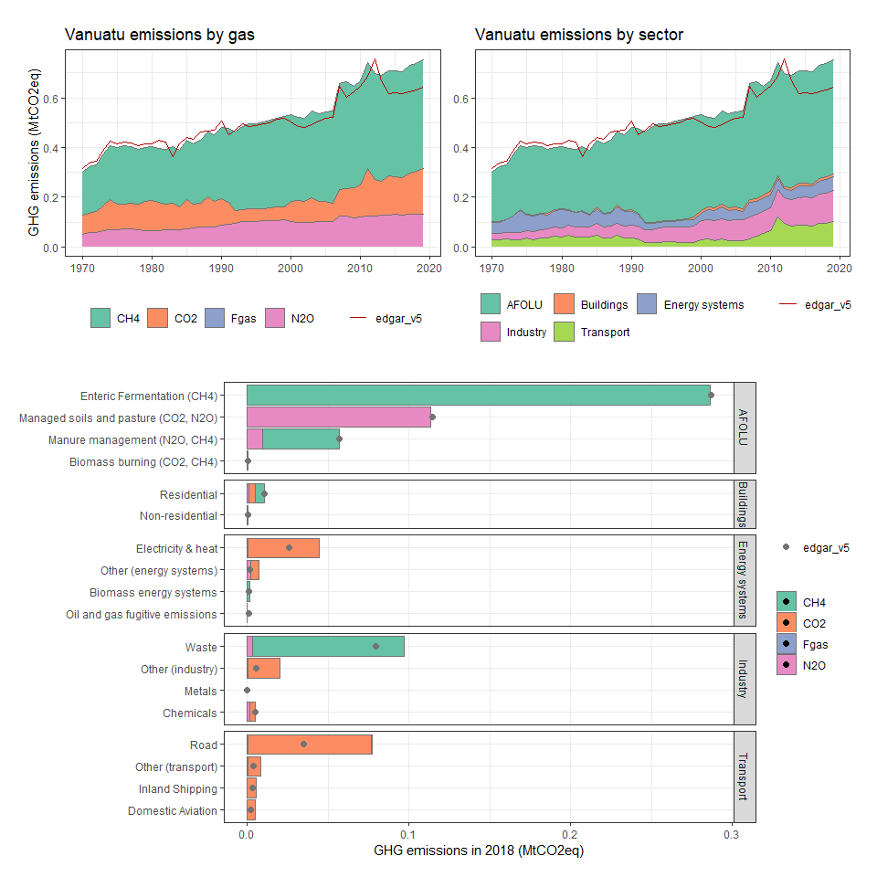

### Venezuela, RB

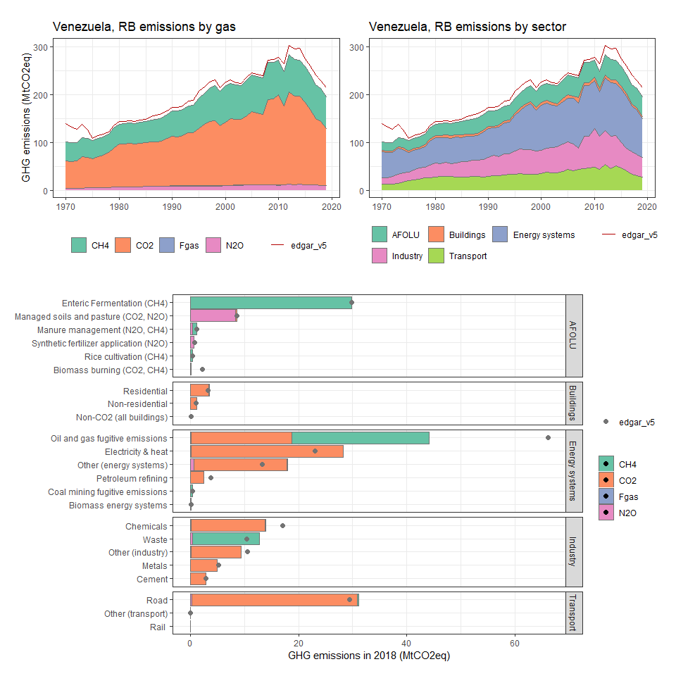

### Vietnam

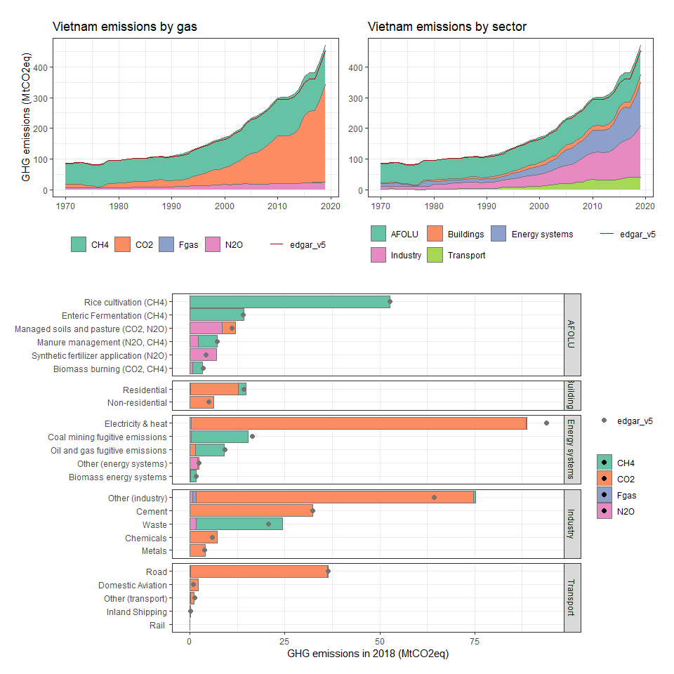

### Virgin Islands (U.S.)

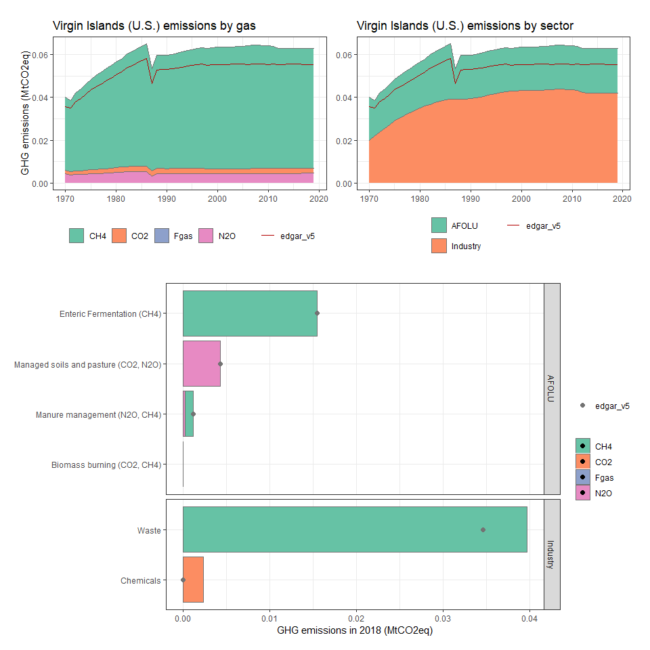

### Wallis and Futuna

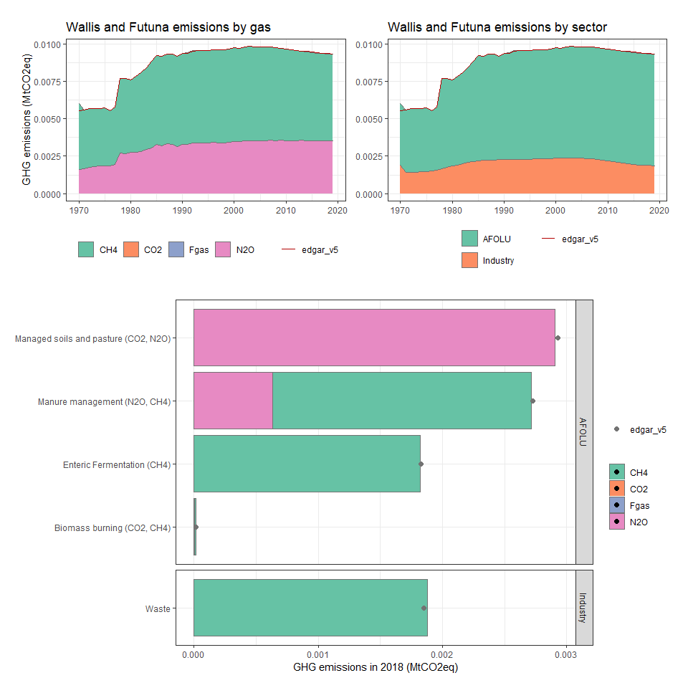

### Western Sahara

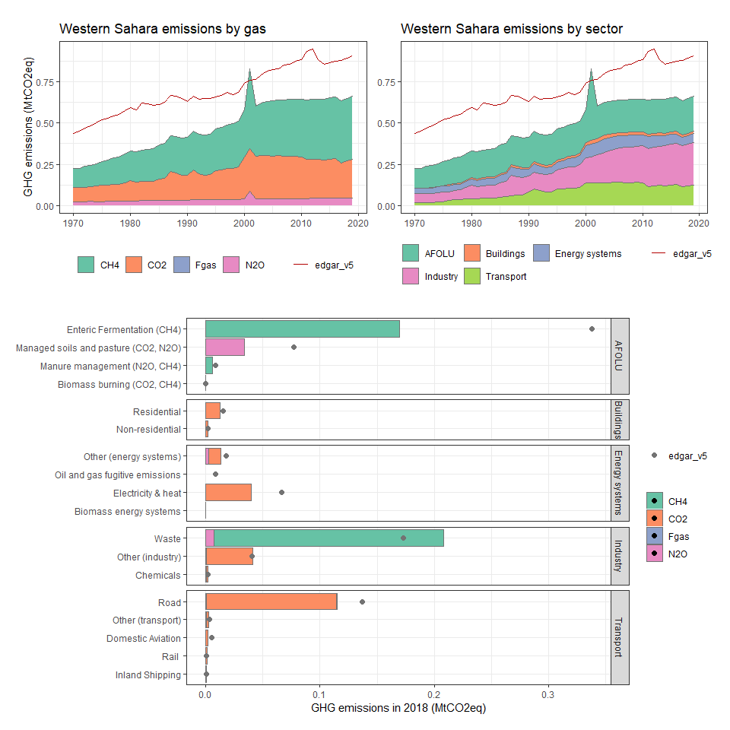

### Yemen, Rep.

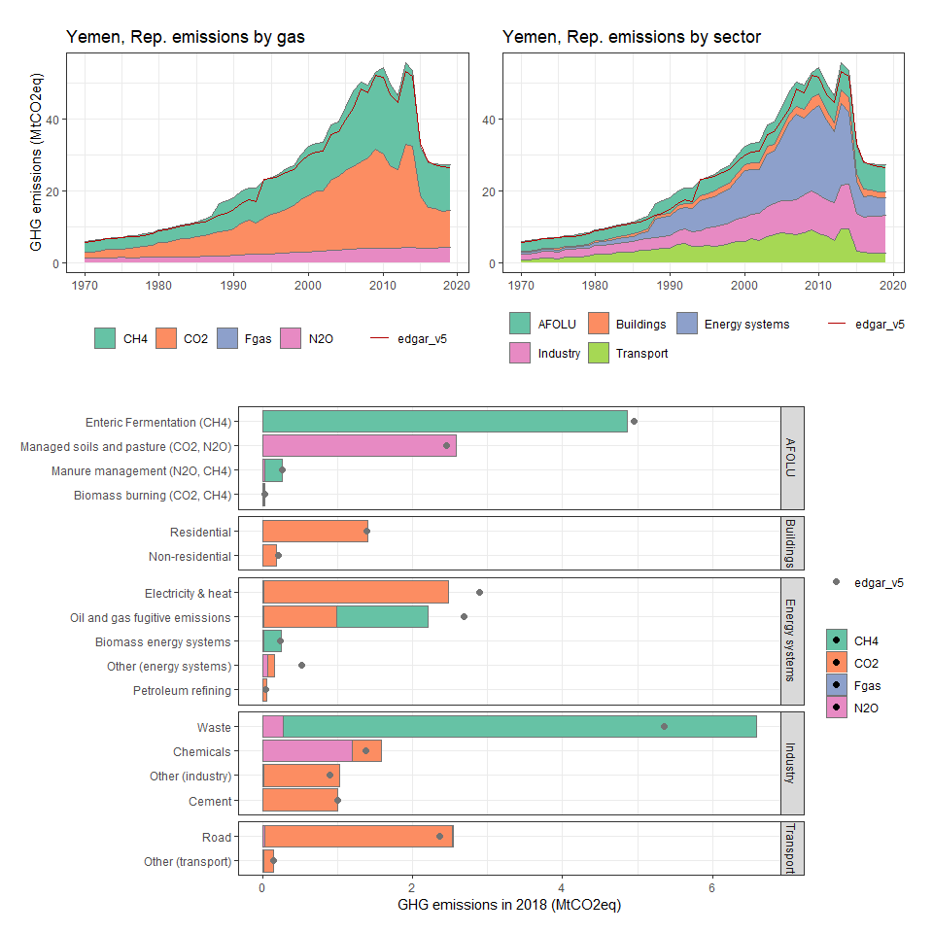

### Zambia

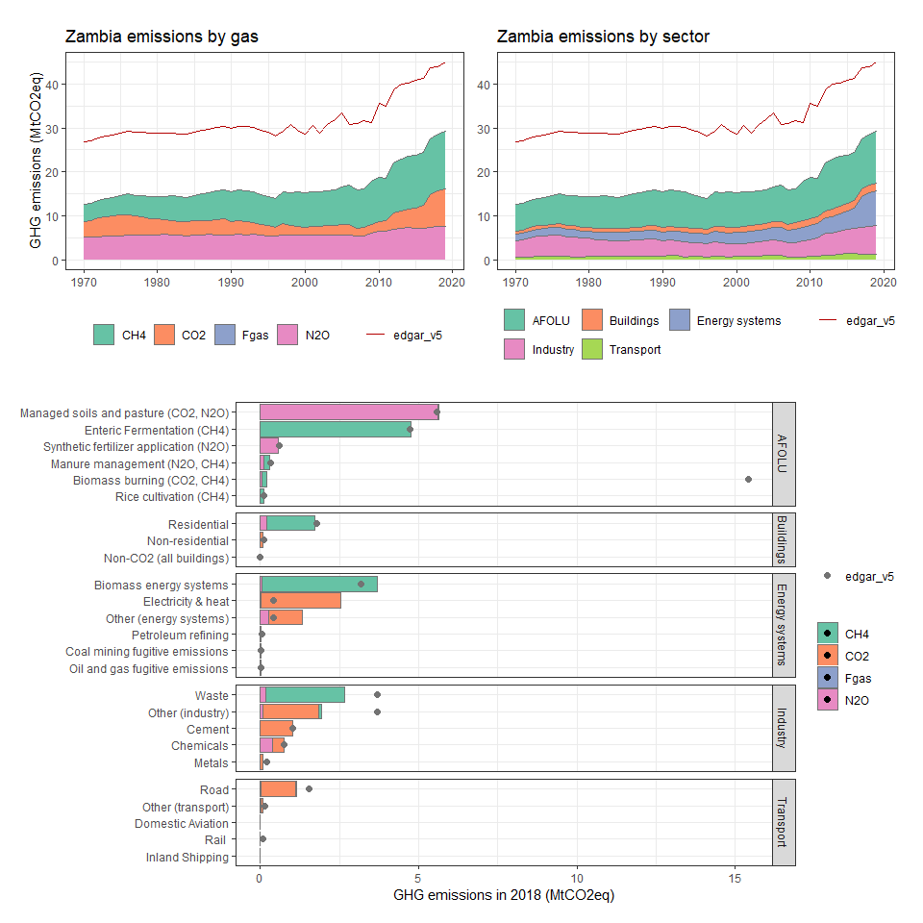

### Zimbabwe

